**Project report**

*Medical store management*



**Submitted by**  **SAP ID**

*Muhammad Esham Qureshi 36511*

**Semester** : 3rd Semester

**Section** : BSCS 3-1

**Submitted To** : Sir Ahmed Nawaz

**Date of submission :** 12 January 2023

**Department of computer Science**

**Riphah International University, Islamabad.**

**Introduction**

My project is related to medical management system named as Riphah medical store which is implemented in Assembly language (8086). where the user will simply login using the password then he / she can buy medicine according to his / her need, can view the record of medicine sale , as well as total earnings per day .

**Project aim and objective**

The aim and objective of my project are to seek knowledge and to understand all concepts of assembly language and implement all concepts in any real-life example.

**Functionality**

Simply user will log in through a password. if the user enter the wrong password then it will display and error message and will ask the user to enter the password again.

Then further on user will have 4 option either he / she want to buy medicine or want to view the record of medicine, user can also view total earning .

1. If the user select first option then in medicine user can select any of available medicine and can also select the quantity of medicine. if the user any wrong entry then an error message will display and will ask the user to enter an valid entry
2. If user select the second option then in if then record of the medicine will be displayed, this record will contain a record of all the medicine sold out. this section of my project is named as medicines statistics
3. If the user selects the third option then in this all earnings of that day will be displayed.
4. If User selects the forth option then it will simply exit the program.
5. If user enter any wrong entry in program then program will display an error message.

**Conclusion**

Seek the use and working of assembly language in our daily life, how assembly language is useful in our life, and how we can optimize our time using assembly language.

**Screenshots**

*If user enter wrong password*

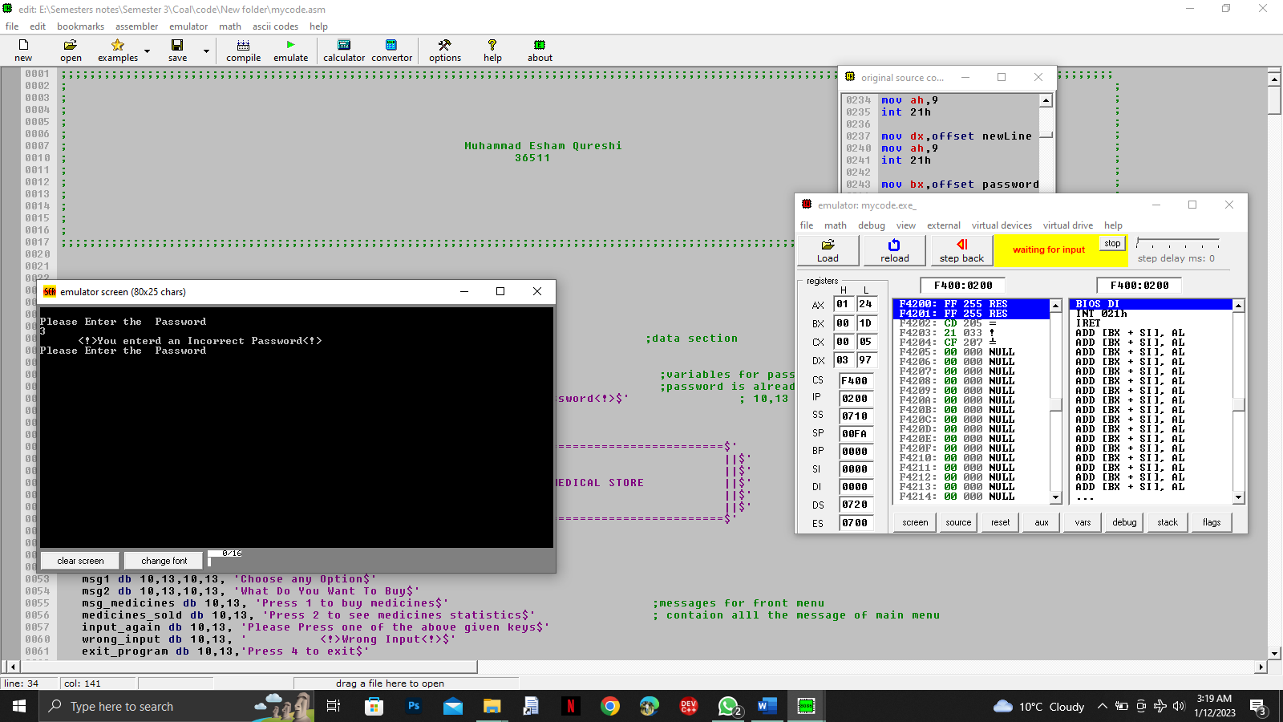

*Front screen after entering correct password*

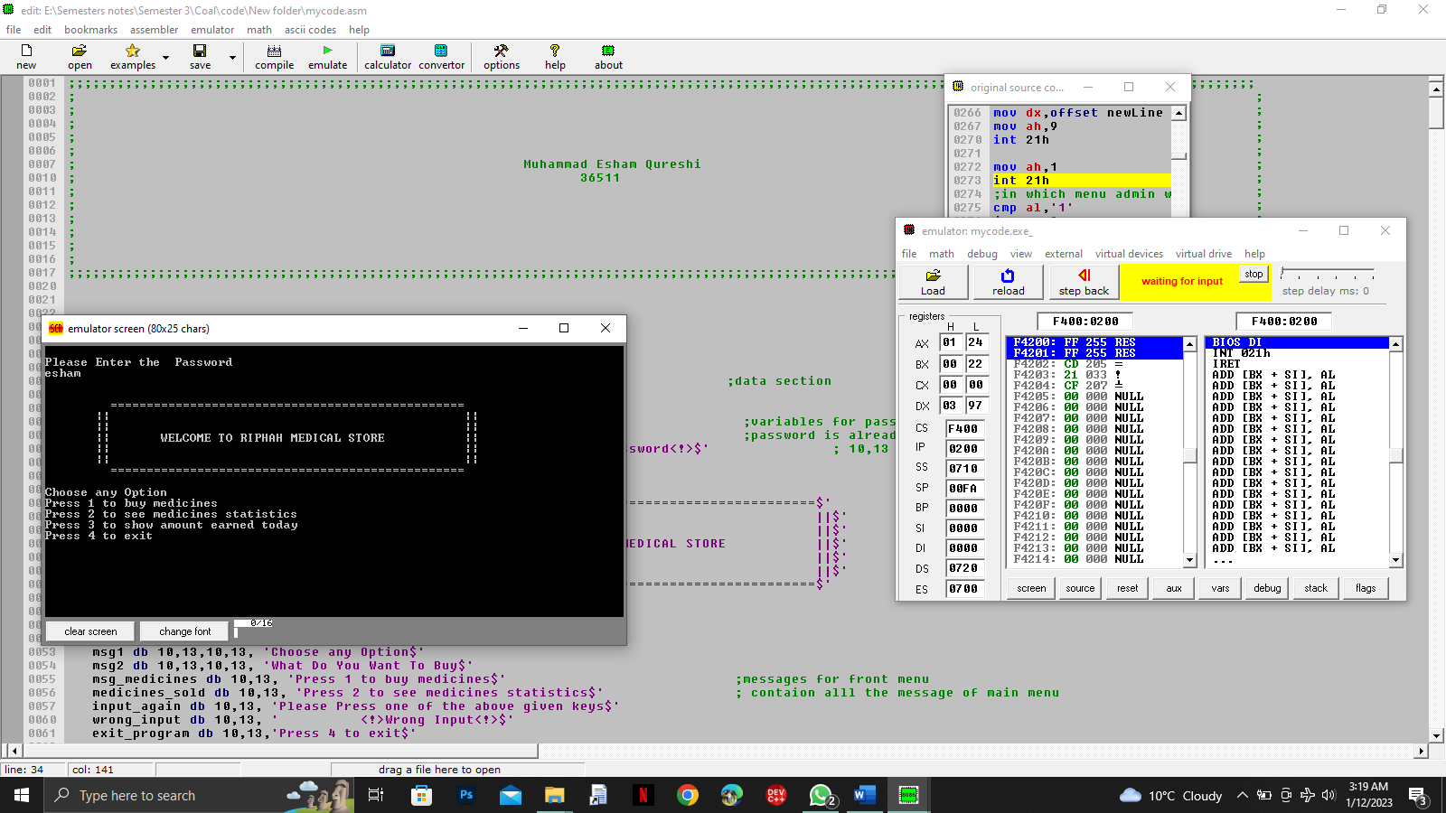

*Medicine section*

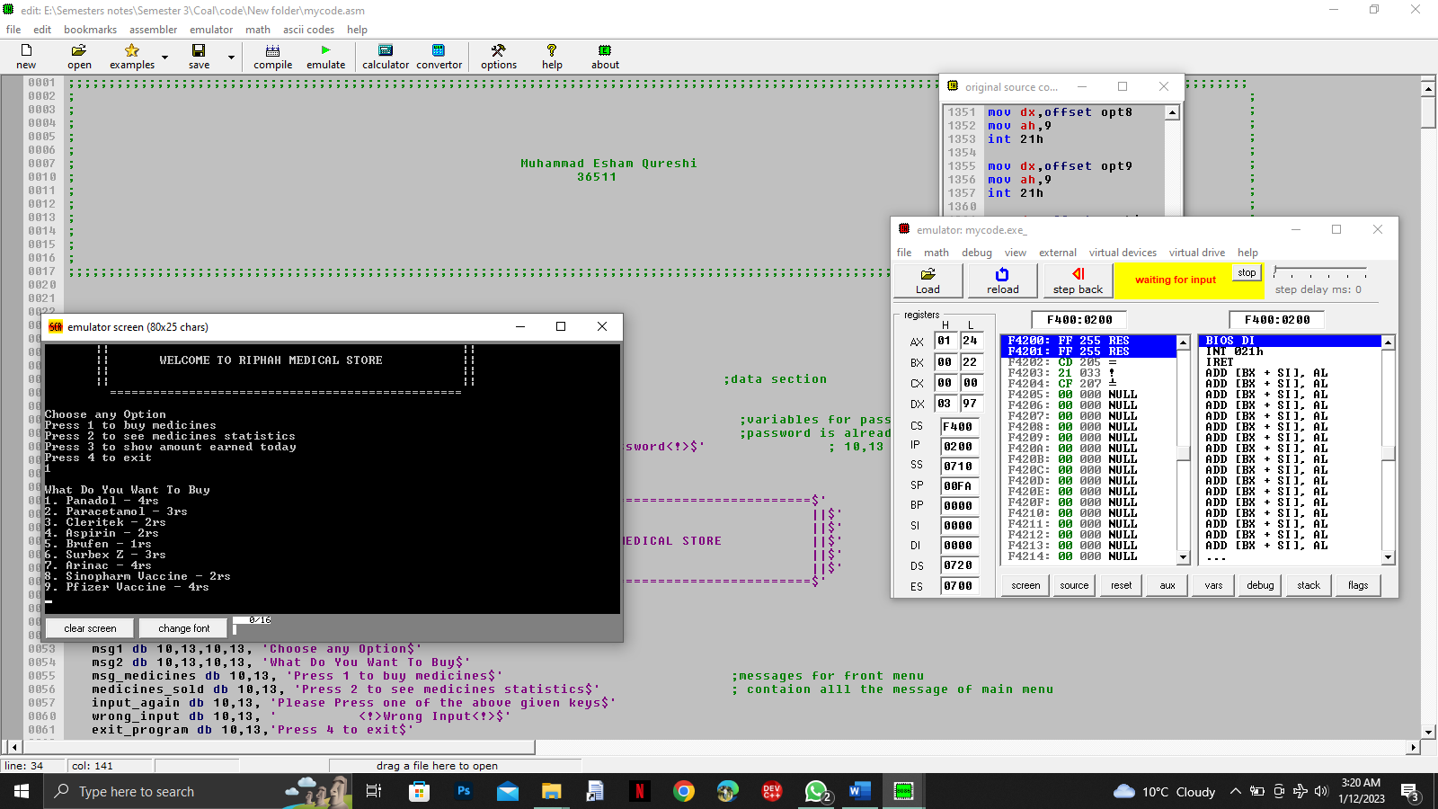

*Asking user to enter quantity*

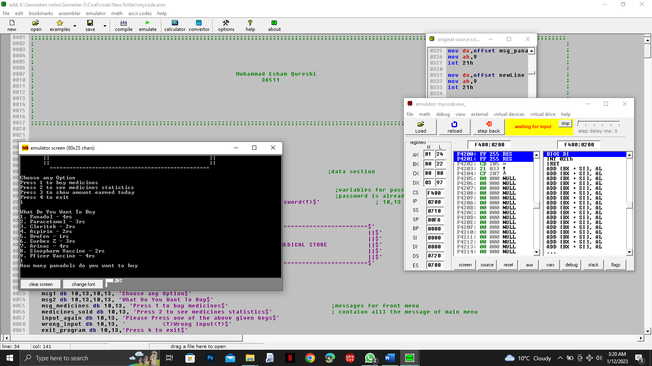

*Total Earning*

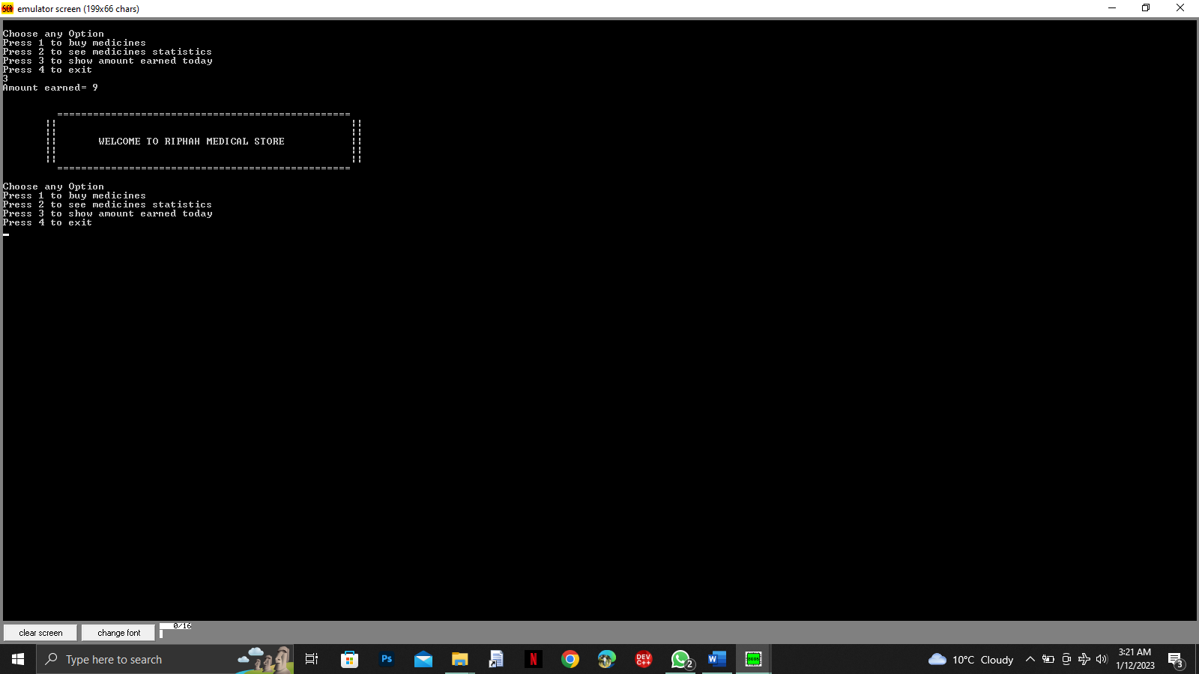

*Medicines statistics*

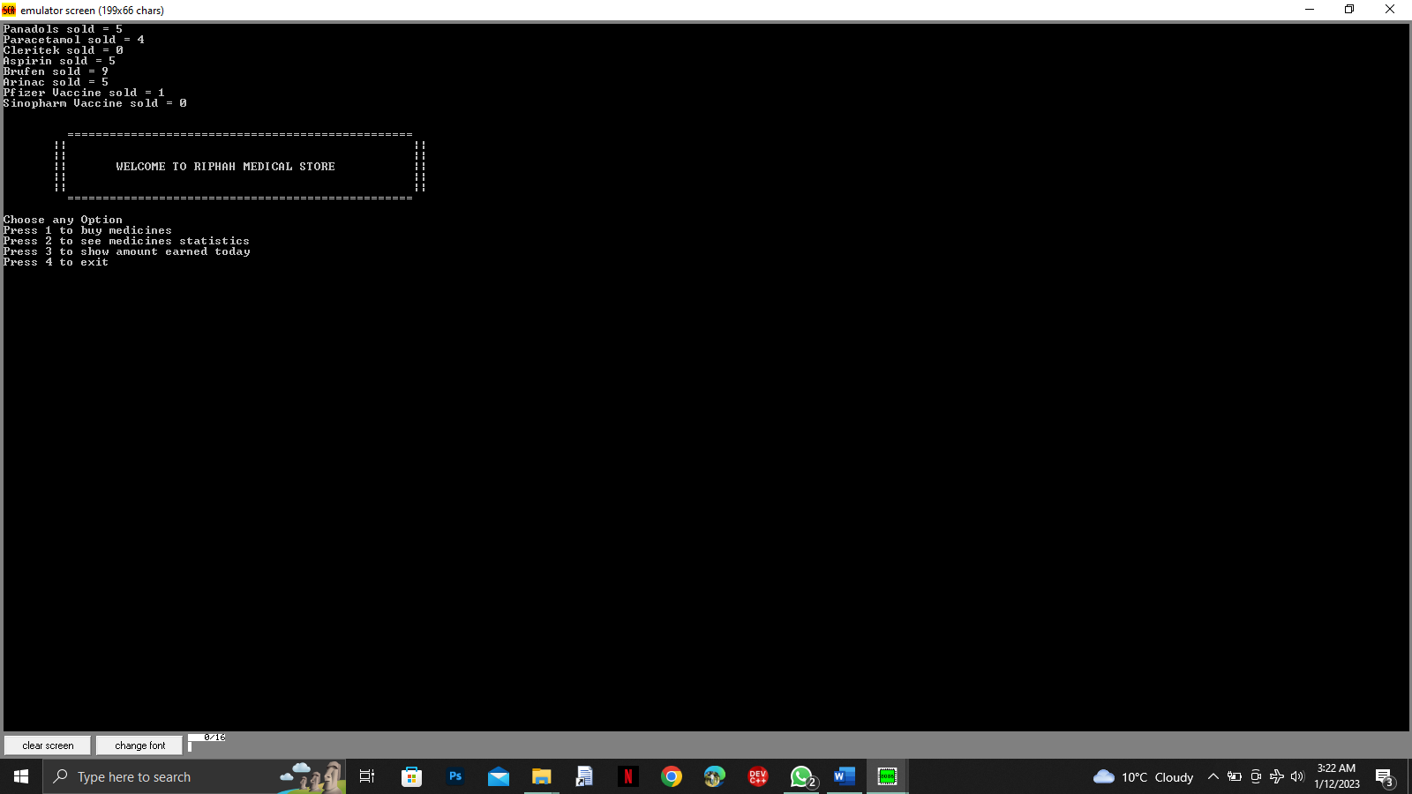

*If user enter wrong input*

