CMPE-257 Sec 02

Final Report

Network Intrusion Detection with
Machine Learning

Group 05

Uday Arora - 019098404
Eshan Chawla - 018225597
Aryan Dandwekar - 019124573
Joao Lucas Veras - 015555345

Date: 12/01/2025

1. Idea

1.1 Description

In the current age of network infrastructure, we can see that there is an increase in both the number of cyber attacks and also an increase in more complicated attacks. With the current traditional defense mechanisms, it is becoming ineffective against these new threats. These defenses are struggling to detect zero-day attacks and cannot scale to meet the high-speed traffic demands of the current age. On top of this, encryption protocols such as TLS/SSL have been widely adopted, making traditional Deep Packet Inspection (DPI) more expensive and also invasive of privacy. Due to this, there is a need for a way to analyze network flow patterns rather than payload contents to identify malicious behavior without compromising privacy or network latency.

To address this issue at hand, this project focuses on implementing an automated Network Intrusion Detection System (NIDS) that is driven by supervised machine learning. This approach that we explore focuses on shifting the paradigm from the static rule-matching approach to a more dynamic behavioral analysis approach. By taking advantage of a flow-based dataset (NF-UNSW-NB15-v3), the system will be able to learn the statistical characteristics of benign and malicious traffic. This solution provides a multi-class classification architecture, allowing it to not only flag anomalies but also to specifically categorize different attacks such as Distributed Denial of Service (DDoS), Botnets, and Brute force attempts. By implementing this system, it will greatly reduce the manual work needed to be done by security analysts.

1.2 Goals/Objectives

The goal of this project was to create an end-to-end data science pipeline that is capable of navigating the complexities of network security data. The way we achieved this goal was by addressing four key technical challenges.

Dataset Acquisition and Understanding:
To construct a realistic model, the first objective of this project is to find and understand a dataset such as the NetFlow v3 dataset. This required us to further our understanding of complex network flow attributes to ensure that the data was able to provide a correct representative sample of modern network traffic while also covering both normal user activity and a variety of attacks.

Preprocessing and Feature Engineering
To prevent the model from overfitting, which is the case when a model memorizes specific targets rather than learning the behaviors, we were required to create a strict preprocessing pipeline. This pipeline would need to ensure it handles infinite values and normalizing distributions. On top of this, the pipeline should handle any feature leakage, which ensures the model would not be trained on features not present in real-time.

Multi-Class Model Training
The core modeling goal is to move beyond simple binary detection of whether an attack occurred, to distinguish between 11 specific attack classes. For this project we will train three machine learning models to see which would be the most accurate and effective. The models we selected were logistic regression for a baseline, KNN, and last Random Forest.

Evaluation
For the last objective we are going to need to validate that the system made is functional enough to be released in a simulated environment. What this requires is for us to analyze different metrics to ensure that the model is accurate when faced with different scenarios and also is not raising false alarms.

2. Work Developed

2.1 Platform

We developed a modular feature engineering pipeline to implement essential data cleaning steps and handle a huge dataset on a single node without distributed computing platforms like Apache Spark (PySpark) hence we have used Google colab for most of our project which has generous memory to handle big datasets [A100 GPU with high system memory]

2.2 Dataset

We had multiple datasets and Netflow Versions, which we discovered from the case study and we finalised the latest Netflow V3 which is the latest and most robust data extraction technique.
For the datasets we have mixed them so that we don't rely on a specific dataset and have the ability to test if our model can be generalized or not.

The datasets chosen for this project combine the following :

(1) UNSW-NB15 with 2,365,424 data flows and 5.4% attack samples :
Classes : Fuzzers, Backdoor, DoS, Exploits, Generic, Reconnaissance, Shellcode, and Worms.

(2) ToN-IoT with 27,520,260 data flows and 38.98% attack samples :
Classes : Backdoor, DoS, DDoS, Injection, MITM, Password, Ransomware, Scanning, and XSS.

(3) BOT-IoT with 16,993,808 data flows and 99.7% attack samples :
Classes : Reconnaissance, DDoS, DoS, and Theft.

(4) CSE-CIC-IDS with 20,115,529 data flows and 12.9% attack samples:
Classes : BruteForce, Bot, DoS, DDoS, Infiltration, Web Attacks

2.3 Feature Engineering

We have created a central data processing pipeline which removes leaky columns depending on attack specific usecase, then handles infinite values, removes duplicate columns with the same data, and also removes highly correlated columns which have 95% same covariance.

Even after all this data reduction we still have a lot of data to train and test on and hence we set a cap of 300k records per category of attack to avoid huge data imbalances across categories.

2.4 Adopted ML Algorithms

In this study, we used a variety of supervised learning algorithms to evaluate their use in distinguishing between benign network traffic and specific network related cyber security attacks. To ensure the reliability of our results and mitigate the risk of overfitting, we implemented K-Fold Cross-Validation across all models. This was done as we had seen over-fitting in our results before and saw this method in the case study paper we had taken.

2.4.1. Logistic Regression (Baseline Model)

Justification: This is a linear classifier. Its purpose is to test if the network data is "linearly separable" (i.e., can a straight line separate attacks from normal traffic?).
Relevance to Project: If this model fails (which it did), it proves that intrusion detection is a complex, non-linear problem requiring advanced algorithms.

2.4.2. K-Nearest Neighbors (Instance-Based Learning)

Justification: KNN classifies traffic based on feature similarity (distance) to known examples rather than learning a specific model structure.
Relevance to Project: This was taken as a comparative model to test if local anomaly detection is more effective than the linear approach.

2.4.3. Random Forest (Ensemble Method)

Justification: We choose this as it builds multiple decision trees and merges them to get a more accurate and stable prediction. Random forest also is great for handling high-dimensional data and for dealing with overfitting.
Relevance to Project: Intended to capture complex attack signatures that simple rules might miss.

2.5 Performance Metrics

Accuracy: The ratio of correctly predicted observations to the total observations.

Precision: Precision measures the accuracy of positive predictions.

Recall: The ability of the classifier to find all the positive samples, weighted by the number of samples in each class.

F1-Score: The harmonic mean of Precision and Recall. This was the primary metric used for ranking because the dataset contains imbalance attack classes.

Matthews Correlation Coefficient (MCC): Used to assess the quality of binary classifications, ensuring that the prediction performs well across all confusion matrix categories.

Detection Rate (DR): The arithmetic mean of the Recall score calculated for each individual class, treating all classes equally regardless of their size.

False Alarm Rate (FAR): The arithmetic mean of the False Positive Rate calculated for each individual class. This was an important domain specific metric we chose as in real word security operation centres a high FAR leads to alert fatigue so, with a low FAR system people only have to deal with alerts that might be from real network intrusion situations.

2.6 Evaluation

Comparative Model Performance

Baseline Failure: Logistic Regression baseline failed to capture the data's complexity, yielding an Accuracy of only 19.36% and a F1 score of 15.22%. This vast discrepancy confirms that network intrusion patterns are highly non-linear. This also had the highest FAR of 7.37% which makes it not ideal for any real world solutions, but it still offers great applications as a baseline to compare to.

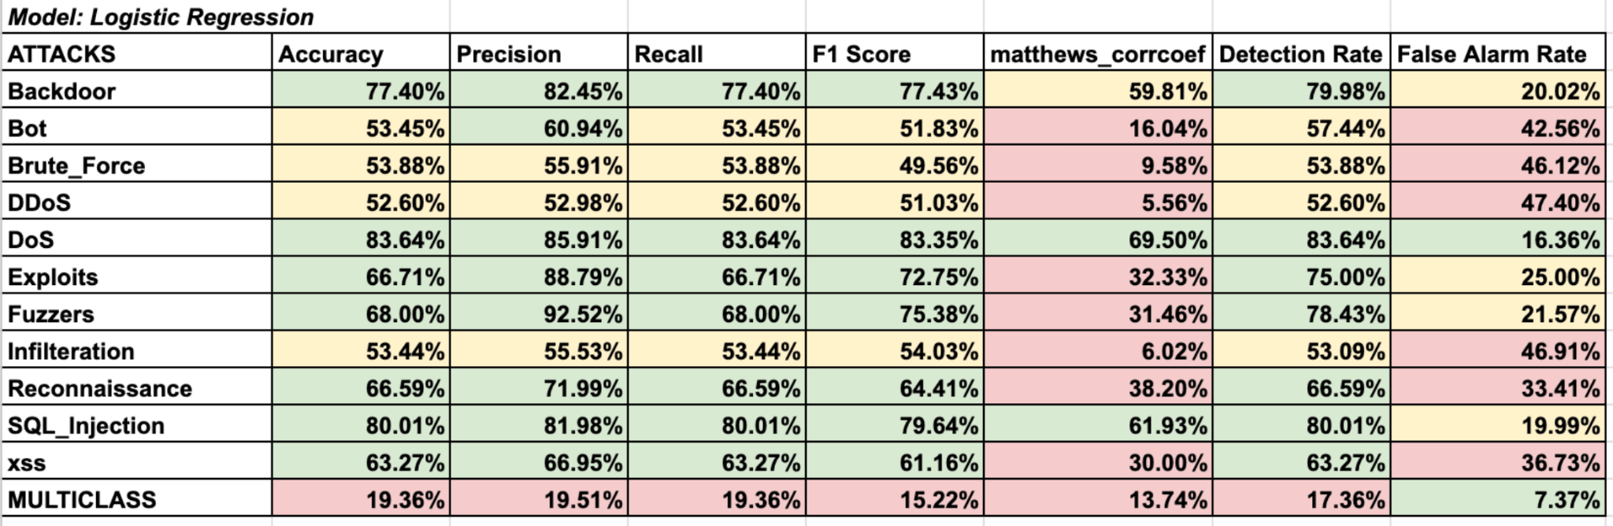

Mid-Tier Performance: The K-Nearest Neighbor model achieved an Accuracy of 87.01%, and a F1 score of 85.38% much better as compared to the baseline but falling short of Random Forest's reliability. It also had much better FAR at 1.21% though it still felt short of random forest, these results still make it a contender worth considering.

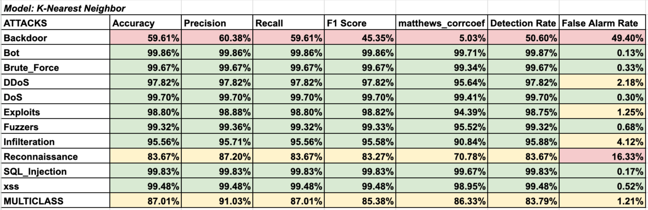

Top Performer: Random Forest model showed the best performance as compared to the other two models, achieving an overall Accuracy of 97.74% and an F1-Score of 97.73%. It also had the lowest FAR of 0.2%. It successfully generalized across the diverse attack types, and looks like it might be a great choice for such applications though we still need to do real world testing, further model tuning and comparison to other models/techniques before concluding on this as the clear winner.

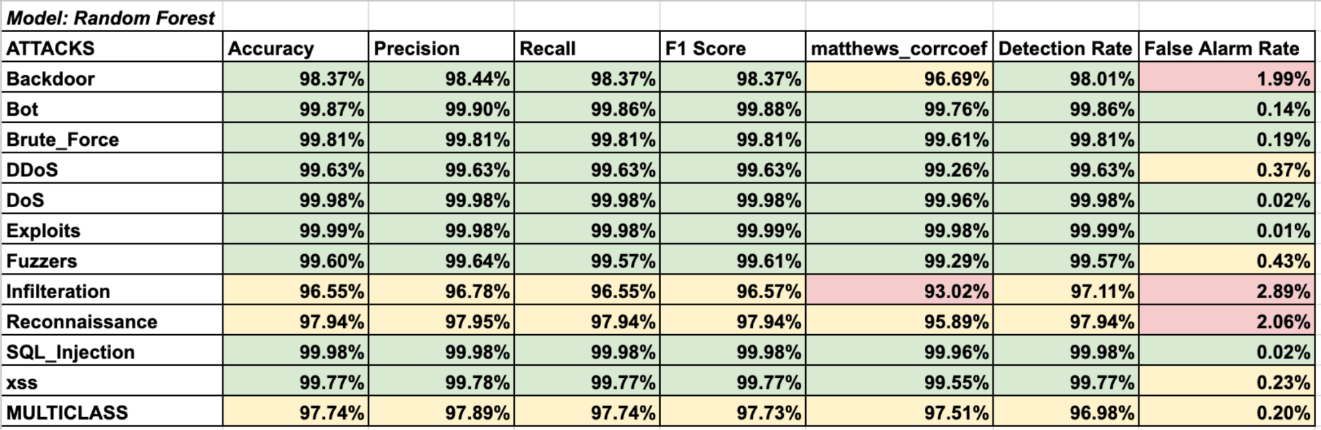

Also, we noticed that all 3 algorithms usually performed much worse at attacks like infiltration, reconnaissance, backdoor which leads us to believe attacks whose detection relies on payload data which is not captured by the netflow data we used may prove to be a challenge, also considering some of our results showed decent results for other attacks such as sql injection and cross site scripting (xss) which we know are also payload reliant for their detection this may show that there is a need to validate these results on real time simulation or on other datasets. While making the decisions for what all attacks we wanted to create models for we wanted to find out if attack specific binary models are significantly better than a single multi class classifier, from the results we do see the multi attack classifier usually performing worse in comparison. This may lead us to believe that a single model finds it difficult to generalize and detect patterns for multiple different types of attacks but considering the lower overhead of having a single model such a solution is definitely still worth considering.

2.7 Recommendations/Future Work

For the future work/recommendations we plan to do the following:

2.7.1. Compare Basic ML with Deep Learning models
We plan to compare the current basic Machine Learning (like Random Forest, Logistic Regression, K-NN) to Deep Learning models such as Convolutional Neural Network for spatial feature extraction or Long Short-Term Memory (LSTM) networks to capture temporal dependencies in network traffic. Since our project is limited to using basic ML models we want to compare and check the system metrics. We plan to use the same preprocessed NetFlow features and split we used for the classical models to keep comparison fair. Using DL models the ability of the model will be enhanced to identify complex, low-volume, and novel attacks that basic models might miss.

2.7.2 Handling Encrypted Traffic and Payload-less attacks
We want our model to work without looking at raw payloads, by using metadata and side-channel information from encrypted flows. From the case study and other papers we have observed that most of the modern traffic is encrypted, so we can’t rely on reading payloads. We need this because most of the modern traffic is HTTPS/TLS/VPN, so payload-based signatures are becoming less effective. In many environments, decrypting traffic is not feasible and to keep the NIDS useful in real world networks, we need methods that work on metadata only. So, for future work the idea is to make better use of everything that’s still visible around the encryption. For example, we can extract TLS handshake features like cipher suite, certificate length or even JA3 fingerprints to build a kind of behavioral signature for connections. Then we compute statistical side channel features like packet size distribution and variance, inter-arrival timing patterns and entropy of packet sizes or directions to spot suspicious flows even when we can’t see the actual content. Finally,we integrate all these features into our existing pipeline and train our model specifically on encrypted traffic subsets where payload is unavailable.

2.7.3 Real-Time Network Simulation and Live Model Deployment
The idea is to deploy our model in a virtual environment and then generate real traffic, including both benign flows and attacks such as DoS, DDoS, or brute-force attempts. Our current model is running offline on a colab notebook where we have static CSVs and stored flows. We need to verify that the model still performs well under real-time conditions and not just a notebook. When we test it in a real-time network the traffic would be converted into NetFlow-style features and sent to our trained model through a middleware layer. This will help us to check not only if the model still detects attacks correctly in a noisy real environment, but also measure important system metrics like latency, throughput, and packet drop rate.

2.7.4 Make Hybrid Detection System
The idea is to design a Hybrid NIDS that combines the strengths of our Netflow-based model with Deep Packet Inspection (DPI). The idea is that our flow model handles the scalable, high-level monitoring which will be good at quickly spotting suspicious patterns like unusually high traffic volumes, weird port usage, or odd communication patterns. But flows alone can’t see everything, especially things hidden in the payload or on the host itself. So in a hybrid setup, the model acts as a fast “First Pass” filter, whenever it flags something as suspicious, that automatically triggers a heavier analysis layer, like Deep Packet inspection or host-based logs that second layer can then look at the actual data content, system processes or malware signatures that the flow features can’t capture. So overall, you get the best of both worlds, speed and scalability from Netflow, plus forensic depth when you really need to zoom in.

3 Project Management

3.1 Final Schedule & Task Distribution (Gantt chart)
We split the work almost equally in the project and everyone was proactive to communicate and contribute for the same.

[Gantt Chart] -
https://docs.google.com/spreadsheets/d/1HfB1MhVN_zPGWc6eZVnTGERnQsFXEHusAt2wCkKRW_8/edit?usp=sharing

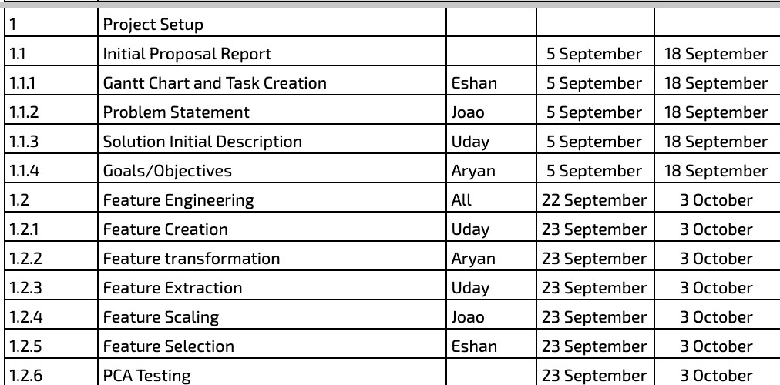

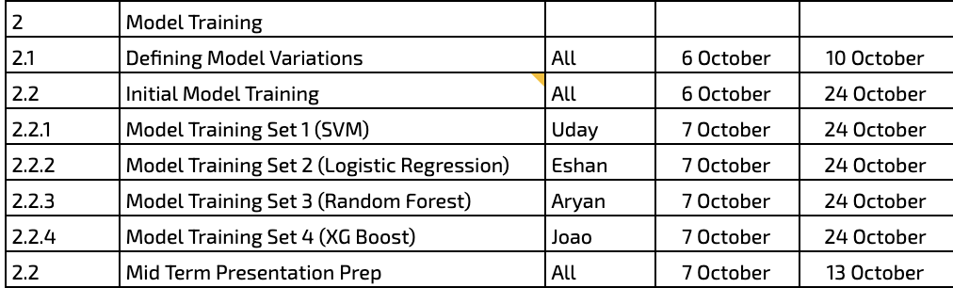

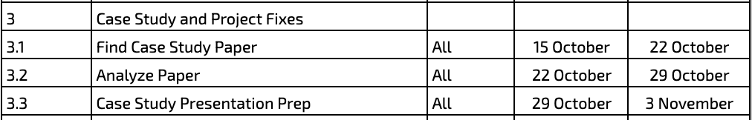
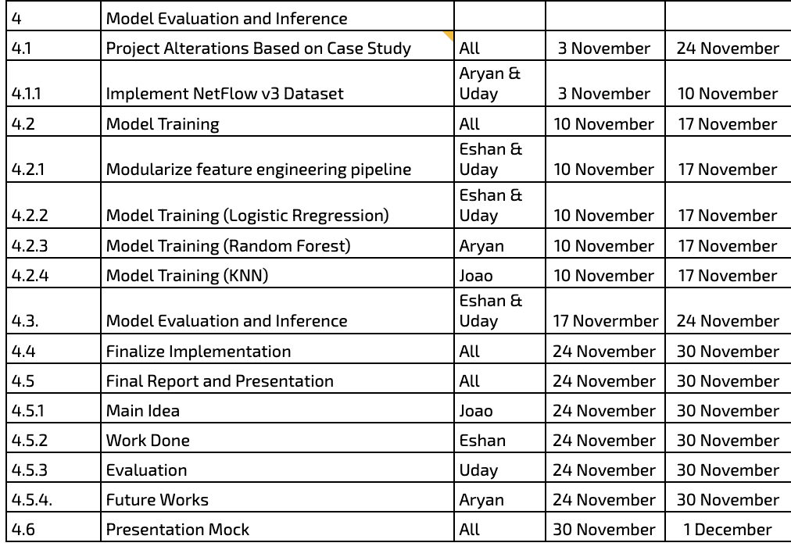

3.2 Challenges

We encountered multiple challenges throughout the project like limited knowledge and expertise of Networking and this project helped us revisit those concepts and made us study those networking fundamentals.

While working within this domain we found out there were multiple netflow versions and techniques with which we can extract data from the standard captured PCAP files which store packets and different datasets were not consistent with the extracted data and hence we had to refer to the latest version and get our dataset in the same format so that we can generalize our findings and make them reproducible.

As Pcap files were huge we had to also develop a lot of utility functions as the processing big data on a single cluster takes a lot of time along with the model training, to solve for this we created functions to download and load the dataframes from google drive to a dataframe which were used across the notebook.

There were too many variations to test and it would not have been sane to split the work into multiple notebooks and amongst our teammates equally as that could lead to a bias and non uniform output and hence we made the entire feature engineering pipeline standard and reusable along with the model training so we can directly test all variations to evaluate results in a single notebook.

3.3 Learning Outcomes
Throughout this project we learnt a lot about machine learning, especially so much that could be achieved with just classic machine learning algorithms, cyber-security aspects like how different attacks happen, what they target and what kind of data we can use to detect them. We also learnt about project management like how to set deliverables, plan a project cycle also as this was a team project we polished many important soft skills .
One of the most significant things we learnt was the importance of a reliable data engineering pipeline when handling high-volume network logs. Dealing with the large size of raw PCAP (packet capture) files and the inconsistencies across various NetFlow versions necessitated the development of custom utility functions for efficient memory management and data loading. We learnt that without a standardized, modular preprocessing pipeline, collaborative development becomes vulnerable to bias and versioning errors. By creating a single feature engineering process, we ensured that every model regardless of who trained it was evaluated on consistent data, teaching us that reproducibility and data hygiene are just as vital as the algorithm selection itself.
This project also helped us learn a lot about networking fundamentals, not just from a theoretical but a practical side as well. We learnt about the distinction between packet-level analysis (deep packet inspection) and flow-level analysis (NetFlow), learning how flow features like duration, byte count, and flag rates can act as fingerprints for malicious activity. We explored the different ways attacks can happen through the network, understanding how different network flow patterns such as the high speed traffic of a DDoS attack versus the stealthy, low-frequency patterns of an Infiltration attempt manifest in the data. Also, we became aware of the concept of "alert fatigue" where for example in a Security Operations Center (SOC) context, a model that floods analysts with False Positives is operationally useless, regardless of its theoretical accuracy as with the high frequency of false alerts to deal with people become used to ignoring such alerts which may prove to be a big issue when an alert for a real intrusion situation that needs to be dealt with arises.
From a machine learning perspective, we learnt that real-world security data is highly non-linear and complex, and that simpler linear models may not be useful for such applications but may work as great reference baselines. We discovered that ensemble methods (like Random Forest) are far better suited for this instead because they can capture the specific, jagged decision boundaries required to separate normal traffic from obfuscated attacks. Additionally, we learnt the critical lesson of metric selection in imbalanced datasets. Since network attacks are often "rare events" compared to benign traffic, we realized that relying solely on "Accuracy" is misleading. So we also focussed on Recall (to ensure no threat is missed) and F1-Score (to balance precision), along with certain domain specific metrics (like False Alarm Rate).
After making the first models using the FLNET2023 dataset we saw that all our models were getting near perfect results which quickly made us think our models were over-fitting, during the case-study research we found out about K-fold cross validation which felt like a good method to validate our model results, after retraining and validating the models with our original feature engineering process we saw much worse results showing that the previous results were indeed not true. So, we made various adjustments such as fixing certain issues with our feature engineering pipeline like revisiting how we dealt with leaky columns, we also chose a better dataset, and tested this with K-fold cross validation and we were able to get much better results this time. All this taught us how important is result validation and testing and also that just numbers on a table may not translate to real world performance which is why we want to test these models in a simulated environment with real attacks happening so we can truly measure how our models perform and understand what we can improve.

4. References

[1] Code Notebook:
https://drive.google.com/file/d/1B4WhYcyInRXWl-pwRsj-9xrWHaSBYmq8/view?usp=sharing
[2] NIDS Dataset:
https://staff.itee.uq.edu.au/marius/NIDS_datasets/
[3] Final Dataset Paper:
Luay, M., Layeghy, S., Hosseininoorbin, S., Sarhan, M., Moustafa, N., & Portmann, M. (2025). Temporal analysis of NetFlow datasets for network intrusion detection Systems. arXiv (Cornell University).
https://doi.org/10.48550/arxiv.2503.04404
[4] Case Study Paper:
Sarhan, M., Layeghy, S., & Portmann, M. (2021). Towards a standard feature set for network intrusion detection system datasets. Mobile Networks and Applications, 27(1), 357–370.
https://doi.org/10.1007/s11036-021-01843-0
[5] Initial Dataset Paper:
Kumar, P., Liu, J., Tayeen, A. S. M., Misra, S., Cao, H., Harikumar, J., & Perez, O. (2023). FLNET2023: Realistic Network Intrusion Detection Dataset for Federated Learning. MILCOM, Military Communications Conference.
https://doi.org/10.1109/milcom58377.2023.10356272

