**CodeByg [This is the code name, not the final name]-**  
  
CodeByg is intended to be a real, competitive platform for coding for the next generation of computers. Attached below is the architectural design-  
 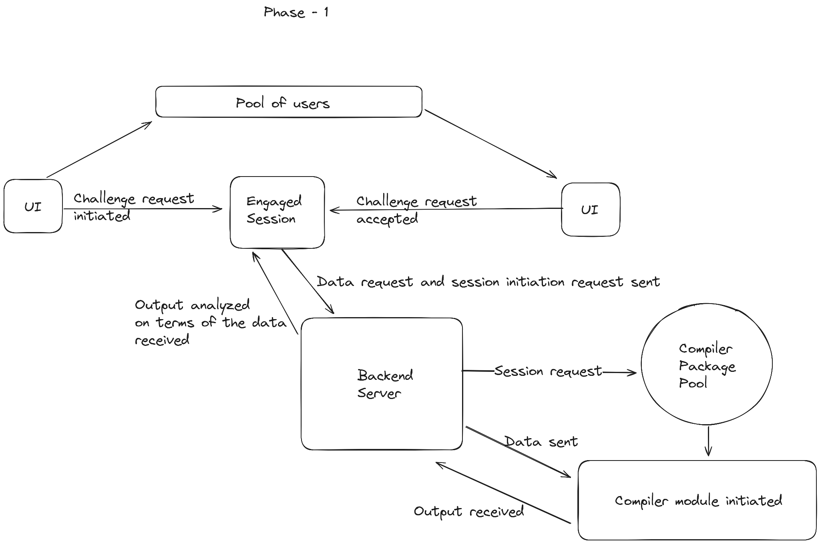We are the ones who created an architecture that actually brings in competitive coding in the real world for developers.  
In the first phase, we will focus on the five main languages that are used to prepare for the DSA. These languages serve as the foundation for the frameworks that are currently in use in the tech sector of the AI, MIL, and primarily web industries.  
  
The flow of the site is as followed-

* User signs up for the platform.
* A challenge is requested by the user.
* The platform connects the user with another user who has put in a challenge request.
* The two users start the session together.
* The engaged session is given the compiler container.
* A DSA-based question is given to users to answer.
* Each user submits their response.
* Platform computes memory usage and runtime execution of the code.
* Based on the code's best approach, the winner is selected.
* The first-submitted user will be declared the winner if both have the same best strategy.

We are the first researchers in the field of security to specifically create a module that forgoes copy-and-paste coding, allowing only those who deserve it to demonstrate their worth.  
Our module is solely front-end dependent; it recognizes when a tab or window is changed and allows the user to return to the screen for a maximum of 2.5 seconds to continue coding. If that time is up, the session ends and the opponent is deemed the winner. [In actuality, it is nearly impossible for a user to copy a question, search for an answer, and then paste that information into the editor in 2.5 seconds.]  
  
In addition to offering developers a competitive platform for coding, this platform can also prove valuable in terms of matching companies with the best developers. Thus, hiring through our site reduces the need for you to go through the laborious process of reviewing applications because you, as the prospective employer, can review each developer's statistics and determine who is the best fit. The developers that win rounds are chosen based on their ability to code, their best approaches, and their timeliness.  
  
**Phase 2: While the first phase of this product's development is ongoing, we have already scheduled the second phase, which will primarily focus on two updates:**   
1. The creation of random test cases, which would vary each time the DSA question is asked in order to prevent the forced generation of answers.   
2. Upgrading to every language; regardless of how well-liked a language may be, we want all developers to be proficient in their preferred coding language   
3. Introducing modes that would allow tech companies or colleges to host their own secure hackathons, as well as tournament modes for the same.  
  
**Phase 3: Since the DSA section of the platform is already operational, we have planned for future updates for a longer runway:**1. Developing a real-time collaborative coding module that will allow two developers, or a team of developers, to work together to build a module or piece of code on our platform. The module or code will be edited in real-time and accessible to all users, with a preview pane appearing to display the final product. [The frontend will be the focus of the preview section, but we can also integrate the backend with the right support.]   
2. In order to allow developers to use this feature from their preferred editor, we plan to expand the extension for VS Code or other code editors after this module is released.   
  
**Market research and business aspect -**With our USP and significant architecture, we can easily maintain our position in this industry. The coding platform market is valued at 182 billion in Indian rupees, and coding preparation platforms account for a significant portion of this.   
In the first phase, we would deal with business-to-consumer (independent programmers or those getting ready), and in the second phase, business-to-business and business-to-corporate would be our focus.   
  
In addition to introducing our in-platform point system, which developers can redeem to receive discounts on these platforms, we will be partnering with various tech product providers that would benefit developers in their professional lives or portfolios.   
  
In the future, we plan to introduce mentor counseling as another option for students to receive appropriate guidance at a very reasonable cost, or for free.   
  
Our USP is the robust DSA platform architecture, which ensures that no loopholes exist and that only the truly deserving can demonstrate their value and contribute competitive coding in the true sense. One-on-one coding challenge session: To prevent cheating, there are tab or window shifting module to terminate session.  
  
Although there may be competitors in the market today that fall under the category of competitive coding platforms, none of them have the same architecture and level of service as ours.   
  
Phase 2 will cater a massive inflow for money because of the functionality of real time coding that can cater to MNC’s too.  
  
**Proof of concept of our module-**  
The compiler module was one of the public backend modules that we created and released as open source software so that developers could use it to create their own products and projects. The good news is that in less than seven days, we had more than 250 downloads.   
  
The NPM PACKAGE - VE-COMPILER package link is [provided here](https://www.npmjs.com/package/ve-compiler). We are continuously updating this package for use by other developers. Additionally, we provided comprehensive documentation on how to use this package. Additionally, we offered the example code.  
  
We anticipate an ETA by the end of the year, at which point, following the completion of all testing and bug-fixing stages, we will publicly release this product. As we also attached above, we have already prepared the HLD and completed the development of over half of the modules.   
  
**Tech Stack Used-  
-**Javascript  
**-**Node and Express js - Backend  
**-**MongoDB - Database  
**-**Redis - Session Management  
**-**Docker & Kubernetes - Contatinerization management  
**-**React js - Frontend