**Project 4 Report**

**Name : Eshan Danayakapura Jagadeesh**

**UTA ID : 1001667159**

**Net ID : exd7159**

**1). Screenshots of Database**

**Screenshot of the entire database which has the following tables:**

1. **Client**
2. **Role**
3. **Contactus**
4. **Clientspetstore**
5. **businesspetstore**

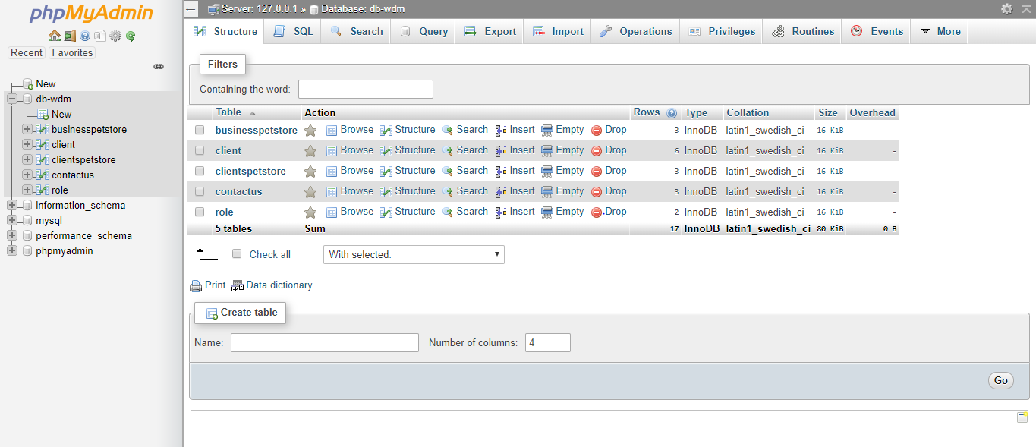

**Screenshot of contactus table which has the following attributes:**

* **Fname**
* **Lname**
* **Email**
* **Phone**
* **Comments**

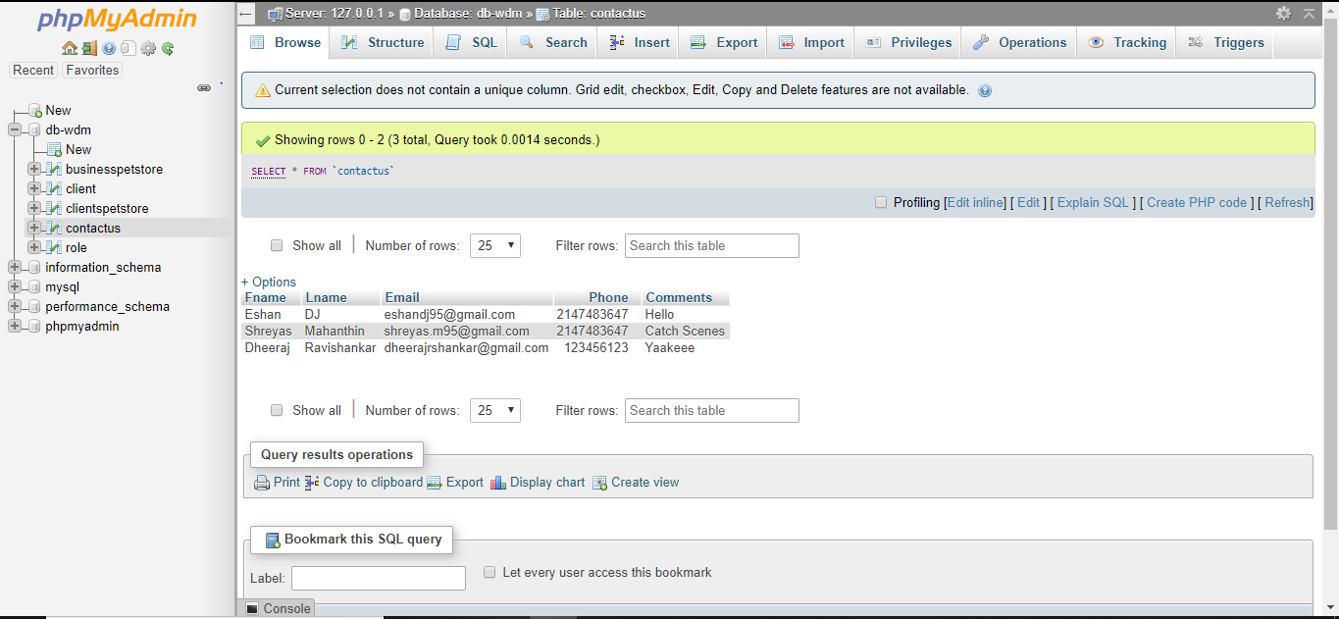

**Screenshot of Client/Service table which has the following attributes:**

* **Firstname**
* **Lastname**
* **Email**
* **Phno**
* **Bn**
* **Password**
* **roleid**

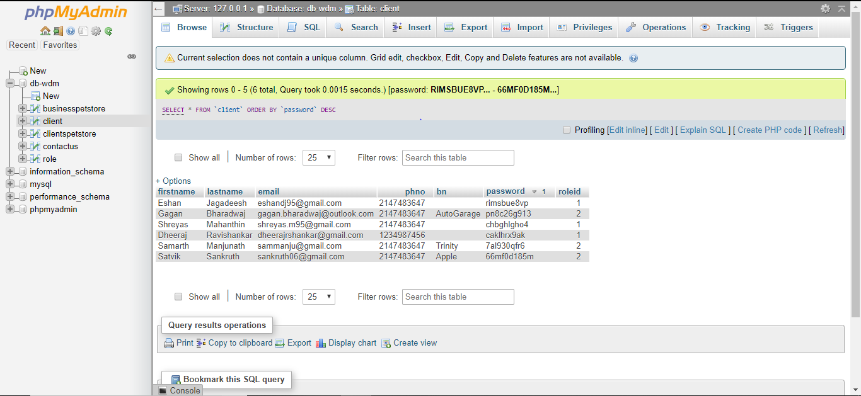

**Screenshot of role table which has the following attributes:**

* **roleid**
* **description**

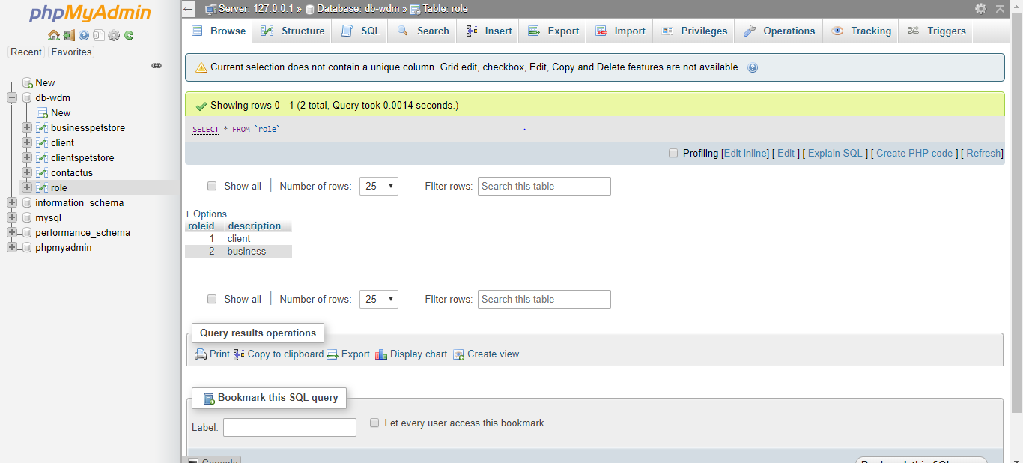

**Screenshot of business pet store whose attributes are:**

* **bname**
* **sname**

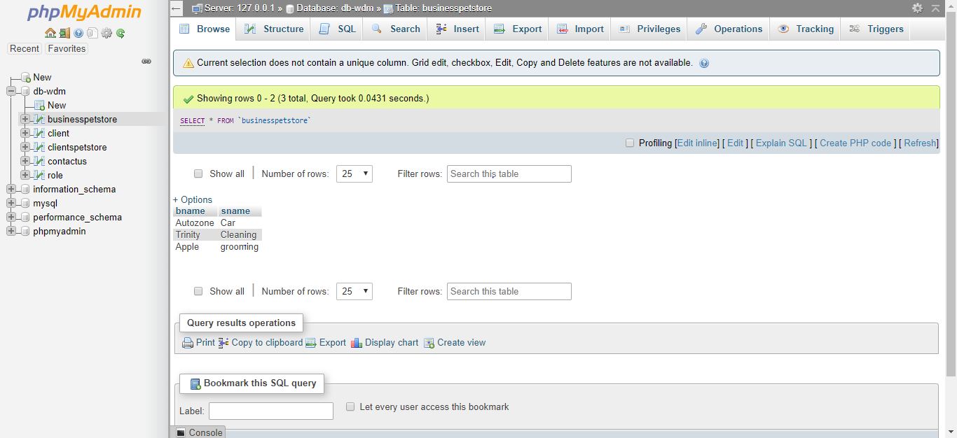

**Screenshot of clients pet store whose attributes are:**

* **cname**
* **sname**

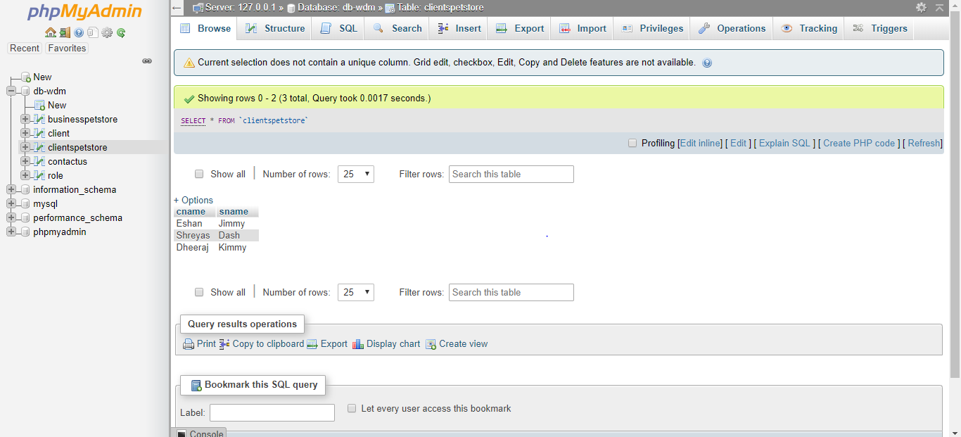

**2). Screenshot of queries and results.**

**Inserting into the database:**

**INSERT into ‘businesspetstore’(‘bname’,’sname’) VALUES (‘cleaners’,’cleaning’);**

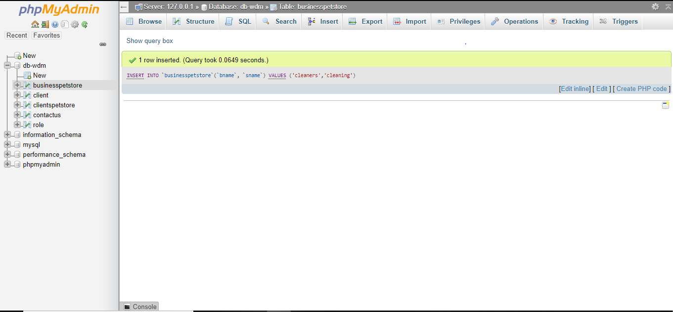

**Deleting a record from the database:**

**DELETE FROM `businesspetstore` WHERE bname='cleaners';**

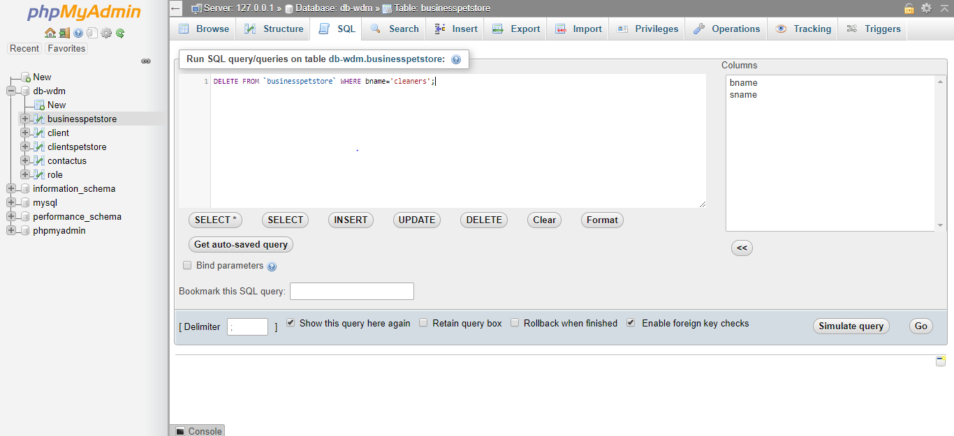

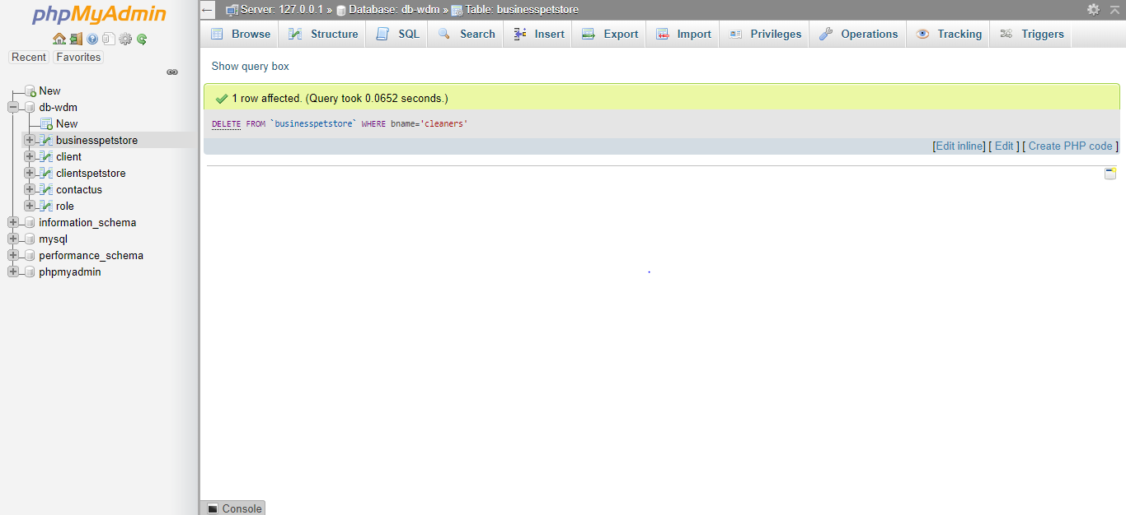

**Selecting records from the database:**

**SELECT * FROM `client` WHERE roleid='1';**

