
DEPARTMENT OF COMPUTER SCIENCE & ENGINEERING
B.TECH COMPUTER SCIENCE & ENGINEERING
PROJECT ID: DA-024
GROUP ID: BTech_DA_06
PROGRAM NAME: DATA ANALYTICS
PROJECT NAME: Bank Loan Approval Data Exploration
SEMESTER / SECTION: III / F
MENTOR NAME: MR. PUNEET ARORA
DEPARTMENT OF COMPUTER SCIENCE & ENGINEERING
COURSE NAME: B.TECH (COMPUTER SCIENCE & ENGINEERING) | SEM III | SECTION F
S.No. | TEAM MEMBERS | STUDENT ID | ROLL NUMBER
1 | SANSKRITI SAXENA | BCS2025482 | 2510303457
2 | SAKSHAM SINGH | BCS2025483 | 2510303453
3 | ESHAN SINGH | BCS2025491 | 2510303196
4 | SWARNIMA SINGH | BCS2025495 | 2510303525
5 | AMRATYA TIKKHA | BCS2025497 | 2510303087
6 | SHASHWAT BAHUGUNA | BCS2025500 | 2510303477
7 | ABHINAV PRADHAN | BCS2025502 | 2510303015
8 | NIHAL SINGH | BCS2025503 | 2510303346
9 | MAYANK KUMAR | BCS2025505 | 2510303298
10 | HIMANSHU | BCS2025513 | 2510303222
11 | VIJAY VERMA | BCS2025515 | 2510303544
12 | ANSHUL KUMAWAT | BCS2025518 | 2510303118
13 | RAHUL KUMAR | BCS2025522 | 2510303406
14 | MAYANK PRATAP SINGH | BCS2025523 | 2510303300

INDEX
1. Introduction 04
2. Problem Statement 05
3. Objective of Project 06
4. Methodology 07
5. Literature Review 08
6. Explanation of Project (Working) 09
7. Workflow 11
8. Program 12
9. Result & Discussions 15
10. Snippets of Output 18
11. Future Scope 25
12. Conclusion 26

1. Introduction

Bank Loan Approval Data Exploration
Bank loans provide financial support for personal, educational, housing, vehicle and business needs. Before a loan is approved, a lender reviews details such as the applicant's income, the requested loan amount, credit history, education, employment type and the area of the property.
A loan approval dataset arranges such information in a table. Each row represents one loan application and each column represents an attribute of the applicant or the loan. The last column records the outcome of the application: Y for approved and N for rejected.
This project applies Exploratory Data Analysis (EDA) to a loan application dataset using Python. EDA is the process of studying a dataset through summary statistics and charts before any advanced modelling. It helps to understand how the values are distributed, to find unusual values and to compare groups of applicants.
The project uses a CSV file named bankloan.csv, which contains 50 loan applications and 11 columns. Of these applications, 33 are approved and 17 are rejected, which gives an approval rate of 66.0%. The data is loaded and checked with Pandas, and the results are shown with Matplotlib and Seaborn charts.
The project is intended for academic learning. It does not build a lending system and it does not provide a rule for deciding whether a real applicant should receive a loan.

Why Exploratory Data Analysis for Loan Data?
- Understanding the data first: summary statistics show the number of records, the data types and the categories before any conclusion is drawn
- Seeing beyond one number: a single overall approval rate cannot show whether approvals differ by credit history, education or property area, so the rate is broken down by category
- Quality checking: missing values and duplicate records can be found early
- Clear communication: charts turn the records into results that can be read quickly

2. Problem Statement
Loan datasets may contain many records and a mixture of numerical and categorical fields. Reading the records one by one makes it difficult to see the overall picture or to compare groups of applicants. One overall approval rate can also hide large differences between groups.
The problem addressed here is to explore the supplied loan application data in a systematic way and to present the patterns between selected applicant attributes and the recorded loan outcome. There is therefore a need for a structured analysis that can:
- Describe what information the dataset contains and how it is organized
- Check the quality of the data, such as missing values and duplicate records
- Summarize how income and loan amount are distributed
- Calculate the overall approval and rejection rate with counts
- Compare the outcomes across credit history, education and property area
- Present the findings through simple charts and clearly stated limitations

Challenges in Exploring the Loan Dataset
- Mixed data types: numerical fields (income, loan amount, credit history) and categorical fields (gender, education, property area) need different treatment
- Hidden group differences: one overall approval rate can hide big differences between groups
- Small sample: with only 50 records, small groups give unstable rates and must be read carefully
- Unclear definitions: the file does not state the currency or unit of ApplicantIncome and LoanAmount, or the exact meaning of the Credit_History codes
- Sensitive attributes: fields such as gender and marital status are sensitive in lending, so patterns in them are only reported, never used to judge an applicant

Manual Reading vs Proposed Approach
Aspect | Reading Records Manually | Proposed EDA with Python
Overall view | Hard to summarize by eye | Summary statistics and counts
Group comparison | Slow and error-prone | crosstab and groupby in Pandas
Data quality | Problems are easy to miss | Systematic checks for nulls and duplicates
Communication | No visual summary | Count plots, histograms, box plot, heatmap
Reproducibility | Hard to repeat | Same script gives the same results

This project aims to solve this problem by exploring the loan dataset with Python and reporting only the patterns that the data supports. The analysis is descriptive: it cannot prove that one attribute caused an approval or a rejection, and its findings cannot automatically be generalized to other banks or applicants.

3. Objective of Project
The primary objectives of this project are:
- To understand the dataset structure, including the number of records, columns, data types and the loan-status categories
- To perform data-quality checks by finding missing values and duplicate records
- To calculate descriptive summaries for the numerical attributes ApplicantIncome, LoanAmount and Credit_History
- To calculate the approval and rejection rate with counts
- To compare recorded outcomes across credit history, education and property area
- To prepare clear visualizations and interpret the observations
- To document the limitations of the analysis and the possible future improvements

Scope of the Project
The project is limited to the supplied file bankloan.csv. It covers data loading, quality checks, descriptive statistics, group comparisons and charts, and it documents the tools and steps needed to repeat the analysis.
The project does not connect to a bank, verify applicants or automate lending decisions. It does not claim to train or evaluate a machine-learning model. The findings describe this particular dataset only.

Expected Outcomes
- A clear understanding of the structure and quality of the loan dataset
- Summary statistics for the numerical fields and approval counts and rates for the loan status
- Group-wise approval rates shown together with the number of applicants in each group
- Charts that show distributions, group differences and relationships between numerical fields
- A documented list of findings and limitations that stays within what the data supports

Tools and Technologies Used
Tool / Library | Purpose
Python | Programming language used for the whole analysis
Pandas | Reading the CSV file, checking missing values and duplicates, crosstab and grouped summaries
Matplotlib | Creating, formatting and saving the charts
Seaborn | Statistical charts such as count plots, histograms, the box plot and the correlation heatmap
CSV file | bankloan.csv, the source of the 50 loan application records
Jupyter Notebook / Google Colab | Environment for running the analysis; the same code is also available as the script bankloan.py

4. Methodology
The project follows a systematic approach consisting of the following stages:

1. Data Collection
- The CSV file bankloan.csv is obtained and kept unchanged in the project folder

2. Data Loading
- pandas.read_csv() loads the file into a DataFrame with 50 rows and 11 columns

3. Data Inspection
- The first records, the shape, the data types and the statistical summary of the numerical columns are displayed

4. Data Quality Check
- Missing values are counted for every column and duplicate records are counted
- No missing values or duplicates were found, so no record had to be removed, imputed or changed

5. Defining Approval Status
- Loan_Status = Y is treated as approved and N as rejected
- Approval rate = approved applications / total applications x 100

6. Exploratory Analysis
- value_counts() counts the outcomes and crosstab() compares them across credit history, education and property area
- groupby() gives approval rates, average income and average loan amount for each group

7. Visualization
- Count plots, histograms, a box plot and a correlation heatmap are drawn with Seaborn and saved as images in the charts folder

8. Interpretation and Reporting
- Only the patterns supported by the data are described, the limitations are noted and the results are arranged in this report

5. Literature Review
Exploratory data analysis became a recognized approach through the work of John Tukey, who argued that analysts should look at their data through simple numerical summaries and graphs before drawing conclusions. This idea is the basis of the present project, which studies the loan dataset in detail before any modelling is considered.
Modern EDA in Python depends on a small set of open-source libraries. Pandas provides the DataFrame structure for tabular data, Matplotlib provides a general-purpose plotting library, and Seaborn builds on Matplotlib to give statistical charts such as count plots, box plots and heatmaps. Together they allow a complete exploration to be written as a short and repeatable script.
Loan approval data is often used for academic practice because it combines numerical fields (such as income and loan amount) with categorical fields (such as education and property area) and a clear outcome column. Studies of such data usually begin with the checks used in this project: data quality, outcome balance and group comparisons.

Comparison of Approaches
Approach | Main Idea | Limitation
Manual record reading | Read applications one by one | Not practical for many records
Overall approval rate | One percentage for the whole dataset | Hides differences between groups
Visual EDA (this project) | Counts, group comparisons and charts on the full dataset | Shows patterns only; does not prove causation
Machine-learning models | Learn a prediction rule from the data | Needs more data, a train/test split, evaluation and fairness checks; outside this project

Research Gap
A public loan dataset can be explored in many ways, but its source, collection method and field definitions are often not documented. In this dataset the currency and unit of the amounts and the exact meaning of the Credit_History codes are not stated, and the sample is small. This project therefore keeps the values as recorded, reports counts next to every percentage, and states clearly that its observations apply only to the supplied data.

References
[1] J. W. Tukey, Exploratory Data Analysis, Addison-Wesley, 1977.
[2] W. McKinney, "Data structures for statistical computing in Python," Proceedings of the 9th Python in Science Conference, 2010.
[3] J. D. Hunter, "Matplotlib: A 2D graphics environment," Computing in Science & Engineering, vol. 9, no. 3, pp. 90-95, 2007.
[4] M. L. Waskom, "seaborn: statistical data visualization," Journal of Open Source Software, vol. 6, no. 60, p. 3021, 2021.

6. Explanation of Project (Working)
The working of the project can be explained step by step as follows.
First, the CSV file bankloan.csv is loaded into a Pandas DataFrame. The file contains 50 rows and 11 columns. Each row is one loan application, and the columns hold an identifier, applicant details, the income and loan amount, the credit history, the property area and the recorded loan status.
Next, the structure is checked with shape and info(). Three columns (ApplicantIncome, LoanAmount and Credit_History) are integers and eight are text. Dependents is stored as text because one of its values is "3+". The quality check finds zero missing values and zero duplicate records, so no record is removed or filled.
After this, the describe() summary is calculated for the numerical columns, and the approved and rejected applications are counted to find the overall approval rate. The loan status is then compared across Credit_History, Education and Property_Area with crosstab. An additional step calculates the approval rate inside every category, the average income and loan amount for each outcome, and the correlation between the numerical fields. Finally, the charts are saved in the charts folder and the observations are written down together with the limitations.

Data Dictionary
Column | Description
Loan_ID | Record identifier (L001 to L050); not treated as a measurement
Gender | Male or Female
Married | Marital status: Yes or No
Dependents | Number of dependents: 0, 1, 2 or 3+ (stored as text because of "3+")
Education | Graduate or Not Graduate
Self_Employed | Whether the applicant is self-employed: Yes or No
ApplicantIncome | Applicant income as a number; currency and period are not specified in the file
LoanAmount | Requested loan amount as a number; unit is not specified in the file
Credit_History | 1 or 0; the file does not define the codes, and 1 is read here as a positive credit history record
Property_Area | Urban, Semiurban or Rural
Loan_Status | Outcome field: Y = approved, N = rejected

Data Quality Check
Check | Result | Action Taken
Missing values | 0 in all 11 columns | None needed
Duplicate records | 0 | None needed
Data types | 3 numeric, 8 text | Dependents kept as text ("3+")
Units and Credit_History codes | Not defined in the file | Kept as recorded
Sample size | 50 applications | Counts shown with every percentage

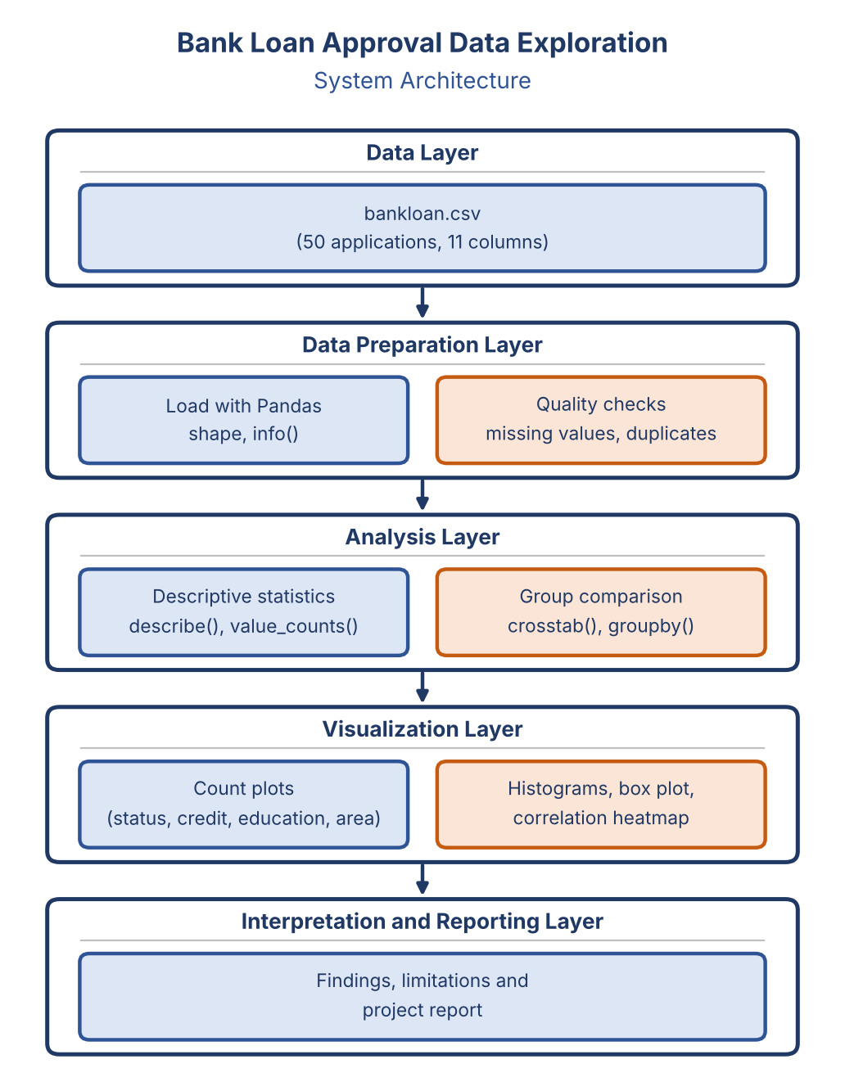
Fig. 6.1: System architecture of the project

Description of the Architecture Layers
- Data Layer: the CSV file with 50 loan applications and 11 columns
- Data Preparation Layer: loading into a DataFrame, checking the shape and data types, and counting missing values and duplicates
- Analysis Layer: descriptive statistics, approval rates, crosstab and groupby comparisons and the correlation matrix
- Visualization Layer: count plots, histograms, a box plot and a correlation heatmap
- Interpretation and Reporting Layer: findings and limitations arranged in this project report

7. Workflow
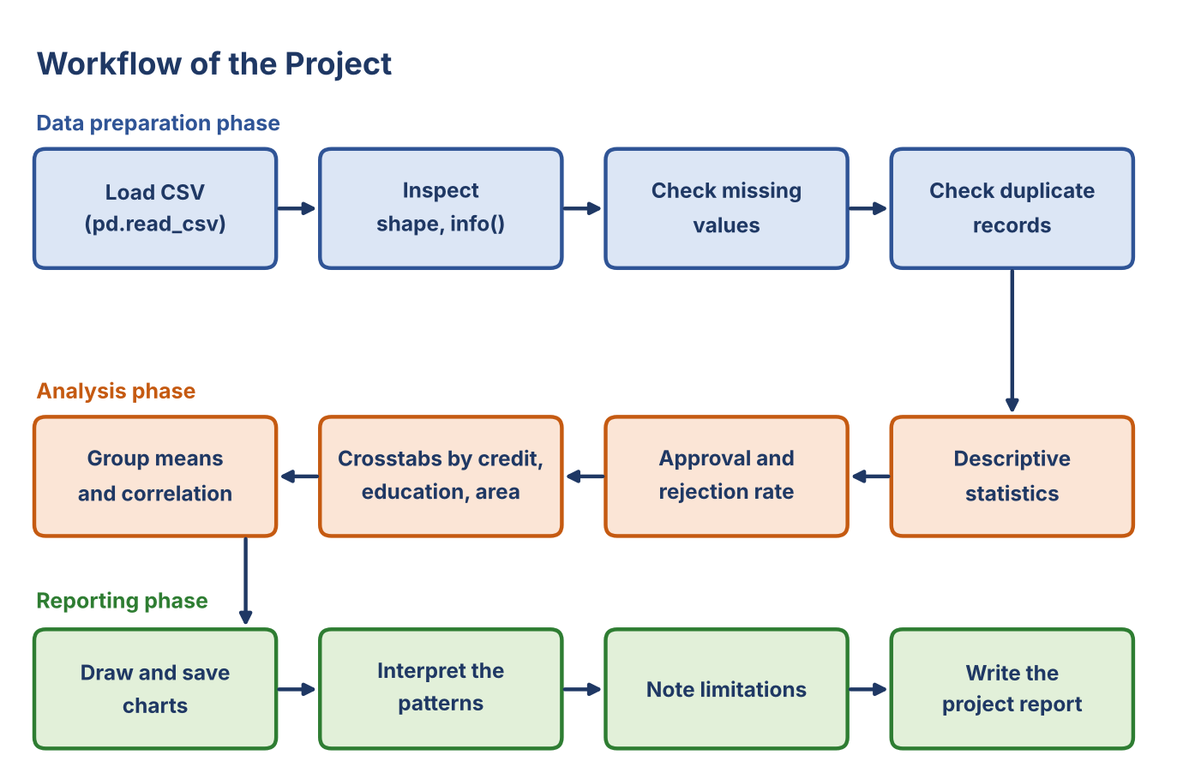
Fig. 7.1: Workflow of the Bank Loan Approval Data Exploration project
The workflow has three phases. In the data preparation phase, the CSV file is loaded, inspected and checked for missing values and duplicates. In the analysis phase, descriptive statistics, approval rates, group comparisons and the correlation matrix are calculated. In the reporting phase, the charts are drawn, the patterns are interpreted, the limitations are noted and the report is written.
Phase | Steps | Output
Data preparation | Load CSV, inspect shape and types, check missing values and duplicates | Checked DataFrame of 50 rows and 11 columns
Analysis | Descriptive statistics, approval rate, crosstabs, group means, correlation | Summary tables and counts
Reporting | Draw charts, interpret patterns, note limitations, write report | Eight charts and the project report

Steps of the Analysis Pipeline
- Keep bankloan.csv and the script bankloan.py in the same folder
- Load the file with pandas.read_csv()
- Check the shape, data types, missing values and duplicate records
- Calculate the descriptive statistics of the numerical columns
- Count approved and rejected applications and calculate the rates
- Compare the loan status across credit history, education and property area
- Calculate the approval rate, average income and loan amount for each group
- Draw the charts and save them in the charts folder

8. Program

Data loading, inspection and analysis (bankloan.py)
# Bank Loan Approval - Data Exploration Project

import pandas as pd
import matplotlib.pyplot as plt
import seaborn as sns
import os

# Folder where the charts are saved
os.makedirs("charts", exist_ok=True)

# 1. Load Dataset
df = pd.read_csv("bankloan.csv")

print("BANK LOAN APPROVAL DATASET")
print("=" * 40)

# 2. Display Dataset
print("\nFirst 5 Records:")
print(df.head())

print("\nDataset Shape:")
print(df.shape)

# 3. Dataset Information
print("\nDataset Information:")
print(df.info())

# 4. Statistical Summary
print("\nStatistical Summary:")
print(df.describe())

# 5. Check Missing Values
print("\nMissing Values:")
print(df.isnull().sum())

# 6. Check Duplicate Records
print("\nDuplicate Records:")
print(df.duplicated().sum())

# 7. Loan Approval Analysis
print("\nLoan Status Count:")
print(df["Loan_Status"].value_counts())

# 8. Approval and Rejection Rate
total = len(df)

approved = (df["Loan_Status"] == "Y").sum()
rejected = (df["Loan_Status"] == "N").sum()

print("\nTotal Applicants:", total)
print("Approved Loans:", approved)
print("Rejected Loans:", rejected)

if total > 0:
print("Approval Rate:", round(approved / total * 100, 2), "%")
print("Rejection Rate:", round(rejected / total * 100, 2), "%")

# 9. Credit History Analysis
print("\nLoan Status by Credit History:")
print(pd.crosstab(df["Credit_History"], df["Loan_Status"]))

# 10. Education Analysis
print("\nLoan Status by Education:")
print(pd.crosstab(df["Education"], df["Loan_Status"]))

# 11. Property Area Analysis
print("\nLoan Status by Property Area:")
print(pd.crosstab(df["Property_Area"], df["Loan_Status"]))

Visualizations and additional analysis (bankloan.py)
# 12. Visualizations

sns.set_theme(style="whitegrid")

# Loan Status Graph
plt.figure(figsize=(7, 5))
sns.countplot(data=df, x="Loan_Status")
plt.title("Loan Approval vs Rejection")
plt.xlabel("Loan Status")
plt.ylabel("Number of Applicants")
plt.savefig("charts/loan_status.png")
plt.show()

# Credit History Graph
plt.figure(figsize=(7, 5))
sns.countplot(data=df, x="Credit_History", hue="Loan_Status")
plt.title("Loan Status by Credit History")
plt.savefig("charts/credit_history.png")
plt.show()

# Education Graph
plt.figure(figsize=(7, 5))
sns.countplot(data=df, x="Education", hue="Loan_Status")
plt.title("Loan Status by Education")
plt.savefig("charts/education_analysis.png")
plt.show()

# Income Distribution
plt.figure(figsize=(7, 5))
sns.histplot(data=df, x="ApplicantIncome", bins=10, kde=True)
plt.title("Applicant Income Distribution")
plt.savefig("charts/income_distribution.png")
plt.show()

# 13. Additional Analysis (added for the report)
df["Approved"] = (df["Loan_Status"] == "Y").astype(int)

print("\nApproval Rate (%) by Category:")
for col in ["Credit_History", "Education", "Property_Area",
"Gender", "Married", "Self_Employed", "Dependents"]:
table = df.groupby(col)["Approved"].agg(Applicants="count", Approved="sum", Rate="mean")
table["Rate"] = (table["Rate"] * 100).round(2)
print("\n" + col)
print(table)

print("\nAverage Income and Loan Amount by Loan Status:")
print(df.groupby("Loan_Status")[["ApplicantIncome", "LoanAmount"]].mean().round(2))

print("\nMinimum and Maximum by Loan Status:")
print(df.groupby("Loan_Status")[["ApplicantIncome", "LoanAmount"]].agg(["min", "max"]))

print("\nEducation vs Credit History:")
print(pd.crosstab(df["Education"], df["Credit_History"]))

print("\nCorrelation Matrix:")
corr = df[["ApplicantIncome", "LoanAmount", "Credit_History", "Approved"]].corr().round(2)
print(corr)

# Property Area Graph
plt.figure(figsize=(7, 5))
sns.countplot(data=df, x="Property_Area", hue="Loan_Status")
plt.title("Loan Status by Property Area")
plt.tight_layout()
plt.savefig("charts/property_area.png")
plt.show()

# Income by Loan Status
plt.figure(figsize=(7, 5))
sns.boxplot(data=df, x="Loan_Status", y="ApplicantIncome")
plt.title("Applicant Income by Loan Status")
plt.tight_layout()
plt.savefig("charts/income_by_status.png")
plt.show()

# Loan Amount Distribution
plt.figure(figsize=(7, 5))
sns.histplot(data=df, x="LoanAmount", bins=10, kde=True)
plt.title("Loan Amount Distribution")
plt.tight_layout()
plt.savefig("charts/loan_amount_distribution.png")
plt.show()

# Correlation Heatmap
plt.figure(figsize=(7, 5))
sns.heatmap(corr, annot=True, cmap="coolwarm")
plt.title("Correlation Matrix")
plt.tight_layout()
plt.savefig("charts/correlation_matrix.png")
plt.show()

# 14. Final Result
print("\nAnalysis Completed Successfully!")

Explanation of the Code
- read_csv(), shape, info() and describe(): load the file, report the rows and columns, the data types and the statistics of the numerical columns
- isnull().sum() and duplicated().sum(): count missing values and duplicate records
- value_counts(): counts the Y (approved) and N (rejected) applications
- crosstab(): shows how many applications were approved and rejected inside each category
- groupby(): calculates approval rates, average income and average loan amount for each group; the helper column Approved is 1 for Y and 0 for N
- Seaborn and Matplotlib: draw the count plots, histograms, box plot and heatmap, and save them in the charts folder

9. Result & Discussions

Dataset Overview
The analysis covers 50 loan applications and 11 columns. The basic quality check found no missing values and no duplicate records. The recorded outcomes are 33 approved and 17 rejected applications.

Loan Status
Loan Status | Applications | Share
Approved (Y) | 33 | 66.0%
Rejected (N) | 17 | 34.0%
Total | 50 | 100%

Approved applications are more numerous than rejected ones in this sample. These counts describe only the supplied dataset and should not be presented as the approval rate of a real bank.

Credit History
Credit_History | Rejected (N) | Approved (Y) | Approval Rate
0 | 16 | 0 | 0.00%
1 | 1 | 33 | 97.06%

Credit history shows the largest difference between the groups. None of the 16 applicants with Credit_History 0 was approved, while 33 of the 34 applicants with Credit_History 1 were approved. The only rejected applicant with Credit_History 1 has an income of 3,000 and a loan amount of 80.

Education
Education | Applicants | Rejected (N) | Approved (Y) | Approval Rate
Graduate | 39 | 6 | 33 | 84.62%
Not Graduate | 11 | 11 | 0 | 0.00%

All 11 Not Graduate applicants were rejected, while 33 of the 39 Graduate applicants were approved. This must be read with care: every Not Graduate applicant also has Credit_History 0 (11 of the 16 applicants with Credit_History 0), whereas 34 of the 39 Graduate applicants have Credit_History 1. Education and credit history therefore overlap in this sample, and their effects cannot be separated.

Property Area
Property_Area | Applicants | Rejected (N) | Approved (Y) | Approval Rate
Rural | 16 | 9 | 7 | 43.75%
Semiurban | 16 | 3 | 13 | 81.25%
Urban | 18 | 5 | 13 | 72.22%

Semiurban applications have the highest approval rate (81.25%), followed by Urban (72.22%). Rural applications have the lowest rate (43.75%), and it is the only area where rejected applications outnumber approved ones.

Income and Loan Amount
Statistic | ApplicantIncome | LoanAmount
Mean | 4,934.00 | 123.40
Median | 4,750.00 | 115.00
Standard deviation | 1,808.44 | 42.35
Minimum | 2,400 | 60
Maximum | 9,000 | 220

Loan Status | Mean Income | Income Range | Mean Loan Amount | Loan Amount Range
Approved (Y) | 5,918.18 | 3,800 - 9,000 | 145.15 | 100 - 220
Rejected (N) | 3,023.53 | 2,400 - 3,700 | 81.18 | 60 - 95

Approved applicants have a higher average income and a higher average loan amount than rejected applicants. The ranges do not overlap in this sample: every approved applicant has an income of at least 3,800 and every rejected applicant has an income of at most 3,700. The units of income and loan amount are not specified in the file, so the values are shown as recorded.

Other Categories
Category | Group | Applicants | Approved | Approval Rate
Gender | Female | 20 | 10 | 50.00%
Gender | Male | 30 | 23 | 76.67%
Married | No | 20 | 12 | 60.00%
Married | Yes | 30 | 21 | 70.00%
Self_Employed | No | 37 | 23 | 62.16%
Self_Employed | Yes | 13 | 10 | 76.92%
Dependents | 0 | 20 | 14 | 70.00%
Dependents | 1 | 12 | 9 | 75.00%
Dependents | 2 | 11 | 6 | 54.55%
Dependents | 3+ | 7 | 4 | 57.14%

These groups are small, so their rates are unstable. Gender and marital status are sensitive attributes in lending; the differences above are reported only to describe the data and are not a basis for judging any applicant.

Summary of Results
Item | Value
Dataset file | bankloan.csv
Records / Columns | 50 / 11
Missing values / Duplicate records | 0 / 0
Approved / Rejected | 33 (66.0%) / 17 (34.0%)
Approval rate by Credit_History 0 / 1 | 0.00% / 97.06%
Approval rate by Education (Graduate / Not Graduate) | 84.62% / 0.00%
Approval rate by Property_Area (Rural / Semiurban / Urban) | 43.75% / 81.25% / 72.22%
Mean income (Approved / Rejected) | 5,918.18 / 3,023.53
Mean loan amount (Approved / Rejected) | 145.15 / 81.18
Tools | Python, Pandas, Matplotlib, Seaborn

Discussion
- The dataset has 50 records and passed the basic quality check, with no missing values and no duplicate records.
- About 66% of the applications are approved and 34% are rejected. This overall rate hides large differences between groups.
- Credit history shows the clearest pattern: no applicant with Credit_History 0 was approved, and 97.06% of those with Credit_History 1 were approved.
- Not Graduate applicants were all rejected, but they also all have Credit_History 0, so education and credit history cannot be separated in this sample.
- Semiurban and Urban applications are approved more often than Rural ones.
- Approved applicants have higher income and higher loan amounts, and income and loan amount are almost perfectly related (correlation 0.99).
- The separation between the groups is unusually clean, for example no overlap in income between approved and rejected applicants. With only 50 records, such a pattern may not appear in larger real-world data.
- All results are descriptive. They do not prove causation and must not be used as rules for real lending decisions.

10. Snippets of Output
The Python script prints the summary values on the screen and produces eight charts. Each output is shown below with a short explanation. All outputs were generated from the supplied bankloan.csv.

A. Terminal Output
The first output shows the loaded data, its shape and its column information.
BANK LOAN APPROVAL DATASET
========================================

First 5 Records:
Loan_ID Gender Married ... Credit_History Property_Area Loan_Status
0 L001 Male Yes ... 1 Urban Y
1 L002 Female No ... 1 Rural N
2 L003 Male Yes ... 1 Semiurban Y
3 L004 Male Yes ... 0 Rural N
4 L005 Female Yes ... 1 Urban Y

[5 rows x 11 columns]

Dataset Shape:
(50, 11)

Dataset Information:
<class 'pandas.DataFrame'>
RangeIndex: 50 entries, 0 to 49
Data columns (total 11 columns):
# Column Non-Null Count Dtype
--- ------ -------------- -----
0 Loan_ID 50 non-null str
1 Gender 50 non-null str
2 Married 50 non-null str
3 Dependents 50 non-null str
4 Education 50 non-null str
5 Self_Employed 50 non-null str
6 ApplicantIncome 50 non-null int64
7 LoanAmount 50 non-null int64
8 Credit_History 50 non-null int64
9 Property_Area 50 non-null str
10 Loan_Status 50 non-null str
dtypes: int64(3), str(8)
memory usage: 4.4 KB
None
Output 10.1: First records, shape and dataset information
The statistical summary, the missing-value count and the duplicate count are shown next.
Statistical Summary:
ApplicantIncome LoanAmount Credit_History
count 50.000000 50.000000 50.000000
mean 4934.000000 123.400000 0.680000
std 1808.439399 42.347445 0.471212
min 2400.000000 60.000000 0.000000
25% 3325.000000 90.000000 0.000000
50% 4750.000000 115.000000 1.000000
75% 6175.000000 150.000000 1.000000
max 9000.000000 220.000000 1.000000

Missing Values:
Loan_ID 0
Gender 0
Married 0
Dependents 0
Education 0
Self_Employed 0
ApplicantIncome 0
LoanAmount 0
Credit_History 0
Property_Area 0
Loan_Status 0
dtype: int64

Duplicate Records:
0
Output 10.2: Statistical summary, missing values and duplicate records
The loan status counts, the overall rates and the crosstabs for credit history, education and property area follow.
Loan Status Count:
Loan_Status
Y 33
N 17
Name: count, dtype: int64

Total Applicants: 50
Approved Loans: 33
Rejected Loans: 17
Approval Rate: 66.0 %
Rejection Rate: 34.0 %

Loan Status by Credit History:
Loan_Status N Y
Credit_History
0 16 0
1 1 33

Loan Status by Education:
Loan_Status N Y
Education
Graduate 6 33
Not Graduate 11 0

Loan Status by Property Area:
Loan_Status N Y
Property_Area
Rural 9 7
Semiurban 3 13
Urban 5 13
Output 10.3: Loan status counts, approval rates and crosstabs
The additional analysis gives the approval rate in each category, the group averages and the correlation matrix.
Approval Rate (%) by Category:

Credit_History
Applicants Approved Rate
Credit_History
0 16 0 0.00
1 34 33 97.06

Education
Applicants Approved Rate
Education
Graduate 39 33 84.62
Not Graduate 11 0 0.00

Property_Area
Applicants Approved Rate
Property_Area
Rural 16 7 43.75
Semiurban 16 13 81.25
Urban 18 13 72.22

Gender
Applicants Approved Rate
Gender
Female 20 10 50.00
Male 30 23 76.67

Married
Applicants Approved Rate
Married
No 20 12 60.0
Yes 30 21 70.0

Self_Employed
Applicants Approved Rate
Self_Employed
No 37 23 62.16
Yes 13 10 76.92

Dependents
Applicants Approved Rate
Dependents
0 20 14 70.00
1 12 9 75.00
2 11 6 54.55
3+ 7 4 57.14

Average Income and Loan Amount by Loan Status:
ApplicantIncome LoanAmount
Loan_Status
N 3023.53 81.18
Y 5918.18 145.15

Minimum and Maximum by Loan Status:
ApplicantIncome LoanAmount
min max min max
Loan_Status
N 2400 3700 60 95
Y 3800 9000 100 220

Education vs Credit History:
Credit_History 0 1
Education
Graduate 5 34
Not Graduate 11 0

Correlation Matrix:
ApplicantIncome LoanAmount Credit_History Approved
ApplicantIncome 1.00 0.99 0.73 0.77
LoanAmount 0.99 1.00 0.69 0.72
Credit_History 0.73 0.69 1.00 0.96
Approved 0.77 0.72 0.96 1.00
Output 10.4: Approval rate by category, group averages, ranges and correlation

B. Outcome, Credit History and Education
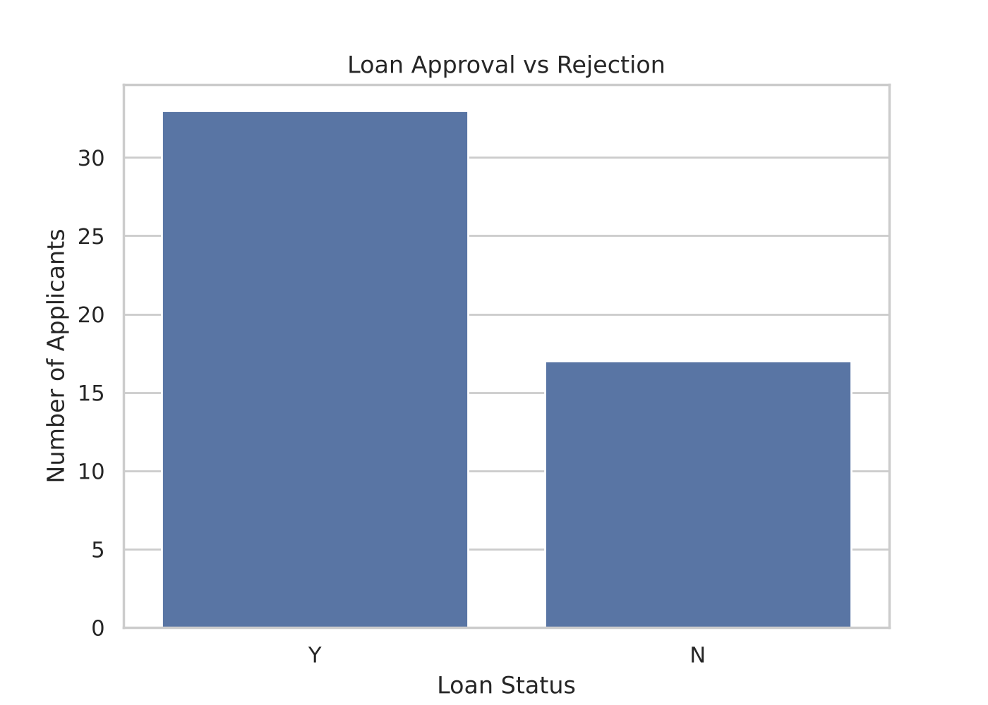
Fig. 10.1: Loan approval vs rejection
The count plot compares the number of approved (Y) and rejected (N) applications: 33 approved and 17 rejected.
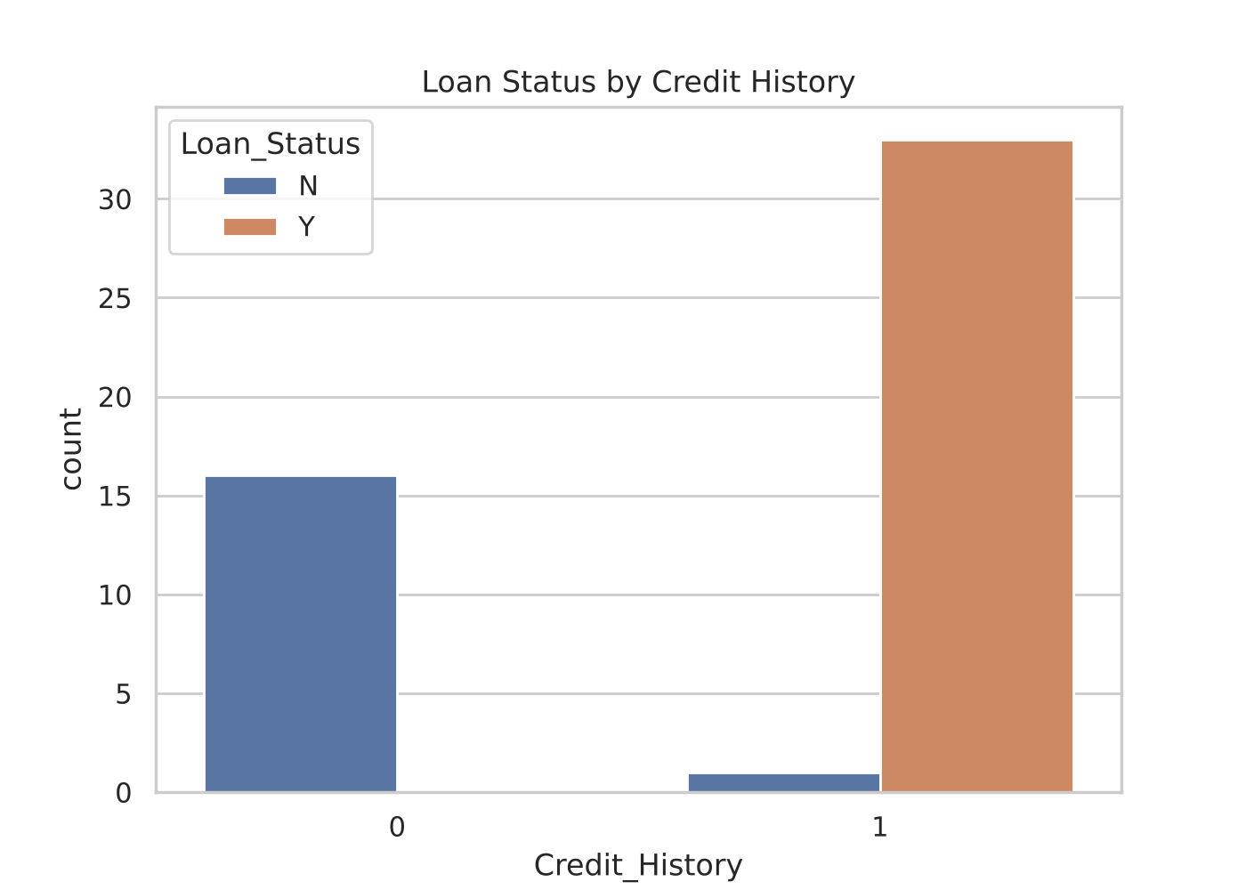
Fig. 10.2: Loan status by credit history
All 16 applications with Credit_History 0 are rejected. Of the 34 applications with Credit_History 1, 33 are approved and 1 is rejected.
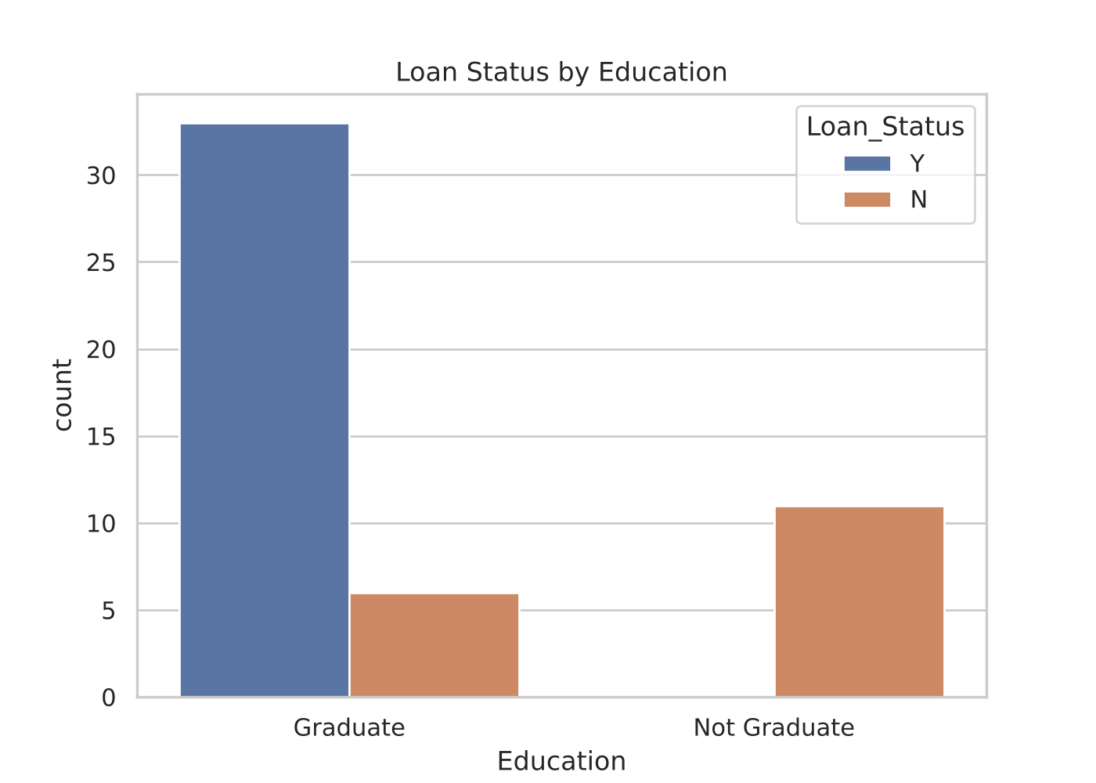
Fig. 10.3: Loan status by education
Graduate applicants have 33 approved and 6 rejected applications. All 11 Not Graduate applications are rejected. Education overlaps with credit history in this sample.

C. Property Area
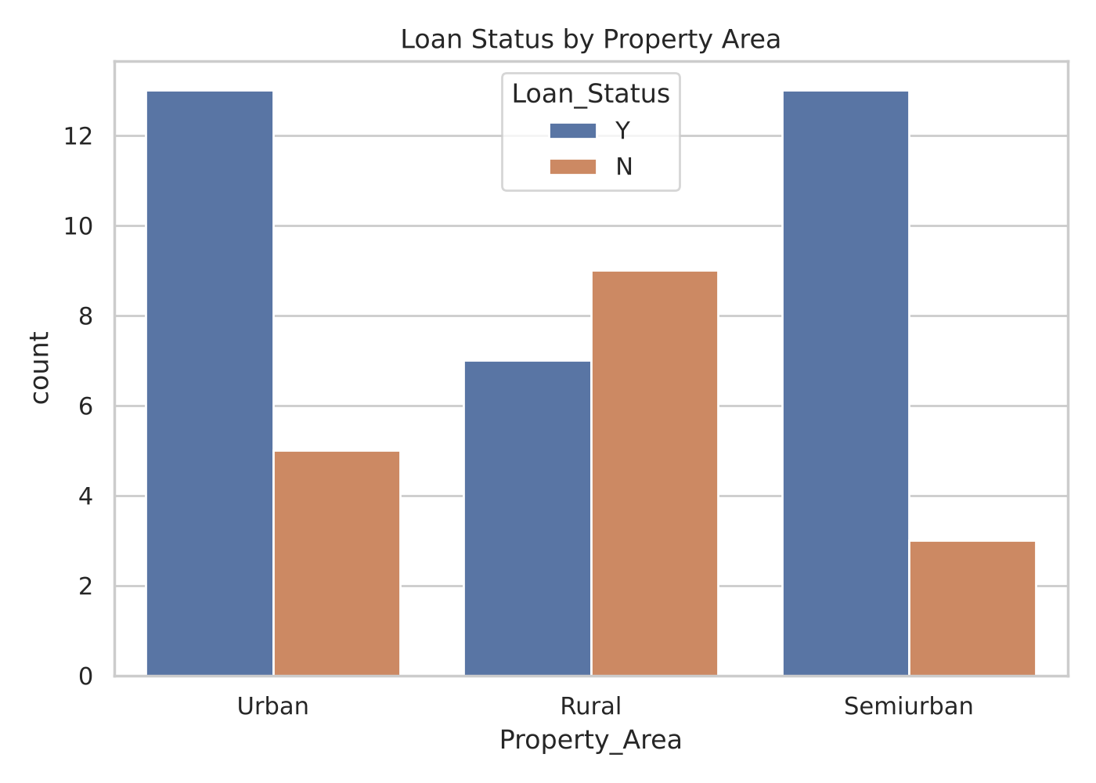
Fig. 10.4: Loan status by property area
Semiurban and Urban each have 13 approved applications, against 3 and 5 rejected. Rural has 7 approved and 9 rejected applications.

D. Income and Loan Amount
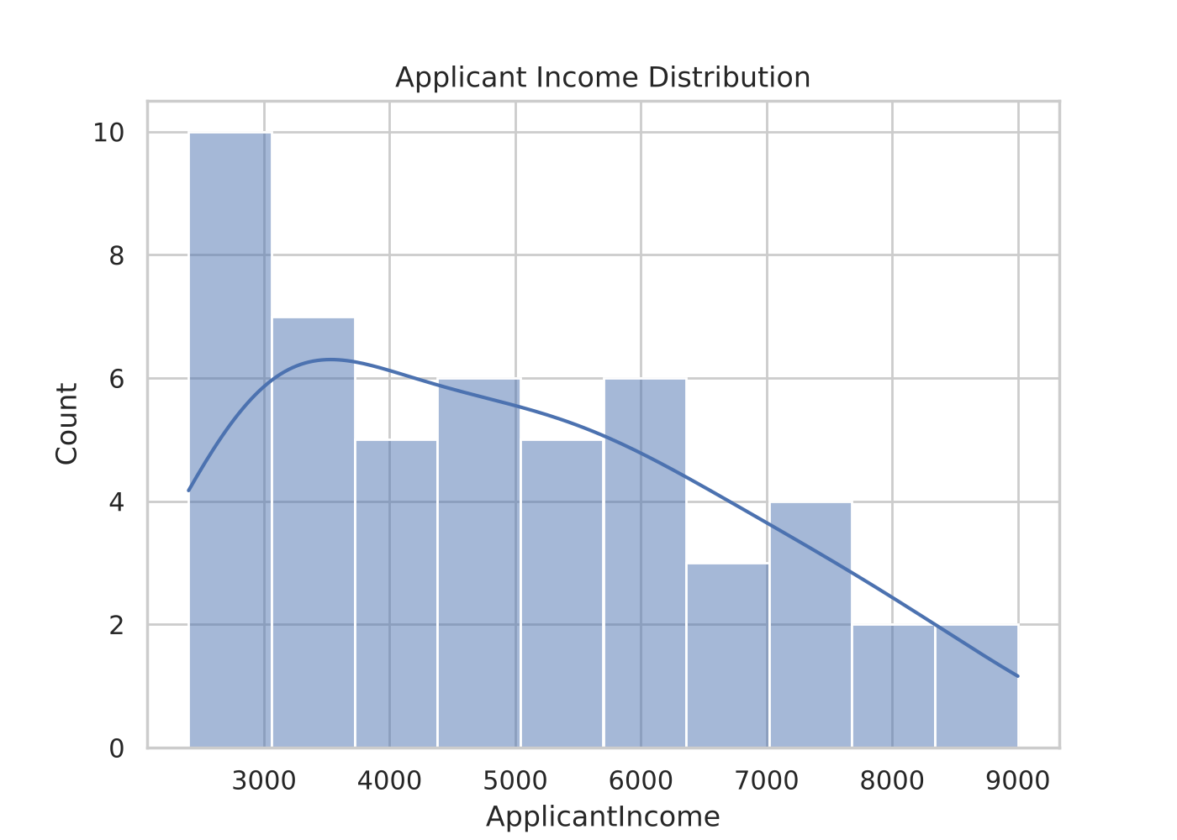
Fig. 10.5: Applicant income distribution
Incomes range from 2,400 to 9,000. More applicants have lower incomes and fewer have high incomes. The mean (4,934) is slightly above the median (4,750), which points to a mild right skew.
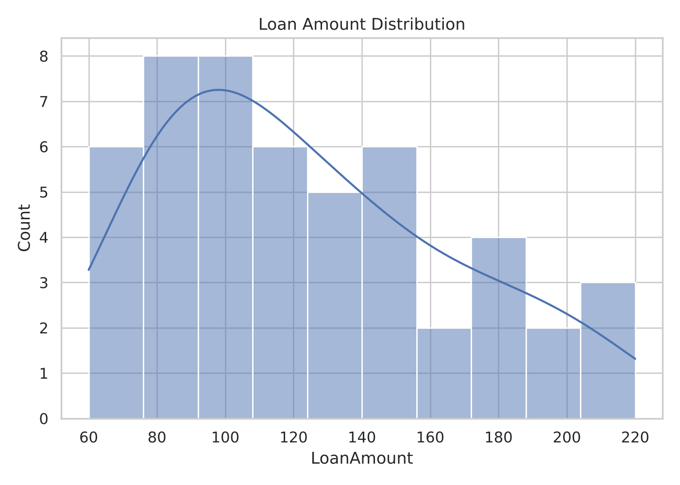
Fig. 10.6: Loan amount distribution
Loan amounts range from 60 to 220. Most applications request smaller amounts, and the mean (123.4) is above the median (115).

E. Group Comparison and Correlation
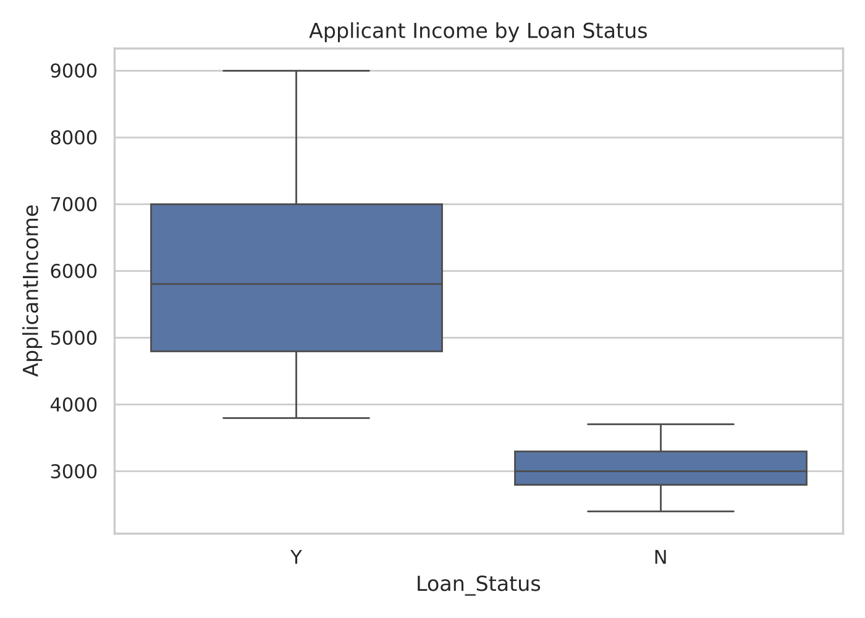
Fig. 10.7: Applicant income by loan status
The box plot shows a higher and wider income range for approved applications (3,800 to 9,000) than for rejected ones (2,400 to 3,700). The two boxes do not overlap.
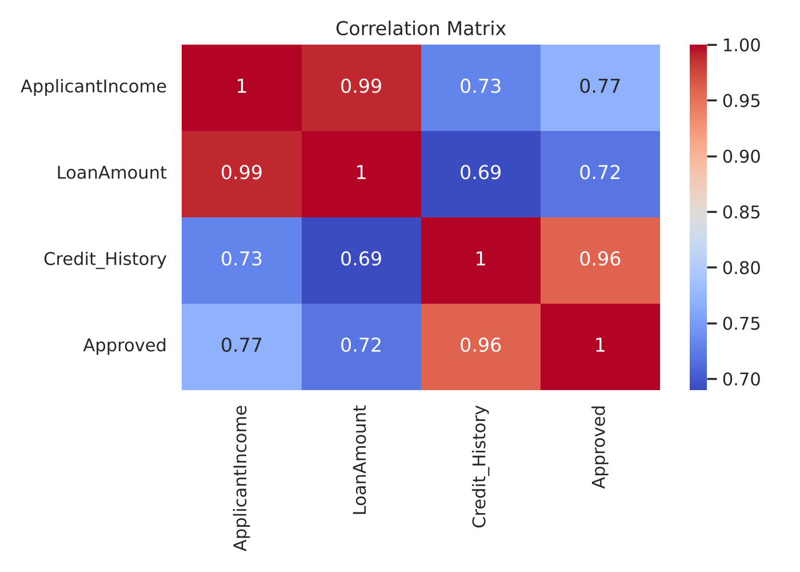
Fig. 10.8: Correlation matrix of the numerical fields
Income and loan amount are almost perfectly related (0.99). Credit history has the strongest relationship with approval (0.96), followed by income (0.77) and loan amount (0.72). Approved is a 0/1 helper column, so these values are a rough guide. Correlation does not prove causation.

Steps to Run the Analysis
- Install Python and the packages pandas, matplotlib and seaborn (pip install -r requirements.txt)
- Keep bankloan.csv and bankloan.py in the same folder
- Run the script with: python bankloan.py
- The summary values are printed on the screen and the charts are saved in the charts folder

11. Future Scope
The project can be further improved in the following ways:
- Review the dataset documentation: to confirm the source, the unit of income and loan amount and the meaning of the Credit_History codes
- Larger dataset: to test whether the same patterns appear in more records and in another reliable source
- Statistical tests: to check whether the differences between groups are significant
- Fairness audit: to compare outcomes across sensitive groups such as gender and marital status
- More features: adding richer financial fields such as co-applicant income and loan term
- Interactive dashboard: a Streamlit view of approval rates that lets users filter and compare groups
- Baseline model: a simple classifier, for learning only, evaluated with a proper train/test split and fairness checks

Possible Uses
With the improvements above, a similar exploration can be used in the following ways. It must not replace a lender's complete assessment, and any real decision-support system would need expert oversight and legal compliance.
- An educational example of how EDA is carried out on tabular data
- A reusable template for checking the quality of other CSV datasets
- A first step to understand the data before any predictive modelling

12. Conclusion
This project used Python-based Exploratory Data Analysis to study a loan application dataset containing 50 records and 11 columns. The work included data loading, quality checks, descriptive statistics, group comparisons and visualizations.
The analysis found that 33 of the 50 applications (66.0%) were approved. The approval rate differed strongly between groups: 0.00% for Credit_History 0 against 97.06% for Credit_History 1, 84.62% for Graduate against 0.00% for Not Graduate applicants, and 43.75% for Rural against 81.25% for Semiurban areas. Approved applicants also had higher income and higher loan amounts.
The project shows how Python libraries can turn raw tabular information into understandable summaries and visual findings. It also shows why a single approval rate is not enough and why data quality and limitations must be stated clearly.

Key Findings
- The dataset contains 50 loan applications and 11 columns, with no missing values and no duplicate records
- 33 applications are approved (66.0%) and 17 are rejected (34.0%)
- Credit history is the clearest pattern: 0 of 16 approved without it and 33 of 34 approved with it
- Not Graduate applicants were all rejected, but they also all have Credit_History 0, so the two effects cannot be separated
- Semiurban (81.25%) and Urban (72.22%) areas have higher approval rates than Rural (43.75%)
- Approved applicants have higher average income (5,918.18 against 3,023.53) and a higher average loan amount (145.15 against 81.18)

Limitations
- The project uses one small dataset of 50 records; its source, collection period and sampling method are not documented
- The units of income and loan amount and the meaning of the Credit_History codes are not defined in the file
- The separation between approved and rejected applications is unusually clean, so the patterns may not hold in larger real-world data
- Descriptive statistics and charts show patterns but do not prove causation
- Sensitive attributes such as gender and marital status are only described and must not be used to judge applicants
- The accuracy of the original records is not independently verified
Overall, the conclusion is restricted to the supplied dataset. The results are educational observations and should not be treated as loan approval rules or as a substitute for a lender's complete assessment.

