Department of Electronic and Telecommunication Engineering

University of Moratuwa Faculty of Engineering

Electronic Circuit Design EN2111

**UART implementation in FPGA**

**Group - 35**

|  |  |
| --- | --- |
| **Name** | **Index Number** |
|  |  |
|  |  |
|  |  |

This report is submitted as the fulfillment of FPGA Assignment of module EN2111

Table of Contents

**Abstract:** 3

**Introduction:** 3

**Methodology and Observations:** 3

1. Setup and Hardware Configuration: 3

2. Data Packet Transmission: 3

3. Data Conversion and Reception: 3

**Appendices** 4

❖ Transmitter 4

❖ Receiver 6

❖ Binary to seven-segment display 7

❖ Testbench 8

## **Abstract:**

This lab report explores UART, a hardware communication protocol for serial communication between Duo Nano boards, focusing on objectives, methodology, observations, and findings. It provides an in-depth understanding of the protocol's practical implementation.

## **Introduction:**

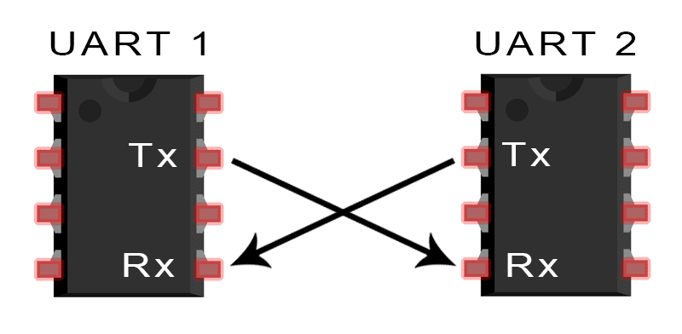

UART is a widely adopted hardware communication protocol for seamless device-to-device communication in embedded systems, microcontrollers, and computers, requiring only two wires for transmitting and receiving data. UART uses asynchronous serial communication without a clock signal, utilizing start, data frame, parity, and stop bits for accurate data transfer. Understanding UART principles is crucial for developing device-to-device communication products. The lab aimed to establish reliable serial communication between Duo Nano boards using UART, demonstrating proper configuration and frame protocol utilization for secure, error-free communication.

## **Methodology and Observations:**

### 1. Setup and Hardware Configuration:

* Two Duo Nano boards were interconnected via UART, where one served as the transmitter (Tx) and the other as the receiver (Rx).
* UART transmitter of one board was linked to the UART receiver of the other, establishing a bidirectional communication link.
* A specific baud rate was configured on both boards to ensure synchronization.

### 2. Data Packet Transmission:

* Data packets were transmitted from the transmitting board to the receiving board using UART.
* Each packet comprised a start bit, data frame, parity bit, and stop bit(s).
* The start bit initiated data transmission, followed by the data frame containing the actual data.
* Parity bits were integrated into the data frame to detect and validate any transmission errors or alterations.
* Stop bits marked the conclusion of each data packet, facilitating clear differentiation between successive packets.

### 3. Data Conversion and Reception:

* The receiving board processed the transmitted data packets upon reception.
* It disregarded the start bit, parity bit, and stop bit(s) to extract the actual data frame.
* Serial data received was converted back into a parallel format for subsequent processing or display.

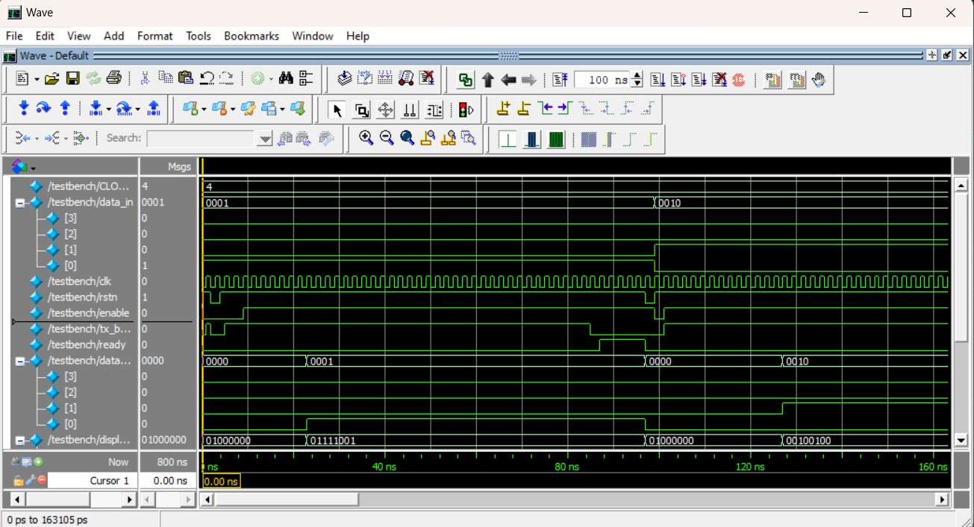

## **Appendices**

### Transmitter

module transmitter #(

    parameter CLOCKS_PER_PULSE = 16

)

(

    input logic [7:0] data_in,

    input logic data_en,

    input logic clk,

    input logic rstn,

    output logic tx,

    output logic tx_busy

);

    enum {TX_IDLE, TX_START, TX_DATA, TX_END} state;

    logic[7:0] data = 8'b0;

    logic[2:0] c_bits = 3'b0;

    logic[$clog2(CLOCKS_PER_PULSE)-1:0] c_clocks = 0;

    always_ff @(posedge clk or negedge rstn) begin

        if (!rstn) begin

            c_clocks <= 0;

            c_bits <= 0;

            data <= 0;

            tx <= 1'b1;

            state <= TX_IDLE;

        end else begin

            case (state)

            TX_IDLE: begin

                if (~data_en) begin

                    state <= TX_START;

                    data <= data_in;

                    c_bits <= 3'b0;

                    c_clocks <= 0;

                end else tx <= 1'b1;

            end

            TX_START: begin

                if (c_clocks == CLOCKS_PER_PULSE-1) begin

                    state <= TX_DATA;

                    c_clocks <= 0;

                end else begin

                    tx <= 1'b0;

                    c_clocks <= c_clocks + 1;

                end

            end

            TX_DATA: begin

                if (c_clocks == CLOCKS_PER_PULSE-1) begin

                    c_clocks <= 0;

                    if (c_bits == 3'd7) begin

                        state <= TX_END;

                    end else begin

                        c_bits <= c_bits + 1;

                        tx <= data[c_bits];

                    end

                end else begin

                    tx <= data[c_bits];

                    c_clocks <= c_clocks + 1;

                end

            end

            TX_END: begin

                if (c_clocks == CLOCKS_PER_PULSE-1) begin

                    state <= TX_IDLE;

                    c_clocks <= 0;

                end else begin

                    tx <= 1'b1;

                    c_clocks <= c_clocks + 1;

                end

            end

            default: state <= TX_IDLE;

            endcase

        end

    end

    assign tx_busy = (state != TX_IDLE);

endmodule

### Receiver

module receiver #(

    parameter CLOCKS_PER_PULSE = 16

)

(

    input logic clk,

    input logic rstn,

    input logic ready_clr,

    input logic rx,

    output logic ready,

    output logic [7:0] data_out

);

    enum {RX_IDLE, RX_START, RX_DATA, RX_END} state;

    logic[2:0] c_bits;

    logic[$clog2(CLOCKS_PER_PULSE)-1:0] c_clocks;

    logic[7:0] temp_data;

    logic rx_sync;

    always_ff @(posedge clk or negedge rstn) begin

        if (!rstn) begin

            c_clocks <= 0;

            c_bits <= 0;

            temp_data <= 8'b0;

            //data_out <= 8'b0;

            ready <= 0;

            state <= RX_IDLE;

        end else begin

            rx_sync <= rx;  // Synchronize the input signal using a flip-flop

            case (state)

            RX_IDLE : begin

                if (rx_sync == 0) begin

                    state <= RX_START;

                    c_clocks <= 0;

                end

            end

            RX_START: begin

                if (c_clocks == CLOCKS_PER_PULSE/2-1) begin

                    state <= RX_DATA;

                    c_clocks <= 0;

                end else

                    c_clocks <= c_clocks + 1;

            end

            RX_DATA : begin

                if (c_clocks == CLOCKS_PER_PULSE-1) begin

                    c_clocks <= 0;

                    temp_data[c_bits] <= rx_sync;

                    if (c_bits == 3'd7) begin

                        state <= RX_END;

                        c_bits <= 0;

                    end else c_bits <= c_bits + 1;

                end else c_clocks <= c_clocks + 1;

            end

            RX_END : begin

                if (c_clocks == CLOCKS_PER_PULSE-1) begin

                    //data_out <= temp_data;

                    ready <= 1'b1;

                    state <= RX_IDLE;

                    c_clocks <= 0;

                end else c_clocks <= c_clocks + 1;

            end

            default: state <= RX_IDLE;

            endcase

        end

    end

    assign data_out = temp_data;

endmodule

### 

### Binary to seven-segment display

module binary_to_7seg (

    input logic [3:0] data_in,

    output logic [6:0] data_out

);

    // Make a LUT to convert digits to 7 segment output

    // Input - 4 bits, output - 7 bits

    logic [15:0][6:0] lut_7seg;

    // Output is gfedcba

    assign lut_7seg[0] = 7'b0111111;

    assign lut_7seg[1] = 7'b0000110;

    assign lut_7seg[2] = 7'b1011011;

    assign lut_7seg[3] = 7'b1001111;

    assign lut_7seg[4] = 7'b1100110;

    assign lut_7seg[5] = 7'b1101101;

    assign lut_7seg[6] = 7'b1111101;

    assign lut_7seg[7] = 7'b0000111;

    assign lut_7seg[8] = 7'b1111111;

    assign lut_7seg[9] = 7'b1101111;

    assign lut_7seg[15:10] = 7'b0;    // unused

     assign data_out = ~lut_7seg[data_in];

endmodule

/*

Seven segment display

    a

f       b

    g

e       c

    d

*/

### Testbench

`timescale 1ns/1ps

module testbench();

    localparam CLOCKS_PER_PULSE = 4;

  logic [3:0] data_in = 4'b0001;

    logic clk = 0;

    logic rstn = 0;

    logic enable = 1;

    logic tx_busy;

    logic ready;

    logic [7:0] data_out;

    logic [7:0] display_out;

    logic loopback;

    logic ready_clr = 1;

    uart #(.CLOCKS_PER_PULSE(CLOCKS_PER_PULSE))

            test_uart(.data_in(data_in),

                        .data_en(enable),

                        .clk(clk),

                        .tx(loopback),

                        .tx_busy(tx_busy),

                        .rx(loopback),

                        .ready(ready),

                        .ready_clr(ready_clr),

                        .led_out(data_out),

                        .display_out(display_out),

                        .rstn(rstn)

                        );

    always begin

        #1 clk = ~clk;

    end

    initial begin

        $dumpfile("testbench.vcd");

        $dumpvars(0, testbench);

        rstn <= 1;

        enable <= 1'b0;

        #2 rstn <= 0;

        #2 rstn <= 1;

        #5 enable <= 1'b1;

    end

    always @(posedge ready) begin

        if (data_out != data_in) begin

            $display("FAIL: rx data %x does not match tx %x", data_out, data_in);

         $finish();

        end else begin

          if (data_out == 4'b1111) begin //Check if received data is 11111111

                $display("SUCCESS: all bytes verified");

                $finish();

            end

            #10 rstn <= 0;

            #2 rstn <= 1;

            data_in <= data_in + 1'b1;

            enable <= 1'b0;

            #2 enable <= 1'b1;

        end

    end

endmodule