MidSem 1

Shreeya Pahune
2018113011

1. Conformations of Butadiene

.com files:

cis_Butadiene

%nproc=2
%mem=2GB
#HF STO-3G opt freq

cis_butadiene

0 1
C1
C2 1 1.4
C3 2 1.4 1 109.0
C4 3 1.4 2 109.0 1 0.0
H5 1 1.0 2 120.0 3 180.0
H6 1 1.0 2 120.0 3 0.0
H7 2 1.0 3 120.0 4 180.0
H8 3 1.0 2 120.0 1 180.0
H9 4 1.0 3 120.0 2 180.0
H10 4 1.0 3 120.0 2 0.0

trans_Butadiene

%nproc=2
%mem=2GB
#HF STO-3G opt freq

trans_butadiene

0 1
C1
C2 1 1.4
C3 2 1.4 1 109.0
C4 3 1.4 2 109.0 1 180.0
H5 1 1.0 2 120.0 3 180.0
H6 1 1.0 2 120.0 3 0.0
H7 2 1.0 3 120.0 4 0.0
H8 3 1.0 2 120.0 1 0.0
H9 4 1.0 3 120.0 2 180.0
H10 4 1.0 3 120.0 2 0.0

Observations:

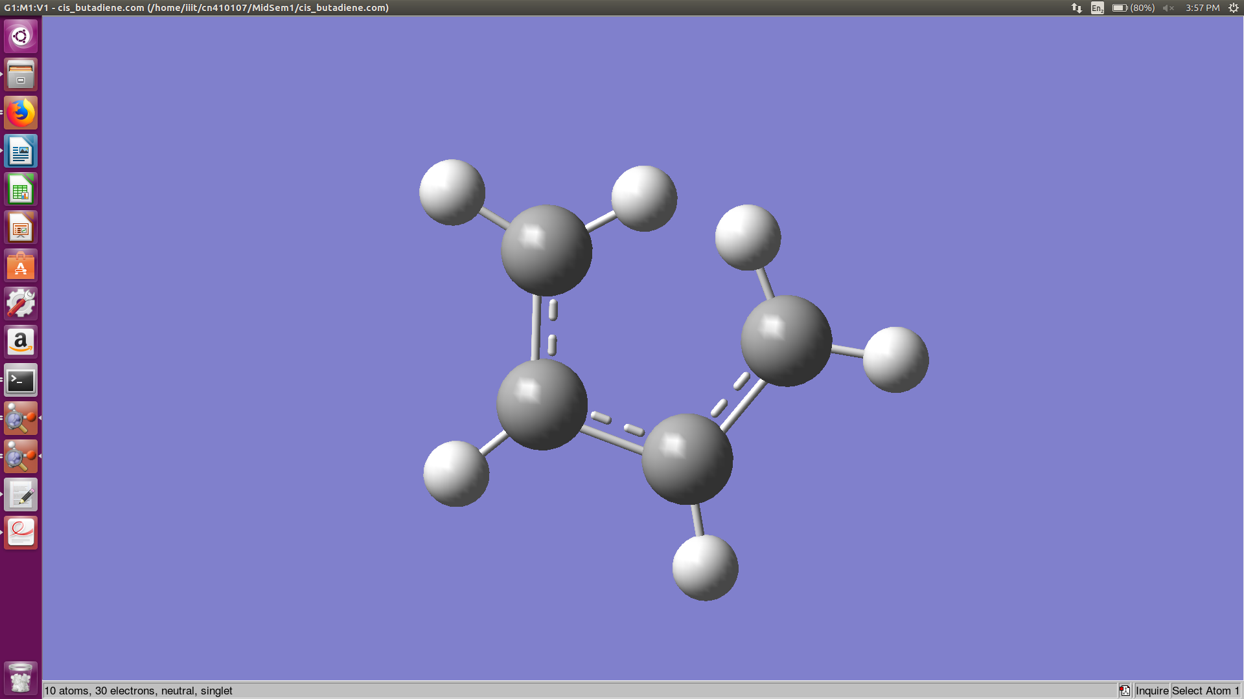

cis-Butadiene

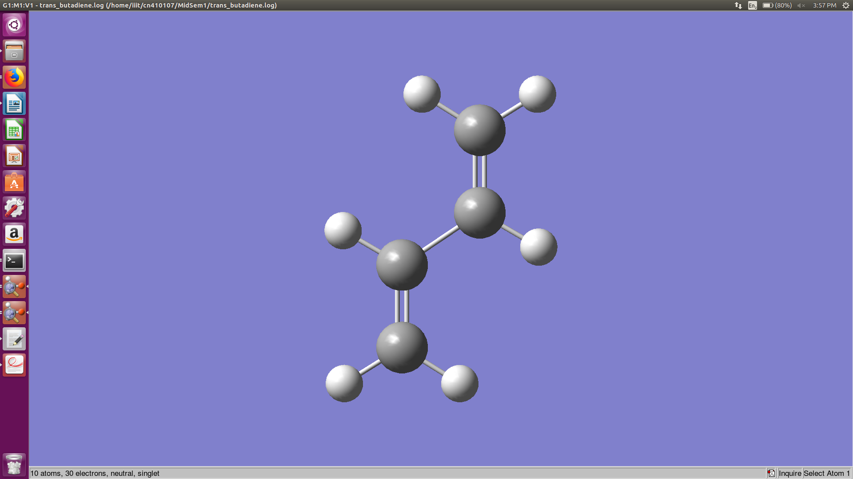

trans-Butadiene

(a)

Yes, these structures are minima as they have the lowest vibration frequencies.

Lowest vibration frequency for :

a) cis-Butadiene = 34.20 cm-1
b) trans-Butadiene = 154.24 cm-1

(b)

The trans-Butadiene conformer is more prevalent (98%)

(c)

The energies of the two conformers are as follows:

a) cis-Butadiene = -153.01744412 Hartree
b) trans-Butadiene = -153.02036443 Hartree

As the energy of trans-Butadiene is more negative which implies it is more stable than cis-Butadiene.
Hence, trans-Butadiene is more prevalent

2. Diels-Alder Reaction

.com file:

%nproc=2
%mem=1GB
%chk=da.chk
#HF STO-3G opt=(ts,calcfc,noeigentest) freq

DA Cyclopentadiene Ethene

0 1
X1
X2 X1 1.0
C3 X2 1.2 X1 90.0
C4 X2 1.2 X1 90.0 C3 72.0
C5 X2 1.2 X1 90.0 C4 72.0
C6 X2 1.2 X1 90.0 C5 72.0
C7 X2 1.2 X1 90.0 C6 72.0
H8 C3 1.0 X2 180.0 X1 90.0
H9 C4 1.0 X2 180.0 X1 90.0
H10 C5 1.0 X2 180.0 X1 90.0
H11 C6 1.0 X2 180.0 X1 90.0
H12 C7 1.0 X2 120.0 X1 0.0
H13 C7 1.0 X2 240.0 X1 0.0
C8 C5 1.5 X2 90.0 X1 0.0
C9 C8 1.3 X2 90.0 X1 0.0
H14 C8 1.0 C9 120.0 X2 90.0
H15 C8 1.0 C9 120.0 H14 180.0
H16 C9 1.0 C8 120.0 H14 0.0
H17 C9 1.0 C8 120.0 H16 180.0

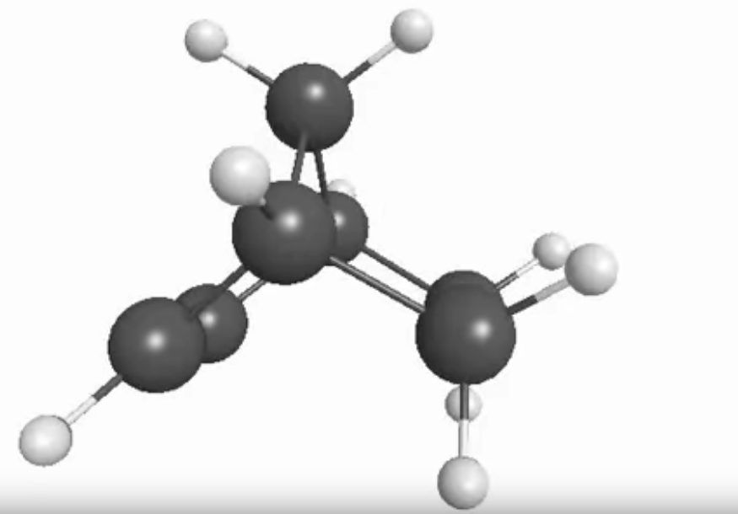

Final

:

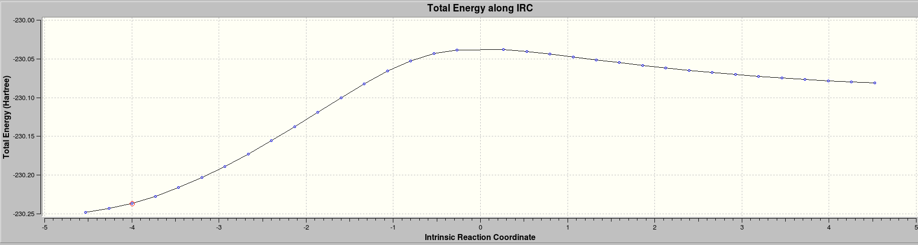
3. Formic Acid

.com files:

Dimer

%nproc=2
%mem=1GB
#HF STO-3G opt freq

Formic Acid Dimer

0 1
C1
O2 C1 1.2
O3 C1 1.45 O2 120.0
H4 C1 1.0 O3 120.0 O2 180.0
H5 O3 0.98 C1 120.0 O2 0.0
H6 O2 2.0 C1 120.0 O3 0.0
O7 H6 0.98 O2 180.0 C1 0.0
C8 O7 1.45 H6 120.0 H5 0.0
O9 C8 1.2 O7 120.0 H4 0.0
H10 C8 1.0 O7 120.0 O9 180.0

Monomer

%nproc=2
%mem=1GB
#HF STO-3G opt freq

Formic Acid Monomer

0 1
C1
O2 C1 1.2
O3 C1 1.45 O2 120.0
H4 C1 1.0 O3 120.0 O2 180.0
H5 O3 0.98 C1 120.0 O2 0.0

Observations:

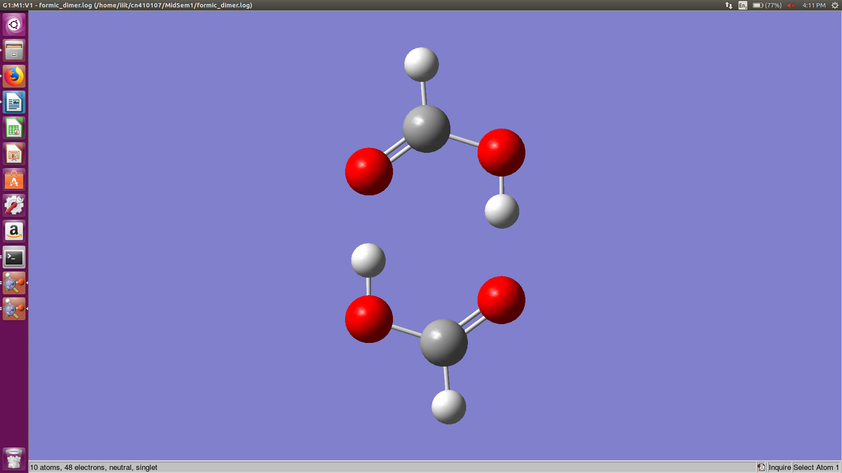

Dimer

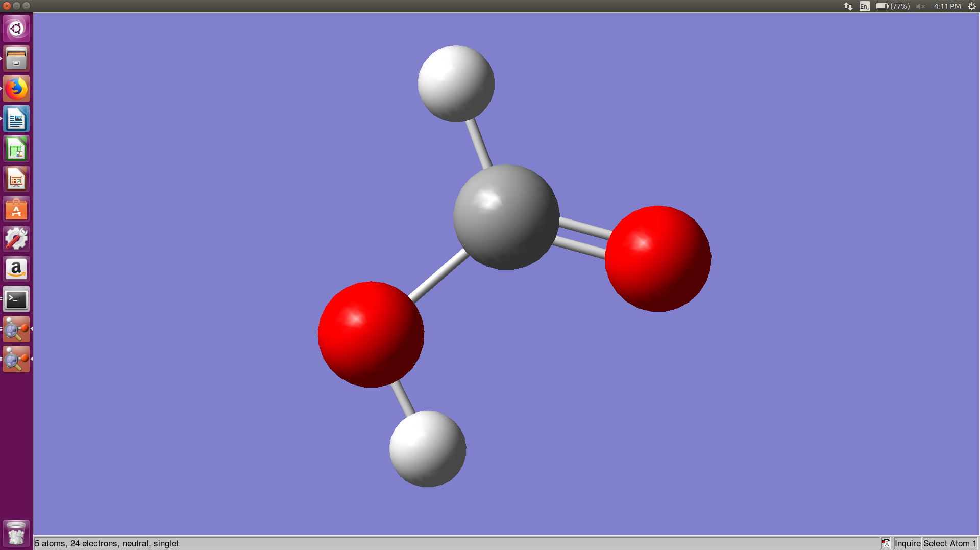

Monomer

(a)

The structures obtained are as given above.

(b)

Energy of the dimer = -372.45991896 Hartree

Energy of the monomer = -186.217884411 Hartree

Comparing the huge difference between the energies of the given molecules we can conclude that the dimer exists as it is much more stable (due to high negative energy value)

