# Part 1

**Questions to Answer**

What is computational pathology (CP)?

### A branch of pathology that involves computational analysis of a broad array of methods to analyse patient specimens for the study of disease. It is the analysis of digitized pathology images with associated metadata, typically using artificial intelligence (AI) methods. It is simply the use of computer algorithms for understanding disease.  How digital tissue slides (histology images) are prepared? 1.Tissue procurement and preparation 2.Fixation 3.Dehydration 4.Clearing 5.Embedding 6.Section cutting 7.Staining and mounting in slide **1. Tissue fixation** Slide preparation begins with the fixation of your tissue specimen. This is a crucial step in tissue preparation, and its purpose is to prevent tissue autolysis and putrefaction

### **2. Specimen Transfer to Cassettes**

After fixation, specimens are trimmed using a scalpel to enable them to fit into an appropriately labelled tissue cassette. Specimens should not be so big that they fill the cassette – they are trimmed so as not to touch the edges. Additionally, they must not be too thick

### **3. Tissue Processing**

Processing tissues into thin microscopic sections is usually done using a paraffin block, as follows:

***Dehydration*,** which involves immersing your specimen in increasing concentrations of alcohol to remove the water and formalin from the tissue.

***Clearing*,** in which an organic solvent such as xylene is used to remove the alcohol and allow infiltration with paraffin wax.

***Embedding*,** where specimens are infiltrated with the embedding agent – usually paraffin wax. The tissue becomes surrounded by a large block of molten paraffin wax, creating what is now referred to as the “block”.  Once the block solidifies, it provides a support matrix that allows very thin sectioning.

### **4. Sectioning**

*Your tissue specimen is now ready to be cut into sections that can be placed on a slide.*

1. Wax is removed from the surface of the block to expose the tissue.
2. Blocks are chilled on a refrigerated plate or ice tray for 10 minutes before sectioning.
3. A microtome is used to slice extremely thin tissue sections off the block in the form of a ribbon.

### **5. Staining**

Most cells are transparent and appear almost colourless when unstained. Histochemical stains (typically hematoxylin and eosin) are therefore used to provide contrast to tissue sections, making tissue structures more visible and easier to evaluate.  Following staining, a coverslip is mounted over the tissue specimen on the slide, using optical grade glue, to help protect the specimen.

What is Whole Slide Image (WSI)? What is the concept of magnification in digital histology images? What is meant by 40x, 20x, 10 and 5x magnification?  
  
**Whole slide imaging,** also known as virtual microscopy, refers to scanning a complete microscope slide and creating a single high-resolution digital file. This is commonly achieved by capturing many small high-resolution image tiles or strips and then montaging them to create a full image of a histological section. It is basically scanning of conventional glass slides in order to produce digital slides.

**Magnification** is a change in the apparent size of an object, performed so that the object can more easily be seen. In traditional light microscopes used for pathology, a wide range of magnifications are available to ensure that the image observed through the oculars is large enough for easy viewing. The field of view is the area seen through the magnifier. As power increases, lens diameter and field of view decrease.  
  
5x :  
A scanning objective lens provides the lowest magnification power of all objective lenses. 5x is a common magnification for scanning objectives and, when combined with the magnification power of a 10x eyepiece lens, a 5x scanning objective lens gives a total magnification of 50x. The name “scanning” objective lens comes from the fact that they provide observers with about enough magnification for a good overview of the slide. At 5 power (5X), field of view is about 1.5.  
  
10x :  
The low power objective lens has more magnification power than the scanning objective lens, and it is one of the most helpful lenses when it comes to observing and analysing glass slide samples. The total magnification of a low power objective lens combined with a 10x eyepiece lens is 100x magnification and it’s field view is about 0.5.  
  
20x :  
While looking at insects and most plant biology, a 10x or 20x objective is probably the right choice.  
  
40x :  
The high-powered objective lens (also called “high dry” lens) is ideal for observing fine details within a specimen sample. The total magnification of a high-power objective lens combined with a 10x eyepiece is equal to 400x magnification,

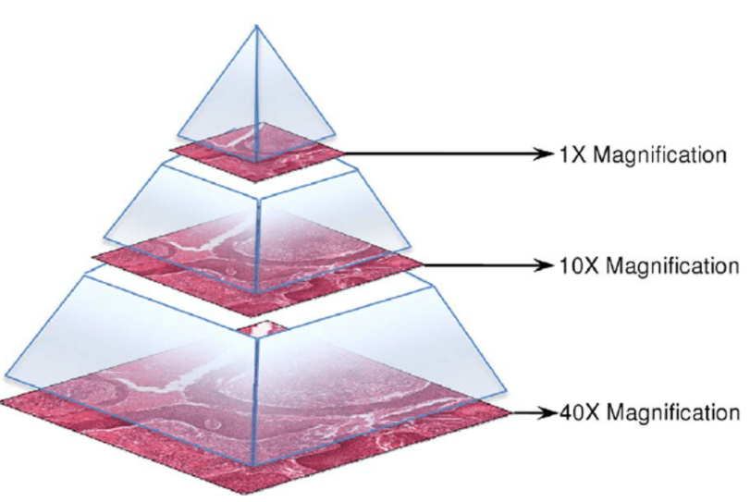

* What is slide staining process and why it is used in digital pathology? What types of stains are used in tissue slides?  
    
  Slide Staining Process:  
  It is a technique used to enable better visualization of cells and cell parts under the microscope. By using different stains, a nucleus or a cell wall are easier to view. Cells are primarily stained to enhance visualization of the cell or certain components  
  It is used in histopathology and diagnosis, as it allows for the identification of abnormalities in cell count and structure under the microscope  
    
  Types of Stains:
* **Haematoxylin and eosin (H & E): Routine stain** This is the most common histologic stain, used to differentiate different tissue structures. It also plays an important role in the diagnoses of various pathologies)
* **Special stains:** Special stains stain are used to identify and demonstrate particular structures and tissues which are not visualized by H&E stains

### **Toluidine blue:** It is particularly attracted to nucleic acids, and is therefore used to stain tissues with high concentrations of DNA and RNA)

* **Alcian blue:** This staining is performed to see the mucoid degeneration and to identify acid mucins which are released by various [connective](https://www.kenhub.com/en/library/anatomy/overview-and-types-of-connective-tissue) and [epithelial tissue](https://www.kenhub.com/en/library/anatomy/overview-and-types-of-epithelial-tissue) tumor
* **Giemsa**: It stains human and pathogenic cells differently, therefore, it is used in the diagnosis of many diseases as it stains human cells purple, and bacterial cells pink, so that they may be differentiate

## **Van Gieson:** The van Gieson stain is a very common stain used to highlight the difference between collagen and other connective tissue such as muscle tissues)

### **Reticulin:** It is mainly used in histopathology of the [liver](https://www.kenhub.com/en/library/anatomy/liver), but can also be used to assess abnormalities in the [spleen](https://www.kenhub.com/en/library/anatomy/the-spleen), bone marrow and [kidneys](https://www.kenhub.com/en/library/anatomy/kidneys). In the liver, both necrosis and cirrhosis cause irregular patterns of reticulin. Changes in reticulin can also signal the presence of tumours

### **Nissl** : Nissl staining is used to visualise Nissl substance (clumps of rough endoplasmic reticulum and free polyribosomes), which is found in [neurons](https://www.kenhub.com/en/library/anatomy/histology-of-neurons).

* What is the AI / Deep learning use cases in computational pathology in context of cancer detection, diagnosis, management and survival?
* Identify Glomeruli in Human Kidney Tissue Images
* Segmentation of Nuclei in Whole Slide Images
* Instance Segmentation
* Nuclei Instance Segmentation
* Fusion of Pathology and Genomics Data for Cancer Diagnosis and Prognosis
* Transformers for Disease Classification Tasks  
  Weakly Supervised Learning for Identification of Prostate Cancer
* Where to look for publications in CP, name top ranked journals and conferences

#### **CONFERENCES:**

* [Medical Image Computing and Computer Assisted Intervention](https://research.com/conference/miccai-2021-medical-image-computing-and-computer-assisted-intervention)
* [IEEE International Symposium on Biomedical Imaging](https://research.com/conference/isbi-2022-ieee-international-symposium-on-biomedical-imaging)
* [ACM Symposium on Applied Computing](https://research.com/conference/sac-2021-acm-symposium-on-applied-computing)
* [Annual International Conference of the IEEE Engineering in Medicine and Biology Society](https://research.com/conference/embc-2021-43rd-annual-international-conference-of-the-ieee-engineering-in-medicine-and-biology-society)
* [International Workshop on Machine Learning in Medical Imaging](https://research.com/conference/mlmi-2021-international-workshop-on-machine-learning-in-medical-imaging)
* [Medical Imaging : Image Processing](https://research.com/conference/spie-image-processing-2022-medical-imaging-image-processing)
* [IEEE International Conference on Bioinformatics and Biomedicine](https://research.com/conference/bibm-2021-ieee-international-conference-on-bioinformatics-and-biomedicine)
* [International Conference on Information Processing in Medical Imaging](https://research.com/conference/ipmi-2021-international-conference-on-information-processing-in-medical-imaging)
* [Medical Imaging : Computer-Aided Diagnosis](https://research.com/conference/medical-imaging-cad-2022-medical-imaging-computer-aided-diagnosis)
* [IEEE EMBS International Conference on Biomedical & Health Informatics](https://research.com/conference/bhi-2021-ieee-embs-international-conference-on-biomedical-health-informatics)
* [ACM International Conference on Bioinformatics, Computational Biology, and Health Informatics](https://research.com/conference/bcb-2021-acm-international-conference-on-bioinformatics-computational-biology-and-health-informatics)
* [Medical Imaging : Digital Pathology](https://research.com/conference/midp-2022-medical-imaging-digital-pathology)
* [Medical Imaging : Imaging Informatics for Healthcare, Research, and Applications](https://research.com/conference/imaging-informatics-for-healthcare-2022-medical-imaging-imaging-informatics-for-healthcare-research-and-applications)
* [International Conference on Medical Imaging with Deep Learning](https://research.com/conference/midl-2021-international-conference-on-medical-imaging-with-deep-learning)
* [IEEE International Conference on Bioinformatics and Bioengineering](https://research.com/conference/bibe-2020-the-20th-ieee-international-conference-on-bioinformatics-and-bioengineering-2)

#### **JOURNALS:**

* [Annual Review of Pathology: Mechanisms of Disease](https://www.scimagojr.com/journalsearch.php?q=11300153736&tip=sid&clean=0)
* [Cell Systems](https://www.scimagojr.com/journalsearch.php?q=21100394875&tip=sid&clean=0)
* [Journal of Pathology](https://www.scimagojr.com/journalsearch.php?q=15991&tip=sid&clean=0)
* [Modern Pathology](https://www.scimagojr.com/journalsearch.php?q=19082&tip=sid&clean=0)
* [Histopathology](https://www.scimagojr.com/journalsearch.php?q=29820&tip=sid&clean=0)
* [American Journal of Pathology](https://www.scimagojr.com/journalsearch.php?q=27062&tip=sid&clean=0)

What are publicly available datasets for following tasks  
 **DATASETS:**

#### WSI TISSUE CLASSIFICATION: - PAIP - METASTATIC-TISSUE-CLASSIFICATION-PATCHCAMELYON

#### WSI SEGMENTATION -Colonoscopy tissue segment dataset -Signet ring cell dataset

#### GLANDS SEGMENTATION - GlaS Dataset https://warwick.ac.uk/fac/cross_fac/tia/data/glascontest/download/

#### NUCLEI INSTANCE SEGMENTATION- CryoNuSeg: A dataset for nuclei instance segmentation of cryo sectioned H&E-stained histological images - NucMM Dataset: 3D Neuronal Nuclei Instance Segmentation at Sub-Cubic Millimetre Scale - PanNuke Dataset:  An Open Pan-Cancer Histology Dataset for Nuclei Instance Segmentation and Classification https://jgamper.github.io/PanNukeDataset/

1. MITOSIS DETECTION- ICPR 2012  
   - ICPR 2014  
   - TUPAC 16

**-** CTMC: Cell Tracking with Mitosis Detection Dataset Challenge

* Elaborate the patch extraction process from WSI, why it is used / necessary?  
    
  Image patches are usually square regions with dimensions ranging from 32 × 32 pixels up to 10,000 × 10,000 pixels with the majority of approaches using image patches of around 256 × 256 pixels ([6](https://www.frontiersin.org/articles/10.3389/fmed.2019.00264/full#B6), [25](https://www.frontiersin.org/articles/10.3389/fmed.2019.00264/full#B25), [35](https://www.frontiersin.org/articles/10.3389/fmed.2019.00264/full#B35))
* Tissue specimen is often investigated as a potential predictor of patient diagnosis, prognosis, or other patient level information.
* 2,3. In the interest of time, a single tissue slide, or its digital counterpart, is often assessed. Annotations associated with a single tissue section can be provided such as whether a malignancy is present
* Consequent to the gigapixel size of WSIs, image analysis requires further image reduction. Patches are often extracted based on annotations, if available, or otherwise

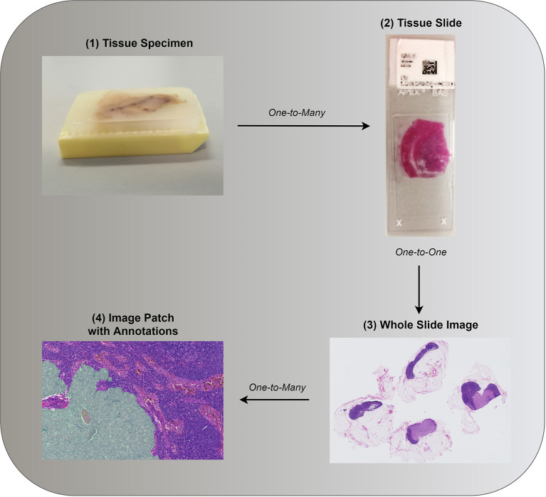

Why Patch extraction method is used:   
Using CNN directly for WSI classification has several drawbacks. First, extensive image down sampling is required by which most of the discriminative details could be lost. Second, it is possible that a CNN might only learn from one of the multiple discriminative patterns in an image, resulting in data inefficiency. Discriminative information is encoded in high-resolution image patches. There- fore, one solution is to train a CNN on high-resolution image patches and predict the label of a WSI based on patch-level predictions.

* Illustrate a typical computational pathology pipeline for cancer grading.

**Computational Pathology Pipeline For Cancer Grading:**  
The pipeline comprises four blocks as described below:

* **Pre-processing**
* **Heatmap generation**
* **Feature extraction**
* **Data balancing**
* **Classification**

The training can broadly split into tissue mask generation, patch extraction and training the models patch wise.   
  
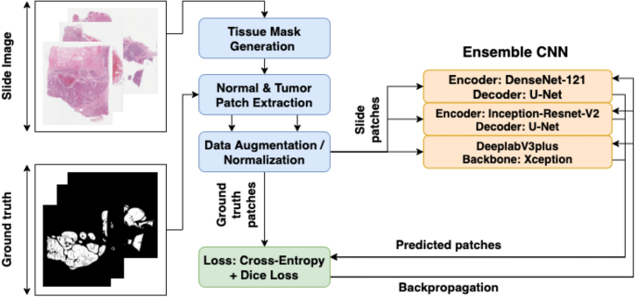

**Tissue mask generation**  
In this step, the entire tissue region was segmented from the background glass region of the WSI image  
**Patch coordinate extraction**  
Using the tissue mask generated from the previous step, patches of the image were randomly extracted to make the training dataset. An equal number of tumorous and non-tumorous patches were extracted. A patch was considered tumorous if at least one pixel inside the patch was classified as a tumour.  
**Data augmentation**  
To increase the number of data points and to better generalize the models across various staining and acquisition protocols, data augmentation schemes were proposed. Augmentations like “horizontal or vertical flip,” “90-degree rotations”, and “Gaussian blurring” along with colour augmentation were performed  
**Loss function**Tumour regions were represented by a minuscule proportion of pixels in WSI images, thereby leading to class imbalance. This issue was circumvented by training the network to minimize a hybrid loss function. The hybrid loss function is comprised of cross-entropy loss and a loss function based on the Dice overlap coefficientt.