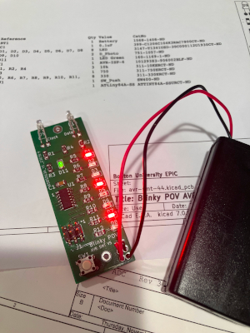
Blinky POV
Kit

Assembly Notes
Rev 11/6/23

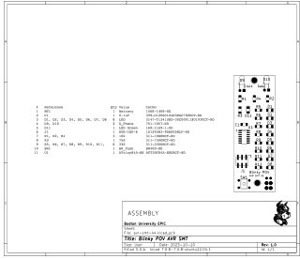
The assembly drawing is your main reference for placing components on the board. The bill of materials (parts list) includes a “Reference” column which matches the labels on the board (“R1” etc).

Resistors and capacitors (R and C) are reversible and can be soldered either way around.
The rest of the parts are not reversible and must be installed the right way around.
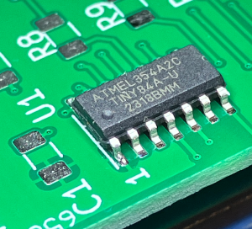
Microcontroller (U1)
LEDs (D1-D8 and D11)
Light sensors (D9 and D10)
Battery holder wires
U1 Orientation
Pin 1 is marked by a dimple in the top of the chip. This should go next to the number “1” on the board.

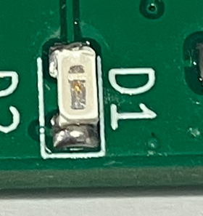

The LEDs D1-D8 should be mounted as shown, with the wider opening towards the board edge.
They should be mounted with the white surface with a transparent window facing up.
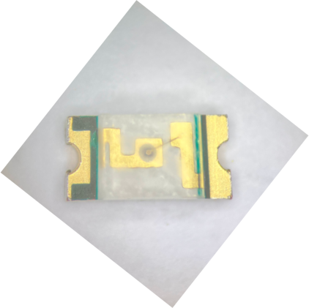
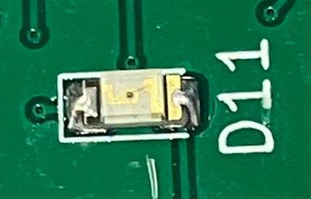
LED D11 orientation.
You have to look closely
for this one.

LEDs are the most common
type of component to install
incorrectly!

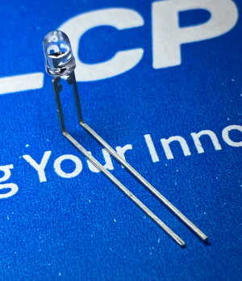
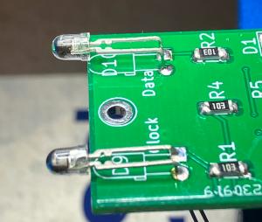
The light sensors (D9, D10) have leads of different lengths.
Bend and install as shown.

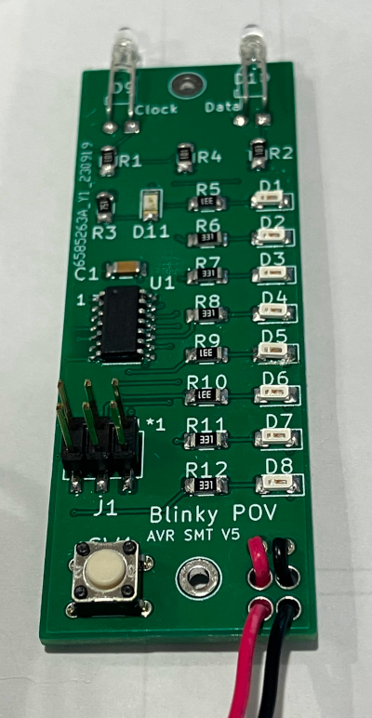
Thread the wires from the
battery holder through the holes as
shown in this photo and solder.

