Blinky Color POV Parts rev 2
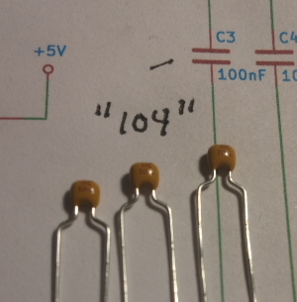  100nF Capacitor  (C1, C3, C4, C6) | 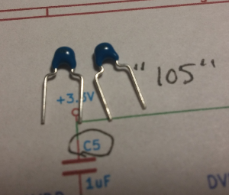  1uF Capacitor( C5, C7, C8)  marked “105” in tiny print  Need 3 of these | 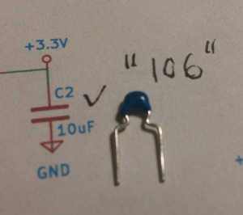  10uF Capacitor (C2)  marked “106” in tiny print  With a black dot
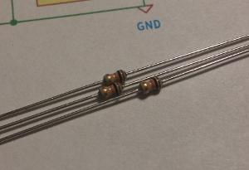  10k Resistor (R1, R4, R5) | 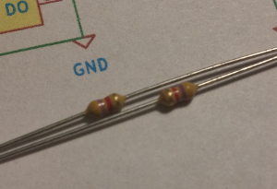  4.7k Resistor (R2, R3) | 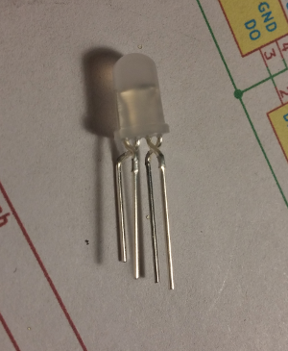  LED (D1-D8)
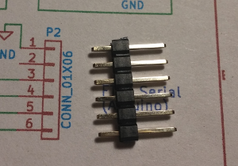  Connector (Optional) P2 | 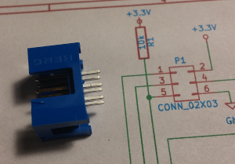  Connector (Optional) P1 | 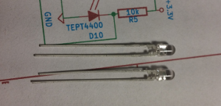  Light sensors (D9, D10)
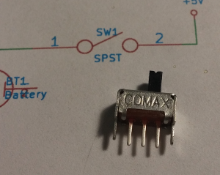  Switch (SW1) | 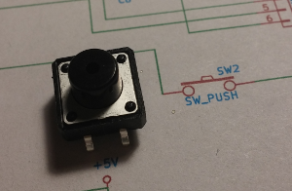  Push button (SW2) | 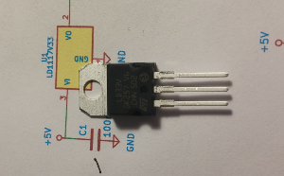  Voltage regulator (U1)

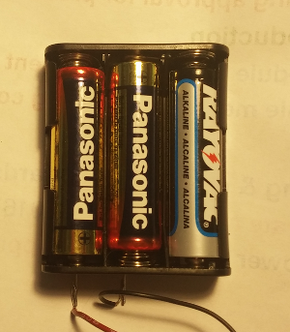  Battery Case | 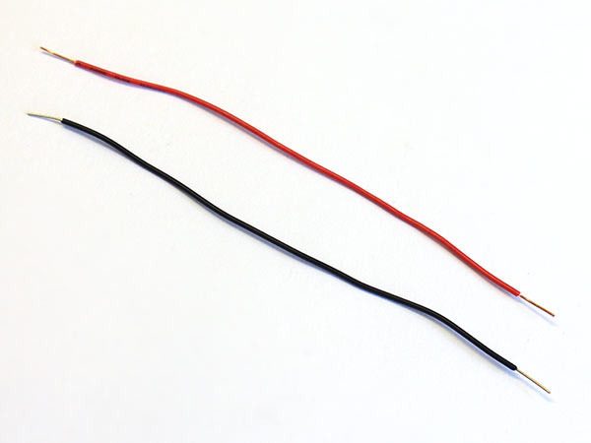  Red and Black Wires | 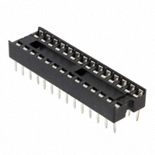  IC Socket
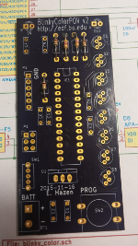
Circuit Board

Directions.....
1. Solder in the resistors  R2 and R3 are 4.7k  Yellow, Violet, Red, Gold  R1, R4 and R5 are 10k  Brown, Black, Orange, Gold | 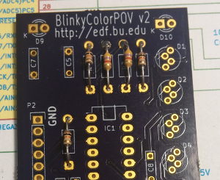
2. Solder in the capacitors  C2 is 10uF “106”  C5, C7, C8 are 1uF “105”  C1, C3, C4, C6 are 0.1uF “104” | 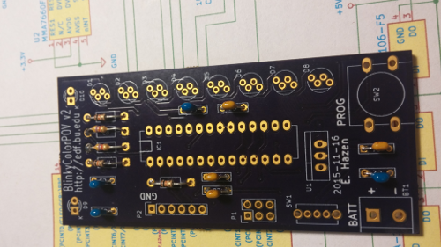
3. Solder in the IC socket  IC1  Be sure the notch is the same way up  as the mark on the board! | 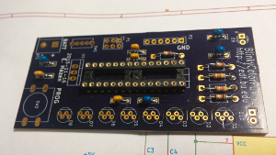
4. Solder in the power switch  SW1 | 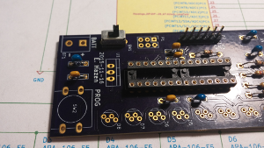
5. Solder in the Programming Button  PROG | 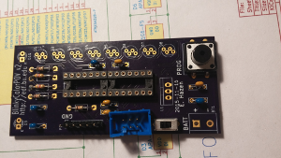
6. Solder in the voltage regulator  U1  Make sure it goes the right way around,  with the metal tab towards U2 | 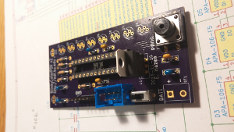
7. Solder in the light sensors  They have to go the right way around  The long lead goes in the round pad  The short lead goes in the square pad  Bend them so they stick out and are  about the same length, as shown | 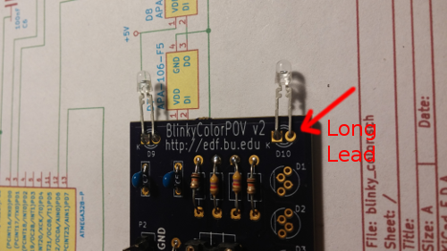
8. Solder in the LEDs  These are tricky. They have 4 leads.  The side with the black dot goes up  towards the top of the board  (where the light sensors are) | 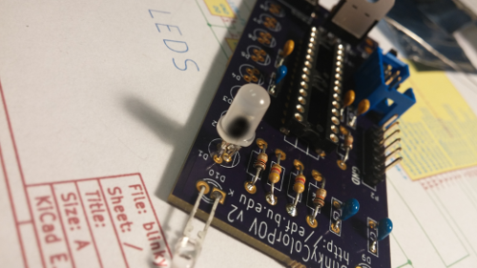
9. Attach the wires to the battery holder  Solder the red and black wires to the battery holder as shown. Be sure the red wire is connected to the pin near the corner.  Solder the other end of the wires into the circuit board. The red wire goes into the “+”hole | 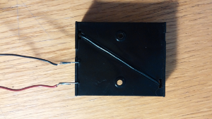  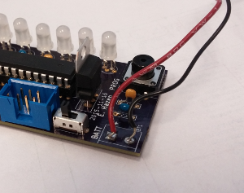

You're done!

Inspect your work carefully, and get your helper to check it out, too.

Then, go ask for batteries and a microcontroller and you're ready to try out your BlinkyColorPOV!

