Blinky Color POV Parts rev 3 Dec 2016
For programming, go to: http://edf.bu.edu/pov
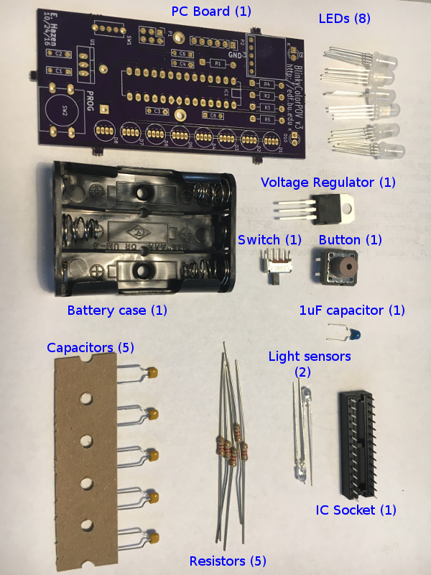
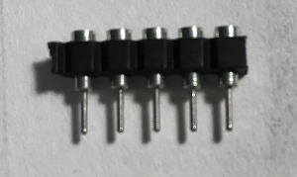
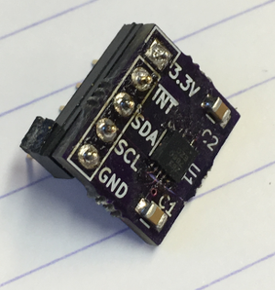
← SIP socket (1)

Accelerometer →
(1)
1. Solder in the resistors  R1, R2, R3, R4, R5  Bend the leads over on the back, solder and cut off the extra wire.  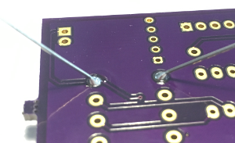 | 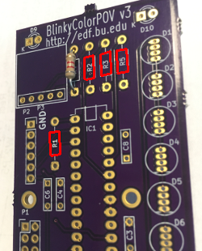
2. Solder in the capacitors  C8 is blue  The others (C1, C2, C3, C4, C6) are yellow | 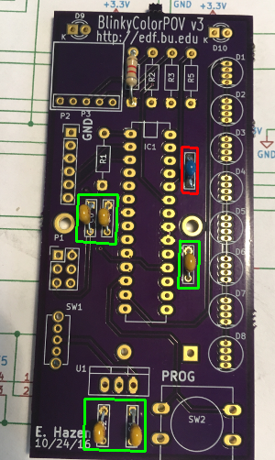
3. Solder in the IC socket  IC1 - bend over two corner pins on the back to keep it from falling out while you solder it.  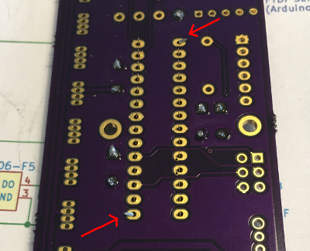 | 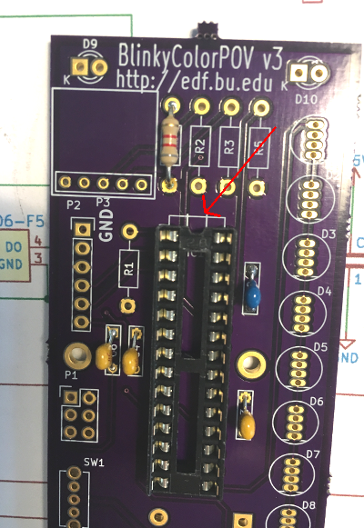  Be sure the notch is the same way up  as the mark on the board!
4. Solder in the power switch  SW1 | 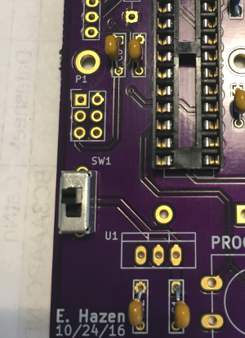
5. Solder in the Programming Button  PROG  6. Solder in the voltage regulator  (be sure to put it the right way around)  U1 | 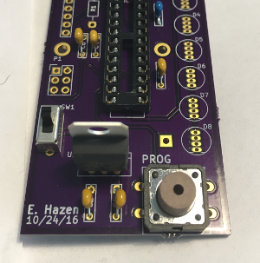
7. Solder in the light sensors (D9, D10)  Bend them so they stick out and are  about the same length, as shown  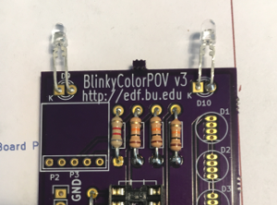 | They have to go the right way around  The long lead goes in the round pad  The short lead goes in the square pad  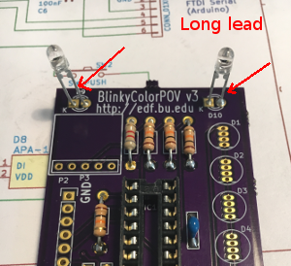
8. Solder in the LEDs (D1...D8)  These are tricky. They have 4 leads, and they have to go the right way around.  Bend the leads apart, and be very careful when you solder them not to make any “solder bridges” between the pins.  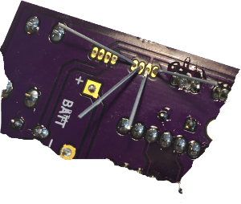 | 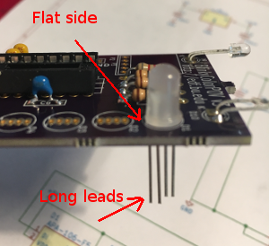
9. Install the SIP socket  P3 – This goes on the front next to the resistors.  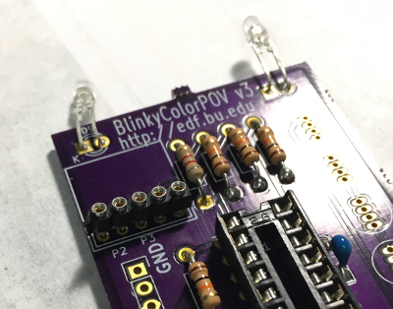 | 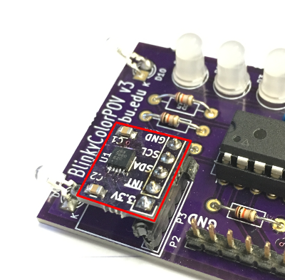  9a. Plug the accelerometer board into the socket
10. Install the battery holder  It goes on the back as shown. The two wires go in the holes marked Batt + and -. Solder the wires on the front where they poke thru the board.  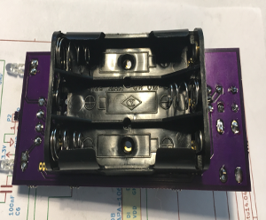 | 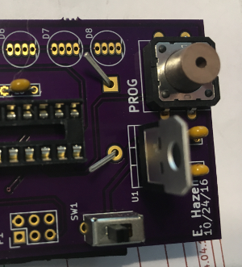

You're done!

Inspect your work carefully, and get your helper to check it out, too.

Then, go ask for batteries and a microcontroller and you're ready to try out your BlinkyColorPOV!

For programming, go to: http://edf.bu.edu/pov

