C1, C3, C4  (3) | Capacitor, 100nF | 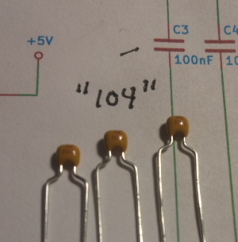
C2  (1) | Capacitor, 10uF | 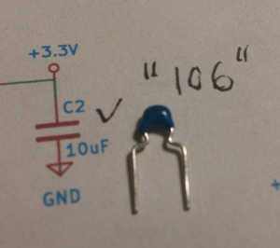
C5, C7, C8  (3) | Capacitor, 1uF | 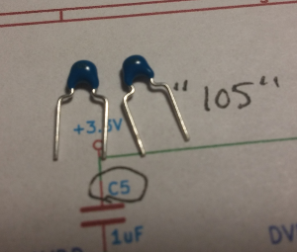
R1, R4, R5  (3) | Resistor, 10k  Brown, Black, Orange, Gold | 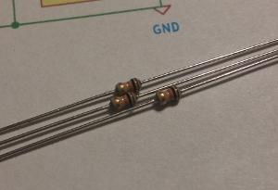
R2, R3  (2) | Resistor, 4.7k  Yellow, Violet, Red, Gold | 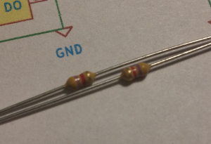
D1-D8 | RGB Addressable LED | 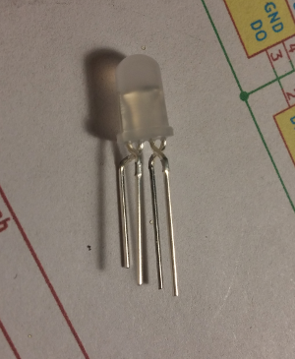
IC1 | IC Socket, 28 pins | MISSING PHOTO
BT1 | Battery holder 3x AA | MISSING PHOTO
P2 | Connector straight 6 pin | 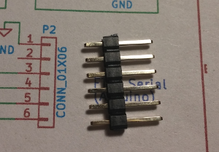
P1 | Pin header 2x6 | 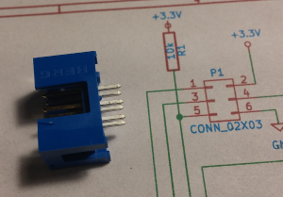
D9, D10 | Light Sensor | 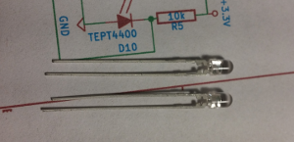
SW1 | Switch | 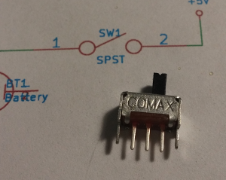
SW2 | Push button switch | 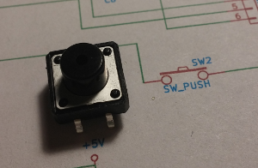
U1 | Voltage Regulator | 