NinjaNIRS 2026/27 Upgrade Notes
Github repo for all design files that have changed compared to the public version on OpenfNIRS: https://github.com/eshazen/ninjanirs-sipm/tree/main/NN26_27/

NinjaNIRS 2026
NN26 is a planned upgrade of the two NN24 whole-head, high-density systems at BU with high-power source optodes, as designed and tested for the UG3 grant milestones.

Source Optodes
NIRx is in the process of manufacturing high-power source optodes for us. Assembly instructions as well as the PCB design files for the small board inside each optode are in the Github repo.

Source Splitter Boards
In testing we have used the NIRx source splitter PCBs and didn’t see any issues. It might still be worth checking the current handling capacities of the PCB traces.
The traces on Eric’s source splitter were designed with the higher currents in mind, but we have only manufactured a few of them.

Source Interface Cards
The NN24 VCCS Source Interface cards from NN24 can also be used for NN26, however several components need to be changed, so it is probably more economical to order new sets of PCBs. Obviously regular NIRx source optodes should not be connected to these modified boards as the LEDs could easily be overdriven!
Here are the components that need to be changed:
Designator | NN24 | NN26 | Notes
R9 | 10 Ohm | 1 Ohm | Change in damping network
R13 | DNP | 2.2 Ohm | Change in damping network
C12 | DNP | 0.22 uF | Change in damping network
R8 | 8.2 Ohm | 1.5 Ohm | Current shunt for higher amps
R30 | 28 kOhm | 59 kOhm | Increase LED drive voltage for series cfg
F1 | 0ZCH0035FF2G | 0ZCH0110AF2E | Increase fuse amps
R2 | 10 kOhm | 12 kOhm | Tune max amps slightly lower

Backplane
The NN24 backplane should be fine. Any backplane with “VCCS” in the designator should be compatible. Only the oldest (v1) backplanes are not compatible as they were designed for the first version source cards without current source.

Control Card
Currently one NN24 system has a v2 control card, the other one has a v3 control card. Both are compatible with the high power optodes, though it would make sense to upgrade the system with the v2 card to v3 when working on it. V3 supports the voltage/current monitoring Sreekanth added to the NinjaWeb.

System Case
The current case should be fine.

Firmware / NinjaWeb GUI
It would be highly advisable to implement some additional safety features to prevent the average optical power of a single optode to exceed ANSI limits. This could currently happen if someone e.g. loads a wrong probe file for much smaller probe so that now the duty cycle of a single optode is much higher.
This safety could e.g. be implemented in the source card firmware, running separately on the second core of the MCU which is currently not used. Or a simpler version could be implemented in NinjaWEB, though this would not catch e.g. as stall in the FPGA.
In NinjaWEB, make sure that in NN24SystemClass.py the following is set:
self.v_src_boost = True
This will increase the source card supply voltage from 5.2V to 9.7V.
A similar setting is in the Matlab initStat() function: stat.v_src_boost = true;

NinjaNIRS 2027
NN27 is a further planned upgrade of the two whole-head, high-density systems at BU with SiPM based high-detectivity optodes, as designed and tested for the UG3 grant milestones.

Detector Optodes
Detector optodes can be manufactured by NIRx in exactly the same way as source optodes. PCB design files are in the Github repo.

Detector Splitter Boards
Eric has designed splitter boards that contain the necessary bias voltage generator. A set of these will have to be ordered, maybe including minor revisions.
Protection of the user from the ~60V bias voltage should also be considered. Potting or conformal coating could be explored.

Detector Interface Cards
The detector interface cards stay largely the same. The only change is to route 12V directly to the splitter board to power the bias generator. This can either be done by manually soldering a jumper wire on a current board, bypassing U13, or by manufacturing a new set of v3 cards with the following changes:
Designator | NN24-26 | NN27 | Notes
R71 | DNP | 0 Ohm | New component; does not exist in prev.
U13 | ADP7142 | DNP
C104 | 10uF | DNP
LF1 |  | DNP
Additional components could be DNP’d in NN27 if desired.

Backplane
The existing backplanes are compatible.

Control Card
Similar to the detector cards, 12V must be routed to the backplane to ultimately power the bias generators. The v3 Control Cards already have provisions for this. V1 and V2 cards are not compatible.
Here are the necessary changes on the v3 control card:
On the front side of the card, bridge pads 3 and 5 of connector footprint J901.
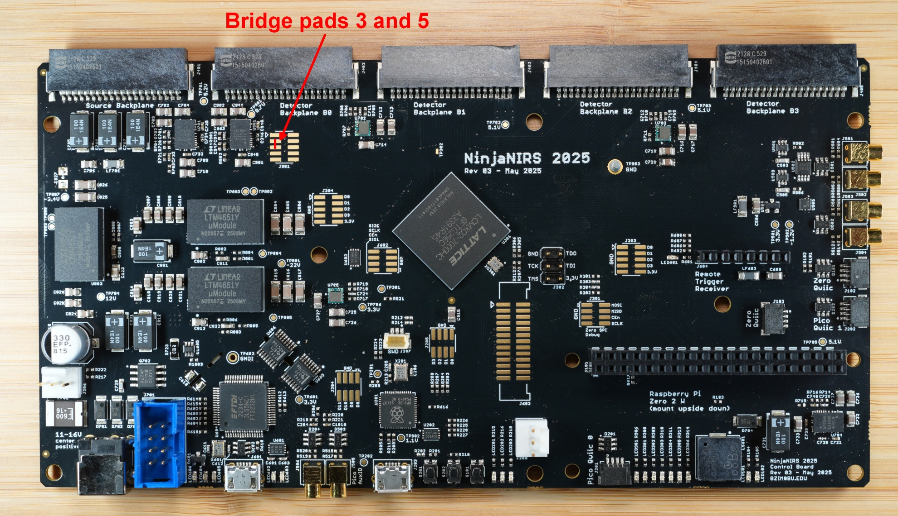
On the back side of the card, move the 0 Ohm resistor from R401 to R402, from R403 to R404, from R405 to R406, and from R407 to R408.
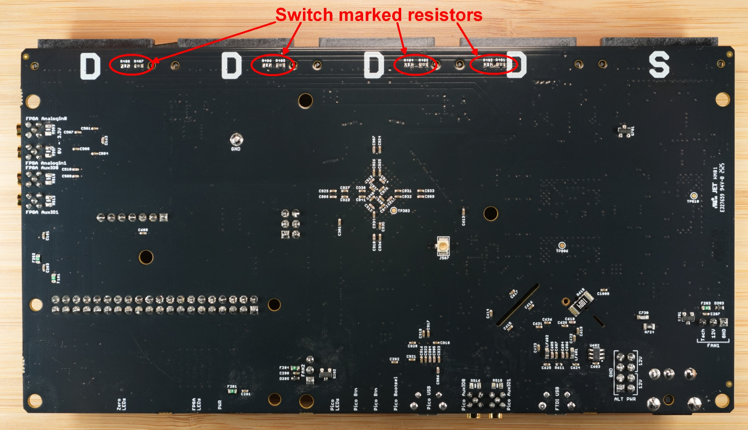

System Case
The system case must be redesigned / enlarged to accommodate the larger detector splitter boards, and possibly to protect the user from the bias voltage.

Firmware / NinjaWeb GUI
As a starting point, no firmware needs to be changed.
However, if control of bias voltage is necessary, it might be desirable to coordinate changes with the larger system, so communication between the splitter board and detector interface board has to be implemented, and then enable communication of this new data to NinjaWeb will also require changes to the FPGA firmware.

