Assembly Instructions for NinjaNIRS
High-Power Source Optodes
March 12th, 2026

Required Materials
- Glue / Epoxy
  - G-S Hypo Cement (optional, can use transparent epoxy instead)
  - Loctite EA M-31CL Clear Epoxy
  - Loctite EA M-21HP Off-White Epoxy (or NIRx potting compound)
- Source PCB with mounted LEDs
- High NA light pipes
- NIRx NIRsport optode cable
- NIRx NIRsport optode shell
- Vise (https://www.stickvise.com) or equivalent
- Putty – XXX instead of vise and putty we might want to 3D print a jig XXX
- Syringe with large diameter blunt needle

Step 1: Build Light-Pipe Pair
- Wipe the light pipes with alcohol. Make sure they are clean.
- Place light pipes in pairs in the vice. (see Figure 1.1)
- Apply a small amount of epoxy (M-31CL) or glue (G-S Hypo) between the two pipes of a pair. (see Figure 1.2)
- Let the glue cure before removing the pair from the vice.
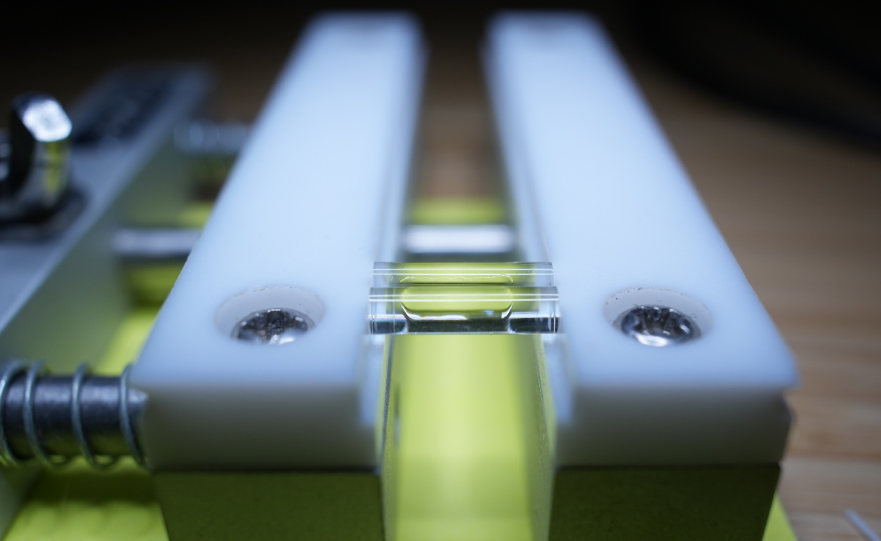
Figure 1.1: Pair of light pipes in vice.
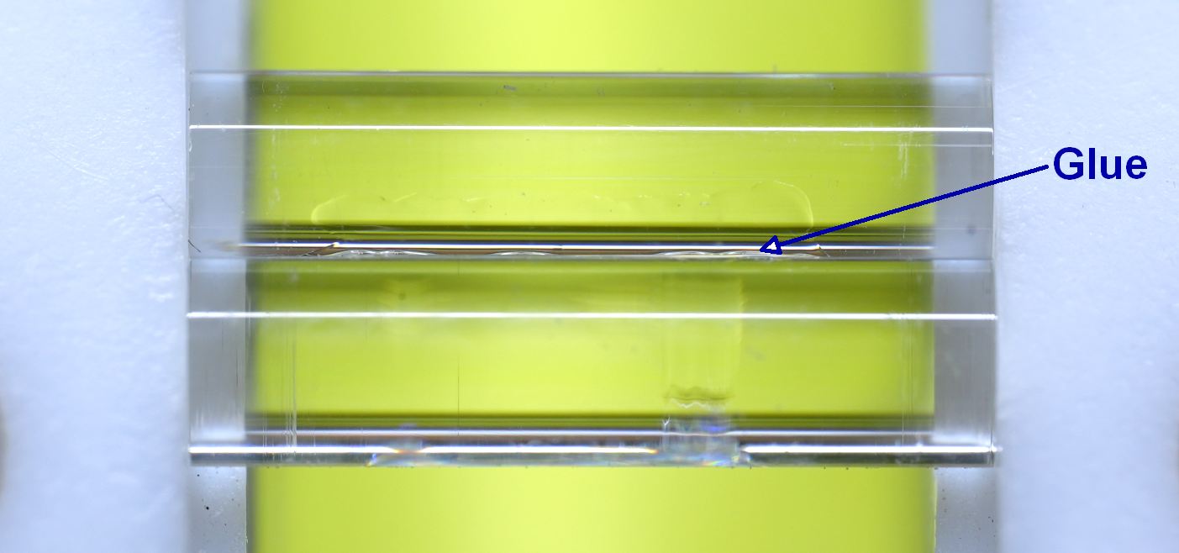
Figure 1.2: Pair of light pipes in vice with glue.

Step 2: Glue the Pair of Light Pipes to the PCB
- Place a blob of transparent epoxy (M-31CL) on the PCB, with the PCB lying on a flat and horizontal surface. A toothpick or similar can be used to push the glue around the LEDs and into all gaps. (see Figure 2.1)
- Place the light pipe pair on top of the LEDs. Try to prevent large air bubbles around the LEDs and underneath the pipes. (see Figure 2.2)
- Align the pipes under a microscope to maximize LED die coverage. (see Figure 2.3)
- Let the epoxy cure. Make sure no one touches or moves the pipes during the curing period!!
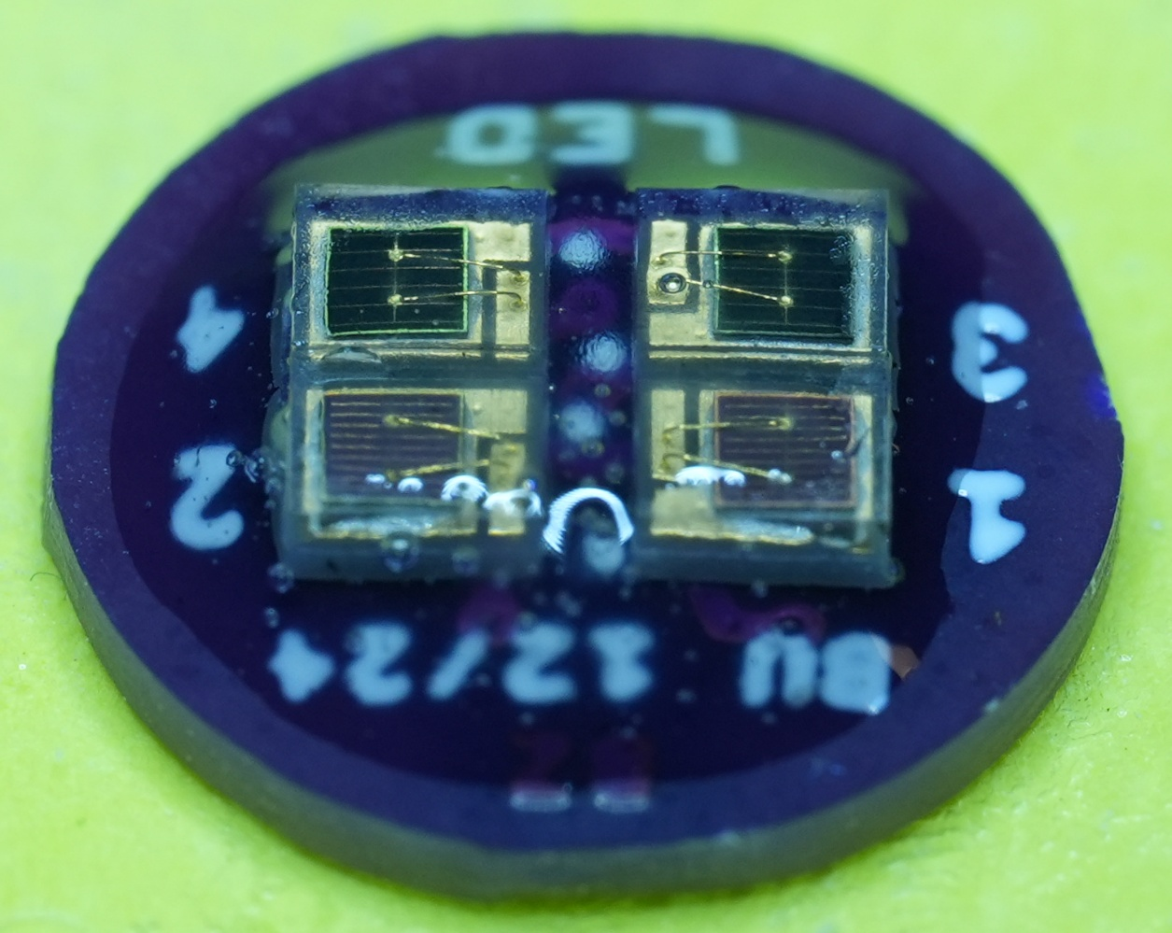
Figure 2.1: Blob of epoxy on PCB.
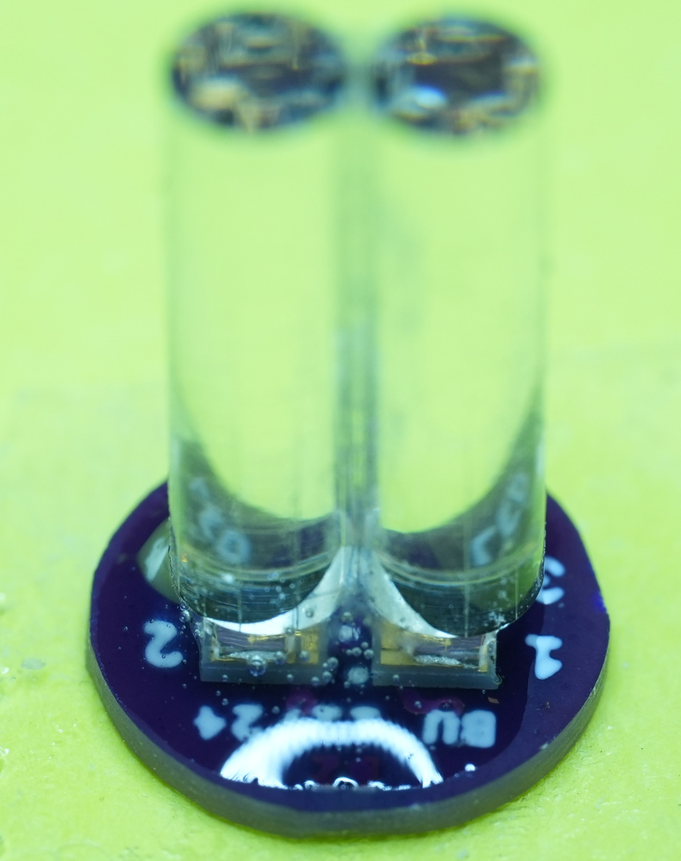
Figure 2.2: Light pipe pair on top of PCB.
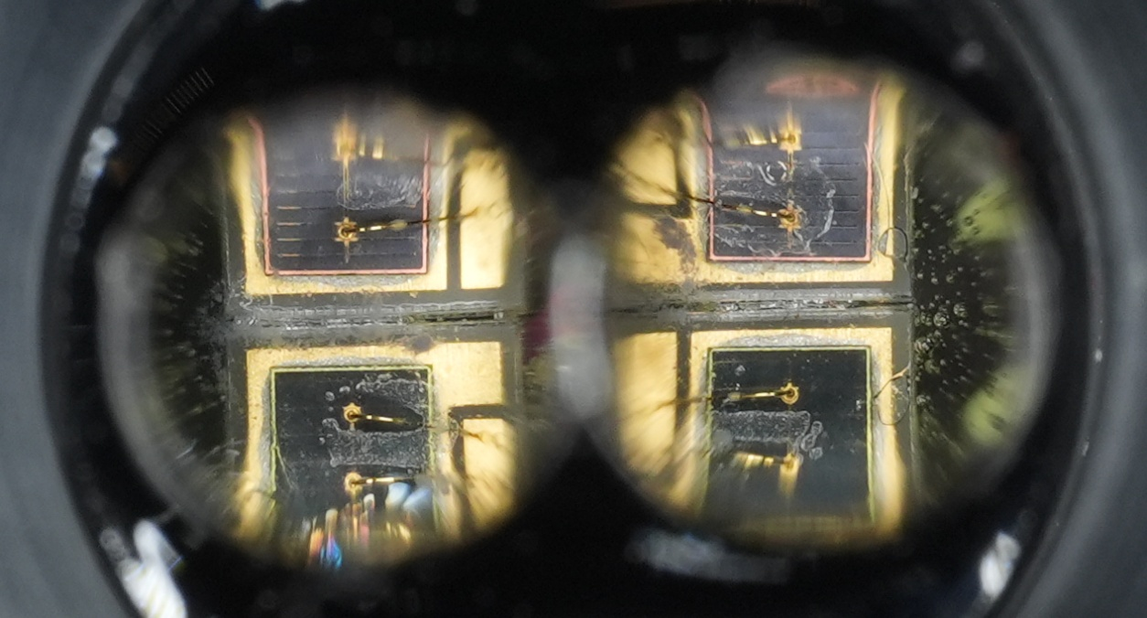
Figure 2.3: Light pipe alignment under microscope.

Step 3: Solder the NIRx Optode Cable to the PCB
- Solder the NIRx optode wire to the back of the PCB. (see Figure 3.1)
- XXX need to add a schematic or picture including the 4 pin connector here as sometimes the colors of the NIRx wires change XXX
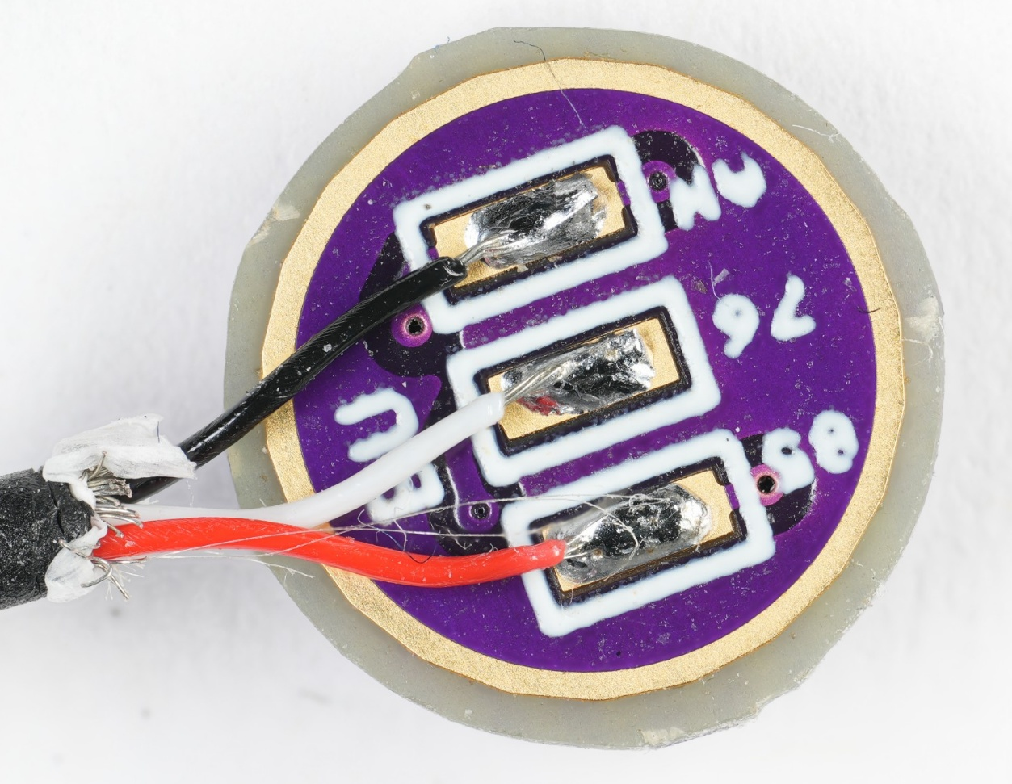
Figure 3.1: Wires soldered to PCB.

Step 4: Pot the PCB Assembly in NIRx Optode Shell
- Clamp the light pipe pair with glued on PCB in the vise. Center the NIRx optode shell and fix it using putty. (see Figure 4.1)
- Fix the PCB inside the shell using small amounts of epoxy (M-21HP). Let the epoxy cure. (see Figure 4.2)
- Completely pot the back side of the using potting medical grade epoxy (M-21HP). Make sure the wire is well embedded in epoxy and fixed in the notch of the optode shell. Let it cure.
- Pot the front side of the optode using medical grade epoxy (M-21HP or M-31CL). Using a syringe, fill the volume inside the optode slowly to avoid air pockets. Let it cure. (see Figure 4.3)
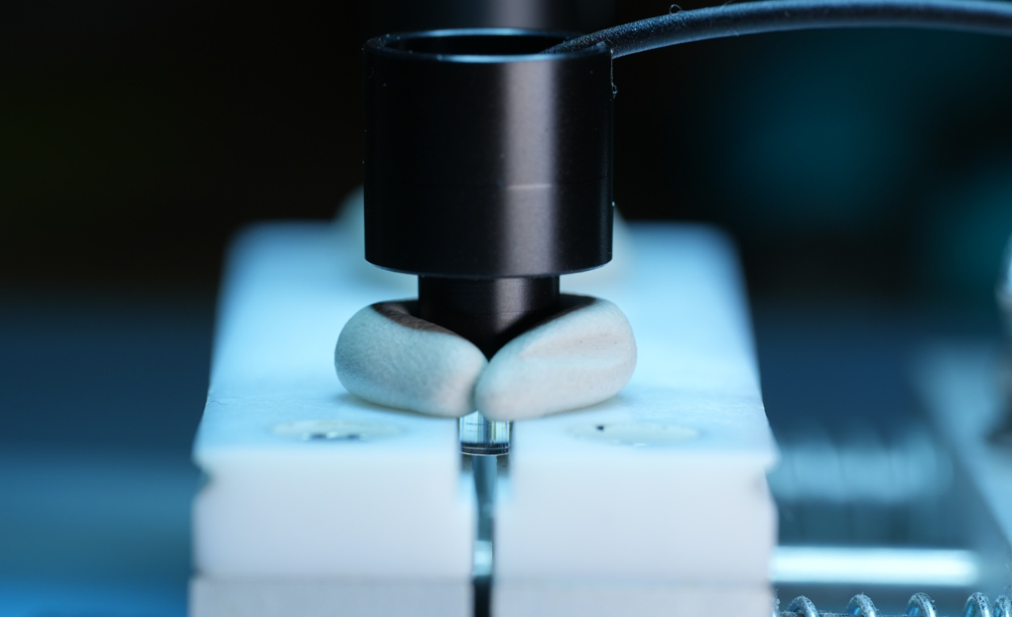
Figure 4.1: Light pipe pair centered in optode shell.
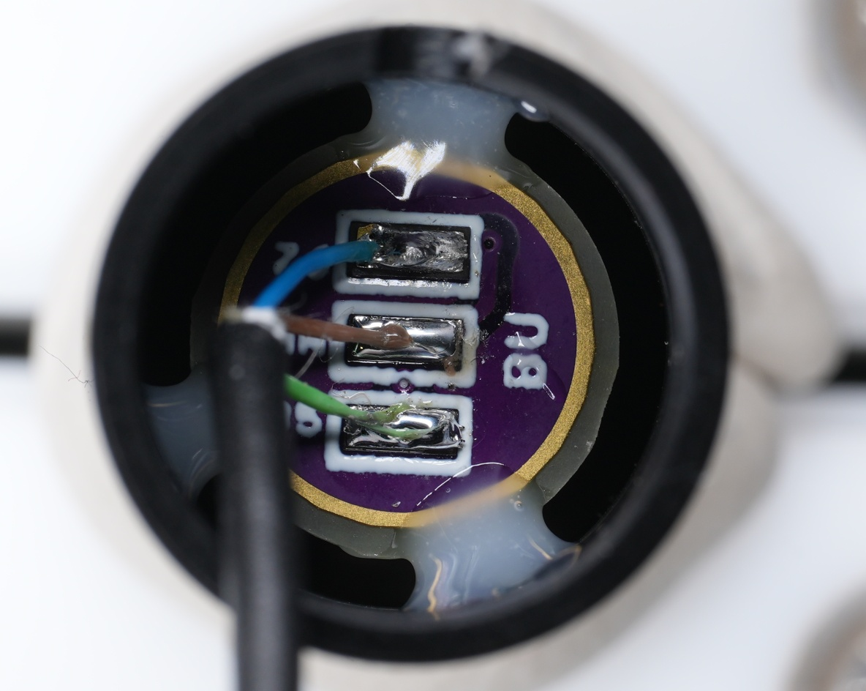
Figure 4.2: Fixation of PCB inside shell using epoxy.
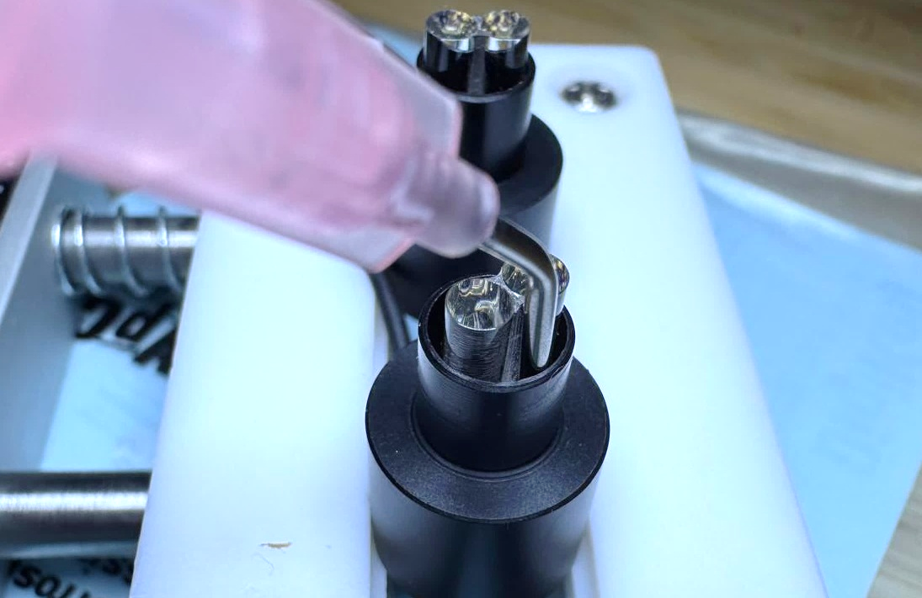
Figure 4.3: Potting of optode front side.

