Assembly Supplement for SiPM Optode
E. Hazen – 2026-10-13

Required Materials
- Standard detector optode cable with 3 conductors plus shield, pinout below.
- Detector housing, double chip (to accommodate two chips as shown)
- Optode cap
- PCB Assembly with
  - (1) PCB fabricated from SiPM_Ada_S13360_v05_DualTip_Gerber.zip
  - (2) Hamamatsu S13360-3050PE
  - (1) Thermistor NTC 10k e.g. Kamaya JSNB103F397FBBXG
- Epoxy and potting compound as used for source optodes
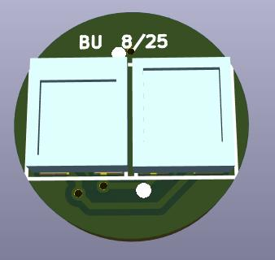
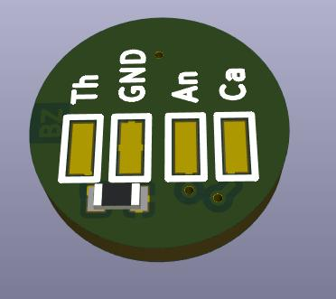
PCB Assembly View. Note that there are two S13360-3050PE SiPM modules with opposite orientations. This results in a 0.5mm vertical offset between the center of the photosensitive areas (probably not important).

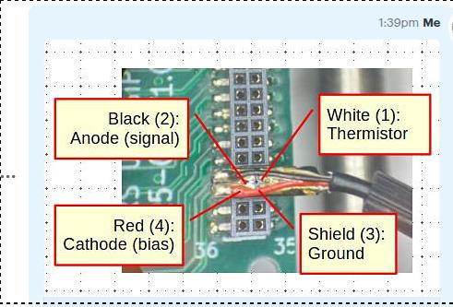

No | Color | Function | PCB Label
1 | White | Thermistor | Th
2 | Black | Anode | An
3 | Shield | Ground | GND
4 | Red | Cathode | Ca

Cable Pinout for SiPM Optode

