Вопрос к лабораторной работе:  
на -O0 сказать, в какой строке происходит первое обращение в память (в 3 строке, для ARM несложно определить, что обращение в память происходит после вызова команд str или ldr, еще одним индикатором обращения в память являются квадратные [] скобки)

Some useful info:

The operation part of a floating-point instruction always starts with an F.

The bottom 64-bits of each of the Q registers can also be viewed as D0-D31, 32 64-bit wide registers for floating-point and NEON use.

X – 64-bits and

W – 32-bits of X

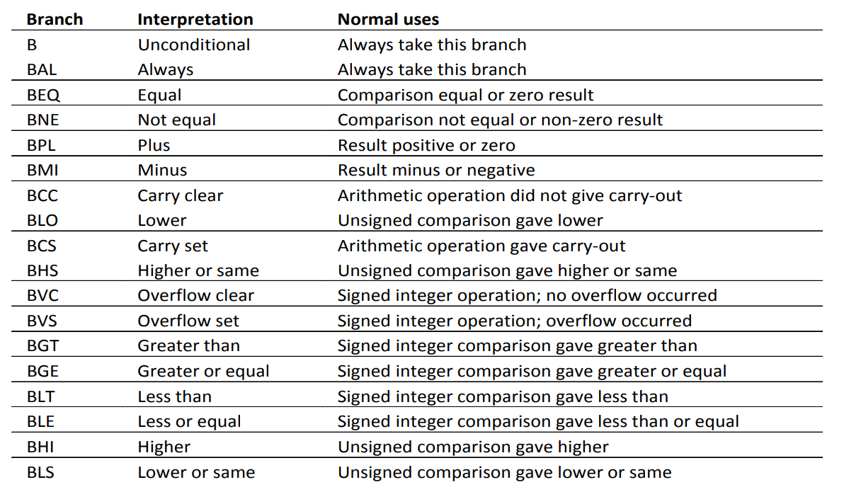

The B instruction will branch. It jumps to another instruction, and there is no return expected. The Link Register (LR) is not touched.

The BL instruction will branch, but also link. LR will be loaded with the address of the instruction after BL in memory, not the instruction executed after BL. It will then be possible to return from the branch using LR.

Power:

        sub     sp, sp, #32 //sp = sp - 32

        str     d0, [sp, 8] //store a register value into memeory, d0 is stored sp+8

        str     d1, [sp] //d1 is stored in sp

        fmov    d0, 1.0e+0 //d0 = 1.0

        str     d0, [sp, 24] //d0 is stored in sp+24

        mov     w0, 1 //w0 = 1

        str     w0, [sp, 20] // w0 is stored in sp+20

        b       .L2 //jump

.L3:

        ldr     d1, [sp, 24] //d1 = sp + 24

        ldr     d0, [sp, 8] //d0 = sp + 8

        fmul    d0, d1, d0 //d0 = d1 * d0

        str     d0, [sp, 24] //sp + 24 = d0

        ldr     w0, [sp, 20] //w0 = sp + 20

        add     w0, w0, 1 //w0 = w0 + 1

        str     w0, [sp, 20] //sp + 20 = w0

.L2:

        ldr     w0, [sp, 20] //w0 = sp + 20

        scvtf   d0, w0 //convert fixed-point w0 to floating-point format and store in d0

        ldr     d1, [sp] //d1 = sp

        fcmpe   d1, d0 //d1 – d0

        bge     .L3 //jump if greater or equal

        ldr     d0, [sp, 24] //d0 = sp + 24

        add     sp, sp, 32 //sp = sp + 32

**ret**

.LC0:

        .string "%f\n"

main:

        stp     x29, x30, [sp, -64]!

pre-index variant that modified the address before storing.

add sp, sp, -64

stp x29, x30, [sp] (sp = x29, sp + 8 = x30)

        mov     x29, sp //x29 = sp

        str     d8, [sp, 16] //sp + 16 = d8

        mov     x0, 211106232532992 //x0 = 211106232532992

**movk**    x0, 0x4062, lsl 48 //moves an immediate value but leaves the other bits of the register untouched (the K is for keep)

в младшие 16 бит записываем число 211106232532992, потом начиная с 48 бита записываем число 0x4062

        fmov    d0, x0 //d0 = x0

        str     d0, [sp, 40] //sp + 40 = s0

        fmov    d0, 5.0e-1 //d0 = 0.5

        str     d0, [sp, 32] //sp + 32 = d0

        str     xzr, [sp, 56] //sp + 56 = xzr

        fmov    d0, 1.0e+0 //d0 = 1.0

        str     d0, [sp, 48] //sp + 48 = d0

        b       .L6 //безусловынй branch

.L7:

        ldr     d1, [sp, 48] //d1 = sp + 48

        fmov    d0, 1.0e+0 //d0 = 1.0

        fadd    d0, d1, d0 //d0 = d1 + d0

        fmov    d1, d0 //d1 = d0

        fmov    d0, -1.0e+0 //d0 = -1.0

        bl      Power

        fmov    d8, d0 //d8 = d0

        ldr     d1, [sp, 48] //d1 = sp + 48

        ldr     d0, [sp, 32] //d0 = sp + 32

        bl      Power

        fmul    d1, d8, d0 //d1 = d8 * d0

        ldr     d0, [sp, 48] //d0 = sp + 48

        fdiv    d0, d1, d0 //d0 = d1 / d0

        ldr     d1, [sp, 56] //d1 = sp + 56

        fadd    d0, d1, d0 //d0 = d1 + d0

        str     d0, [sp, 56] //sp + 56 = d0

        ldr     d1, [sp, 48] //d1 = dp + 48

        fmov    d0, 1.0e+0 //d0 = 1.0

        fadd    d0, d1, d0 //d0 = d1 + d0

        str     d0, [sp, 48] //sp + 48 = d0

.L6:

        ldr     d1, [sp, 48] //d1 = dp + 48

        ldr     d0, [sp, 40] //d0 = dp + 40

        fcmpe   d1, d0 //flag d1 – d0

        bls     .L7 //0 or negative (lower or same)

        ldr     d0, [sp, 56] //d0 = sp + 56

        adrp    x0, .LC0 //

        add     x0, x0, :lo12:.LC0 //x0 = x0 + :lo12:.LC0

        bl      printf

        mov     w0, 0 //w0 = 0

        ldr     d8, [sp, 16] //d8 = sp + 16

**ldp**     x29, x30, [sp], 64 //x29 = sp, s30 = sp+8, sp = sp + 64

        ret

Power:

        fmov    d2, 1.0e+0 //d2 = 1

        mov     w0, 1 //w0 = 1

        fcmpe   d1, d2 флаг по d1-d2

//floating-point compare. If E ispresent, an exception is raised if either operand is any kind of NaN. The FCMP instruction subtracts the value in Fm from the value in Fd and sets the VFP condition flags on the result. FCMP instructions can produce Invalid Operation exceptions.

        bmi     .L1 result minus or negative // "jumps", to the address specified if, and *only* if the [negative flag](https://www.c64-wiki.com/wiki/Negative_flag) is set. If the negative flag is clear when the CPU encounters a BMI instruction, the CPU will continue at the instruction following the BMI rather than taking the jump.

.L4:

        add     w0, w0, 1 //w0 = w0 + 1

        fmul    d2, d2, d0 //d2=d2*d0

FMUL and FNMUL operations can produce Invalid Operation, Overflow, Underflow, or

Inexact exceptions.

        scvtf   d3, w0 //covert fixed-point w0 to floating-point format and store in d3

        fcmpe   d3, d1 //flag d3 – d1

        bls     .L4 // (if (or (not cbit) zbit) (set pc soffset8))

типа lower or same

.L1:

        fmov    d0, d2 //d0 = d2

        ret

.LC0:

        .string "%f\n"

main:

        fmov    d5, 1.0e+0 //d5 = 1.0

**movi**    d0, #0 //d0 = 0

if s (i) is specified:

updates the N and Z flags according to the result

can update the C flag during the calculation of Operand2

does not affect the V flag

        stp     x29, x30, [sp, -16]! //sp = sp – 16, sp = x29, s + 8 = x30

        mov     w1, 150 //w1 = 150

        fmov    d7, d5 //d7 = d5

        fmov    d6, 5.0e-1 //d6 = 0.5

      mov     x29, sp //x29 = sp

.L16:

        fmov    d4, d5 //d4 = d5

        mov     w0, 1 //w0 = 1

        fadd    d5, d5, d7 //d5 = d5 + d7

        fmov    d1, 1.0e+0 //d1 = 1

        fcmpe   d4, #0.0 //d4 - 0;

        bmi     .L11

.L13:

        add     w0, w0, 1

        fneg    d1, d1

        scvtf   d2, w0

        fcmpe   d5, d2

        bge     .L13

        fcmpe   d4, d7

        mov     w0, 1

        fmov    d2, 1.0e+0

        bmi     .L11

.L15:

        add     w0, w0, 1

        fmul    d2, d2, d6

        scvtf   d3, w0

        fcmpe   d3, d4

        bls     .L15

        fmul    d1, d1, d2

.L11:

        fdiv    d1, d1, d4

        subs    w1, w1, #1

        fadd    d0, d0, d1

        bne     .L16

        adrp    x0, .LC0

        add     x0, x0, :lo12:.LC0

        bl      printf

        mov     w0, 0

        ldp     x29, x30, [sp], 16

        ret