The effect of price salience on willingness to rent and perceived fairness of price in the Boston housing market

Team 10: Oumou Barry, Dhruv Shah, Jessica Tong, Alima Abdirova, Sonya Dreyer

03/07/2024

**Introduction**

This experiment aims to uncover the effect of price salience on individuals’ behavior in the Boston housing market. It will look specifically into the participant’s willingness to rent housing and their perceived fairness of the price displayed on the listings they see in a survey. Our hypothesis is that having less salient prices will make the customer more likely to rent a listing.

Research exploring the effect of price salience on consumer behavior has been at the intersection of economics and psychology, particularly within the realm of behavioral economics. Scholars in this field aim to understand how individuals make decisions in real-world settings, often departing from the traditional economic assumption of perfect rationality. One seminal study by Drazen Prelec and George Loewenstein in 1998 investigated the impact of price transparency on consumer preferences, revealing that making prices more salient increased price sensitivity and reduced willingness to pay. This finding resonates with behavioral economics theories, such as prospect theory, which suggests that individuals are more sensitive to losses than gains, and thus, increased price salience may heighten the perceived cost of a product or service.

Expanding on this foundation, recent studies have further explored the effects of price presentation formats on consumer decision-making. Additionally, some businesses such as StubHub, German cinemas, and many others have also conducted similar experiments. These studies have demonstrated that presenting prices prominently and transparently can lead to more cautious decision-making and decreased purchase intentions. This aligns with insights from behavioral economics, which emphasize the role of cognitive biases and heuristics in shaping individuals' choices. For instance, the prominence of prices may trigger mental accounting processes, prompting consumers to evaluate the perceived value of a purchase more critically.

Price salience has practical implications for pricing strategies and marketing practices. By understanding how different presentations of price information affect consumer behavior, businesses can tailor their pricing strategies to optimize sales and profitability. For example, retailers may strategically adjust the visibility and format of prices to influence consumers' perceptions and purchasing decisions. Overall, research in this area not only advances theoretical understanding but also offers valuable insights for practitioners seeking to navigate the complexities of consumer decision-making in the marketplace.

Price salience in the housing market is important for several reasons. Firstly, it helps potential buyers or renters make informed decisions by providing clear and transparent information about the cost of a property. When prices are salient, individuals can easily compare different housing options and evaluate their affordability. Additionally, price salience promotes market efficiency by reducing search costs and facilitating price discovery. It also enhances market competition, as transparent pricing encourages sellers to offer competitive rates and buyers to negotiate effectively. Overall, price salience contributes to a more transparent, efficient, and competitive housing market, benefiting both consumers and market participants.

Our research question is: How does price salience affect consumers’ willingness to rent a property and their perceived fairness of the price?

**Methods**

For the purpose of this project we used survey sampling. We distributed our survey to individuals residing in the USA due to our use of American Dollars as the currency for rent prices. We believed that US residents would be more suitable respondents. We opted for simple random sampling, utilizing Qualtrics' built-in feature to randomly select respondents in equal proportions for two sets of questions. Setting up the Qualtrics survey was relatively straightforward but time-consuming. Initially, we gathered real apartment information from listing websites and contacted brokers to understand broker fees. Subsequently, we designed our survey on Qualtrics, which included demographic questions such as email address, age, employment status, and monthly rent budget. The main questions of the survey focused on each apartment, assessing the likelihood of signing a lease, whether the apartment was perceived as underpriced, overpriced, or fairly priced, and if not fairly priced, the respondent's suggested fair price. This allowed us to measure respondents' reactions to price salience after viewing apartment pictures and reading amenities descriptions. The only variation between groups was the price section, where the treatment group saw a price inclusive of additional fees like broker fees and monthly expenses as a percentage, while the control group saw an all-inclusive price. The screenshot for a sample of our survey question can be found in the appendix (figure 12-13)

**Data Analysis**

During our exploratory analysis, we examined various characteristics of our data and created visualizations to illustrate the distribution of respondents across different variables such as treatment group, location, gender, employment status, and rent budget. Additionally, we generated visualizations that highlighted differences in outcomes based on the treatment group. For instance, we explored the likelihood to lease by apartment type, average price perception by apartment type, and other relevant factors. The figures corresponding to these visualizations can be found in the appendix (figures 1-9).

ATE

*Likelihood of Leasing*

The ATE of the likelihood of leasing is **-0.12**. This is surprising as the alternative hypothesis imposed a positive ATE due to less salience price treatment. This means that by making the rent price less salient, people are 0.12 less likely to want to rent it in a spectrum from 0 to 5.

*Price Perception*

The ATE of price perception is **0.05**, which is also the opposite of the alternative hypothesis. This means that by making the rent price less salient, people are 0.05 more likely to think it’s overpriced in a range from 0 to 3.

*Price Suggestion*

The ATE for price suggestion is **-54**, which indicates that people who see less price salient rents believe the price should be $54 less than the ones who see more price salient rents (people see the holistic price).

CATE:

*Gender*

The CATE of the likelihood for men to sign a lease is **-0.31**. This is a much larger effect than the overall ATE. This means that men are more sensitive to less salient rent prices. With the rent being less salient, they’re 0.31 less likely to want to sign a lease in a spectrum of 5. The CATE of the likelihood for women to sign the lease is **0.08**. This shows that women are 0.08 out of 5 more likely to sign a lease when encountering less salient rent prices.

*Location*

The CATE of the likelihood of responders who are located in Boston is **-0.24**. This shows that people who currently live in Boston are 0.24 out of 3 less likely to want to sign a lease when seeing less salient rent prices. On the other hand, it’s **0.08** out of 3 more likely for people who live outside of Boston to want to sign the lease, when encountering less salient rent prices.

*Employment Status*

When it comes to responders who are unemployed, we’re seeing a negative ATE of **-0.18**. Their counterpart part-time and full-time employees, on the other hand, have a positive ATE of **0.16**. This shows that employed responders accept rent salience better than the all-inclusive rent.

Statistical Power

By calculating the statistical power of the three results, they each are **0.39**, **0.46**, and **0.31**. These results show that the survey lacks statistical power to make a significant conclusion based on the observed effect. To reach an 80% statistical power, we need an 892 to 1438 sample size, depending on the outcome observed. This is a much larger sample size than the 79 that our experiment obtained.

Regression analysis

*Likelihood of Lease Regressions: OLS*

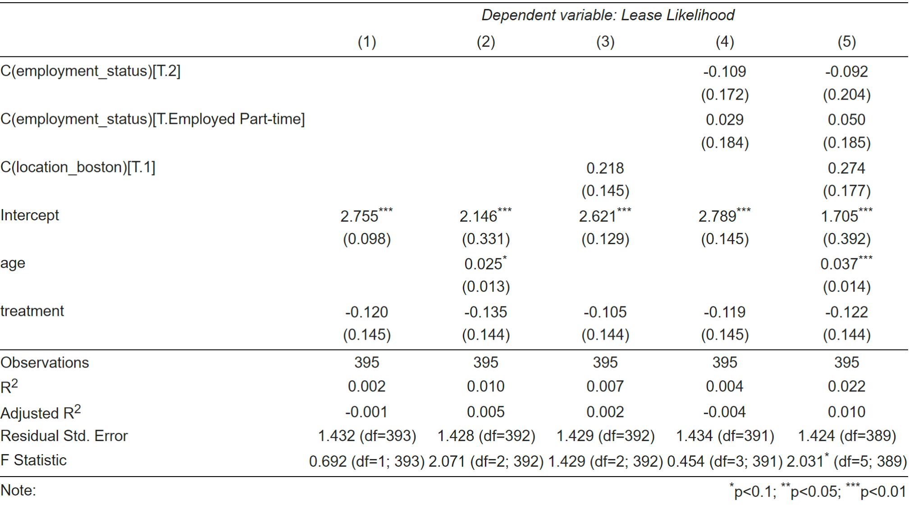

*Table 1: OLS Regression on Likelihood of Lease Regressions*

In this analysis, we explored the association between the treatment variable and the likelihood of lease, while considering age, employment status, and location (specifically, Boston) as covariates. The findings revealed that throughout all the regressions treatment negatively affects the outcome. In other words, people in the treatment group are less likely to rent the apartment than people in the control group. The fifth regression with all of the covariates also indicates the negative effect. In summary, our analysis demonstrates that the treatment variable consistently yields a negative impact on the likelihood of lease across all regressions. However, it's crucial to note that these effects are not statistically significant, highlighting the need for further investigation into the complex dynamics influencing apartment rental decisions.

*Likelihood of Lease Regressions: Fixed Effects*

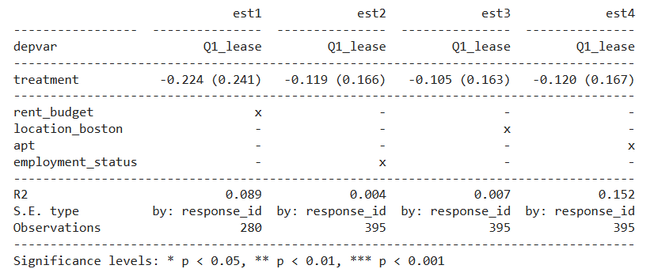

*Table 2: Fixed Effect Regression on Likelihood of Lease Regressions*

The regression analysis performed with various fixed effects, considering factors such as budget constraints, employment status, location (Boston), and apartment characteristics, does not provide statistical evidence to suggest that making the prices more salient has a significant effect on the decision to sign a lease. In every model estimated, the treatment effect was negative **-0.224** (est1), **-0.119** (est2), and **-0.105** (est3), **-0.120** (est4), and not statistically significant, which means we cannot confidently say that price salience influenced participants' leasing decisions.

Additionally, the R-squared values are low, except for the apartment fixed effect model, which has a much higher R-squared of **0.152,** indicating a better fit.This implies that the models do not explain much of the variability in the leasing decisions of the participants. Therefore, based on this analysis, we might conclude that there are other, more influential factors that determine whether a participant decides to sign a lease, beyond the immediate visibility of rental prices and additional fees.

*Price Perception Regressions: OLS*

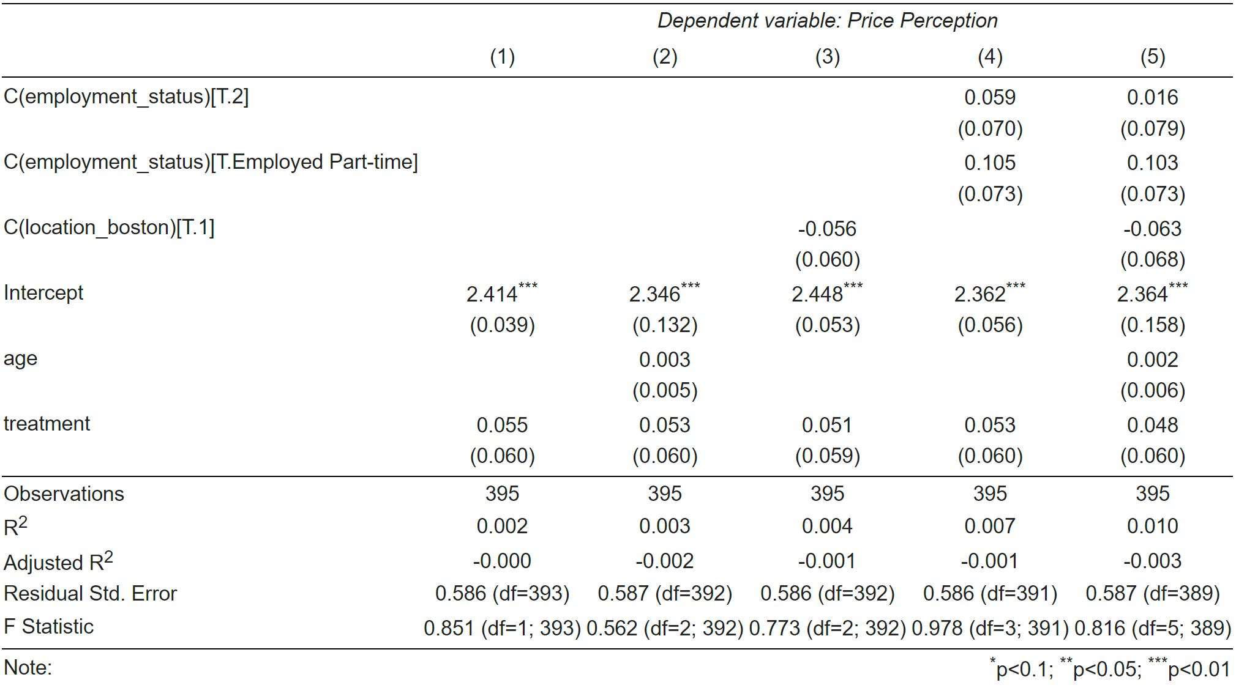

*Table 3: OLS Regression on Price Perception*

In this analysis, we examined the relationship between treatment, age, location (specifically, being in Boston), and employment status on the price perception results. The results indicate that while there are some associations between these variables and price perception, they are generally weak and statistically insignificant. The treatment variable shows a positive but nonsignificant effect on price perception, suggesting that the treatment may not significantly influence perceptions of price. Similarly, demographic factors such as age, location (being in Boston), and employment status do not appear to have significant effects on price perception in the examined models. Overall, the models exhibit low explanatory power, as indicated by the low R-squared values. These findings underscore the complexity of understanding perceptions of price and suggest the need for further investigation into additional factors that may influence consumer perceptions.

*Price Perception Regressions: Fixed Effects*

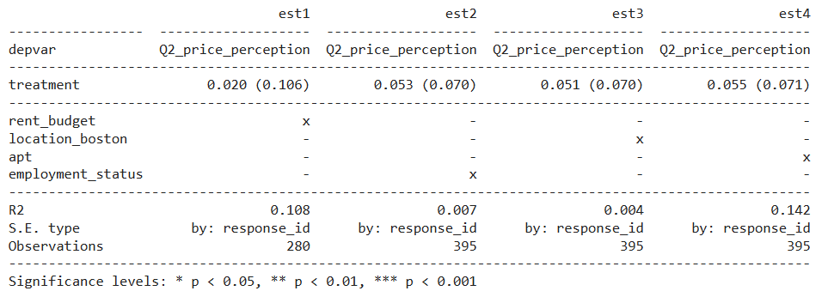

*Table 4: Fixed Effect Regression on Price Perception Regressions*

In the analysis employing fixed effects, the results reveal varying impacts of the treatment on price perception when considering different fixed effects. When considering fixed effects related to employment status, location (Boston), and apartment types, the treatment reveals effects on price perception in the models, indicating its influence may depend on these contextual factors. However, the role of variables like rent budget in explaining price perception seems comparatively weaker. Once again, the results are not statistically significant. Further research exploring additional variables and their interactions could provide a more comprehensive understanding of these dynamics.

*Price Suggestion Regressions: OLS*

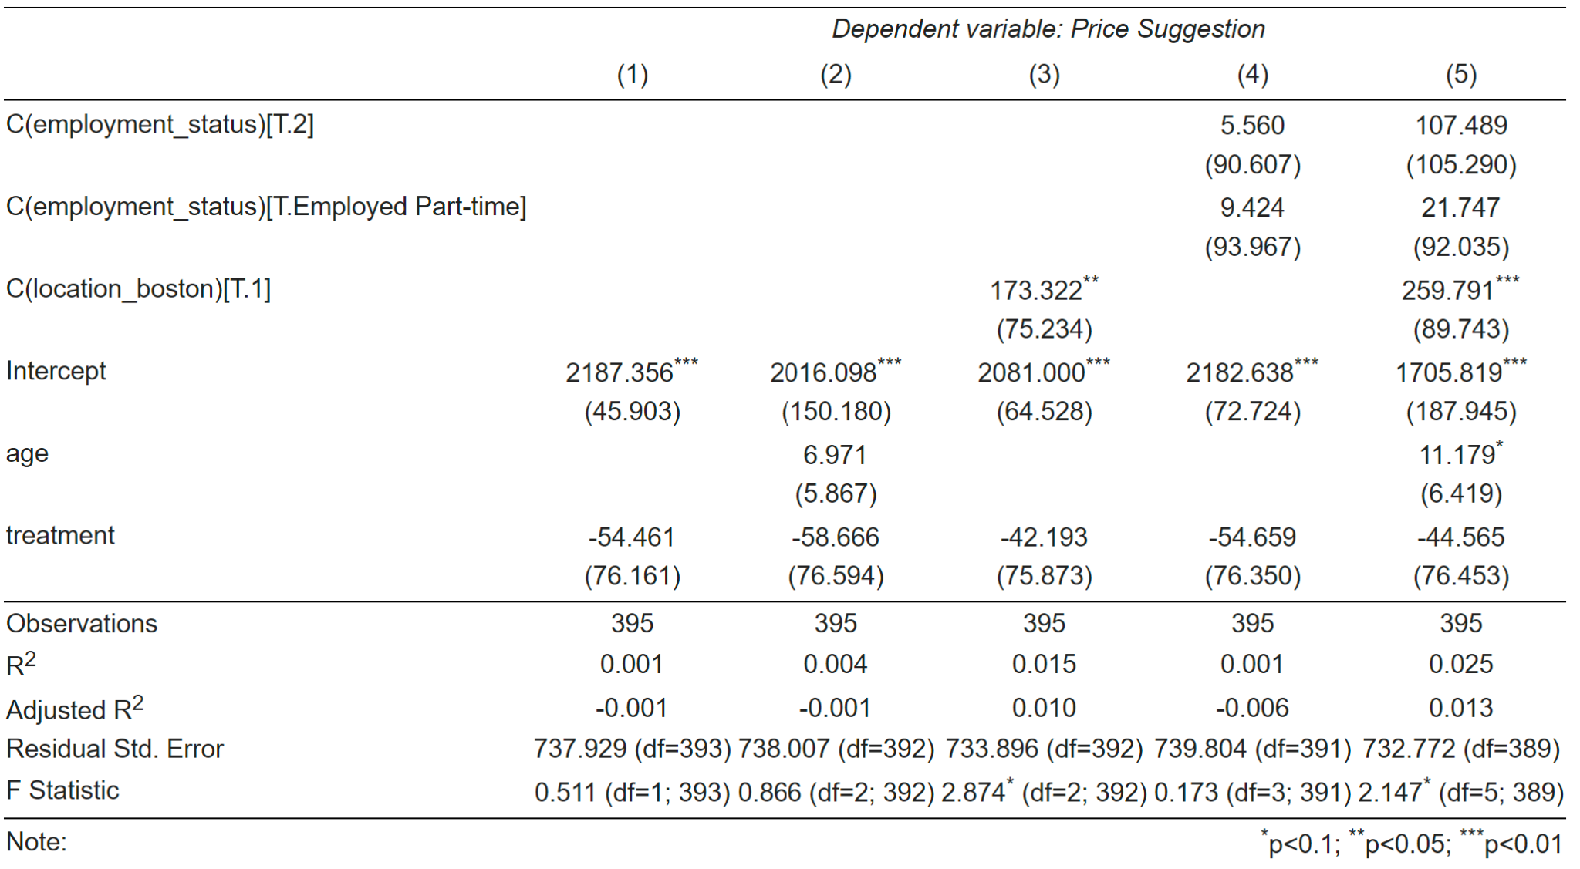

*Table 5: OLS Regression on Price Suggestion Regressions*

In this specific regression, the relationship between employment status, location, age, and treatment effect is explored. After adding in all of the covariates, we see a treatment effect of **-44.67**. This means that responders are willing to pay less when encountering a less salient price. However, this is not statistically significant.

*Price Suggestion Regressions: Fixed Effects*

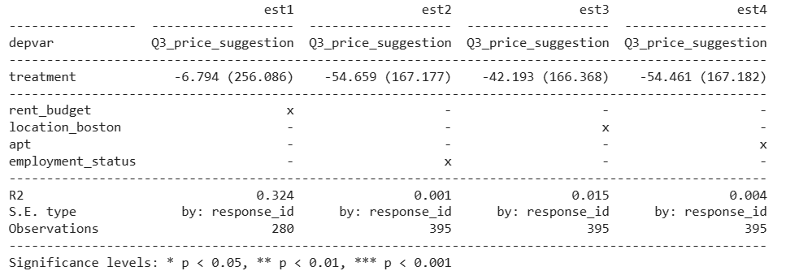

*Table 6: Fixed Effect Regression on Price Suggestion Regressions*

The model above demonstrates the impact of a treatment on price suggestions, considering several fixed effects such as budget, employment, location (Boston), and apartment characteristics.The treatment coefficients are substantially negative across all four models: **-6.794** (est1), **-54.659** (est2), **-42.193** (est3), and **-54.461** (est4), and the absence of asterisks next to these numbers indicates that they are not statistically significant. Additionally, the large standard errors, exemplified by **256.086** for est1, indicate a lack of precision in the estimation of the treatment's effect, thus undermining their statistical significance.

The R-squared values are mixed, with the budget fixed effect model showing a moderate R-squared of **0.324**, while the other models demonstrate very low explanatory power (0.001, 0.015, 0.004). The higher R-squared in the budget model suggests a better fit, but the low R-squared values in the other models suggest they have little predictive power regarding price suggestion outcomes.

**Limitations**

Due to the presence of spam entries, our intended proportions for the experiment were not achieved, resulting in an unanticipated imbalance in the sample distribution. Consequently, the sample size obtained was smaller than anticipated, leading to a significant reduction in statistical power. To adequately detect the effects of the treatment, an average increase of approximately 1000 participants would be necessary, as determined through power calculations.

For the treatment group, we opted to present the price section for each listing using percentages of fees instead of distinct amounts. This decision was made to create a clearer distinction between the treatment and control groups in terms of straightforwardness. However, we acknowledge that including a second treatment arm with straightforward amounts could have provided additional insights.

Assumptions

Non-interference assumes that the assignment of treatment to one unit does not affect the outcome of another unit. In the context of our experiment, this would mean ensuring that exposure to price salience in one group does not inadvertently influence the responses of participants in the control group. Since we did simple random sampling and we used across-subject design, participants were only exposed to either treatment survey questions or control ones. Therefore, the assumption of non-interference was not violated.

Excludability refers to the ability to ensure that the treatment is applied exclusively to the treatment group and not to the control group and the only thing that differentiates treatment and control is the treatment itself. The only variation between groups was in the presentation of price information, with the treatment group seeing a price inclusive of additional fees like broker fees and monthly expenses as a percentage. In contrast, the control group saw an all-inclusive price.

Generalizability

External validity, also known as generalizability, refers to the extent to which the findings of a study can be generalized or applied to populations, settings, or contexts beyond the specific conditions under which the study was conducted. In terms of generalizability, the experiment of price salience itself is generalizable to a wider population but the attitude towards prices is not because housing prices in Boston will be very different compared to people out of state.

Biases

Hypothetical Bias: Participants' responses may be influenced by the hypothetical nature of the scenario presented in the survey. Their stated willingness to rent and perceptions of price fairness may not accurately reflect their real-world behavior in a housing decision.

Social Desirability Bias: In your experiment, social desirability bias may influence participants' responses when assessing their willingness to rent and their perceptions of price fairness. Participants may feel pressure to provide responses that align with social norms or expectations, such as indicating a willingness to pay a higher rent or perceiving prices as fair, even if their true preferences or perceptions differ.

Information Bias: Information bias may arise if participants' perceptions and responses are influenced by incomplete or inaccurate information about the housing market or the properties being considered. For instance, the participants in our survey did not have information about the location (our conscious choice to reduce the variance), so they could have assumptions about the safety of the area, proximity to transportation, and public infrastructure.

Preference Uncertainty: Preference uncertainty refers to participants' difficulty in accurately articulating or assessing their true preferences amidst the complex factors involved in housing decisions. In our experiment, participants may experience uncertainty when evaluating their willingness to rent and their perceptions of price fairness, especially if they encounter unfamiliar or ambiguous pricing information.

**Conclusion**

In conducting our experiment on price salience and its implications for behavior and perceptions within the Boston housing market, we embarked on a comprehensive exploration of how individuals respond to variations in the visibility of rental prices. Our hypothesis, grounded in economic and psychological theories, proposed that reducing the salience of prices would positively influence individuals' willingness to lease and their perceptions of price fairness. Despite consistently observing negative effects of the treatment across multiple analyses, none of these effects reached statistical significance. This lack of statistical significance underscores the importance of exercising caution in drawing definitive conclusions from our results.

Our study faced limitations due to a small sample size and the presence of spam entries, reducing statistical power and leading to imbalanced sample distribution. Presenting rental prices as percentages of fees for the treatment group may have introduced confounding variables. Additionally, biases may have influenced participants' responses, highlighting the complexities of studying consumer behavior in real-world contexts and emphasizing the need to address these challenges in future research.

Despite these limitations, our experiment contributes valuable insights to the literature on price salience and consumer behavior within the housing market. By illuminating the complexities of how individuals respond to variations in price visibility, our findings underscore the need for further research with larger, more representative samples and more refined experimental designs. Addressing these methodological challenges will be essential for gaining deeper insights into the mechanisms underlying consumer decision-making in the housing market and informing the development of effective pricing strategies and marketing practices.

____________________________________________________________________________

**Bibliography**

Catalogue of Bias Collaboration, Buckell, J., Buchanan, J., Wordsworth, S., Becker, F., Morrell, L., Roope, L., Kaur, A., Abel, L. Hypothetical Bias. In: Catalogue of Bias. 2020.

Dertwinkel-Kalt, Markus; Köster, Mats; Sutter, Matthias (2020) : To buy or not to buy? Price salience in an online shopping field experiment, DICE Discussion Paper, No.333, ISBN 978-3-86304-332-2, Heinrich Heine University Düsseldorf, Düsseldorf Institute for Competition Economics (DICE), Düsseldorf

Drazen Prelec, George Loewenstein, (1998) The Red and the Black: Mental Accounting of Savings and Debt. Marketing Science 17(1):4-28.

Nikolopoulou, K. (2023a, March 3). What is information bias? | Definition & Examples. Scribbr. <https://www.scribbr.com/research-bias/information-bias/#:~:text=Researchers'%20expectations%20or%20opinions%20can,participants%20are%20randomly%20assigned%20to>.

Nikolopoulou, K. (2023, March 24). What is social desirability bias? | Definition & Examples. Scribbr. <https://www.scribbr.com/research-bias/social-desirability-bias/>

Tom Blake , Sarah Moshary, Kane Sweeney, Steve Tadelis (2021) Price Salience and Product Choice. Marketing Science 40(4):619-636.

**Appendix**

**Figure 1: Treatment and Control Distribution**

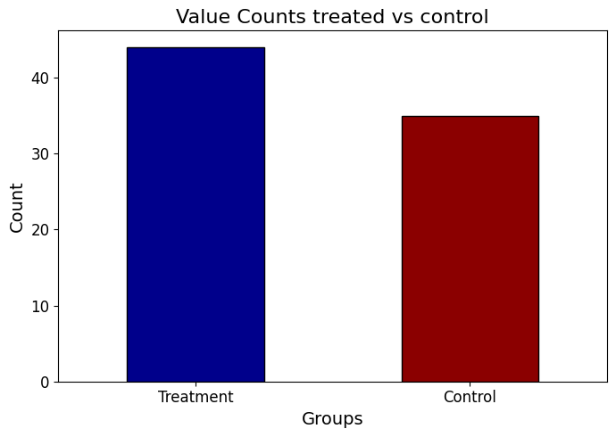

**Figure 2: Participant’s Location**

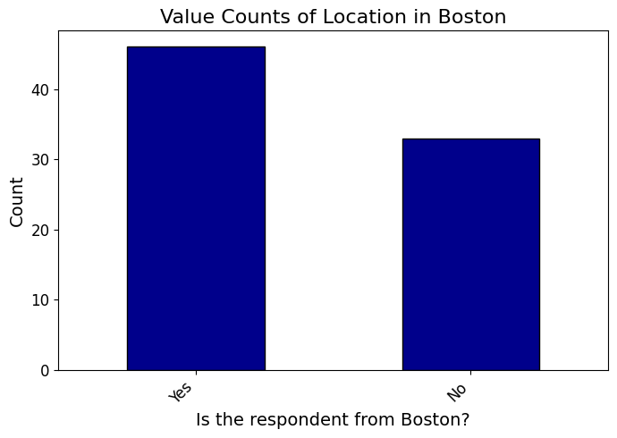

**Figure 3: Gender Distribution**

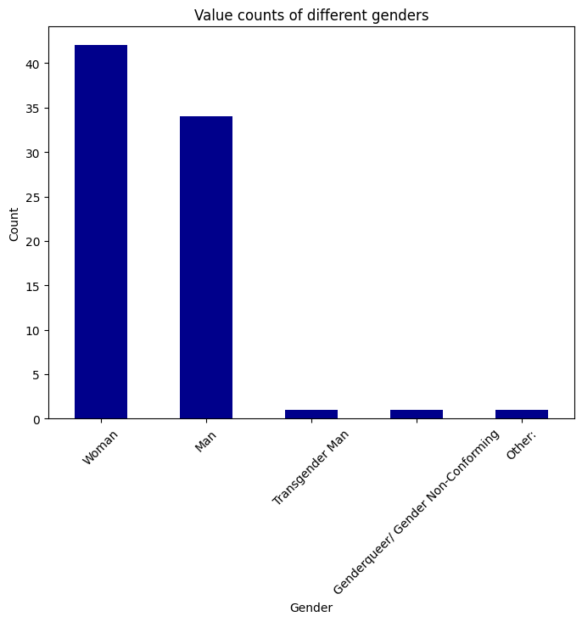

**Figure 4: Employment Status Distribution**

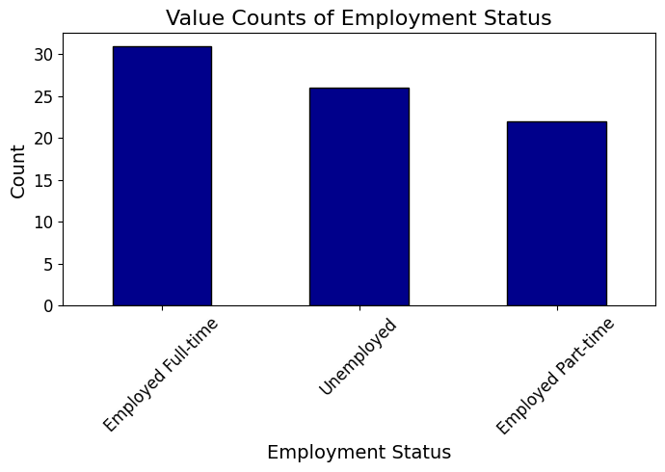

**Figure 5: Rent Budget**

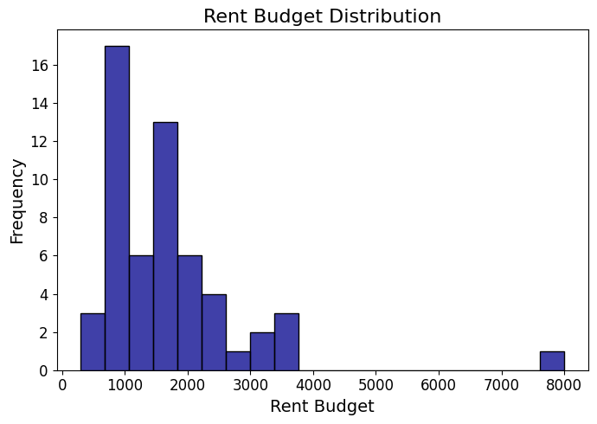

**Figure 6: Likelihood to Lease by Apartment Type**

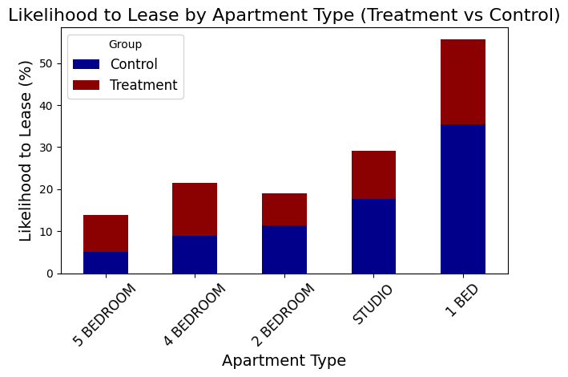

**Figure 7: Average Price Perception by Apartment Type**

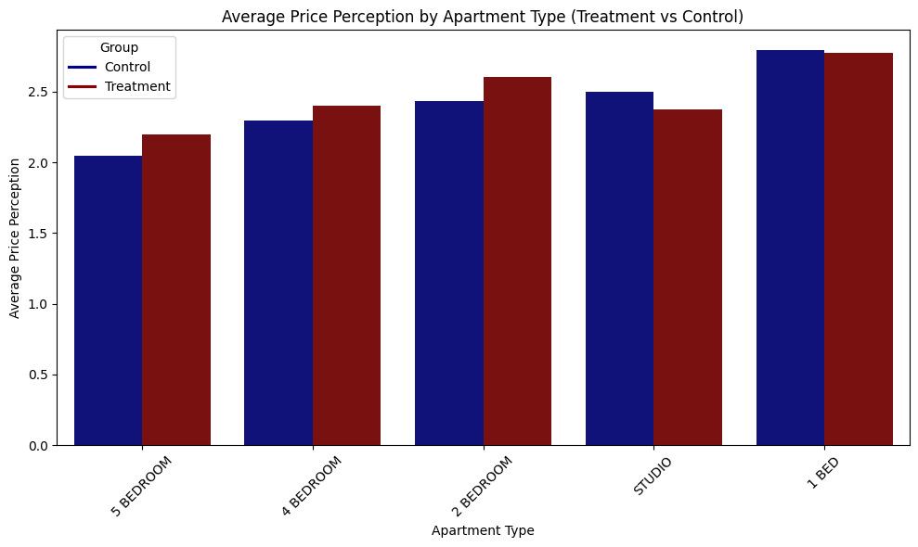

**Figure 8: Price Perception by Apartment Type**

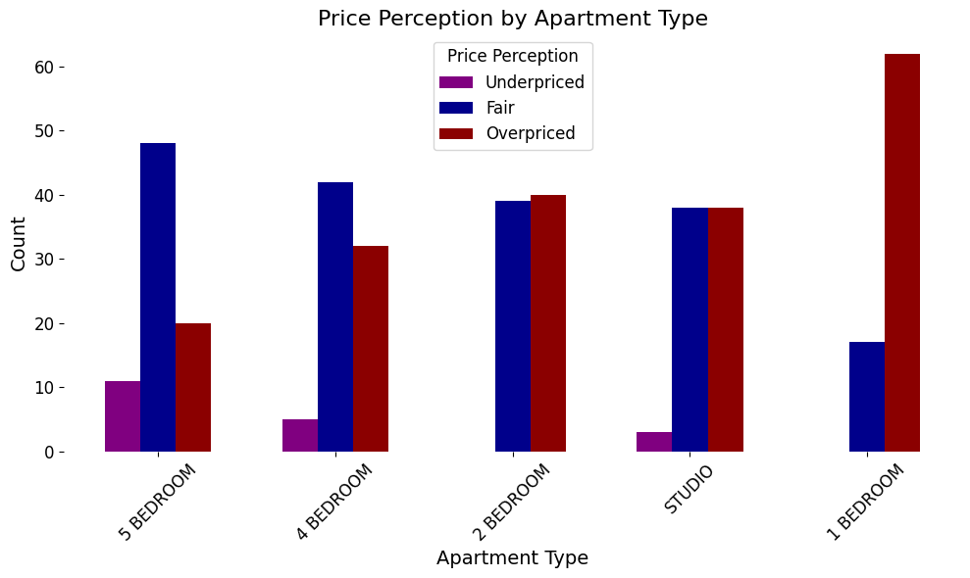

**Figure 9: Lease Likelihood by Apartment Type**

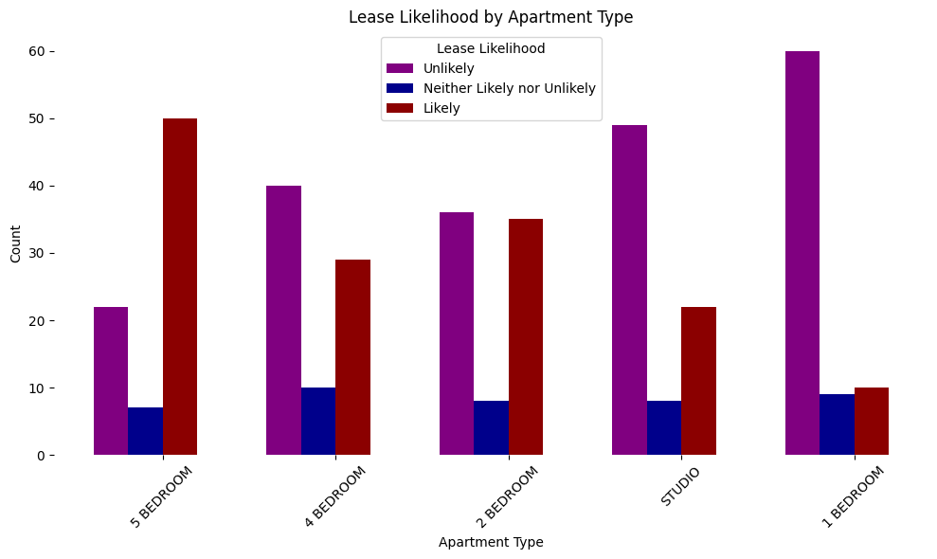

**Figure 10: Price Suggestion vs Age Regression**

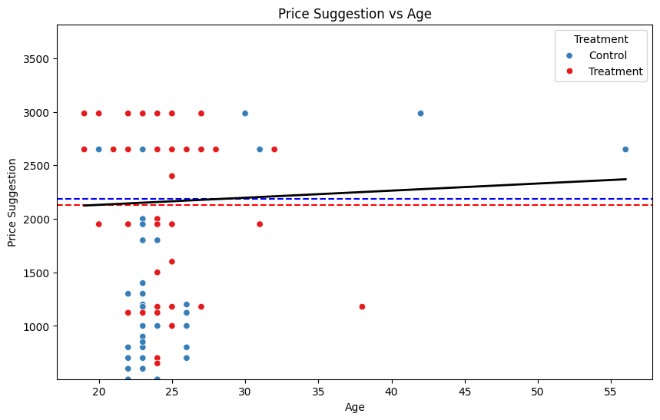

**Figure 11: Price Suggestion vs Rent Budget Regression**

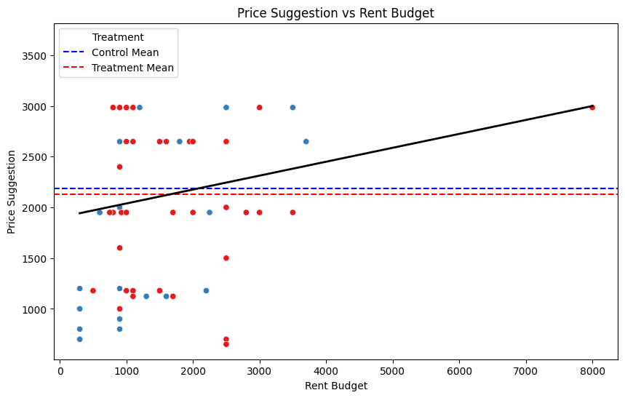

**Figure 12: Survey Screenshot**

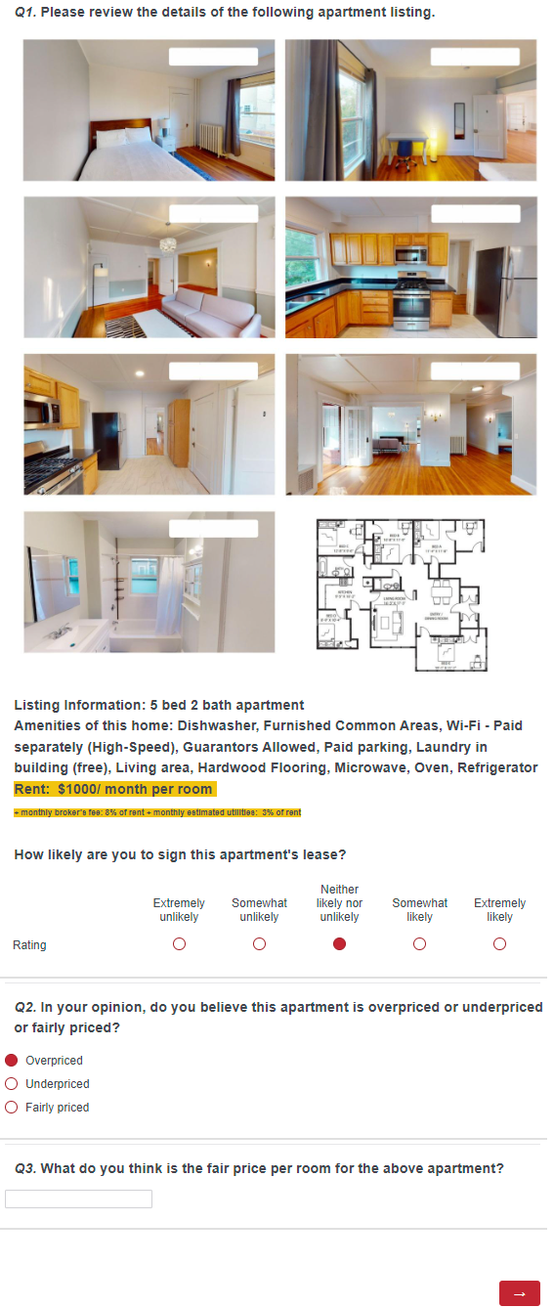

**Figure 13: Survey Screenshot**

