

Deep Learning Methods for Seizure Detection
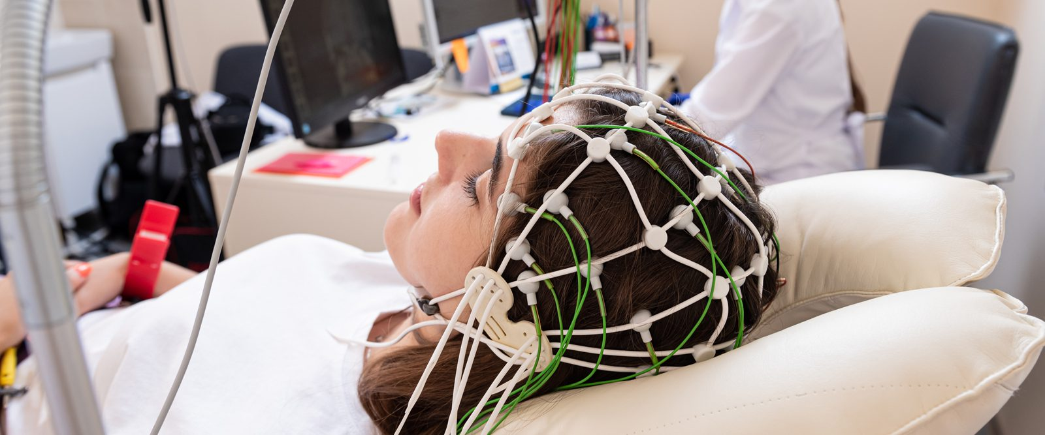

Submitted by:
Twyla Keating, 1770979
Zijian Li, 1781642
Enoch Shin, 1767565
Wenqi Zhang, 1785174

Deep Learning
26 March 2026

1. Introduction
According to the World Health Organization (WHO), epilepsy is a chronic brain disease that affects around 50 million people worldwide, with nearly 80% of people with epilepsy living in low- and middle-income countries [2]. Epilepsy is characterized by recurrent seizures, which are episodes of involuntary movement caused by excessive electrical discharge in brain cells.
This drives a multitude of comorbidities such as physical injuries (bruises, fractures, and the like), as well as psychological symptoms such as anxiety and depression. Moreover, the risk of premature death in epilepsy-afflicted people is up to three times higher than that of the general population, but the WHO estimates that up to 70% of people suffering from this condition could live seizure-free if properly diagnosed and treated [2].
Therefore, detecting and classifying seizure events in an automated and unsupervised fashion is an important and highly motivated task due to the potential for assisting millions of people in faster diagnosis and treatment.
In this report, we investigate the application of deep learning methods in the classification of epileptic seizures from normal brain activity using electroancephalographic (EEG) recordings. EEG is a non-invasive method for measuring neuronal electrical activity in the human brain cortex, defined by a set of N electrodes placed in various regions of the scalp. For each monitored patient, EEG recordings provide N temporal single-dimensional signals (i.e, one per channel). In the diagnostic process of epilepsy, a neurologist explores these EEG recordings visually to find patterns of spikes, sharp, and slow waves, that characterize an epileptic seizure.
Goals
The main goal of this challenge is to train and evaluate various deep learning models to distinguish between seizures and normal EEG brain activity. Broadly, we approach the task with two distinct philosophies: one,
2. Methodology
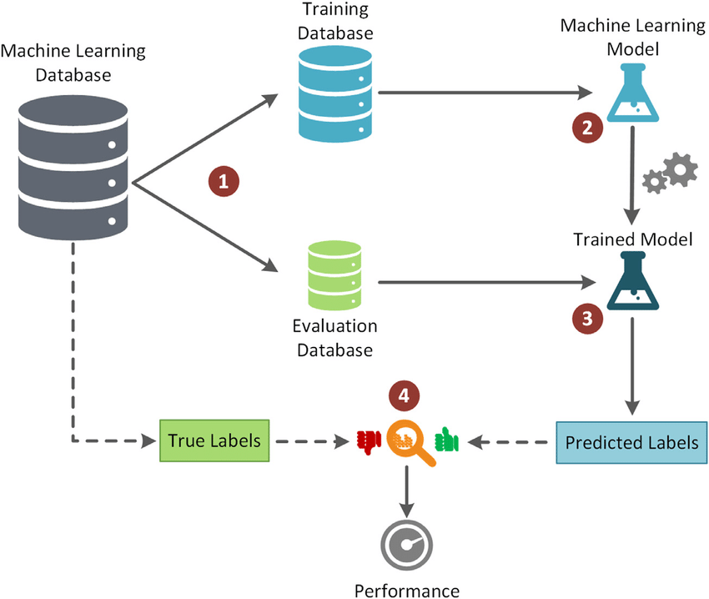
This section should include the detailed description of each stage of your methodologies you have used to solve the challenge. First, explain the general workflow relevant to your project. Include a descriptive figure of the method pipeline with a text describing the main steps of the pipeline. Afterward, describe your project's specific workflow and include another figure. All figures must be referenced in the text, for example, “Our workflow is illustrated in Figure 1.”
Figure 1. WorkFlow of the Methodology
2.1 Step1 (font size 14)
Describe the methods used in your project. For each method, include citations and explain the method's advantages.
Method1
Provide an explanation of Method 1 [2] and its advantages. Include a scheme with text explanations of the method main steps and workflow.
Method2
Provide an explanation of Method 2 [3] and its advantages. Include a scheme with text explanations of the method main steps and workflow.
…
2.2 Step2 (font size 14)
Describe the methods used in your project. For each method, include citations and explain the method's advantages.
Method1
Provide an explanation of Method 1 [2] and its advantages. Include a scheme with text explanations of the method main steps and workflow.
Method2
Provide an explanation of Method 2 [3] and its advantages. Include a scheme with text explanations of the method main steps and workflow.
…
3. Experimental Design (font size: 16)
Describe the dataset (including number of samples, and annotations), goals of the experiments, methods that are compared, hyperparameters of the methods and training configuration, partition in train and test, validation metrics and statistics used to assess performance.
3.1 Dataset Description. (font size 14)
MIT epilepsy DATA

The MIT epilepsy RAW data originally has 24 patients
* For each patient, a directory with a series of files with consecutive recordings, 23 channels and the initial and final time. For data protection reasons, date is not known
* The channels are not directly the sensors but the difference between two consecutive sensor measurements combined as specified in figure 3 from DataDescription.pdf

The data has been processed such that:
1. All patient data is contained in a single file in the raw directory
2. An excel file has been generated with the information of this data that is in the annot directory: df_annotation_full.xlsx

This file has the following columns for each .edf file:
1. type: indicates whether the .edf file contains an attack: normal, if there is no attack, seizure, if there is any
2. PatID: patient identifier
3. filename: .edf filename that identifies the recording
4.seizure_id: number that identifies the attack in the edf file, 0 if there is no attack, and the attack order in case there is more than one (e.g. if there are several consecutive attacks in the file it would be a 1 for the first a 2 for the second, etc.).
5. seizure_start: time (seconds) the attack begins in the .edf recording
6. seizure_end: : time (seconds) the attack ends in the .edf recording
7. rec_duration: duration of the .edf recording (seconds)
8. seizure_duration: duration (seconds) of each attack



Figure 2. This figure shows samples of the dataset

3.2 Experiments and Metrics (font size 14)
Explain each of the tests you have carried out to assess the method, including comparison to other approaches and/or the different approaches you have proposed. You might also include an ablation study [2] on the impact of the method main steps.
Explain the quality metrics used to evaluate the different methods, including their equations and definitions of each variable. The metrics described here must be consistently used in the tables and/or figures presented in the Results section. For each metric, explain the concept, include its equation, and describe each component.
Describe the training configuration and hyperparameters of each of the tested methods, as well as, the splitting into train/test. You might include a figure to better illustrate the partition if it includes several levels of generalization.
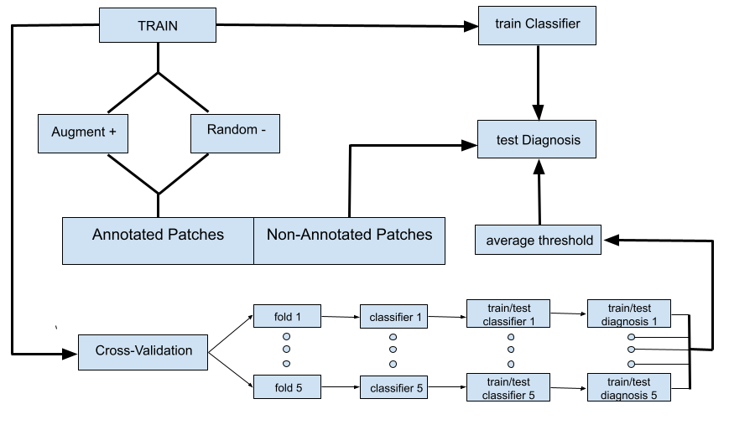
Figure 3. Data Split
Finally, describe the statistical tests and summarizing plots you have used to report and compare metrics across the different methods and/or configurations.
4. Results (font size: 16)
For each experiment, report the results obtained for the different methods. Report descriptive statistics of each metric considered in your experimental design. Report the p-values and CIs of the statistical tests used to detect significant differences across method’s performance. Support Tables with descriptive plots (e.g., Boxplots, histograms, ROC curves, …) for the comparison of the metrics. All Tables and plots must have a descriptive explanation.
4.1 Experiment 1 (font size 14)
Tables including metrics that were described previously. Report at least descriptive statistics in a Table, like the example of Table 1. Highlight in the text the main findings, best and worst performers, most stable metrics across folds.
Model | Metric1 | Metric2 | Metric3
model1 | 0.9 +/- 0.01 | 0.9 +/- 0.01 | 0.9 +/- 0.01
model2 | 0.9 +/- 0.01 | 0.9 +/- 0.01 | 0.9 +/- 0.01
Table 1. Descriptive Statistics of Experiment1

You might also include confusion matrices for the different models (see Figure 4).
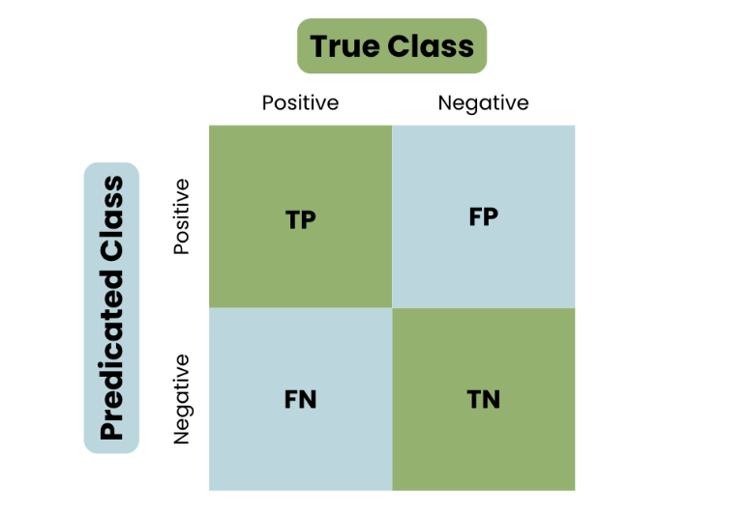 | 
(a) | (b)
Figure 4. Confusion matrices of Method1, (a), and Method2, (b).
4.3 Experiment 2 (font size 14)
Include descriptive graphics of metrics for visual comparison like the boxplots shown in Figure 5.
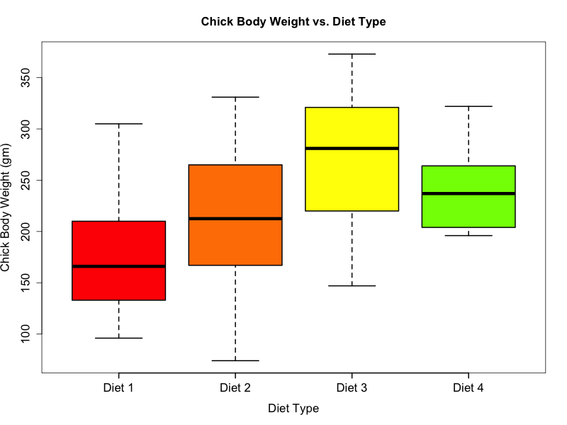
Figure 5. Boxplots
Report the p-values and CIs of the statistical tests used to detect significant differences across method’s performance. You can use a Table, with its corresponding explanations, to report them. Take into account that statistical tests detect what methods are significantly performing worse than others and, thus, should be consistent with descriptive statistics.

5. Discussion and Conclusions
Analyse and interpret the results and their implications, addressing any noteworthy findings. Summarize the project's outcomes and suggest possible areas for improvement.

6. References (font size: 16, maximum 1 page)
(List all sources cited throughout the report using appropriate citation style.)
[1] Fishman, Levi. “What to Expect in an Epilepsy Monitoring Unit.” NewYork-Presbyterian, 10 Nov. 2023, https://healthmatters.nyp.org/what-to-expect-in-an-epilepsy-monitoring-unit/.
[2] Epilepsy. https://www.who.int/news-room/fact-sheets/detail/epilepsy. Accessed 12 Mar. 2026.

