Project description:

**Patient Health Monitoring System using ESP8266 & Arduino:**

With tons of new healthcare technology start-ups, IoT is rapidly revolutionizing the healthcare industry. In this project, we have designed the **IoT Based Patient Health Monitoring System using ESP8266 & Arduino**. The IoT platform used in this project is ThingSpeak. ThingSpeak is an open-source Internet of Things (IoT) application and API to store and retrieve data from things using the HTTP protocol over the Internet or via a Local Area Network. This IoT device could read the pulse rate and measure the surrounding temperature. It continuously monitors the pulse rate and surrounding temperature and updates them to an IoT platform.

The Arduino Sketch running over the device implements the various functionalities of the project like reading sensor data, converting them into strings, passing them to the IoT platform, and displaying measured pulse rate and temperature on character LCD.

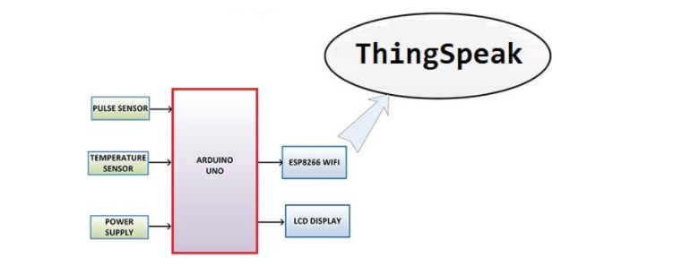

This is a simple block diagram that explains the **IoT Based Patient Health Monitoring System using ESP8266 & Arduino**. Pulse Sensor and LM35 Temperature Sensors measure BPM & Environmental Temperature respectively. The Arduino processes the code and displays it to 16*2 LCD Display. **ESP8266 Wi-Fi module** connects to Wi-Fi and sends the data to IoT device server. The IoT server used here is Thingspeak. Finally, the data can be monitored from any part of the world by logging into the Thingspeak channel.

List of components

|  |  |  |  |
| --- | --- | --- | --- |
| 1 | Arduino Board | Arduino UNO/Nano or any other Board | 1 |
| 2 | ESP8266-01 | ESP8266-01 Wifi Module | 1 |
| 3 | LCD Display | JHD162A 16X2 LCD Display | 1 |
| 4 | Potentiometer | 10K | 1 |
| 5 | Pulse Sensor | Pulse Sensor from pulsesensor.com | 1 |
| 6 | Temperature Sensor | LM35 Analog Temperature Sensor | 1 |
| 7 | Resistor | 2K | 1 |
| 8 | Resistor | 1K | 1 |
| 8 | LED | 5mm LED any Color | 1 |
| 9 | Connecting Wires | Jumper Wires | 10-20 |
| 10 | Breadboard | - | 1 |

1.pulse sensor

The **Pulse Sensor** is a plug-and-play **heart-rate sensor for Arduino**. It can be used by students, artists, athletes, makers, and game & mobile developers who want to easily incorporate live heart-rate data into their projects. The essence is an integrated optical amplifying circuit and noise eliminating circuit sensor. Clip the **Pulse Sensor** to your earlobe or fingertip and plug it into your Arduino, you can ready to read heart rate. Also, it has an Arduino demo code that makes it easy to use.

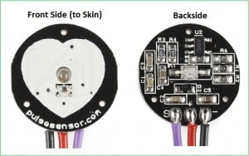

3.LM35 TEMPERATURE SENSOR

The **LM35** series are precision integrated-circuit temperature devices with an output voltage linearly-proportional to the Centigrade temperature. The LM35 device has an advantage over linear temperature sensors calibrated in Kelvin, as the user is not required to subtract a large constant voltage from the output to obtain convenient Centigrade scaling. The LM35 device does not require any external calibration or trimming to provide typical accuracies of ±¼°C at room temperature and ±¾°C over a full −55°C to 150°C temperature range.

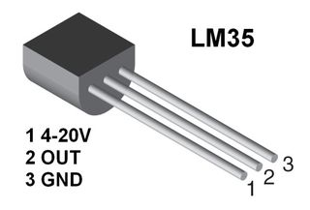

3.ESP8266

The **ESP8266** is a very user-friendly and low-cost device to provide internet connectivity to your projects. The module can work both as an Access point (can create hotspot) and as a station (can connect to Wi-Fi), hence it can easily fetch data and upload it to the internet making the Internet of Things as easy as possible. It can also fetch data from the internet using API’s hence your project could access any information that is available on the internet, thus making it smarter. Another exciting feature of this module is that it can be programmed using the Arduino IDE which makes it a lot more user-friendly.

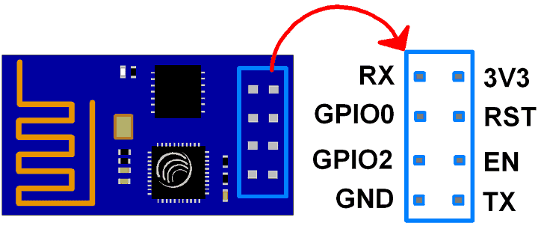

CIRCUIT DIAGRAM AND CONNECTIONS

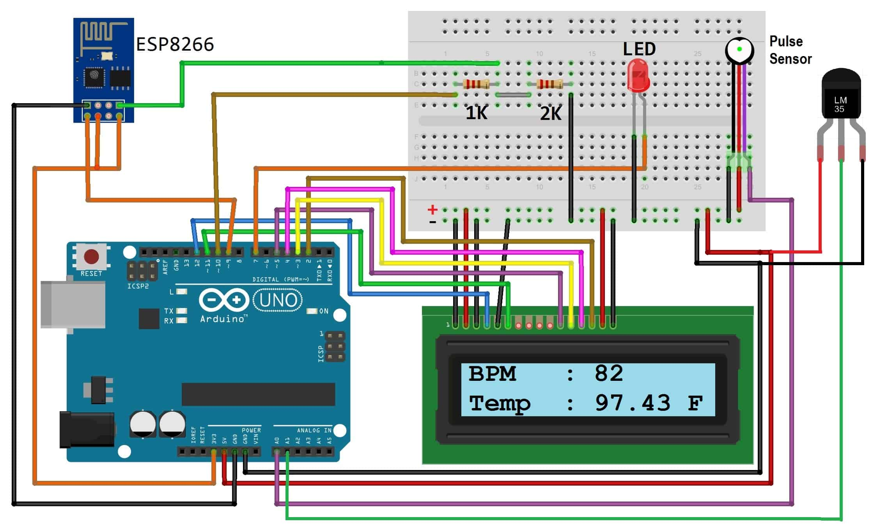

PLX-DAQ

Parallax Data Acquisition tool (PLX-DAQ) software add-in for Microsoft Excel acquires up to 26 channels of data from any Parallax microcontrollers and drops the numbers into columns as they arrive. PLX-DAQ provides easy spreadsheet analysis of data collected in the field, laboratory analysis of sensors and real-time equipment monitoring.

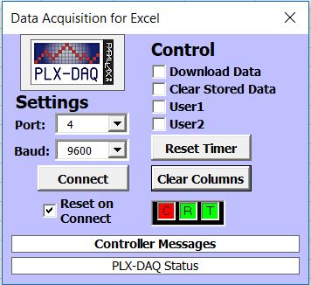

BY:

VRUSHIKA SHAH

SYED FURQAN IQBAL

PALAK THAKKAR