Atlantic Container Line faces $34m annual USTR bill -Unpredictable!!
Shipping that operates con-ro vessel hit with nasty surprise on first day the new US port fees came into effect
Ganesh Vishwanathan
October 27, 2025
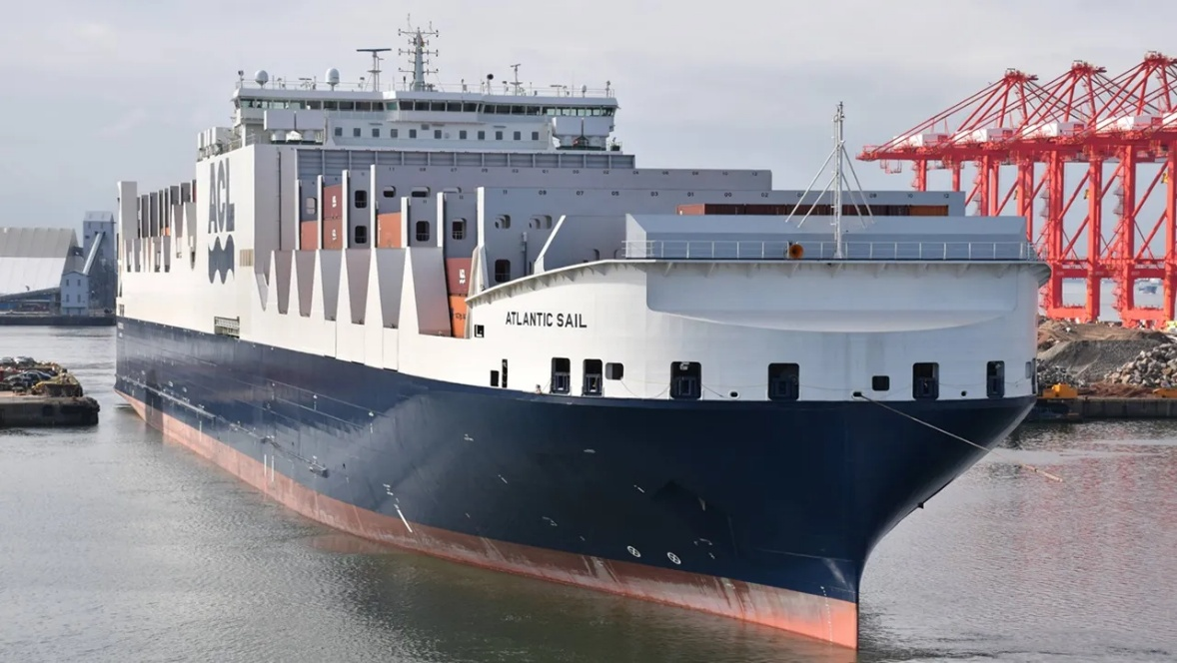
Atlantic Container Line’s (ACL) CON-RO vessels are being treated as vehicle carriers under the new USTR Section 301 charges for Chinese built vessels.
The company had expected to avoid charges as its vessels as they are less than 4,000 teu in capacity which is the threshold for exemption from the USTR charges that came into force on 14 October.
However, the 3,800 teu vessels which also have 28,900 sq metres of high and heavy ro-ro decks which has resulted in the ships being classified as vehicle carriers by US Customs & Borders Patrol for the purposes of the fees, even though this only accounts for 20% of total cargo.
The result is CNBC reported ACL paid a $1.4 million fee for one of its ships that called in the US on the first day the fees came into force on 14 October.
The company operates five vessels on a weekly service across the Atlantic each of which would be liable for the port fees a maximum of five times a year when calling US ports.
"That's 25 vessels being charged $1.4 million a year," Andrew Abbott, CEO of ACL, told CNBC. "We are looking at a tariff total of $34 million a year."
"The vessel should be classified by the majority of freight we move. That's containers. We have always been considered a container vessel. This time around, Customs and Border Protection changed it to RO-RO container."
Abbot warned that the fees could force it long term to exit the trade and US customers currently moving plant and heavy lift onboard its vessels could be forced to charter entire ships instead of buying space with ACL.
Abbot described its customers as incredulous that it is being charged the USTR fees. "They never thought in 1,000 years that we would be affected. And we're trying to tell people now, and the magnitude of what is at stake is putting people in shock. At this point, the importers are dealing with tariffs, and this is now something on top of that, and possibly could shut them down,” he said.
Source
Sea-Trade Maritime News

