PL/ SQL EXERCISES

Assumptions
Since the database schema was not provided in the assignment, the following tables were created to implement and test the PL/SQL solutions.
Customers Table
CREATE TABLE Customers (
CustomerID NUMBER,
Name VARCHAR2(20),
Age NUMBER,
Balance NUMBER,
IsVIP VARCHAR2(5)
);
Loans Table
CREATE TABLE Loans (
LoanID NUMBER,
CustomerID NUMBER,
InterestRate NUMBER,
DueDate DATE
);
Sample Data:
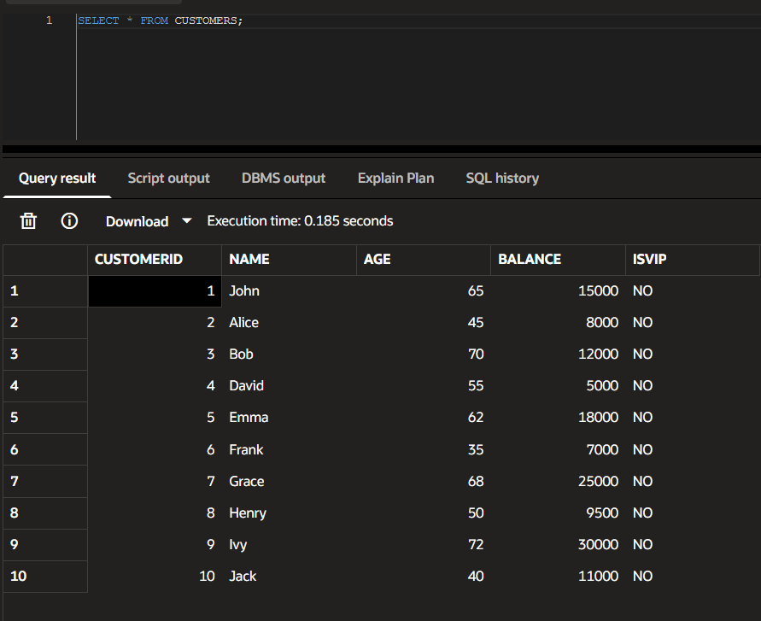
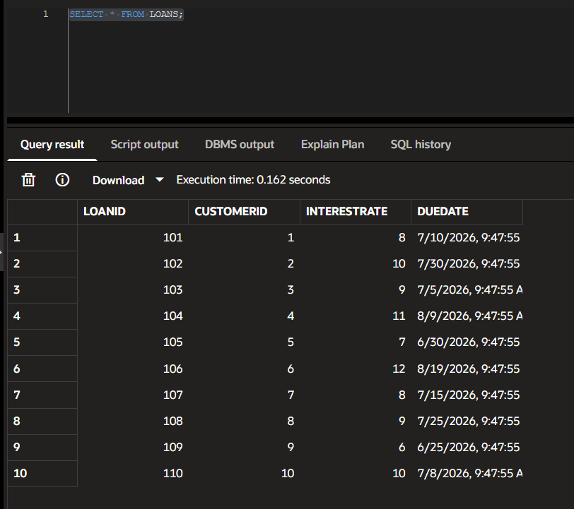

Exercise 1: Control Structures
Scenario 1: The bank wants to apply a discount to loan interest rates for customers above 60 years old.
- Question: Write a PL/SQL block that loops through all customers, checks their age, and if they are above 60, apply a 1% discount to their current loan interest rates.

PL/SQL Code:
BEGIN
FOR c IN (
SELECT CustomerID, Age
FROM Customers
)
LOOP
IF c.Age > 60 THEN
UPDATE Loans
SET InterestRate = InterestRate - 1
WHERE CustomerID = c.CustomerID;
END IF;
END LOOP;

COMMIT;
END;
/

OUTPUT VERIFICATION:
SELECT * FROM Loans;
OUTPUT:

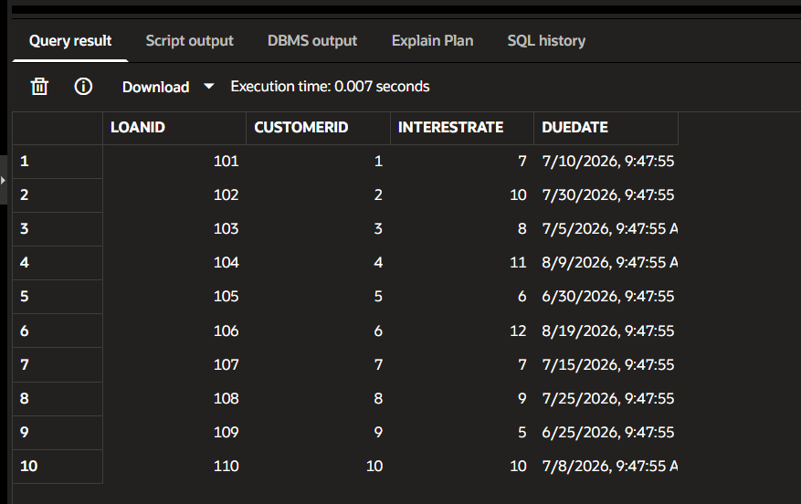

Scenario 2: A customer can be promoted to VIP status based on their balance.
- Question: Write a PL/SQL block that iterates through all customers and sets a flag IsVIP to TRUE for those with a balance over $10,000.

PL/SQL CODE:

BEGIN
FOR c IN (
SELECT CustomerID, Balance
FROM Customers
)
LOOP
IF c.Balance > 10000 THEN
UPDATE Customers
SET IsVIP = 'YES'
WHERE CustomerID = c.CustomerID;
END IF;
END LOOP;

COMMIT;
END;
/

OUTPUT VERIFICATION:
SELECT * FROM CUSTOMERS;

OUTPUT:
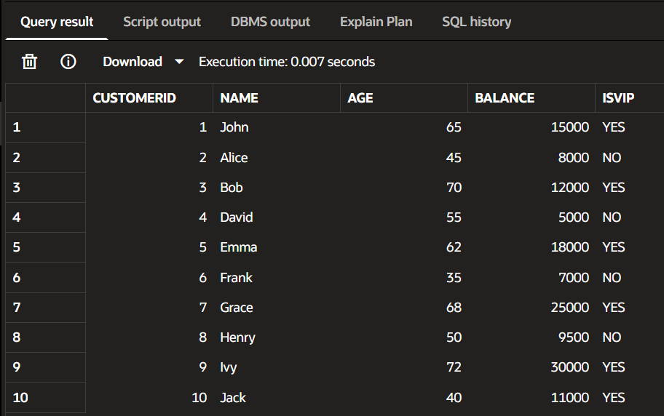

Scenario 3: The bank wants to send reminders to customers whose loans are due within the next 30 days.
- Question: Write a PL/SQL block that fetches all loans due in the next 30 days and prints a reminder message for each customer.

PL/SQL CODE:

BEGIN
FOR l IN (
SELECT CustomerID, DueDate
FROM Loans
WHERE DueDate <= SYSDATE + 30
)
LOOP
DBMS_OUTPUT.PUT_LINE(
'Reminder for Customer '
|| l.CustomerID
|| ' Loan Due On '
|| l.DueDate
);
END LOOP;
END;
/

OUTPUT:
