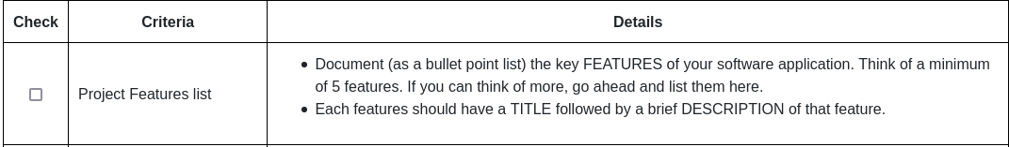

## Project Feature List:

**Feature 1: Home Feed**

Description: The users will be shown a list of locations based on their previous choices along with recommended users that they have rated highly or have went to places that they rate highly.

**Feature 2:**

Description:

**Feature 3:**

Description:

**Feature 4:**

Description:

**Feature 5:**

Description:

## Project Plan:

