
WORLD FOOD DAY 2026
Photo frame and placard: guide for comms leads and HR focal points
Innovate today. Nourish tomorrow. | 16 October 2026 | #WorldFoodDay
Thank you for coordinating World Food Day in your office. This guide explains how to print the photo frame and placard, set them up with the QR code, and get colleagues' photos back to us. Colleagues can either hold the photo frame around them or, if the frame can't be printed, hold the placard. Both carry the FAO theme for 2026, "Innovate today. Nourish tomorrow.", and the GAIN brand.
Your role | What you do
Comms lead | Print the materials, set them up with the QR code, take or coordinate the photos, and post on 16 October.
HR focal point | Gather colleagues for the photo, make sure everyone pictured agrees to be photographed and shared, and remind them to upload by 14 October.

WHERE TO FIND THE FILES
Print files: GAIN WFD 2026 print files (Google Drive)
Photo submissions: GAIN WFD 2026 photo submissions (Google Drive)
File | What it is | Print size
GAIN_WFD2026_Photo_Frame_A2_CMYK.pdf | Photo frame with a cut-out window | A2, 59.4 × 42 cm (print shop)
GAIN_WFD2026_Placard_Red_A2_CMYK.pdf | Placard, GAIN red background | A2, 59.4 × 42 cm (print shop)
GAIN_WFD2026_Placard_White_A2_CMYK.pdf | Placard, white background (uses less ink) | A2, 59.4 × 42 cm (print shop)
GAIN_WFD2026_QR_Stickers_A4.pdf | 20 small QR stickers (4.2 × 4.8 cm), one per frame or placard | A4 (office printer)
This guide | How to print, set up, photograph and share | A4

WHICH ONE SHOULD WE USE?
 | Photo frame | Placard
Best for | Fun, eye-catching photos of 1 to 2 people | Offices that cannot print or cut the frame
How it works | Cut out the window and hold the frame around your face and shoulders | Write your country name in the white box and hold it at chest height
Window / writing space | About 47.5 × 25.5 cm window | About 47.5 × 11 cm writing box
Effort | Print shop plus a few minutes of cutting | Print and write; no cutting

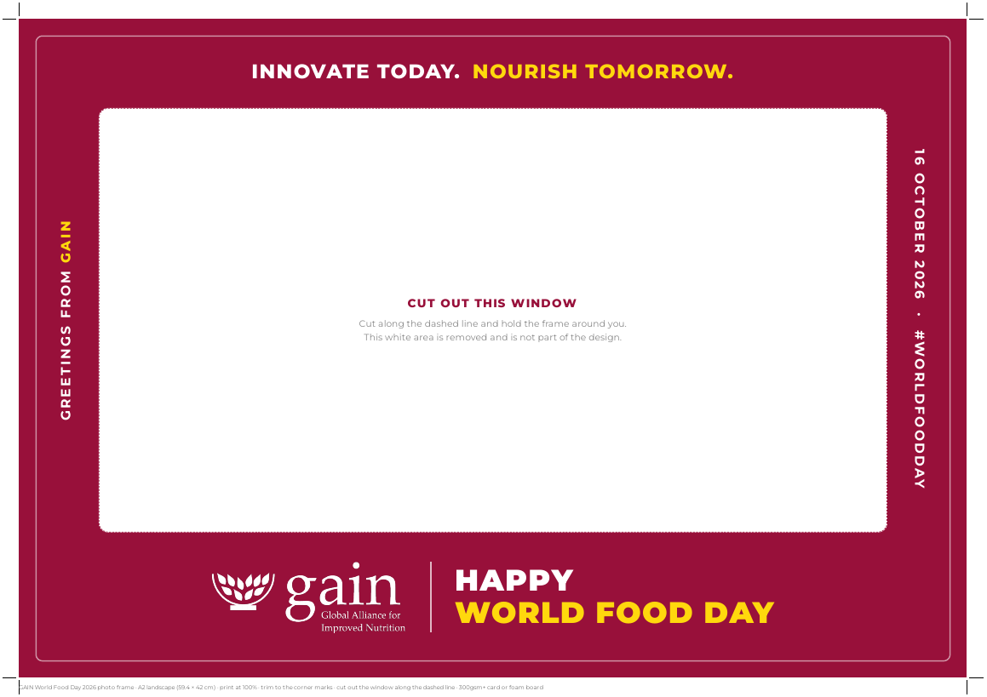
Photo frame (A2)
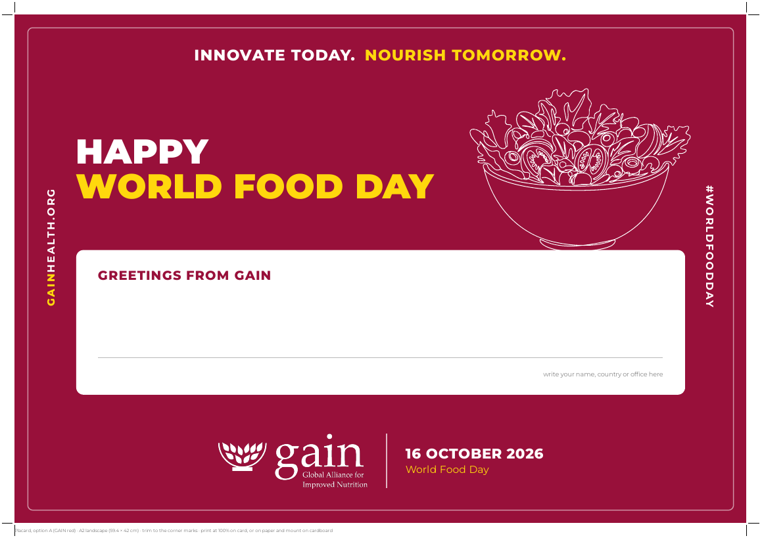  Placard, red (A2) | 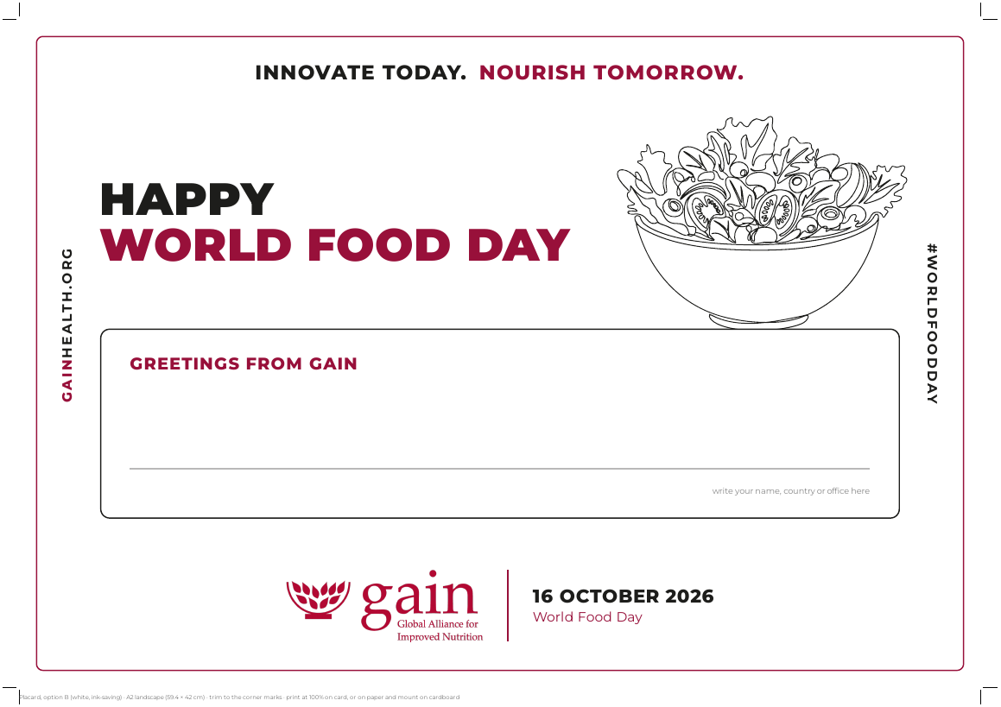  Placard, white (A2)

PRINTING
The A2 files are print-ready: CMYK colour, GAIN brand colours, embedded fonts and corner trim marks. Send them to a local print shop as they are. Print the QR sheets on any office printer.
- Size: A2 landscape (59.4 × 42 cm). Print at 100% scale; do not use "fit to page".
- Paper for the frame: 300 to 350 gsm card, or foam board (3 to 5 mm) so it stays rigid when held. A matt finish avoids glare from camera flash.
- Paper for the placard: 250 gsm card or more, or print on paper and glue it onto cardboard.
- Which placard: the red version gives the strongest look; the white version is cheaper to print.
- Trimming: cut along the corner trim marks. The artwork already has a white margin, so no bleed is needed.
Quick brief for the printer: "A2, CMYK, print at 100%, no bleed, trim to the crop marks, on 300 gsm matt card or 5 mm foam board."

CUTTING THE PHOTO FRAME WINDOW
- Lay the frame on a cutting mat or thick cardboard.
- Using a sharp craft knife and a metal ruler, cut along the dashed line around the white window.
- Cut the four rounded corners slowly by hand, following the line.
- Remove the white panel. Nothing printed on it is part of the design.
Safety: An adult should do the cutting, away from other people, and keep the blade covered when not in use.

ADDING THE QR CODE TO THE BACK
A small QR code sticker goes on the back, so it never appears in photos. As soon as a photo is taken, the person holding the frame or placard turns it over, scans the sticker with their phone camera and uploads the photo straight to our Google Drive folder.
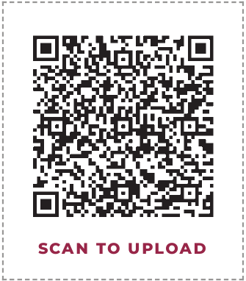
QR sticker (actual size 4.2 × 4.8 cm)
- Print the QR sticker sheet on an office printer at 100% and cut out one sticker per frame or placard.
- Photo frame: stick it on the back of the bottom border, near a corner, where hands hold the frame. It fits inside the border without covering the window.
- Placard: stick it on the back, in the top-right corner (as seen from the back), right where the holder's hand is when they turn the placard over.
- Test it: before the photo session, scan the code with a phone to check it opens the submissions folder.
- Can't scan? the submissions folder link is in this guide and printed at the bottom of the sticker sheet.

FILLING IN THE PLACARD
- Write your country name only, in capital letters, for example "NIGERIA" or "KENYA". Please don't add individual names.
- Use a thick black marker (bullet or chisel tip) so it shows clearly in photos.
- Keep it to the country name so the writing can be large and every placard looks consistent. Do not add other logos or slogans.

TAKING A GREAT PHOTO
- Orientation: shoot in landscape so the whole frame or placard is in the picture.
- Light: face a window or daylight; avoid strong light behind people.
- Position: hold the frame at face height with face and shoulders fully inside the window. Hold the placard at chest height, below the chin.
- Distance: the photographer stands about 1.5 to 2 metres away, at eye level.
- Background: a tidy office, a GAIN banner, a market or a field works well. Avoid clutter.
- Groups: up to two people inside the frame; for larger groups, one person holds the frame and others stand around it, or use several placards.
- Check: make sure the GAIN logo and the theme line are visible and not covered by hands.

SHARING YOUR PHOTOS
When | What to do
By 14 October | Scan the QR code on the back (or open the submissions folder link) and upload your best 2 to 3 photos. Name each file with your country, for example KENYA_1.jpg. Global comms will create a collage for 16 October.
On 16 October | Post on your own and office channels with #WorldFoodDay and tag GAIN and FAO.
17 to 23 October | Reshare GAIN's World Food Day posts and add your local story.

Submissions folder: GAIN WFD 2026 photo submissions
Suggested caption:
"Happy World Food Day from GAIN [country]! This year's theme is Innovate today. Nourish tomorrow. Here's to the ideas and people making nutritious, safe food available to everyone. #WorldFoodDay"
Consent: only upload and share photos of people who have agreed to be photographed and posted. Ask parents or guardians before including children.

BRAND DO'S AND DON'TS
- Do print the files as supplied, at 100% scale.
- Do keep the logo, theme line and date visible and uncovered.
- Don't edit, stretch, recolour or crop the designs, or add other logos.
- Don't print the frame smaller than A2: the window becomes too small for a face.

QUESTIONS
Contact the global communications team: [name, email]. If you need the files in another size or language, ask before printing.

