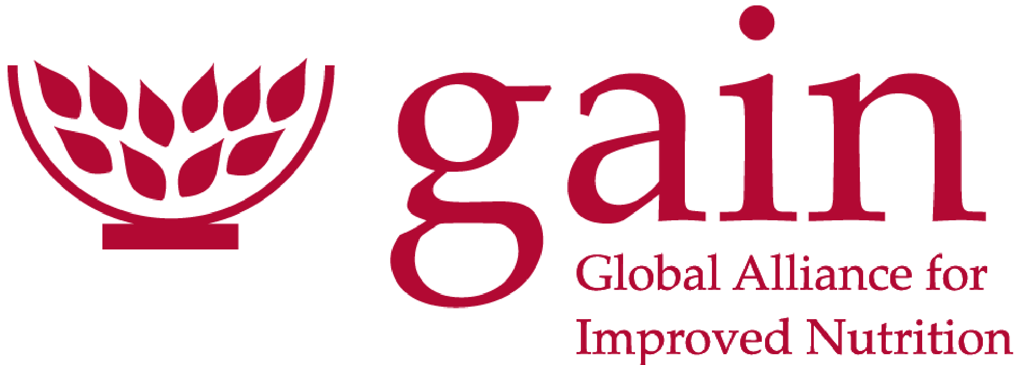

GAIN World Food Day 2026 – Campaign Concept Note
Sep 29, 2026

Background
World Food Day falls on 16 October 2026, and FAO's theme is "Innovate today. Nourish tomorrow." That theme maps directly onto GAIN's work, so our campaign can ride FAO's global moment rather than compete with it.
FAO's core message: forward-thinking solutions, combined with traditional knowledge and inclusive approaches, can ensure everyone has access to sufficient, diverse, safe and nutritious foods while safeguarding the planet (FAO World Food Day).
FAO assets and moments we can plug into:
- #WorldFoodDay as the anchor hashtag
- #FoodHeroes, FAO's celebration of people taking food action in their communities
- Events in nearly 150 countries, which our country offices can join
- The FAO poster contest for ages 5–19 (closes 6 November 2026) and FAO MuNe, its food and agriculture museum

Campaign concept and objectives
Working concept: "Innovation that nourishes". GAIN shows how evidence, data and business innovation already put more nutritious, safe food on people's plates. We echo FAO's line and answer it with proof: Innovate today (the tools), Nourish tomorrow (the people and diets they reach).
Guiding principle: quality over quantity. Eight items, each told well, beat a long catalogue.
Objectives:
- Position GAIN as a practical innovator in food systems and nutrition during the World Food Day moment.
- Showcase a small set of GAIN tools and programmes with a clear "what it is, who it helps, what changed" story for each.
- Drive audiences to one GAIN campaign web page that links to FAO's World Food Day assets.
- Give country offices and partners ready-to-use content they can share on and after 16 October.
Audiences: governments and policymakers, donors and investors, food businesses and MSMEs, nutrition researchers, and the wider public through social media.

Items to showcase
Recommended shortlist: eight items that each tell a different part of the "from evidence to plate" story. DQQ and N3F are suggested additions; GAIN's AI strategy closes the list with a look at what comes next.
Innovation | What it is | Story angle for World Food Day | Spokesperson
Priority Micronutrient Density list | 2022 global analysis ranking foods by the bioavailable micronutrients most lacking in low- and middle-income countries. Top foods: organ meats, small fish, dark leafy greens, shellfish, ruminant meat, eggs, milk and canned fish with bones (GAIN blog). | Evidence innovation: "Which foods pack the most nutrition per bite?" Myth-busting and visual food rankings. | Ty Beal
NourishNext West Africa 2026: Youth Agrifood Innovation Challenge (Nutrition Connect) | One of Nutrition Connect's series of country innovation challenges. Led by GAIN with the SUN Movement, supported by SDC and ECOWAS, in Benin, Côte d'Ivoire, Nigeria and Senegal. Youth-led enterprises in fruit and vegetable value chains compete for $5,000 seed funding, mentorship and a regional showcase in Dakar. | Youth innovation: young entrepreneurs turning local fruit and vegetables into nutritious products and markets. Applications close around World Food Day (Benin and Senegal 30 September, Côte d'Ivoire 11 October), so the campaign can spotlight finalists or past challenge winners. | Nutrition Connect team, plus a challenge participant
DFQT+ (Digital Fortification Quality Traceability Plus) | Digital system giving real-time, traceable data on fortification quality from premix to factory to market. Piloted and scaled 2022–2025 in Bangladesh, India and Nigeria with partners incl. BASF, BioAnalyt, DSM, NAFDAC and FSSAI. | Tech innovation: "Is the fortified flour or oil you buy really fortified?" Dashboards that let regulators and producers catch gaps fast. | Fortification team
Global Diet Quality Project / DQQ | GAIN, Gallup and Harvard's Diet Quality Questionnaire, adapted for use in 140 countries, to measure what the world eats. | Data innovation: you can't fix diets you don't measure. Pairs well with Ty Beal's work. | Data and evidence team
Food Systems Dashboard | One platform bringing together about 40 data sources and 300+ indicators on nutrition, health, environment and livelihoods, built with Columbia University. Six subnational dashboards cover Bangladesh, Indonesia, Kenya, Mozambique, Nigeria and Pakistan (about 1 billion people); climate projections and AI-powered search are planned. | Data innovation: "a map of your food system from farm to fork" showing where things are going well and where they need attention. Clip from Bite the Talk EP 26. | Ty Beal
Nutritious Foods Financing Facility (N3F) | Blended finance plus technical assistance for agrifood SMEs. In 2025: 10 investees in 6 African countries, 1.1 billion nutritious food servings, about 7 million consumers reached. | Finance innovation: making nutrition investable. Links neatly to the MSME Week stories. | N3F team
Nutrition Futures Initiative | GAIN's co-innovation approach to making social protection programmes more nutritious, bringing governments, innovators and communities together. Includes the Innovators Team, a digital platform built with Proportion Global that guides partners through human-centred design. Active in Uganda and Malawi. | Co-innovation: solutions designed with the people they serve. Uganda example: the process showed small millers (under 20 tons a day) don't have to fortify flour, yet they are the biggest sellers in the informal market. Clip from Bite the Talk EP 30. | Dr Anthony Wenndt
GAIN's AI strategy | GAIN's 2025 strategy for using AI across its programmes, by Mduduzi Mbuya and Ty Beal. Three areas: design (better targeting of programmes and populations), delivery (better data and efficiency, including checking fortification compliance) and scale (faster expansion of what works, including localising content). | Future innovation: the "Nourish tomorrow" half of FAO's theme. How AI will help GAIN target, deliver and scale nutrition programmes; links to DFQT+ on fortification. A closing beat for the flagship video and the web page. | Mduduzi Mbuya and Ty Beal
Other GAIN work we could draw on if a slot opens: the SUN Business Network, workforce nutrition, and the Uganda FreshValue Innovation Challenge on food loss.

Content plan
One flagship video anchors the campaign; everything else is cut from it or repurposed from existing material.
1. Flagship video (60–90 seconds)
- Arc: the problem (diets lacking key nutrients) → the innovations (AI, evidence, data, digital traceability, finance, entrepreneurs) → the result (more nutritious, safe food reaching people).
- Voices: GAINer/VO on the evidence; one MSME founder from the MSME Week stories; a closing line tying back to "Innovate today. Nourish tomorrow."
- Cut-downs: a 30-second teaser, 15-second social clips and one short clip per innovation.
2. Repurposed MSME Week content
GAIN's World MSME Day 2026 (22–27 June) ran on the theme "Innovation: The Future of Nutrition Businesses" (GAIN). Strongest stories to reuse:
- Kennie O. Cold Chain Logistics (Nigeria): temperature-stabilising cold chain
- Whey2Value (Pakistan): cheese by-products turned into nutritious drinks
- Nutribaik (Mozambique): bicycle-based last-mile food safety
- Himalayan Foods (Pakistan): cutting fruit loss in supply chains
Re-cut two or three of these as "innovator" profiles rather than reusing all six.
3. Expert inputs: Ty Beal and Stella
- Ty Beal: a short interview or explainer on priority micronutrient-dense foods; a quote card; possibly a LinkedIn post or op-ed under his name. (We have)
- Stella: a short interview on data
- DFQT+ spokesperson
4. Supporting assets
- One social card per innovation (what it is, one number, one link)
- A short blog or LinkedIn article from GAIN leadership on the theme
5. Repurposed podcast content (Bite the Talk)
Three episodes of GAIN's Bite the Talk podcast fit the innovation theme. Cut 30–60 second audiograms or quote cards from each rather than promoting full episodes.
Episode | Guests | Innovation angle | Clip to pull
EP 26: Global Food Systems Dashboard | Jessica Fanzo (Columbia University) and Ty Beal; host Mark Gachagua | Data innovation: about 40 data sources and 300+ indicators in one platform, six subnational dashboards covering about 1 billion people, and AI-powered search planned. Links to Ty Beal's work and the AI strategy. | "A map of your food system from farm to fork"
EP 30: Nutrition Futures Initiative | Dr Anthony Wenndt (Lead, Social Protection, GAIN); Thomas Schuumanns (Founder and Director, Proportion Global); Commissioner Patrick Mugisha (Uganda Ministry of Trade, Industry and Cooperatives); host Mark Gachagua | Co-innovation: governments, innovators and communities designing solutions together to make social protection more nutritious. Features the Innovators Team, a digital platform built with Proportion Global that guides partners through human-centred design, and a Scaling Innovation Canvas. Uganda example: the approach exposed that millers producing under 20 tons a day don't have to fortify flour, yet they are the biggest sellers in the informal market. | "Co-innovation requires putting your 'expert mindset' aside and looking at a challenge with open eyes." "Partnership is the driver." "There is no risk in just listening."
EP 33: Start Where You Are | Aida Eyasu, Act4Food youth leader, Ethiopia; hosts Mark Gachagua and Stephanie Sargeant | Youth-led local solutions: vegetable gardens in displacement camps, a 40-member volunteer group and school meal fundraising. Pairs with the NourishNext youth challenge. | "Start where you are now… just start with what you have" and "Food is much more about dignity than it is about supply and demand"

Channels
All content points to one GAIN World Food Day web page, built by Gloria Ireri.
- Campaign web page (Gloria Ireri): flagship video at the top, one card per innovation linking to its full page, the Ty Beal and Stella pieces, and a link to FAO's World Food Day site. Mirror FAO's theme wording and visual cues so the page reads as part of the global moment.
- Social (LinkedIn, X, Instagram, Facebook): #WorldFoodDay plus a GAIN tag; tag FAO; join #FoodHeroes with MSME founders as GAIN's "food heroes".
- Newsletter and partner channels: a short send on 16 October; share assets with country offices, SUN Business Network members and N3F investees.
- Events: country offices join local FAO World Food Day events where they already have a presence.

Timeline
The web page draft is due this Friday, 2 October, because Gloria Ireri is on leave the week of 5 October; she finalises the page on her return, 12–14 October. The draft can use placeholders for the video and the Ty Beal and Stella pieces, which land while she is away.
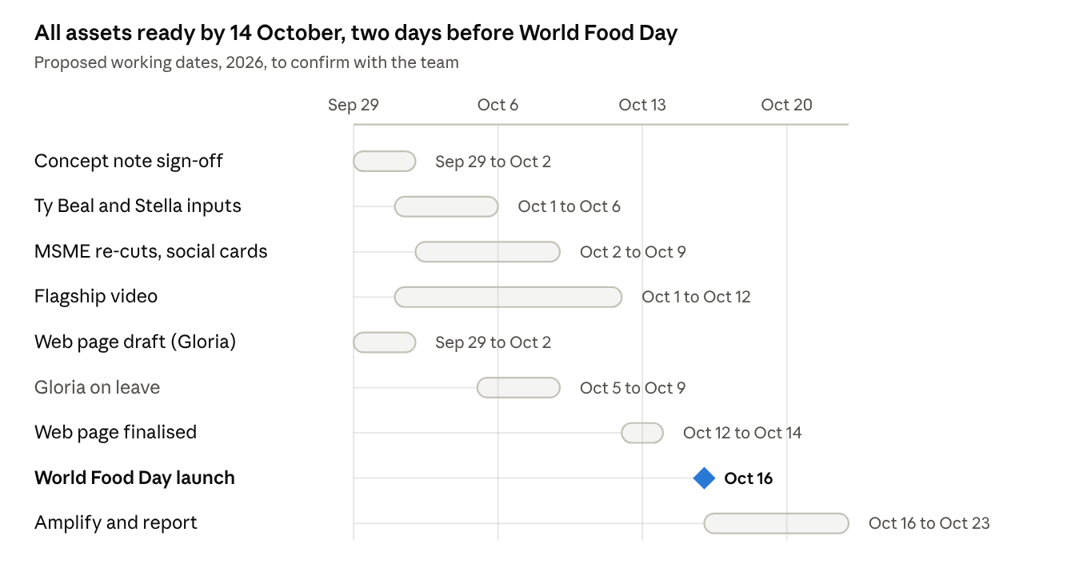
Campaign timeline · 29 Sep to 23 Oct 2026
Assumes Gloria is back on Monday 12 October; other dates are proposed and can shift once the video producer confirms lead times.

Open questions and next steps
- ☐ Confirm the final shortlist: keep DQQ and N3F, or stay with the three named tools?
- ☐ Confirm Stella's full name, role and topic, and book time with her and Ty Beal this week
- ☐ Confirm the DFQT+ spokesperson and whether there are pilot results we can share publicly
- ☐ Brief the video producer and agree the script outline
- ☐ Pull the MSME Week source files (video, photos, quotes) for re-cutting
- ☐ Send Gloria Ireri the page structure and innovation card copy by Wednesday 30 September so the draft is ready by Friday 2 October
- ☐ Agree a campaign hashtag alongside #WorldFoodDay

How it all ties together
Everything in this note sits under three pillars that tell one story: we know what nourishes, we make food systems deliver it, and we back the people who build it. GAIN's AI strategy runs through all three and is the "Nourish tomorrow" payoff on 16 October.
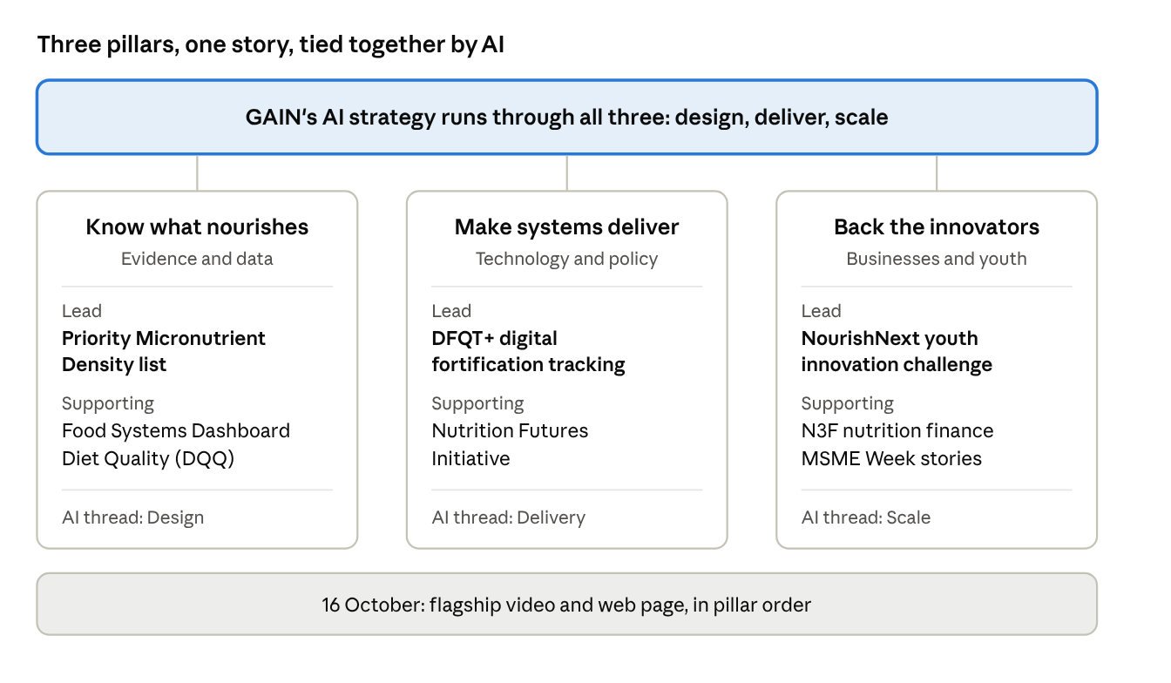
Campaign structure · 3 pillars, AI strategy across all

The three pillars
Pillar | Lead item | Supporting items | Podcast clip | AI thread (strategy area)
1. Know what nourishes (evidence and data) | Priority Micronutrient Density list (Ty Beal) | Food Systems Dashboard; Global Diet Quality Project / DQQ | EP 26: Global Food Systems Dashboard | Design: better targeting of programmes and populations; AI-powered search coming to the Food Systems Dashboard
2. Make systems deliver (technology and policy) | DFQT+ | Nutrition Futures Initiative | EP 30: Nutrition Futures Initiative | Delivery: better data and efficiency, including checking fortification compliance alongside DFQT+
3. Back the innovators (businesses and youth) | NourishNext Youth Agrifood Innovation Challenge | N3F; MSME Week stories | EP 33: Start Where You Are (Aida Eyasu) | Scale: faster expansion of what works, including localising content for each country
Pillar names are working titles; adjust them to GAIN's house style.

How the AI strategy fits
- Each pillar's posts carry one short "what AI adds next" line, so the strategy shows up in context, next to real tools.
- The flagship video closes on it: GAIN is using AI to design, deliver and scale better nutrition.
- Ty Beal, co-author of the strategy, bridges his evidence work and the AI story in his interview.

Rollout
- 12–15 October, teasers: one day per pillar, in order (Pillar 1, 2, 3), then a teaser of the flagship video.
- 16 October, World Food Day: flagship video covering all three pillars and closing on the AI strategy; web page goes live, organised by pillar.
- 17–23 October, deep dives: one richer post per pillar (interview, podcast clip or founder profile).

Keeping it cohesive
- One colour and icon per pillar, used on every post, video chapter and web page section.
- One card template: pillar name, what the item is, one number, one link.
- Lead first: each pillar leads with its lead item; supporting items appear in deep dives, not as separate launches.
- Same order everywhere: Pillar 1, 2, 3 in the video, on the web page and in the posting calendar.
- One campaign hashtag alongside #WorldFoodDay on every post.

