Оглавление

Build 2

Installation on a single machine 3

Distributed installation 4

How to configure daily reports 6

Troubleshooting 10

Feedback 10

# Build

Prerequisites:

* .NET Framework 4.5.2

Build:

1. Run build\ClickToBuild.cmd
2. Goto Artifacts folder and ensure that the build contains the following files:

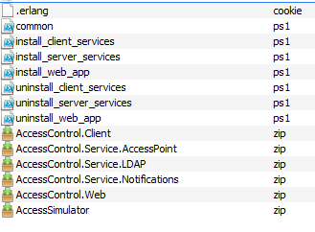

# Installation on a single machine

Prerequisites:

* .NET Framework 4.5.2
* MS SQL Server 2012+
* IIS 7+

Installation:

1. **Install and configure RabbitMQ**
   1. Download and install Erlang <http://www.erlang.org/download.html>
   2. Download and install RabbitMQ <https://www.rabbitmq.com/download.html>
   3. Run RabbitMQ Command prompt and execute the commands

*rabbitmq-plugins.bat enable rabbitmq_management*

*rabbitmq-service.bat stop*

*rabbitmq-service.bat install*

*rabbitmq-service.bat start*

*rabbitmqctl add_user evgeny Test123*

*rabbitmqctl set_permissions evgeny ".*" ".*" ".*"*

*rabbitmqctl set_user_tags evgeny management*

*rabbitmqctl delete_user guest*

1. **Create a new database for access control system**
   1. Create a new empty MSSQL SERVER database. You should not create database schema, application will created schema automatically at first startup. (by default, database name is AccessControlSystem)
2. **Install and configure** 
   1. Copy files from artifacts folder and run the scripts:

*install_server_services.ps1*

*install_client_services.ps1*

*install_web_app.ps1*

* 1. Enter the information asked by the scripts
  2. Go to the Services snap-in and ensure that the services listed below run:

*AccessControl.Service.LDAP*

*AccessControl.Service.AccessPoint*

*AccessControl.Service.Notifications*

*AccessControl.Client*

* 1. Go to IIS and ensure that AccessControl.Web website runs.
  2. **Optional step**: You can create a sample organizational structure automatically. To perform it, copy create_ldap_users.ps1 and import_create_ad_users.csv to your LDAP server and run the script.

1. **Run and test**
   1. Navigate to <http://localhost:8967> and login using your LDAP account credentials (if the script create_ldap_users.ps1 was run you can login with username <domain>\bill.gates and password Test123.).
   2. Create some access points
   3. Grant access rights for users and groups
   4. Assign biometric information for users
   5. Run %InstallationPath%\AccessSimulator\AccessSimulator.exe and play

# Distributed installation

Prerequisites:

* .NET Framework 4.5.2
* Windows Server 2012 Failover Cluster + MS SQL Server Failover Cluster
* NLB cluster for server-side services
* NLB cluster for client-side services (for each manufacturing facility)
* NLB cluster for web server
* RabbitMQ Federation

Deployment diagram

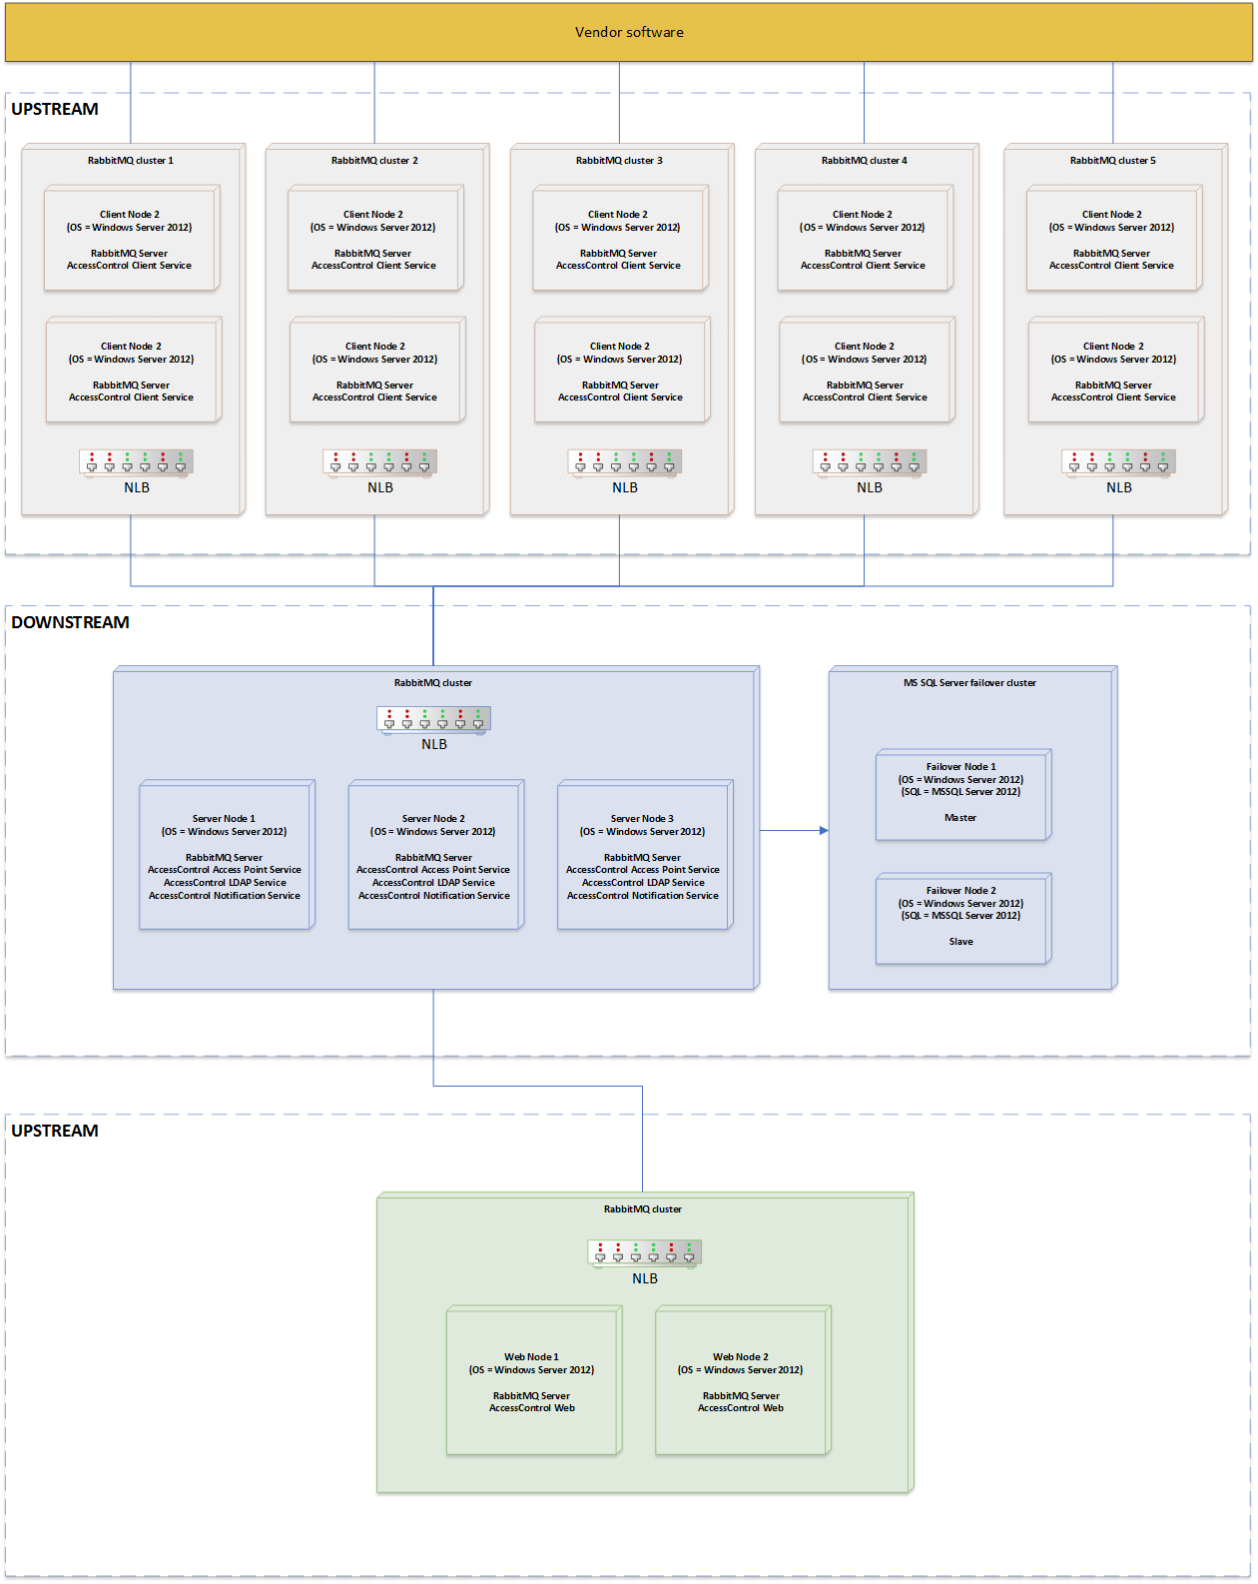

1. **Configure RabbitMQ cluster for server-side services.**
   1. Create RabbitMQ cluster
   2. Configure mirroring policy.
   3. Copy and replace .erlang.cookie to %Windows%, %Windows%\ServiceProfiles\LocalService on each node.
   4. Execute *install_server_services.ps1* on each node and connect services to local RabbitMQ queue.
   5. Configure Network Load Balancing cluster.
2. **Configure database**
   1. Follow MS SQL Server documentation and configure Window Server failover cluster and then SQL Server failover cluster.
   2. Create a new empty MSSQL SERVER database. You should not create database schema, application will create schema automatically at first startup. (by default, database name is AccessControlSystem)
3. **Configure RabbitMQ cluster for client-side services for each facility.**
   1. Create RabbitMQ cluster
   2. Configure mirroring policy
   3. Copy and replace .erlang.cookie to %Windows%, %Windows%\ServiceProfiles\LocalService on each node.
   4. Execute *install_client_services.ps1* on each node and connect services to local RabbitMQ queue.
   5. Configure Network Load Balancing cluster.

1. **Configure Web site cluster**
   1. Follow Windows Server 2012 documentation and configure load-balanced cluster for web application.
   2. Create RabbitMQ cluster
   3. Copy and replace .erlang.cookie to %Windows%, %Windows%\ServiceProfiles\LocalService on each node.
   4. Execute *install_web_app.ps1* on each node and connect web sites to local RabbitMQ queue.
2. **Configure RabbitMQ federation**
   1. Follow RabbitMQ documentation and configure brokers and federation.
   2. Connect upstream clusters to the downstream server cluster.
3. **Run**
   1. Navigate to web site and login using your LDAP credentials. At first startup, the system generates database schema.
   2. Enjoy.

# How to configure daily reports

This section describes how to configure the system to create daily reports.

Prerequisites:

* Installed and configured Access Control System
* MSSQL Reporting Services
* Properly configured SMTP for sending emails by MSSQL Reporting Services

Note: Sorry for Russian on the screenshots. I have only localized version of Reporting Services.

1. **Prepare database.**
   1. Run MSSQL Management Studio and open *reporting\report_functions.sql* script.
   2. Replace values of *@AD_UserName* and *@AD_Password* variables with your Active Directory credentials.
   3. Execute the script
2. **Configure Report Manager**
   1. Open Report Manager web application.
   2. In Report Manager create a new data source and configure connection string to the database. This data source is going to be used for fetching report data.
   3. Click on Subscriptions and then create a new data-driven subscriptions.

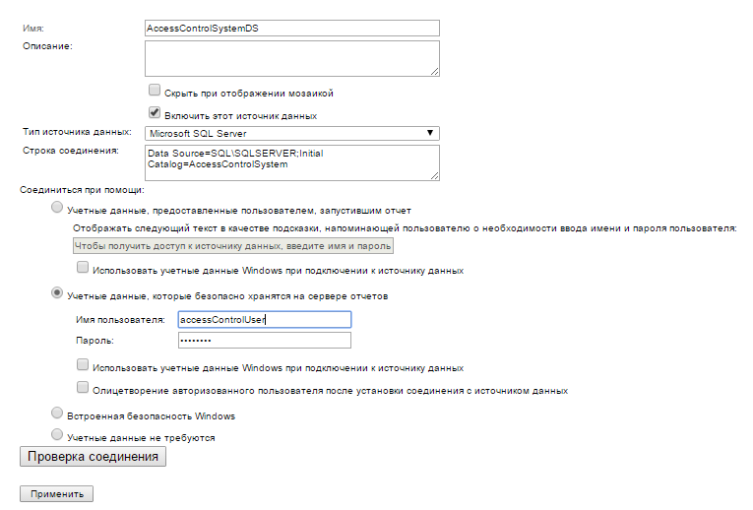

* 1. From Report Manager run Report Builder and open *reporting\department-wise-activity.rdl* file.
  2. Add a server data source created earlier and upload that file on Report Manager.
  3. Locate the uploaded file and click Management in context menu and navigate to Subscriptions

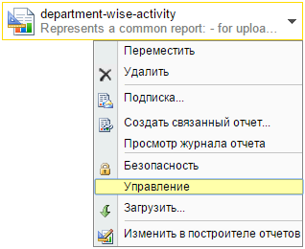

1. **Schedule daily department-wise activity log mailed to managers.**
   1. Create a new data-driven subscription.
   2. Enter description: Mailing to the department managers
   3. Use the data source AccessControlSystemDS created earlier
   4. Enter the following query to execute:

*DECLARE @domain VARCHAR(100) = '<domain name, for instance, evriqum.ru>'*

*DECLARE @dayOffset INT = 0 -- current day*

*EXEC dbo.ListDayLogTargets @domain, @dayOffset*

* 1. Specify values: sender – ManagerMail, Attach report – True, Format - PDF

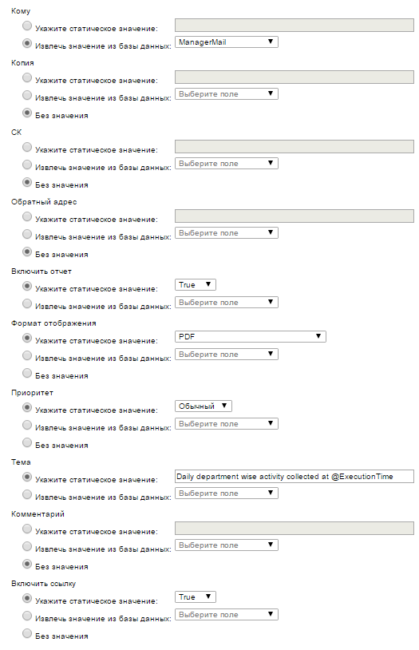

* 1. Enter report parameter values:

@domainManagerName = DomainManagerName from DB

@dayOffset = 0

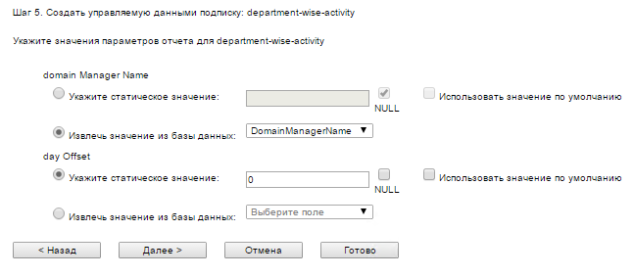

* 1. Create a new schedule for the subscription

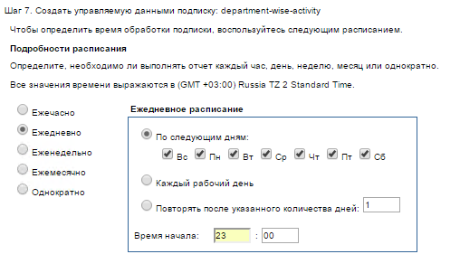

* 1. Click Finish

1. **Schedule department-wise attendance log uploaded as CSV into a shared folder.**
   1. Create a new data-driven subscription.
   2. Enter description: Uploading to a shared folder
   3. Use the data source AccessControlSystemDS created earlier
   4. Enter the following query to execute:

*DECLARE @domain VARCHAR(100) = '<domain name, for instance, evriqum.ru>'*

*DECLARE @dayOffset INT = 0 -- current day*

*EXEC dbo.ListDayLogTargets @domain, @dayOffset*

* 1. Specify deployment values

File name – RelativePath from database

Path – absolute path to a shared folder

Format – CSV

Mode - Overwrite

Your credentials to access the specified shared folder

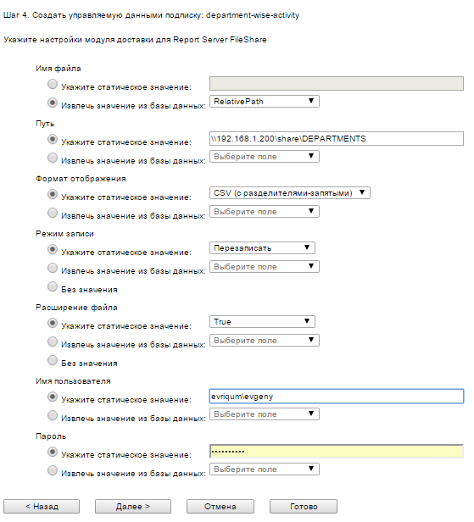

* 1. Specify report parameter values:

@domainManagerName = DomainManagerName from database

@dayOffset = 0



* 1. Create a new schedule for the subscription



* 1. Click Finish

# Troubleshooting

1. In case of problems with WCF services, when Windows blocks an URL because it is not added to the access control list, execute the following commands:

*netsh http add urlacl url=http://+:9981/AccessCheckService user=<your user name>*

*netsh http add urlacl url=http://+:9981/AccessPointRegistry user=<your user name>*

1. If you have a problem with IIS and ASP.NET 4.5. Execute the following command

*dism /online /enable-feature /all /featurename:IIS-ASPNET45*

# Feedback

I found some black spots in the specification. Here is the summary.

1. I assume that user names remains read-only because LDAP directory usually does not allow changing it.
2. I did not find any specification of 3rd party API exposed by vendor software. So I assumed that vendor API defines a WCF contract or we can create a bridge between vendor API and the WCF service hosted by AccessControl.Client.
3. I did not find any requirements to management system of access points but managers should do it. Therefore, I assumed that manager is responsible for management of access points located in his departments only.
4. Because of Internet can be switched off unexpectedly, we should guarantee that employees allow access points. However, there are no requirements, which would say if the system should guarantee email and SMS delivery at the time when access violation occurs. At this point, this implementation is out of the scope of the task.
5. There are no security requirements. I believe that the system should support Single Sign-On; therefore, I have created a simple implementation. System creates an encrypted ticket and passes it to remote services. Real implementation should use the SSO server.

Perhaps for security reasons, we should encrypt data stored in database with an encryption key.

Also, have to mention configuration files. I believe that we should not save passwords as plain text in configuration files in such distributed system. For this purpose, we should use a password storage. At current point, this is out of the scope.

1. The system should communicate using SSL, to protect data from unauthorized access. At current point, this is out of the scope of the task.
2. I did not find any requirements, which would describe how system handles electricity issues. Therefore, I assumed that 3rd party vendor hardware is responsible for it.
3. The last but not least, the system should take care of duplicated messages. It can be as a result of unexpected failures of components. One of possible solutions is to handle message ID in order to decide if the message is already processed.