Contents
High level requirements analysis and the assumptions 1
Functional requiremens 1
Security requirements 1
Technical requirements 1
The solution and system architecture 2
System architecture 2
Multiple tiers 3
Deployment Scenario 4
High level presentation of domain model 5
Communication diagrams 6
Packages diagram 8
Technical implementation summary and design patterns 9
What have I done? 9
What have not I done? 9
Used design patterns 9

High level requirements analysis and the assumptions

Functional requiremens
We should create three applications for stakeholders:
- Web Portal, which should provide facility to work with customer accounts
- ATM windows-based application installing on bank ATM
- Standalone Notification Service responsible for email delivering.
Web Portal encapsulates some business solutions:
- Provides web interface for customers.
- Provides online payment facility, which external web sites can integrate;
- Exposes an API used by an ATM application to process bank card requests;
- Delivers events to observers when transactions occur.
Web Portal does not provide API for online payments. Web Portal provides a link, which merchant’s website can use to do payments. Why not API? It is much safer because merchant cannot get details of the credit card of the customer.
ATM windows-based application represents a simple thin client connecting to the Web Portal API via HTTPS and providing user interface for ATM customers.
Notification Service is a standalone application, which guarantees emails delivery. All emails are stored in database and this service observe database by timer and deliver scheduled emails to clients. If an error occurs then Notification Service leaves the email, caused the error, in the scheduled pool and repeats delivery later.

Security requirements
All application communicate to each other via HTTPS only. Unsafe HTTP is not allowed.
Web Portal forbids access for non-authorized users. Customers cannot register on Portal, it’s a responsibility of the bank’s employees. Customer can access his account using his login name and password provided by an employee or a linked account of social network. Customer can link his account of social network only after first login.
ATM application checks pair of bankcard number and PIN code. Then ATM application sends this credentials pair with each request to Web Portal. Web Portal can decline an operation if bankcard number or PIN code is invalid.
Notification Service connects to the Web Portal using the authentication token. If the authentication token is invalid, Web Portal declines the connection.

Technical requirements
The solution should be highly scalable and highly available. For achieving this, the solution should support deployment on network-load balancing and fail-safe clusters. Fail-safe cluster should contain few instances of MSSQL Server to guarantee that database is always available and can process data. Network load balancing cluster is to ensure that many users can access the Web Portal at the same time.
The solution should support real-time data communication. It means that application should receive new data right after changes regardless of the type of application.

The solution and system architecture

System architecture
According to functional and technical requirements, the solution is built using multitier model combined with modern RESTfull and Event-Driven Architecture. Multitier model means that each tier has a single responsibility; for instance, data access tier is responsible for data access only, business logic tier is responsible for calculation and processing, etc. RESTfull and Event-Driven Architecture allow building highly responsive applications, which process data in real time. Event-Driven Architecture allows building small services, which can be load balanced independently and hosted on cloud.
Customers communicate with web browser or ATM which access Web Portal to get data or process a request. Web Portal cannot access data directly, it uses business tier to process requests. When a transaction occurs Web Portal sends events to Notification Service and client web browsers. Notification Service checks email pool by timer and sends scheduled emails via SMTP.
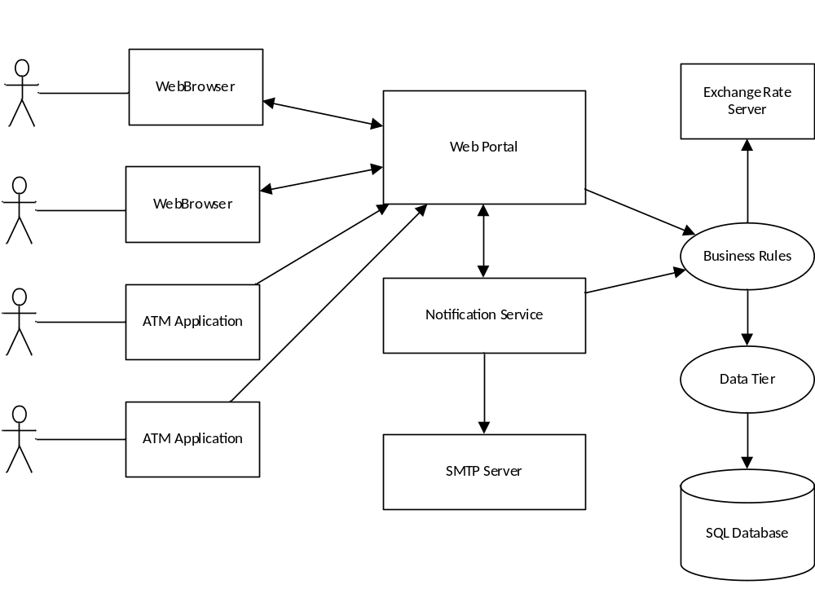

Multiple tiers
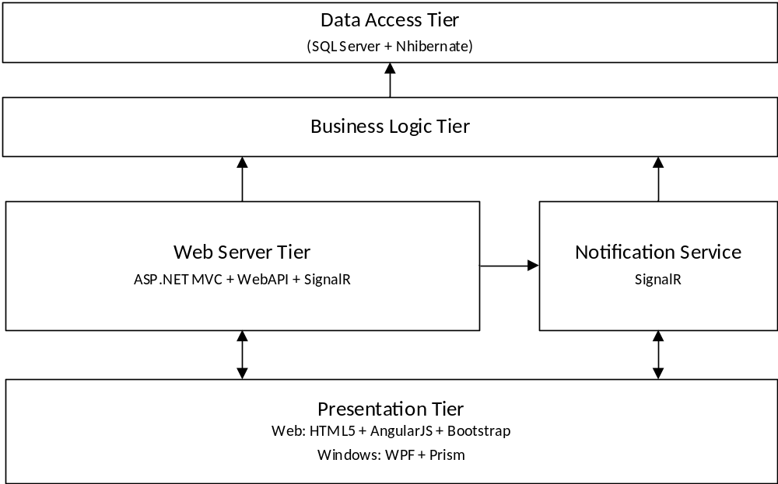
The technologies involved:
ASP.NET WebAPI – RESTfull services
SignalR – Event-Driven Architecture implementation
ASP.NET MVC + AngularJS + Bootstrap – presentation tier of the web application
WPF + Prism – presentation tier of the ATM application
NHibernate + MS SQL Server 2014 – data tier
Applications communicate with each other via HTTPS using ASP.Net Web API services and ASP.Net SignalR hubs regardless of the type of application – web application, windows application or windows service.
User communicate with web application via user interfaces built on HTML5, Bootstrap and AngularJS. ATM application is built on WPF and Prism.

Deployment Scenario
To deploy the system on production you should:
- Create a fail-safe cluster for MSSQL Server 2012+;
- Create network load balancing cluster;
- Deploy web-application and notification service on the NLB cluster;
- Deploy ATM application on each ATM.
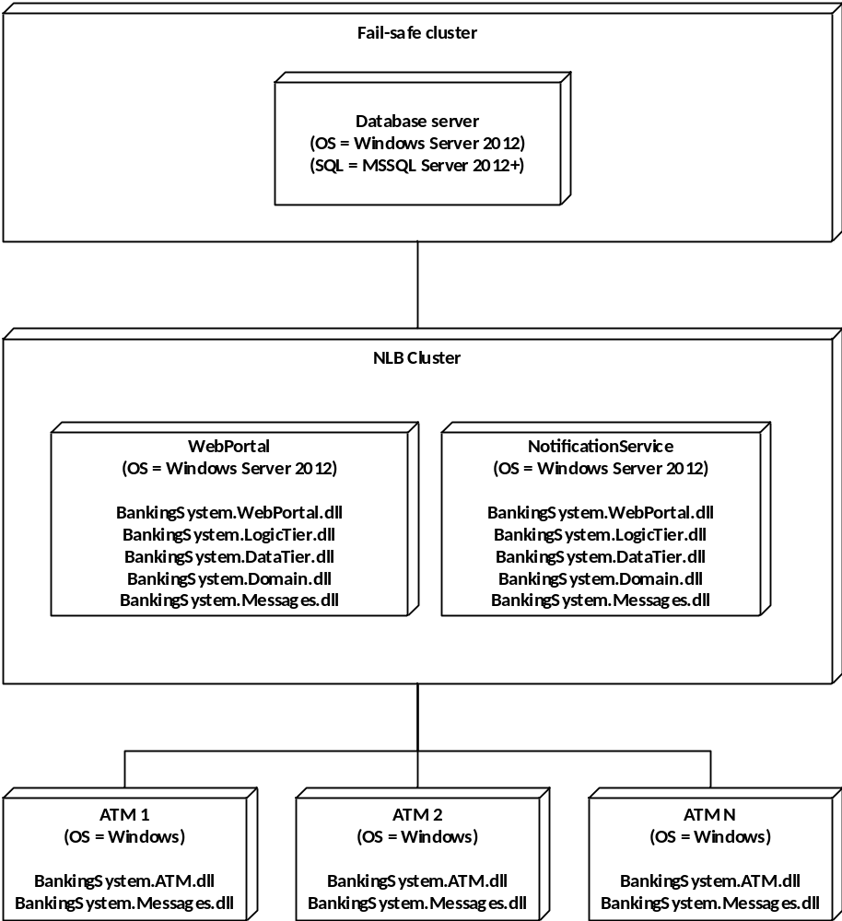

High level presentation of domain model

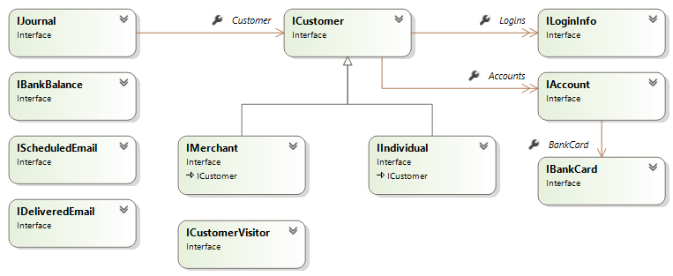

Domain model is quite simple. Each customer has a collection of bank accounts and a collection of social accounts used to login. Each bank account reference a bank card (one-to-one relationship). Each transaction is logged in database as Journal entry. Customer does not provide a collection of journals because it may affect performance while retrieving data from database.
Bank balance is a simple entity which has a commision balance of the bank.
Scheduled email is contains a message data of the email which is not delivered yet.
When an email is delivered it becomes DeliveredEmail entity.

Communication diagrams
Account-to-account money transfer
Account controller searches for the current authenticated customer, then it retrieves source and destination accounts. If validation is successful, then controller calls AccountService to transfer money. AccountService is decorated by AccountServiceDecorator which adds some extra functionality. It sends BalanceChangedMessage to all observers, including CustomerAccountHandler, which is responsible for scheduling emails, and WebBrowser.
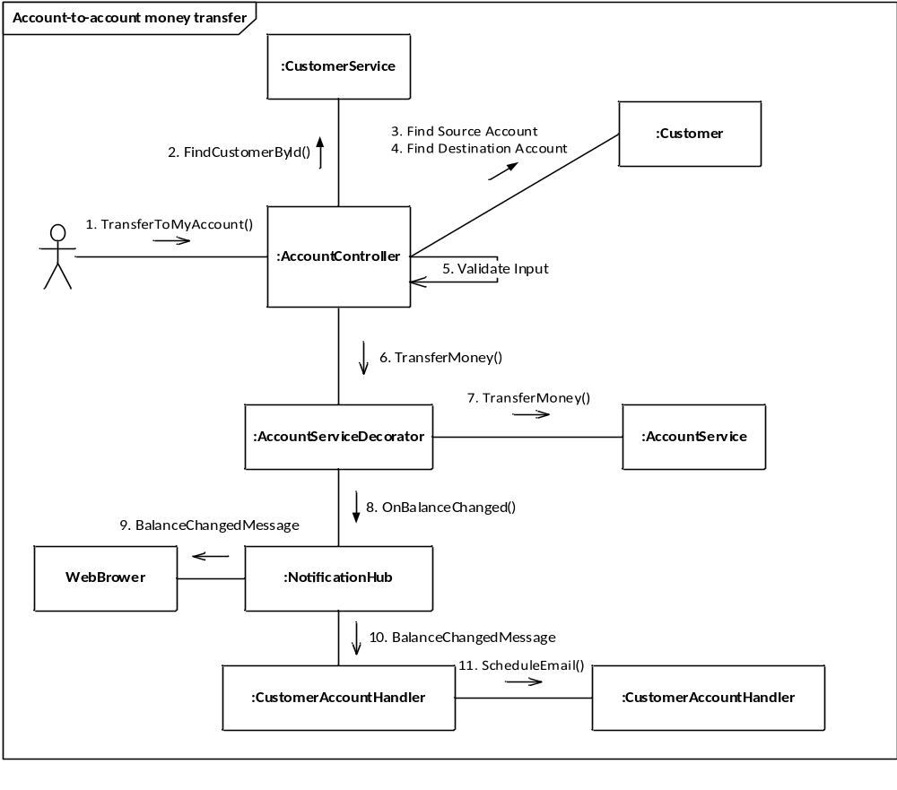
Checking balance in ATM
Checking balance in ATM represents a simple flow. BankingServiceProxy calls ApiBankCardController, which is responsible for PIN code validation. If the PIN code is valid then it calls BankCardService to get bankcard balance.
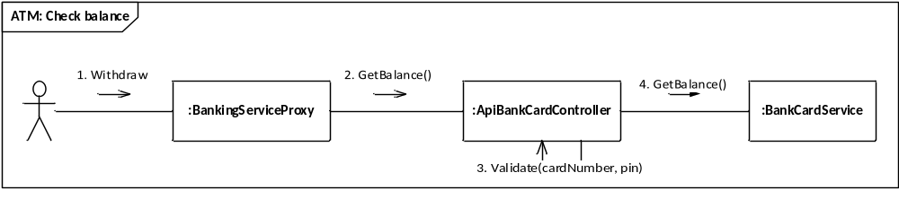
Withdrawal money in ATM
BankingServiceProxy calls ApiBankCardController to update the current bankcard balance. ApiBankCardController validates the card number, PIN code, and then calls AccountService to update balance. AccountService is decorated by AccountServiceDecorator, which sends notifications to all observers if the balance is updated successfully.
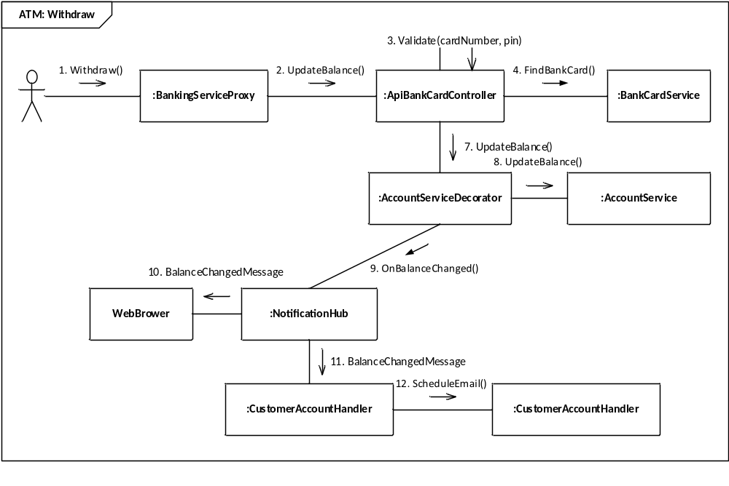
Online payment
To integrate online payment facility Merchant should provide a link to bank online payment in the following format:
https://locahost:44300/onlinepayment/5D9168B6-A03B-412E-A5D9-1AC5C5105BA9/USD/1000?redirectUrl=url
Where:
- GUID is the merchant identifier
- USD represents a currency of the merchant’s account to credit.
- 1000 is a payment sum.
- redirectUrl represents an URL on which the payment service will redirect when payment is completed
The diagram shows this process. Customer requests a merchant that redirects the request on the OnlinePaymentController. The controller sets temporary data and redirect internally to Payment action. It is necessary to forbid the user to refresh the page. Then user enters bankcard data and submits the form. OnlinePaymentController validates user input and then calls AccountService to transfer money from the user’s account to the merchant’s account. Next steps are the same with described above, because AccountController is decorated.
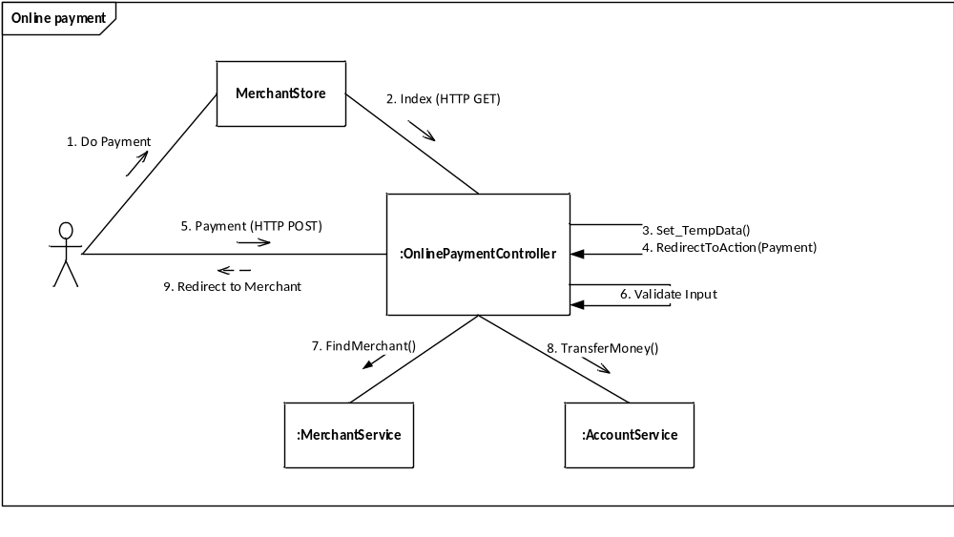

Packages diagram
The following diagram shows dependencies between system packages.
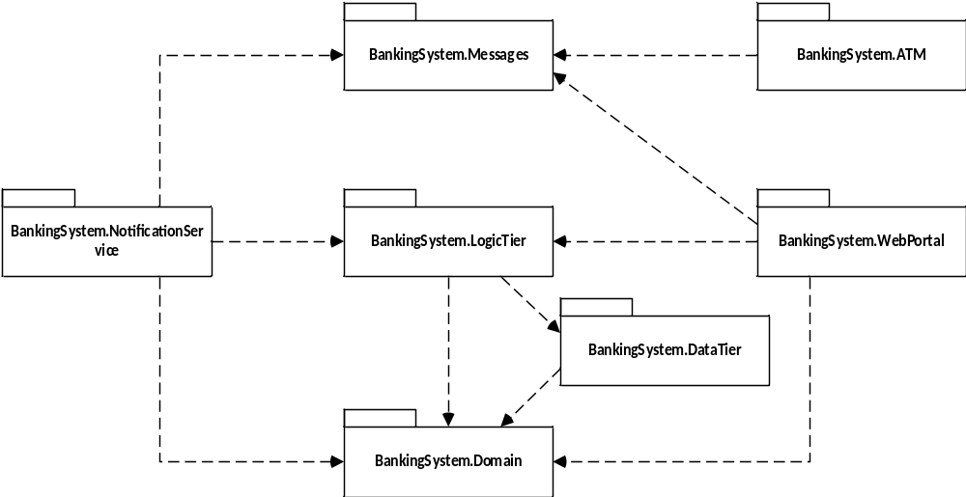

Technical implementation summary and design patterns

What have I done?
I have developed a banking system, which is going to be highly available and scalable. It is achieved by using modern technologies like SOA 2.0 and Event Driven Architecture. Data communication works in real time because clients communicate with each other using SignalR hub based on HTML5 WebSockets.
High maintainability is achieved by good separation of concerns and single responsibility of each solution component.
Next, we can add new features to the solution easily because solution contains some good examples, how the code should be organized and tested with automatic tests.

What have not I done?
I decided to not implement micro-services architecture using any popular messaging queues (MSMQ, RabbitMQ, etc.), because it is not necessary in this scope. Meanwhile, it can be easily introduced when it is necessary. NotificationService represents a simple example of such approach built on SignalR.

Used design patterns
Visitor – good pattern to get rid of conditional logic when some subclasses of a base class need to be processed differently. See ICustomerVisitor and ICustomer.
Decorator – good pattern when you need to add an extra functionality for a class without its modification. See AccountServiceDecorator and JournalServiceDecorator.
Abstract factory – good pattern for separating object creation and object usage. See SmtpFactory.
MVC – good pattern to separate presentation and presentation logic. ASP.NET MVC is based on this pattern. See BankingSystem.WebPortal.
MVVM – good pattern for windows-based applications. Usually it is used by default in WPF application. See BankingSystem.ATM
Inversion of Control – good principle increasing modularity of the program and making it extensible. Everywhere in the solution.
Object-relational mapping – good principle for converting data between domain model and any data store. See BankingSystem.DataTier.

