Report on
AUTOMATED WEB SECURITY SCANNER
IBM SkillsBuild Cybersecurity Course

Name: PRABRISHA BHARADWAJ
Stream: COMPUTER SCIENCE AND ENGINEERING (CSE)
Date of Submission: 23.10.2026
Abstract
Web application attacks are not always a result of the use of vulnerable code. In many cases, attackers exploit simple configuration mistakes. Some of these are using unsecured or incorrectly configured HTTP security headers, lack of protection for cookies and permissive Cross-Origin Resource Sharing (CORS) policies. Manually verifying and validating these configuration settings at scale is both tedious and error-prone.
An automated web application security scanner, written in Python, is presented. The scanner automatically visits the URLs provided, parses and evaluates six HTTP security headers, verifies cookie attributes, probes for software version disclosures and actively tests CORS policy with crafted Origin headers. Findings are categorized based on severity, and targets are scored based on the number and severity of their findings. Each target is assigned a letter grade, and results are exported in the formats HTML, CSV and JSON.
Two types of validations were done on the tool. The first was done on a reproducible local lab, started in the notebook. This lab consisted of three servers (vulnerable, hardened and mixed) that the scanner scored as 0 (F), 100 (A) and 60 (D) respectively, based on their configuration. The second type of validation was done on public web resources. demo.testfire.net was scored at 54 (D), httpbin.org was scored at 0 (F) and testphp.vulnweb.com could not be reached from the test network and was reported as an error.
Keywords: Web Security, HTTP, Software Version Disclosure, Misconfiguration, CORS, Cookies, Automated Scanning, Python.
1. Introduction
1.1 Problem Statement
Application development processes often require the deployment of web applications before configurations can be thoroughly reviewed. Security headers and CORS policies, for example, are set at the server or application layer and mistakes can affect all application users. Security Misconfiguration is one of the top 10 OWASP risks and, as such, should be considered when developing web applications. Creating a tool to audit web application configuration for common mistakes can help development and security teams find issues early in the development lifecycle.
1.2 Objectives
- Identify and explain missing or weak HTTP Security Headers and the resulting risks.
- Perform CORS misconfiguration tests using various origins and preflight requests.
- Identify cookies lacking the Secure, HttpOnly and SameSite attributes.
- Identify information disclosure due to the presence of headers like Server and X-Powered-By.
- Rate the findings and produce a score and grade.
- Create a shareable report of the findings.
- Create a safe and reproducible testing environment.
1.3 Scope
The scanner performs GET and OPTIONS requests to the provided URLs. It does not crawl, brute force, fuzz, or exploit anything. It evaluates web application configuration and security, not logic and controls.
2. Background
2.1 HTTP Headers and Security Headers
When a web server receives a request to load a web page, it sends back the content of that page along with a set of instructions called HTTP headers. Browsers follow these instructions. Protective HTTP headers instruct browsers to prevent certain attacks. If they are not present, the browser falls back to default settings that allow certain attacks. The scanner reads these HTTP headers and determines whether the necessary protective headers are present.
Header | If missing | Purpose
Strict-Transport-Security | High | Protects against man in the middle attacks and stripping of TLS by forcing the browser to load HTTPS.
Content-Security-Policy | High | Restricts loading of scripts and other resources from specified sources; principal protection against cross site scripting.
X-Frame-Options | Medium | Prevents clickjacking by ensuring a page cannot be loaded in a frame.
X-Content-Type-Options | Low | Tells the browser not to guess the content type if the value is nosniff.
Referrer-Policy | Low | Controls the referrer header sent to other origins.
Permissions-Policy | Low | Disables page features.
Table 1: Severity of security headers if not present
2.2 Same-Origin Policy and CORS
An origin is the combination of protocol, domain and port. For example, https://bank.com and https://evil.com are different origins. In a web browser, the Same-Origin Policy (SOP) guarantees that a page cannot access data from a page of a different origin. Without it, a malicious page could read data from another origin (including a page where a user is logged in). SOP is built in to all modern browsers. To allow a page from a different origin to access data from a resource, the server can use Cross-Origin Resource Sharing (CORS).
CORS is a controlled exception to SOP. To invoke a secure approach, a server can check which origins can read its responses by defining Access-Control-Allow-Origin (ACAO) and Access-Control-Allow-Credentials (ACAC). ACAO defines trusted origins. ACAC defines whether cookies and login information can be sent with a request. A secure approach is an allow list of trusted origins. Here are some insecure patterns:
- Reflected origin: a server copies whatever Origin it receives in a request into ACAO, so the server trusts all origins.
- Reflected origin with credentials: an attacker’s origin can send requests with cookies and login information to read all authenticated data of a user (Critical).
- Trusting null: frames and local files can be sandboxed to send Origin: null. Attackers can craft such requests.
- Weak pattern matching: a server can trust any origin that contains the legitimate domain; for example, a server that trusts example.com also trusts example.com.evil.com.
- Wildcard (*): a wildcard should only be used for fully public data. Credentials should never be combined with a wildcard.
- Permissive preflight: state changing methods (PUT, DELETE, PATCH) should never be allowed to untrusted origins.
A misconfigured CORS policy is a mistake by the server, not by the user. The browser just follows the instructions set by the server.
2.3 Cookie Attributes
A cookie is a token used by the server to recognize a user. Anyone who can obtain the cookie can impersonate the user. For protection, a cookie can be set to:
- Secure: sent only over a secure channel.
- HttpOnly: hidden from JavaScript.
- SameSite: not sent with cross-site requests, so that only requests that originate from the site itself carry the cookie.
2.4 Information Disclosure
Revealing software and version details (e.g., Server: Apache/2.2.8 or X-Powered-By: PHP/5.2.4) could potentially put the software at risk of version-related attacks. The scanner rates this risk as Low.
3. Tools and Technologies
Technology | Role in the project
Python 3 | The implementation language.
Requests/urllib3 | Sending GET and OPTIONS requests with custom headers; parsing raw Set-Cookie headers.
Pandas | Storing results in dataframes, grouping and summarizing, exporting to CSV and JSON.
Matplotlib | Visualizing results in stacked severity charts.
http.server, threading | Starting local lab servers.
Jupyter notebook/Google Colab | Interactive development, documentation and presentation.
Table 2: Technologies used
4. System Design
4.1 Architecture
The scanner is composed of a series of independent modules (checks), with each module returning a list of Finding records. Adding new checks does not require changes to the other components of the scanner.
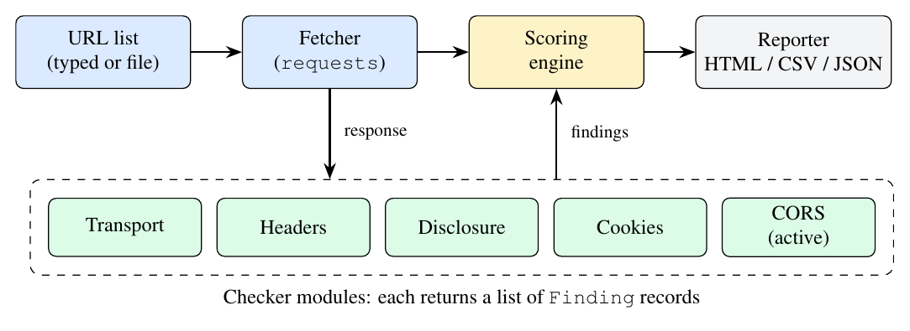
Figure 1: Scanner architecture
4.2 Finding Data Model
All results are stored in a record with the fields url, category, check, status (PASS, FAIL, INFO or ERROR), severity, detail and recommendation. Only Finding records with a status of FAIL affect the score of a target.
4.3 Severity and Scoring
Severity | Penalty | Typical example
Critical | 25 | Arbitrary origin reflected with credentials allowed.
High | 15 | Missing CSP or HSTS; null origin trusted with credentials.
Medium | 8 | Weak CSP; plain HTTP; missing X-Frame-Options; risky preflight methods.
Low | 3 | Missing Referrer-Policy; version disclosure
Table 3: Severity penalties
Score = 100 − sum of penalties for failed checks; floor = 0. Grades: A (90 or more), B (80 to 89), C (65 to 79), D (50 to 64) and F (below 50). An unreachable target is reported as ERROR, its score is N/A, and no grade is given, since no checks were performed. The weights are a simple heuristic chosen for illustration and do not follow a standard such as CVSS.
5. Implementation
5.1 Fetching and Normalization
URLs without a scheme are prefixed with https://. Outgoing requests use a 10 second timeout and follow redirects. The scanner collects Set-Cookie headers from all redirect hops, so no cookie is lost.
5.2 Header Analysis
The scanner reports a failure when a header is missing, and performs validation if it is present:
- HSTS: requires max-age of at least 180 days (15,552,000 seconds). HSTS is marked as not applicable on responses served over HTTP.
- CSP: must not contain ‘unsafe-inline’, ‘unsafe-eval’ or a wildcard script source.
- X-Frame-Options: the absence of the header is accepted if CSP defines frame-ancestors. Otherwise, the value must be either DENY or SAMEORIGIN.
- X-Content-Type-Options: must be nosniff.
- Referrer-Policy: the values unsafe-url and no-referrer-when-downgrade are flagged.
- Permissions-Policy: the scanner checks whether the header is present. If it is missing, the scanner records a Low-severity finding. The scanner does not validate individual directives or whether the permitted browser features are appropriately restrict

5.3 Cookie Analysis
Each Set-Cookie value is parsed into attributes. If an attribute is missing, that is flagged, and a cookie takes the highest severity among its problems.
5.4 CORS Testing
The scanner simulates a browser by sending the same GET request four times, each with a different crafted Origin header, and then sending an OPTIONS request to retrieve the preflight response.
Probe | Origin sent | Weaknesses detected
Arbitrary origin | https://evil-attacker.com | Server reflects any origin.
Null origin | null | The null origin is trusted.
Lookalike suffix | https://<host>.evil-attacker.com | Suffix or domain-contains match.
Lookalike prefix | https://evil-<host> | Prefix or substring match.
Preflight | OPTIONS with Access-Control-Request-Method: DELETE | Untrusted origins may use state-changing methods.
Table 4: CORS probes
The decision logic for each response is:
- No ACAO header: the origin is refused (pass).
- ACAO = * with credentials: High. ACAO = * without credentials: Low.
- ACAO = attacker origin: Critical with credentials, Medium without. For the null origin: High with credentials, Medium without.
- ACAO is a fixed value that differs from the Origin sent: the origin is not reflected (pass).
- A missing Vary: Origin on a reflected response adds a cache-poisoning note.
5.5 Reporting
Results are stored in a Pandas DataFrame. The DataFrame is then summarized and exported as HTML, CSV, JSON and PNG files. The HTML file is the report and contains all the results. All values are HTML escaped, so a hostile server cannot inject markup into the report. The report is self-contained.
6. The Local Test Lab
6.1 Why a Lab Is Needed
It is often illegal to use scanning systems without authorization. Public practice sites may be slow or unavailable. To ensure that the project is reproducible and legal to demonstrate, the notebook creates small web servers on the user’s computer. Each server is deliberately configured in a known way. Since the correct answer for each server is known in advance, the scanner can be validated against them. The start-up code shuts down any servers that may be left over from an earlier run, to avoid port conflicts.
6.2 How the Servers Are Hosted
- A handler class (LabHandler, based on Python’s BaseHTTPRequestHandler) defines how a server answers requests. It implements do_GET, do_HEAD and do_OPTIONS. Each defines and sends a list of response headers, and a short response body.
- Three servers (ThreadingHTTPServer) are created and bound to 127.0.0.1 (the loopback interface) and the following ports: 8081, 8082 and 8083. Since the servers are bound to the loopback interface, they are accessible only from the local machine and not on the network.
- Each server is started in a background thread and runs serve_forever(). This enables the notebook to continue processing other cells while the servers are listening.
- One handler (LabHandler) has three different behaviors. The port number is checked to determine the type of site: 8081 is vulnerable, 8082 is hardened and 8083 is a mixed site.
- No default banner. The handler uses send_response_only, so Python does not add its own Server header and spoil the version-disclosure test.
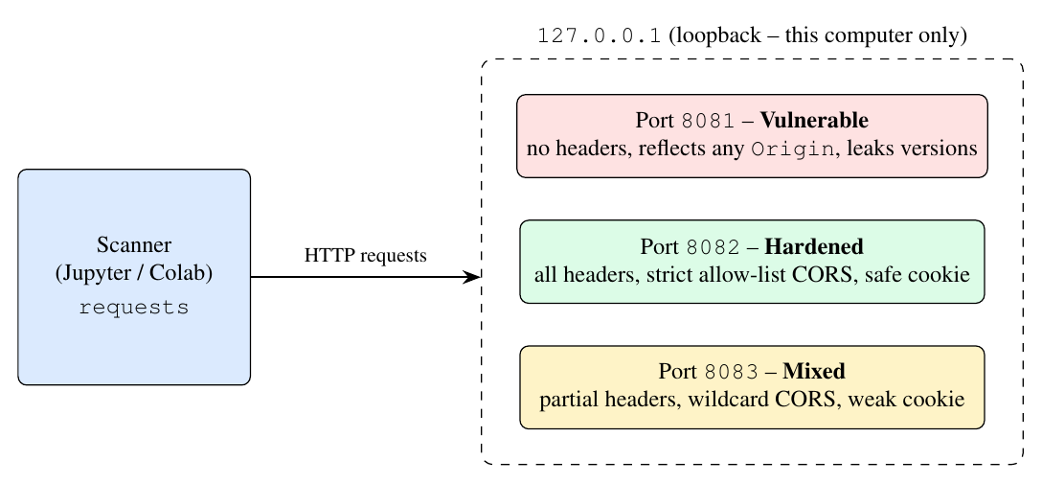
Figure 2: The local lab. All three servers run inside the notebook process and are accessible only via the loopback address
6.3 Server Configurations
Port | Profile | Configuration
8081 | Vulnerable | No security headers; reflects any Origin with credentials allowed; supports PUT and DELETE; banners Apache/2.2.8 (Ubuntu) and PHP/5.2.4; session cookie with no flags.
8082 | Hardened | All six headers with strong values; CORS allows only https://trusted.example.com; cookie with Secure, HttpOnly and SameSite=Strict; Vary: Origin; banner nginx.
8083 | Mixed | Only X-Content-Type-Options; CSP with ‘unsafe-inline’; wildcard CORS (*); cookie with HttpOnly; banner gunicorn/20.1.0.
Table 5: Intended configuration of each lab server
7. How a Test Is Performed
The scanner processes every target in the same way, using a total of six HTTP requests:
- Baseline GET. A standard request that follows redirects. The response headers are evaluated by the transport, header, disclosure and cookie checks. If the baseline GET request fails, the target is logged as ERROR and no further processing is done.
- Four CORS GET requests, each with a different crafted Origin header (Table 4).
- One preflight OPTIONS request to check whether the DELETE method is allowed from the attacker’s origin.
- Scoring. Failed checks are converted to penalties, resulting in a score and grade.
- Reporting. The results are displayed in tables, charted and exported.
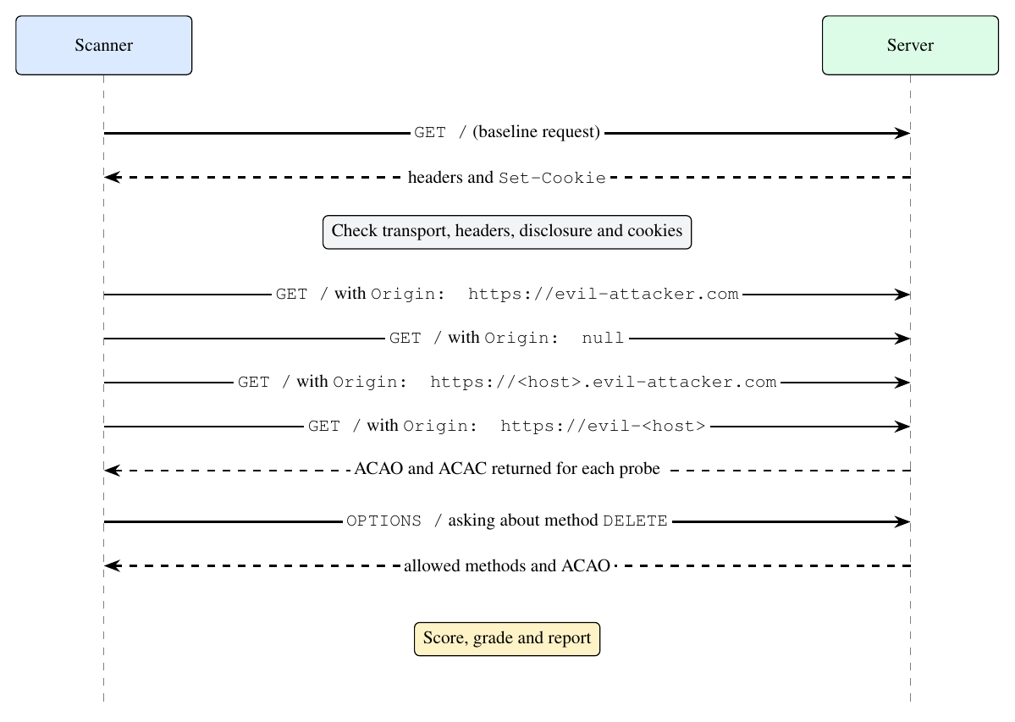
Figure 3: Sequence diagram of the requests for one target. Solid lines represent requests, dashed lines represent responses
Worked example (port 8081). The scanner sends a request with Origin: https://evil-attacker.com. The vulnerable handler responds with an insecure, reflected CORS response: Access-Control-Allow-Origin: https://evil-attacker.com and Access-Control-Allow-Credentials: true. The scanner determines that the ACAO header matches the origin it sent and that credentials are allowed, resulting in a Critical finding. The same request to port 8082 returns no ACAO header, so the probe is recorded as a pass.
8. Results
8.1 Local Lab
Target | Score | Grade | Crit. | High | Med. | Low
127.0.0.1:8081 (vulnerable) | 0 | F | 3 | 2 | 3 | 5
127.0.0.1:8082 (hardened) | 100 | A | 0 | 0 | 0 | 0
127.0.0.1:8083 (mixed) | 60 | D | 0 | 0 | 2 | 8
Table 6: Lab results (counts are failed checks by severity)
The vulnerable server loses 3×25 + 2×15 + 3×8 + 5×3 = 144 points, which is greater than 100, so its score is floored at 0. The mixed server loses 2×8 + 8×3 = 40 points, resulting in a score of 60.
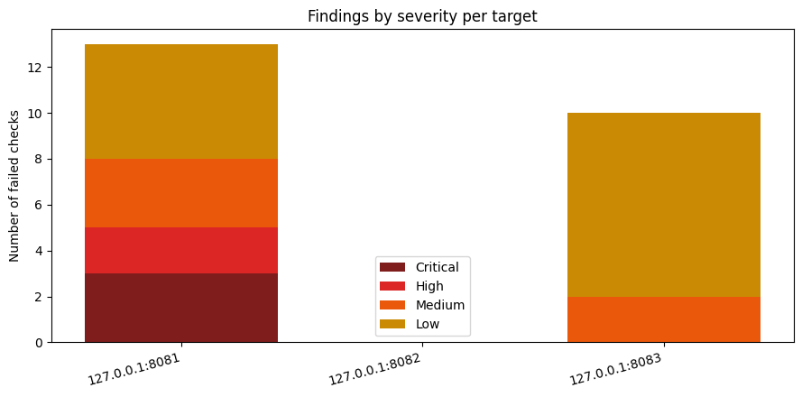
Figure 4: Failed checks by severity for each lab target. The hardened server (8082) has no bar because it had no failed checks
Findings on the vulnerable server (8081).
Check | Severity | Detail
CORS: arbitrary origin | Critical | https://evil-attacker.com reflected with credentials allowed; Vary: Origin missing.
CORS: lookalike suffix | Critical | https://127.0.0.1.evil-attacker.com reflected with credentials.
CORS: lookalike prefix | Critical | https://evil-127.0.0.1 reflected with credentials.
CORS: null origin | High | null reflected with credentials.
Content-Security-Policy | High | Header missing.
X-Frame-Options | Medium | Header missing.
Cookie PHPSESSID | Medium | Secure, HttpOnly and SameSite all missing.
CORS: preflight | Medium | Untrusted origin may use PUT and DELETE.
X-Content-Type-Options, Referrer-Policy, Permissions-Policy | Low | Three headers missing (three findings).
Server, X-Powered-By | Low | Apache/2.2.8 (Ubuntu) and PHP/5.2.4 disclosed (two findings).
Table 7: Failed checks for port 8081
Findings for the mixed server (port 8083). The mixed server failed ten checks. There was a permissive CSP (‘unsafe-inline’) and no X-Frame-Options (Medium). There was no Referrer-Policy or Permissions-Policy, a gunicorn/20.1.0 banner and a session cookie lacking both Secure and SameSite (Low), and the wildcard Access-Control-Allow-Origin: * (Low), which was reported once for each of the four origin probes. The preflight probe passed because no risky methods were advertised.
8.2 Live Targets
Three public targets were scanned from the notebook.
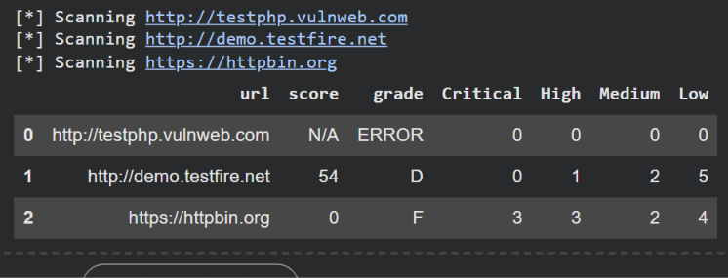
Figure 5: Notebook output for the three live targets
Target | Score | Grade | Crit. | High | Med. | Low
testphp.vulnweb.com | N/A | ERROR | - | - | - | -
demo.testfire.net | 54 | D | 0 | 1 | 2 | 5
httpbin.org | 0 | F | 3 | 3 | 2 | 4
Table 8: Live results
testphp.vulnweb.com. The baseline request timed out (connection timeout of 10 seconds), so the site could not be assessed from the test network. Such a target is reported as N/A and ERROR, because a target that could not be tested must not be graded.
demo.testfire.net. The site was reachable and the findings are in Table 9. The score is 100 − (15 + 2×8 + 5×3) = 54.
Check | Severity | Detail
Content-Security-Policy | High | Header missing.
HTTPS enforced | Medium | Site is reachable over plain HTTP.
X-Frame-Options | Medium | Header missing (clickjacking risk).
X-Content-Type-Options | Low | Header missing.
Referrer-Policy | Low | Header missing.
Permissions-Policy | Low | Header missing.
Server | Low | Reveals Apache-Coyote/1.1.
Cookie JSESSIONID | Low | Secure and SameSite missing.
Five CORS probes | Pass | No Access-Control-Allow-Origin returned; no CORS weakness found.
HSTS | Info | Not applicable: response was not served over HTTPS.
Table 9: Findings on demo.testfire.net
httpbin.org. The site scored 0 (F) with 3 Critical, 3 High, 2 Medium and 4 Low findings, for a total penalty of 3×25 + 3×15 + 2×8 + 4×3 = 148, which is floored at 0. The failed checks are listed in Table 10.
Check | Severity | Detail
CORS: arbitrary origin | Critical | https://evil-attacker.com reflected with credentials allowed; Vary: Origin missing.
CORS: lookalike suffix | Critical | https://httpbin.org.evil-attacker.com reflected with credentials allowed.
CORS: lookalike prefix | Critical | https://evil-httpbin.org reflected with credentials allowed.
CORS: null origin | High | null reflected with credentials allowed.
Strict-Transport-Security | High | Header missing, although the site is served over HTTPS.
Content-Security-Policy | High | Header missing.
X-Frame-Options | Medium | Header missing.
CORS: preflight | Medium | Untrusted origin may use PUT, DELETE and PATCH.
X-Content-Type-Options | Low | Header missing.
Referrer-Policy | Low | Header missing.
Permissions-Policy | Low | Header missing.
Server | Low | Reveals gunicorn/19.9.0.
HTTPS enforced | Pass | Site uses HTTPS.
Cookies | Info | No cookies set on this response.
Table 10: Findings on httpbin.org
The result shows how the server behaved with respect to CORS: it copied every untrusted origin, including null and both lookalike forms, into the Access-Control-Allow-Origin header while allowing credentials. The server also allowed state-changing methods in the preflight response. httpbin.org is a publicly accessible HTTP request testing service that serves no private user data, and permissive cross-origin behavior is expected on a service built for testing. The low score is therefore the result of a permissive configuration, not of a breach; the same findings on an account or banking API would be serious. The result also shows that the scanner can differentiate a site that omits CORS headers (demo.testfire.net, where all five CORS probes passed) from one that reflects every origin.
8.3 Validation
The three lab profiles were ranked in the expected order (hardened, then mixed, then vulnerable). The hardened server generated no failed checks, so there were no false positives for that profile. Every weakness planted in the vulnerable and mixed servers was detected, so there were no false negatives against the planted flaws. On the live targets, the scanner demonstrated sensible behavior and returned a mid-range grade for a weak banking demo, a failing grade for a permissive testing service, and an explicit error for an unreachable host. The scanner displayed the expected behavior on the controlled targets and consistent behavior on the real-world targets. Accuracy across varied real-world situations is not claimed. It is recommended that the results be validated by an independent method, for example by viewing the raw HTTP response headers with the browser developer tools or curl.
9. Discussion
The demonstration illustrated that some of the most serious flaws come from just a few patterns. These include reflection of the Origin header, omission of the Content-Security-Policy, and delivery of a site over plain HTTP. The scoring model made differences between configurations visible and allows a team to track progress over time. Including a remediation recommendation with each finding allows the team to use the tool as an aid in fixing the problems.
Validating the checks in separate functions allowed each one to be tested against the lab servers to ensure that it works correctly. Adding new checks does not affect the other checks in the pipeline.
There are two design observations to make. First, penalties are counted per probe rather than per root cause. As a result, a single wildcard CORS setting produced four Low findings on the mixed server, and a single reflection bug produced three Critical findings on the vulnerable server. While the resulting grades remain sensible, grouping by root cause would be more accurate. Second, this tool cannot prove that a hardened configuration is secure. A score of 100 merely indicates that no checked misconfiguration was found.
Unreachable targets are considered errors and are not graded, because no evidence about a target’s configuration can be gathered from a request that never receives a response. Failure paths must be handled as carefully as successful scans, because a timeout would otherwise be indistinguishable from a perfectly configured website.
10. Limitations and Future Work
10.1 Limitations
- The tool does not crawl. Therefore, only the URLs that are provided are scanned.
- The tool does not verify or evaluate the HTTP status code. As a result, block pages and CAPTCHAs served by a firewall or a content delivery network would be scored as if they were the real site.
- CORS is only tested on the URL provided. CORS problems usually occur on API endpoints, so a clean result on a home page does not mean the API is safe.
- CSP is evaluated using pattern matching rather than a full policy parser, and a CSP delivered via a meta tag is reported as missing.
- CORS findings identify a potential risk, but exploitability depends on whether the endpoint returns sensitive information.
- CDNs, web application firewalls and JavaScript may insert different headers in successive requests.
- Cookies set after a user logs in are never seen by the scanner.
- HSTS cannot be evaluated over plain HTTP, so it was not exercised in the lab.
- Results for public targets may vary depending on the state of the network.
- Scoring weights are a heuristic, not a standard.
10.2 Future Work
- Flag non-200 responses as potentially unreliable and store the HTTP status code.
- Accept a list of specific API endpoints to test for CORS misconfigurations.
- Implement a command line interface using argparse.
- Perform TLS and certificate checks (e.g., expired certificates, supported TLS versions and cipher suites).
- Crawl for other endpoints and perform authenticated scanning.
- Parse the full CSP and check Cache-Control headers and CSRF tokens.
- Group findings by root cause and implement fairer scoring.
- Integrate with a CI server so that a build is aborted if the score of the scanner falls below a threshold.
11. Ethical and Legal Considerations
The scanner sends ordinary GET and OPTIONS requests and waits between targets. Scanning systems without authorization may still violate laws or policies. The CORS probes in particular are active tests that send crafted Origin headers, which goes beyond ordinary browsing. Therefore, by default, the project uses a local lab and lists only deliberately vulnerable practice targets (testphp.vulnweb.com, demo.testfire.net, httpbin.org) and a public testing service (httpbin.org) for optional live testing. Users should obtain written permission before scanning any other system.
12. Conclusion
The project built a web security scanner that automates the auditing of HTTP headers, cookies and software version disclosure and the detection of CORS misconfigurations, and provides security scores with recommendations. In a local lab, the scanner automatically distinguished vulnerable, mixed and fully hardened configurations, scoring them 0 (F), 60 (D) and 100 (A) respectively. It also scored publicly available sites (54 (D) for demo.testfire.net and 0 (F) for httpbin.org) and reported an unreachable site honestly as an error. The project demonstrated that, with little effort, security review can be integrated into web development.
References
- OWASP Foundation. OWASP Secure Headers Project. https://owasp.org/www-project-secure-headers/
- OWASP Foundation. Web Security Testing Guide: Testing Cross Origin Resource Sharing. https://owasp.org/www-project-web-security-testing-guide/
- OWASP Foundation. OWASP Top 10: Security Misconfiguration. https://owasp.org/Top10/
- MDN Web Docs. Cross-Origin Resource Sharing (CORS). https://developer.mozilla.org/docs/Web/HTTP/CORS
- MDN Web Docs. HTTP headers reference. https://developer.mozilla.org/docs/Web/HTTP/Headers
- Python Software Foundation. http.server documentation. https://docs.python.org/3/library/http.server.html
- Python Requests documentation. https://requests.readthedocs.io

