Assignment: Module 05
Problem Solving with AI (Claude Code + JavaScript)
Name: Eshrat Jahan

Program 1: Convert Celsius to Fahrenheit
Source Code
function celsiusToFahrenheit(celsius) {
return (celsius * 9 / 5) + 32;
}

let celsius = 25;
let fahrenheit = celsiusToFahrenheit(celsius);

console.log("Celsius:", celsius);
console.log("Fahrenheit:", fahrenheit);
Input and Output
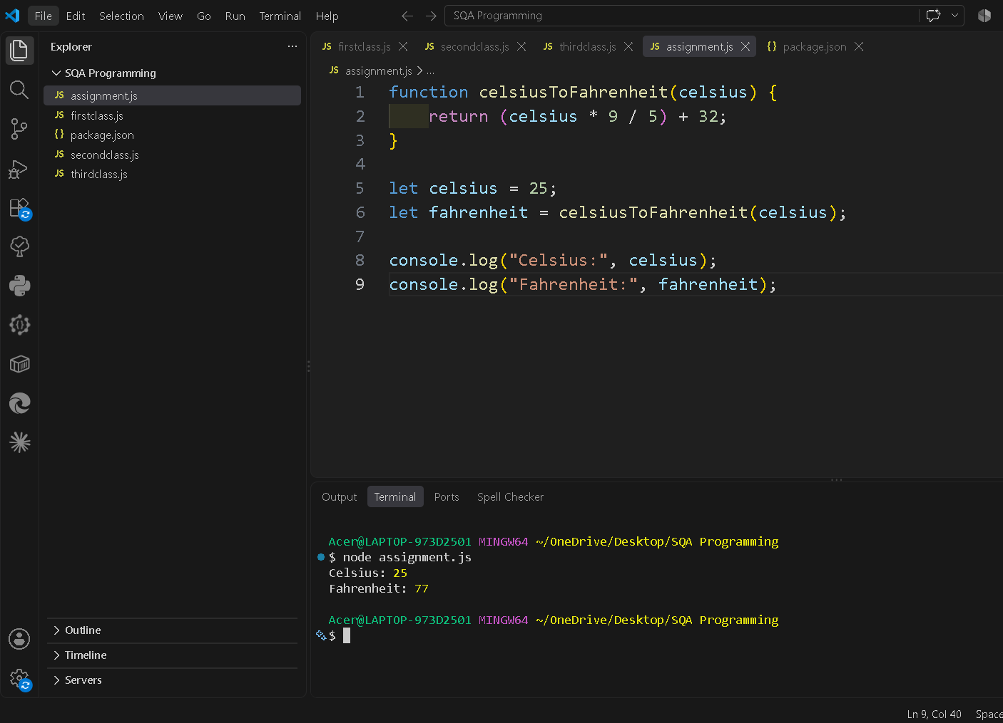
Explanation
· The celsiusToFahrenheit() function takes the temperature in Celsius.
· It applies the formula: F = (C × 9/5) + 32
· For 25°C, the result is 77°F.
· console.log() displays the result.

Program 2: Find the Factorial of a Number
Source Code
function factorial(number) {
let result = 1;

for (let i = 1; i <= number; i++) {
result = result * i;
}

return result;
}

let number = 5;

console.log("Number:", number);
console.log("Factorial:", factorial(number));
Input and Output
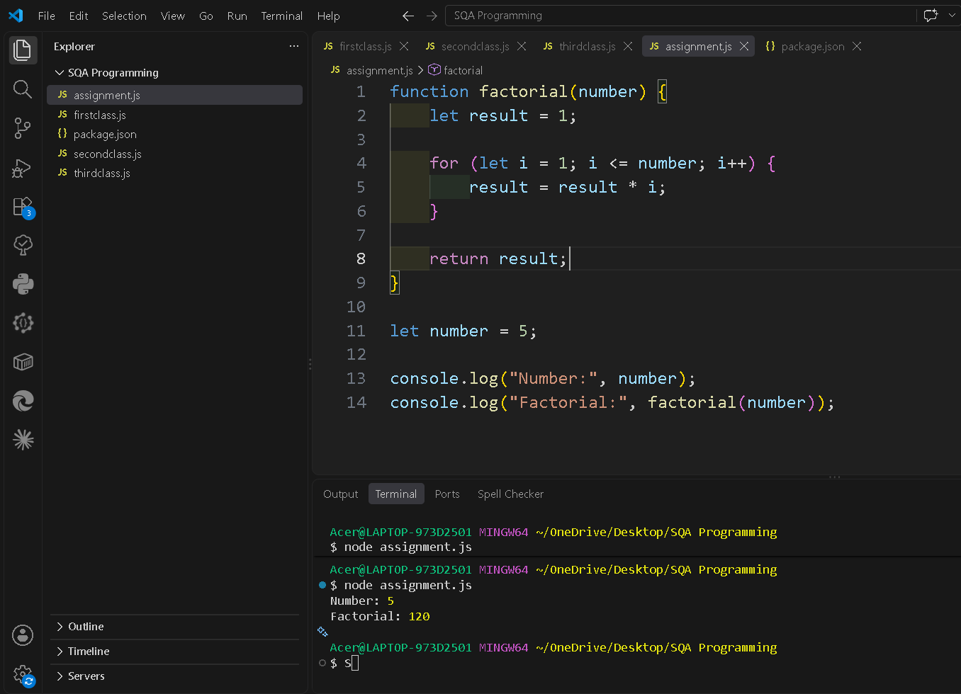
Explanation
· The factorial() function calculates the factorial of a number.
· result starts from 1.
· The for loop multiplies the numbers from 1 to the given number.
· For 5: 5! = 1 × 2 × 3 × 4 × 5 = 120
· The function returns 120.

Program 3: Check for Palindrome
Source Code
function isPalindrome(word) {
let reversed = word.split("").reverse().join("");

return word === reversed;
}

let word = "racecar";

console.log("Word:", word);
console.log("Is Palindrome:", isPalindrome(word));
Input and Output
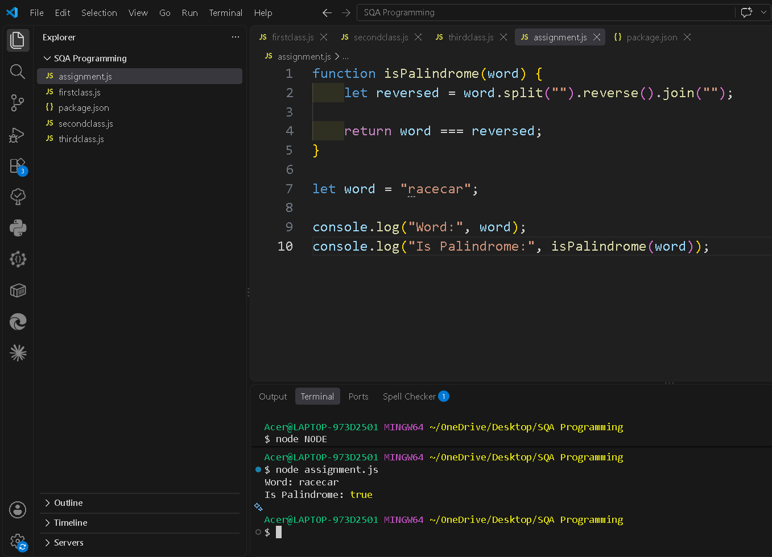
Explanation
· A palindrome is a word that reads the same forward and backward.
· split("") converts the word into individual characters.
· reverse() reverses the characters.
· join("") creates the reversed word again.
· The program compares the original word with the reversed word.
· If they are the same, it returns true; otherwise, it returns false.
.

Program 4: Sum of Array Elements
Source Code
function sumArray(numbers) {
let sum = 0;

for (let number of numbers) {
sum = sum + number;
}

return sum;
}

let numbers = [10, 20, 30, 40];

console.log("Array:", numbers);
console.log("Sum:", sumArray(numbers));
Input and Output
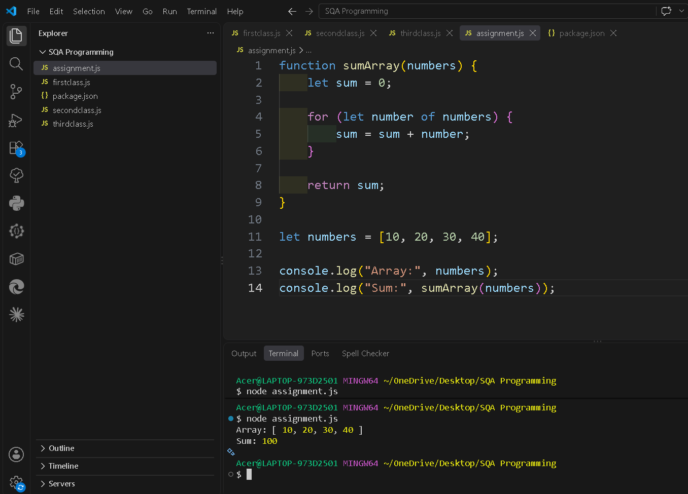
Explanation
· The sumArray() function takes an array of numbers.
· sum starts from 0.
· The for...of loop goes through each number in the array.
· Each number is added to sum.
· Finally, the total sum is returned.
· Here: 10 + 20 + 30 + 40 = 100

Program 5: FizzBuzz (Basic)
Source Code
for (let i = 1; i <= 15; i++) {

if (i % 3 === 0 && i % 5 === 0) {
console.log("FizzBuzz");
} else if (i % 3 === 0) {
console.log("Fizz");
} else if (i % 5 === 0) {
console.log("Buzz");
} else {
console.log(i);
}
}
Input and Output
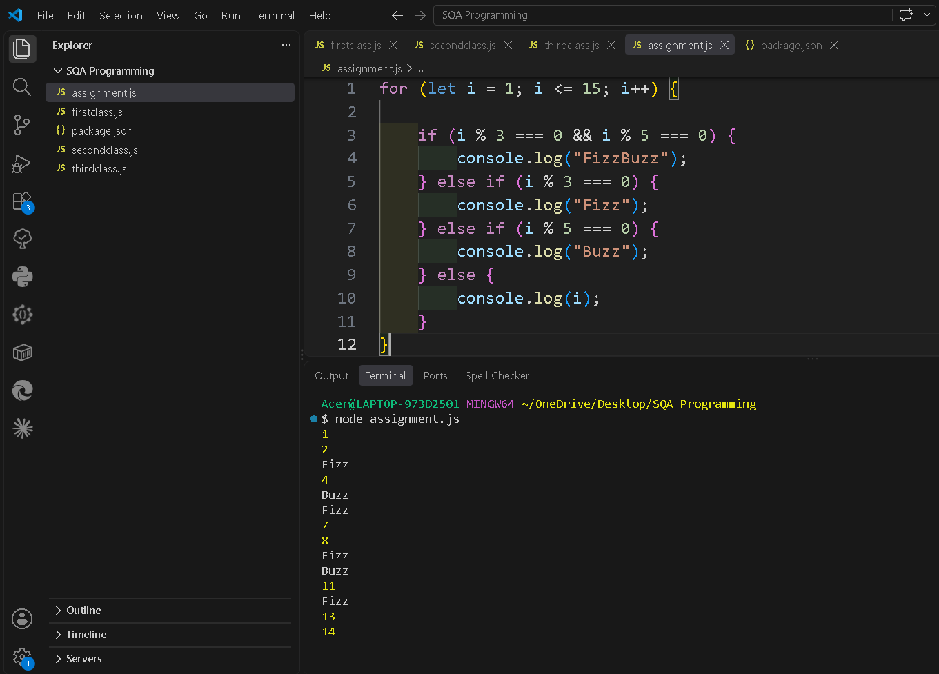
Explanation
· The for loop runs from 1 to 15.
· % is the modulus operator, which gives the remainder.
· If a number is divisible by both 3 and 5, it prints FizzBuzz.
· If it is divisible only by 3, it prints Fizz.
· If it is divisible only by 5, it prints Buzz.
· Otherwise, it prints the number itself.
· The condition for FizzBuzz is checked first so that numbers like 15 are not printed only as Fizz or Buzz.

