Installing the FINRA BrokerCheck Widget

Installing the FINRA BrokerCheck Widget on any page of your website involves just three easy steps.

#### Step 1: Insert Cascading Style Sheet Code

Insert the Cascading Style Sheet (CSS) reference highlighted below in the <head> section of the web page as shown in the example below:

<head>

<title>Your Web Page Title</title>

<link type="text/css" rel="stylesheet" href="http://syndication.finra.org/BrokerCheck/Widget/css/style.min.css">

</head>

#### Step 2: Insert Required Script

Insert the highlighted script below just before the end of body tag as shown in the following example. The function call shown is required.

…page body content…

<script src="http://syndication.finra.org/BrokerCheck/Widget/js/jquery.finra.static.min.js" type="text/javascript"></script>

<script type="text/javascript">var j171 = jQuery.noConflict();</script>

<script src="http://syndication.finra.org/BrokerCheck/Widget/js/jquery.finra.bcwidget.min.js" type="text/javascript"></script>

<script>

(function( j171 ) {

j171(".add-finra-bc-widget").BCWidget();

})( jQuery );

</script>

</body> //end of body tag

#### Step 3: Placement of Widget:

Include the following DIV structure in the section of the page where the BrokerCheck Widget needs to be displayed.

<div class="bcwidgetCover">

<div class="add-finra-bc-widget"></div>

</div>

Note: The broker check widget takes the width of the container DIV. The width of the container can go up to a maximum width of 480px. However it is expected to be at least 370px.

The rendered BrokerCheck Widget will look like this:

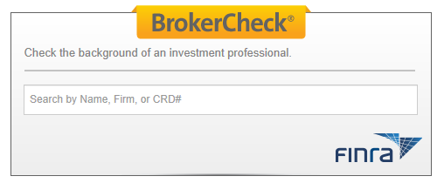

Type a few characters to see the dropdown displayed below:

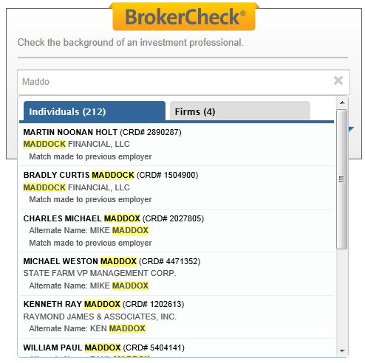

Select an item from the dropdown to see the results screen displayed below:



#### Questions and Support Issues:

Should you have any questions or need further technical support installing the BrokerCheck widget, please email us at DL_InvestorServices@finra.org.