Activation Functions in Deep Learning
Equations • Graphs • Advantages • Disadvantages • Applications

1. Introduction
An activation function is a mathematical function applied to the weighted sum produced by a neuron. It introduces non-linearity, allowing a neural network to learn complex relationships.
For a neuron:
z = w₁x₁ + w₂x₂ + … + wₙxₙ + b
a = f(z)
Here, x represents inputs, w represents weights, b is the bias, z is the weighted sum, and a is the activated output.

2. Why Are Activation Functions Required?
- Without activation functions, a network containing only linear transformations remains equivalent to a linear transformation, even if it has many layers.
- Activation functions introduce non-linearity.
- They determine how strongly a neuron responds to its input.
- They are essential for learning complex patterns in images, text, speech, and other data.

3. Binary Step Function
f(z) = 1 if z ≥ 0; f(z) = 0 if z < 0
The output changes abruptly from 0 to 1 at zero.
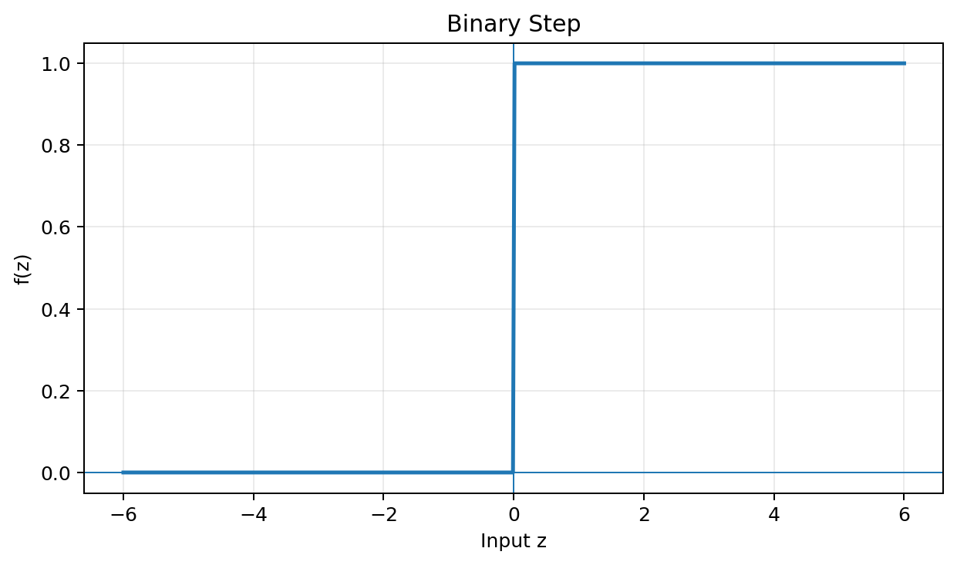

Advantages:
- Very simple and computationally inexpensive.
- Useful for understanding the original perceptron.

Disadvantages:
- Not differentiable at zero.
- Derivative is zero almost everywhere, so it is unsuitable for standard gradient-based backpropagation.
- Rarely used in modern deep networks.

Typical applications:
Basic perceptron and threshold decision systems.

4. Linear Activation Function
f(z) = z; f′(z) = 1
The output is directly proportional to the input.
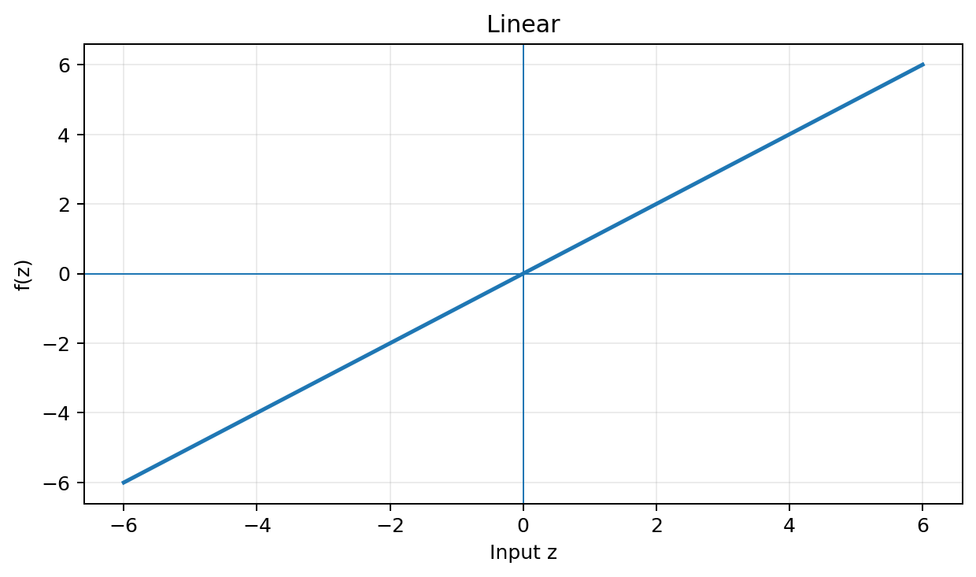

Advantages:
- Simple and fast.
- Useful when the output can take any real value.

Disadvantages:
- Does not introduce non-linearity.
- Multiple linear layers still collapse to a single linear transformation.
- Not suitable as the main hidden-layer activation in deep networks.

Typical applications:
Regression output layers.

5. Sigmoid Function
f(z) = 1 / (1 + e^(−z)); f′(z) = f(z)[1 − f(z)]
Maps any real-valued input to a value between 0 and 1. At z = 0, the output is 0.5.
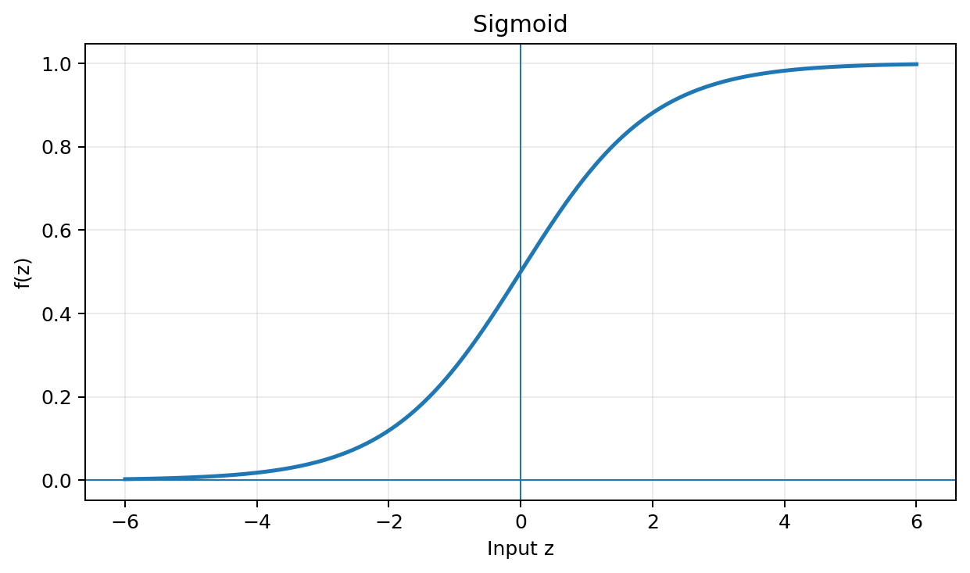

Advantages:
- Smooth and differentiable.
- Output can be interpreted as a probability.
- Useful for binary classification output.

Disadvantages:
- Can suffer from vanishing gradients when saturated.
- Not zero-centered.
- Exponential calculation is more expensive than ReLU.

Typical applications:
Output layer of binary classification.

6. Tanh Function
f(z) = tanh(z) = (e^z − e^(−z)) / (e^z + e^(−z)); f′(z) = 1 − tanh²(z)
Maps input to a range between −1 and +1 and is zero-centered.
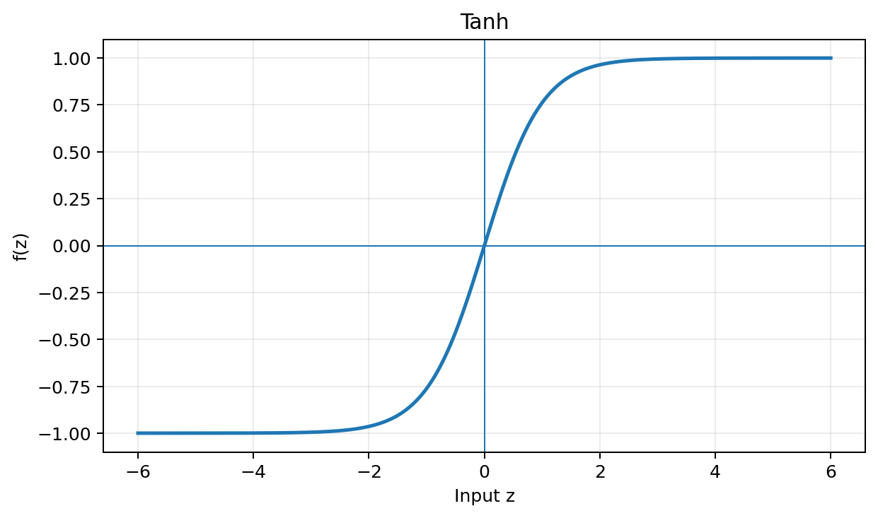

Advantages:
- Zero-centered.
- Smooth and differentiable.
- Often more suitable than sigmoid for hidden representations in some architectures.

Disadvantages:
- Can suffer from vanishing gradients.
- Saturates for large positive and negative inputs.
- More computationally expensive than ReLU.

Typical applications:
Some hidden layers and recurrent neural network architectures.

7. ReLU (Rectified Linear Unit)
f(z) = max(0,z)
Outputs zero for negative inputs and the input itself for positive inputs. Its derivative is 0 for z < 0 and 1 for z > 0.
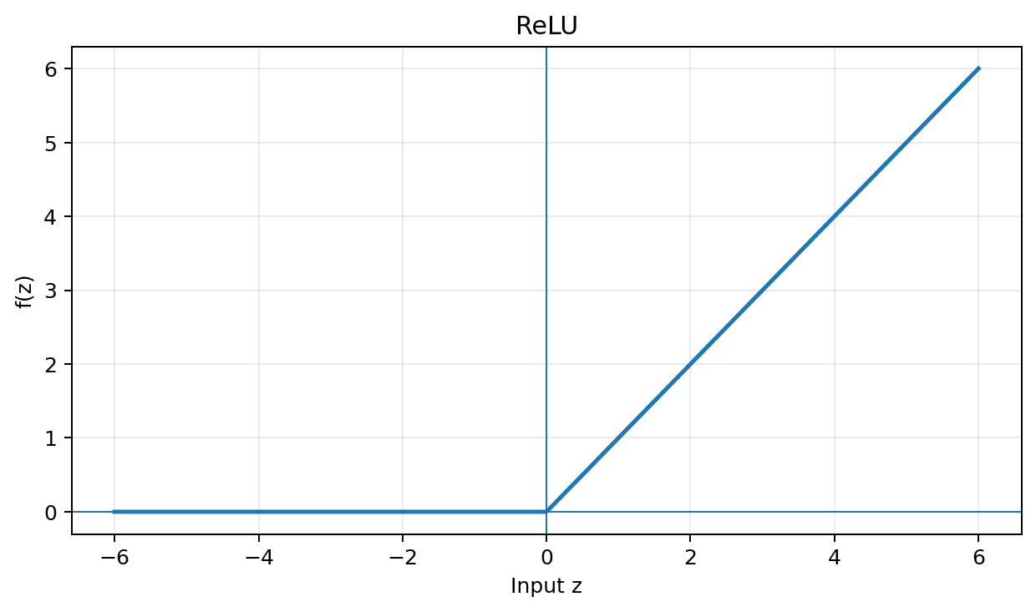

Advantages:
- Simple and fast.
- Helps reduce vanishing gradients for positive inputs.
- Creates sparse activations.
- A strong default choice for many hidden layers.

Disadvantages:
- Can suffer from the dying ReLU problem.
- Negative inputs produce zero output and zero gradient.

Typical applications:
Hidden layers of deep neural networks and CNNs.

8. Leaky ReLU
f(z) = αz if z < 0; f(z) = z if z ≥ 0; commonly α = 0.01
Keeps a small non-zero slope for negative inputs.
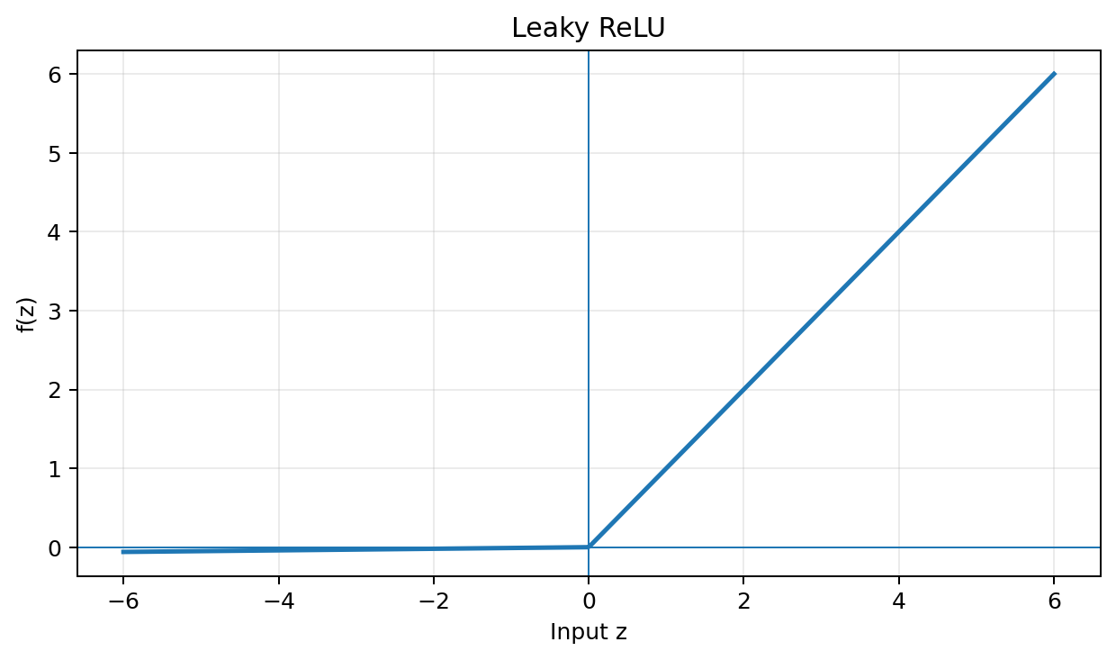

Advantages:
- Reduces the dying ReLU problem.
- Simple and computationally efficient.
- Allows gradient flow for negative inputs.

Disadvantages:
- Requires choosing α.
- The chosen slope may not be optimal for every problem.
- Does not always outperform standard ReLU.

Typical applications:
Alternative hidden-layer activation when ReLU causes inactive neurons.

9. PReLU (Parametric ReLU)
f(z) = αz if z < 0; f(z) = z if z ≥ 0
Similar to Leaky ReLU, but α is learned during training.
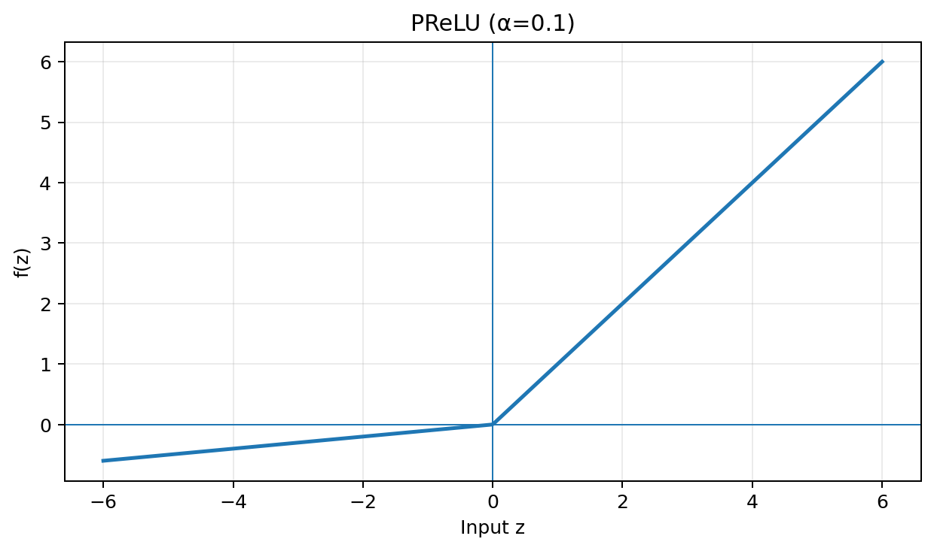

Advantages:
- Negative slope is learned automatically.
- Reduces the dying ReLU problem.
- Provides additional flexibility.

Disadvantages:
- Adds trainable parameters.
- Can increase model complexity and overfitting risk.

Typical applications:
Some deep neural networks and computer vision architectures.

10. ELU (Exponential Linear Unit)
f(z) = z if z > 0; f(z) = α(e^z − 1) if z ≤ 0
The positive region is linear, while the negative region smoothly approaches −α.
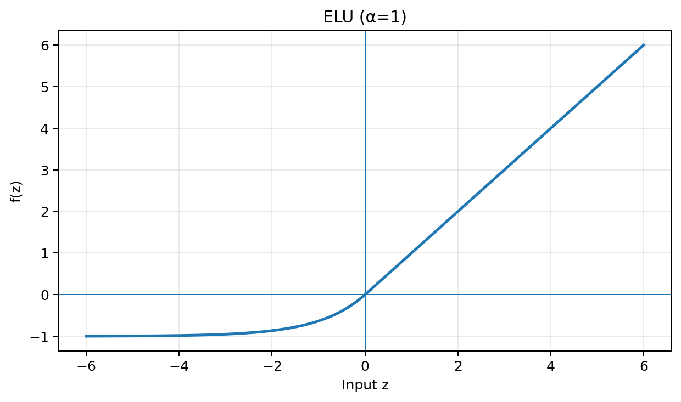

Advantages:
- Allows negative outputs.
- Smooth negative region.
- Can reduce some problems associated with dead neurons.

Disadvantages:
- More computationally expensive than ReLU.
- Requires the α hyperparameter.
- Not always necessary for simple models.

Typical applications:
Some deep neural networks as an alternative to ReLU.

11. SELU (Scaled Exponential Linear Unit)
f(z) = λz if z > 0; f(z) = λα(e^z − 1) if z ≤ 0
SELU is designed to encourage self-normalizing behavior under suitable network conditions.
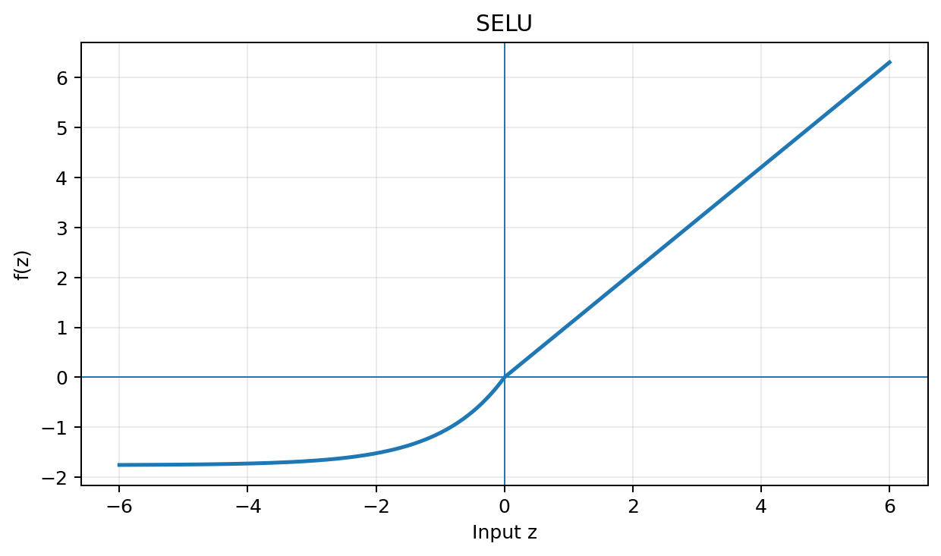

Advantages:
- Can help maintain stable activation statistics.
- Designed for self-normalizing neural networks.

Disadvantages:
- Works best under specific architectural conditions.
- Usually paired with suitable initialization and network design.
- Less commonly used than ReLU.

Typical applications:
Self-normalizing neural networks.

12. Softmax Function
Softmax converts a vector of logits into a probability distribution. For K classes:
f(zᵢ) = e^(zᵢ) / Σⱼ e^(zⱼ)
Example logits: [2.0, 1.0, 0.1]. The corresponding probabilities are approximately [0.659, 0.242, 0.099].
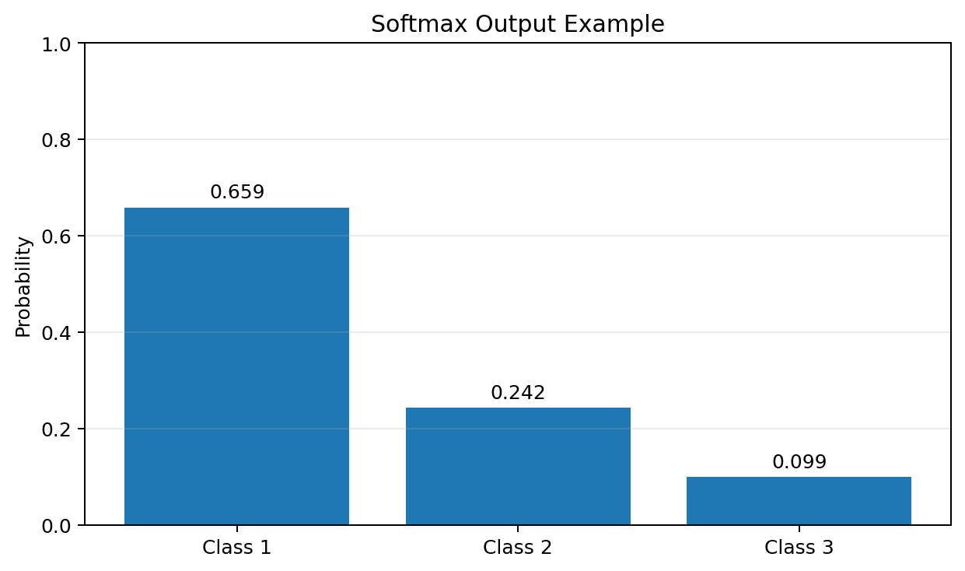

Advantages:
- Produces probabilities that sum to 1.
- Natural choice for multi-class classification output.
- Works well with categorical cross-entropy loss.

Disadvantages:
- Normally used in the output layer rather than hidden layers.
- Very large logits require numerically stable implementation.
- A class with a low logit can receive a very small probability.
Typical applications: multi-class image, text, and digit classification.

13. Comparison of Activation Functions
Function | Output Range | Main Strength | Main Limitation | Typical Use
Binary Step | 0 or 1 | Simple threshold | Not gradient-friendly | Basic perceptron
Linear | −∞ to +∞ | Simple; no saturation | No non-linearity | Regression output
Sigmoid | 0 to 1 | Probability output | Vanishing gradients | Binary classification output
Tanh | −1 to 1 | Zero-centered | Vanishing gradients | Some hidden/RNN layers
ReLU | 0 to +∞ | Fast and effective | Dying ReLU | Hidden layers
Leaky ReLU | −∞ to +∞ | Non-zero negative gradient | Requires α | Hidden layers
PReLU | −∞ to +∞ | Learned negative slope | Extra parameters | Deep networks
ELU | −α to +∞ | Smooth negative side | More computation | Deep networks
SELU | Scaled range | Self-normalization | Specific conditions | Self-normalizing networks
Softmax | 0 to 1 | Class probabilities | Output-layer focused | Multi-class classification

14. Activation Functions and Vanishing Gradient
During backpropagation, gradients are propagated through layers using the chain rule. If activation-function derivatives are repeatedly very small, the gradient can become extremely small.
For a sequence of layers, the chain rule contains products such as:
∂L/∂w ≈ (∂L/∂a)(∂a/∂z)(∂z/∂w)
Sigmoid and tanh can have very small derivatives in their saturated regions. ReLU avoids this for positive inputs because its derivative is 1 there, although it can produce the dying ReLU problem for negative inputs.

15. Which Activation Function Should You Choose?
Problem / Layer | Common Choice | Reason
Hidden layers | ReLU | Simple, fast, and effective starting point
Hidden layers when dead neurons are a concern | Leaky ReLU / PReLU / ELU | Provides a negative-side gradient
Binary classification output | Sigmoid | Produces a value between 0 and 1
Multi-class classification output | Softmax | Produces class probabilities summing to 1
Regression output | Linear | Allows unrestricted real-valued predictions

16. Key Takeaway
The basic neuron flow is:
Inputs → Weighted Sum → Activation Function → Output
z = Σ wᵢxᵢ + b
a = f(z)
For beginners, the most important functions to understand deeply are Sigmoid, Tanh, ReLU, Leaky ReLU, and Softmax. The correct choice depends on whether the function is used in a hidden layer or output layer and on the type of machine-learning problem.

