Loss Functions in Machine Learning and Deep Learning
Regression vs Classification • Mathematical Equations • Graphs • Advantages • Disadvantages

1. What Is a Loss Function?
A loss function is a mathematical function that measures how far a model's prediction is from the actual target. During training, the neural network tries to minimize this loss by using backpropagation and an optimizer.
For a single prediction, the error (residual) can be written as:
e = y − ŷ
where y is the actual value and ŷ is the predicted value.
The general training flow is:
Input → Weighted Sum → Activation → Prediction → Loss → Backpropagation → Weight Update

2. How Loss Functions Are Segregated
Loss functions can be broadly organized according to the type of prediction problem:
- Regression: predicts a continuous numerical value. Common losses include MSE, RMSE, MAE, Huber Loss, and Log-Cosh Loss.
- Binary classification: predicts one of two classes. Binary Cross-Entropy is the standard neural-network loss.
- Multi-class classification: predicts one class among multiple classes. Categorical Cross-Entropy and Sparse Categorical Cross-Entropy are common.
- Margin-based classification: Hinge Loss is important in Support Vector Machines and can also be used in some neural-network settings.
- Imbalanced classification: Focal Loss gives more attention to difficult examples.

3. Regression Loss Functions
Regression predicts continuous values such as house price, salary, temperature, sales, or marks. Regression losses generally compare the numerical difference between y and ŷ.

3.1 Mean Squared Error (MSE)
MSE is the average of squared prediction errors.
MSE = (1/n) Σᵢ (yᵢ − ŷᵢ)²
Example: if errors are 2, −5, and 2, MSE = (4 + 25 + 4)/3 = 11.
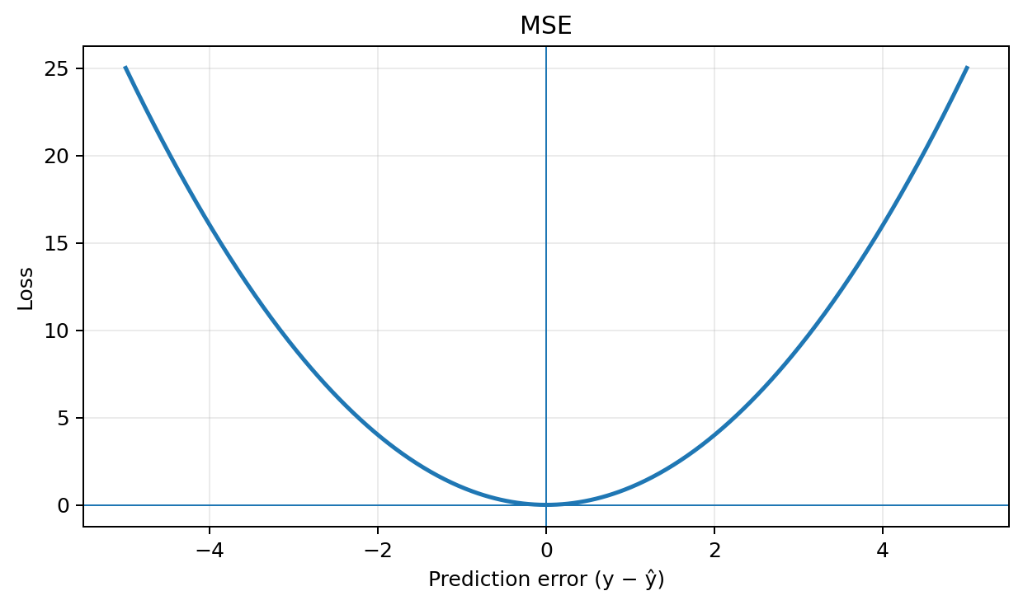
Graph interpretation: MSE gives very large errors more influence because the error is squared.

Advantages
- Simple and widely used.
- Differentiable and convenient for gradient descent.
- Strongly penalizes large errors.

Disadvantages
- Sensitive to outliers.
- A few very large errors can dominate the loss.
Typical use: Regression, especially when large errors should be strongly penalized.

3.2 Mean Absolute Error (MAE)
MAE takes the average absolute value of the prediction errors.
MAE = (1/n) Σᵢ |yᵢ − ŷᵢ|
Example: errors 2, −5, 2 give MAE = (2 + 5 + 2)/3 = 3.
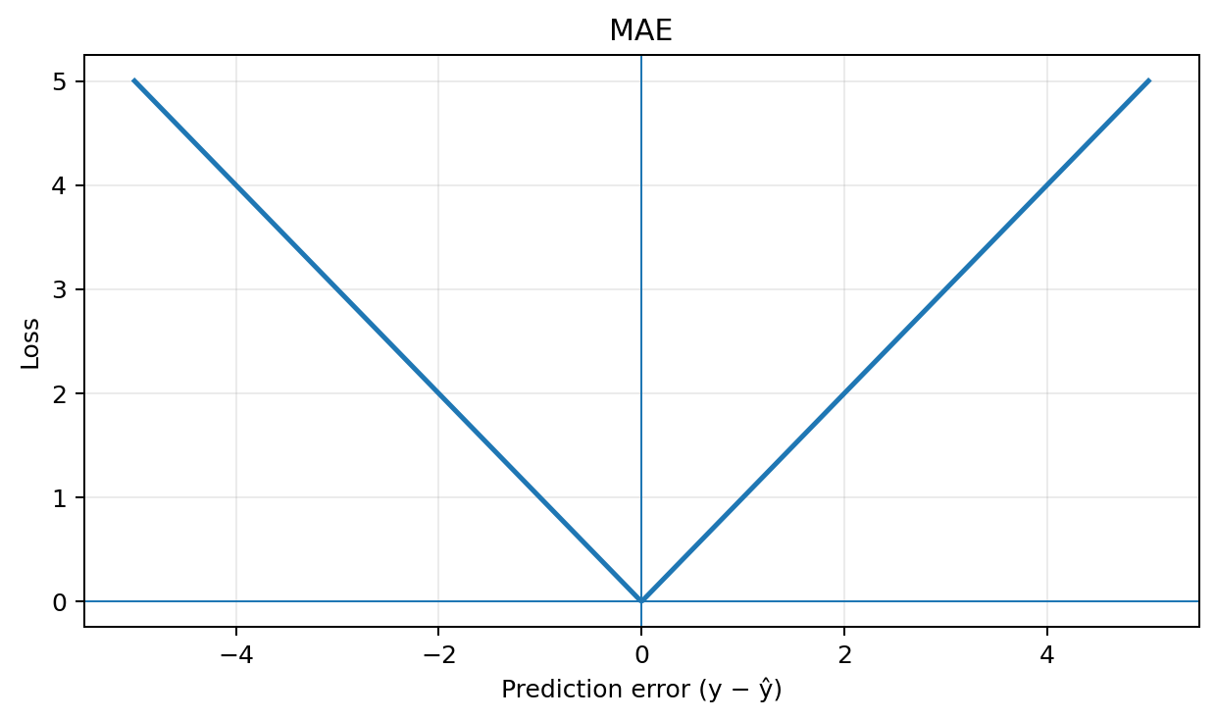
Graph interpretation: The graph is V-shaped because the absolute value is used.

Advantages
- Less sensitive to outliers than MSE.
- Easy to interpret in the target's units.

Disadvantages
- Not differentiable exactly at zero.
- Optimization can be less smooth than MSE.
Typical use: Regression when robustness to outliers is important.

3.3 Root Mean Squared Error (RMSE)
RMSE is the square root of MSE.
RMSE = √[(1/n) Σᵢ (yᵢ − ŷᵢ)²]
If MSE = 25, then RMSE = 5.

Advantages
- Penalizes large errors.
- Easy to interpret because it uses the original target units.

Disadvantages
- Sensitive to outliers.
- Usually used as an evaluation metric rather than a distinct training behavior.
Typical use: Regression evaluation and model comparison.

3.4 Huber Loss
Huber Loss behaves like MSE for small errors and like MAE for large errors.
Lδ(e) = ½e², if |e| ≤ δ; δ(|e| − ½δ), if |e| > δ
For δ = 1, errors inside −1 to +1 use the quadratic part; larger errors use the linear part.
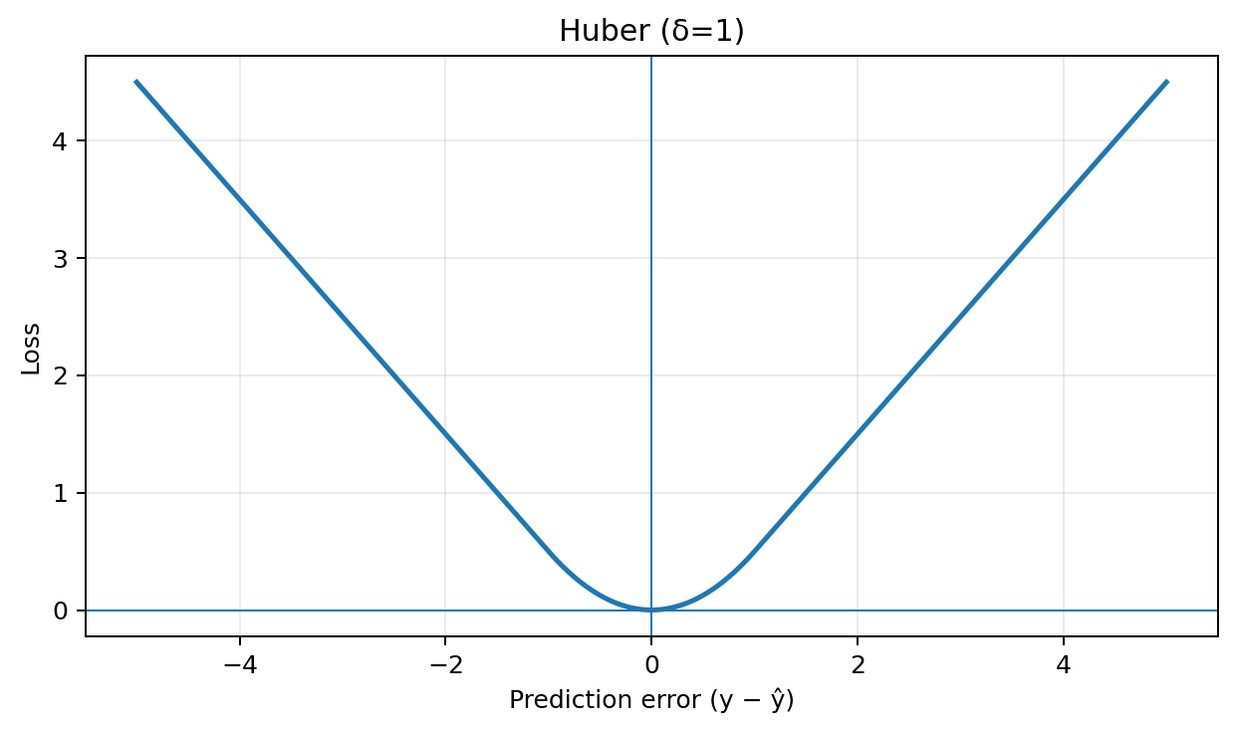
Graph interpretation: The graph is quadratic near zero and linear for large positive or negative errors.

Advantages
- More robust to outliers than MSE.
- Smooth around the transition point.
- Combines useful properties of MSE and MAE.

Disadvantages
- Requires choosing δ.
- Slightly more complicated than MSE or MAE.
Typical use: Regression with occasional outliers.

3.5 Log-Cosh Loss
Log-Cosh is a smooth regression loss based on the logarithm of the hyperbolic cosine.
L(e) = log(cosh(e))
For small errors it behaves approximately like e²/2; for large errors it behaves approximately like |e| − log(2).
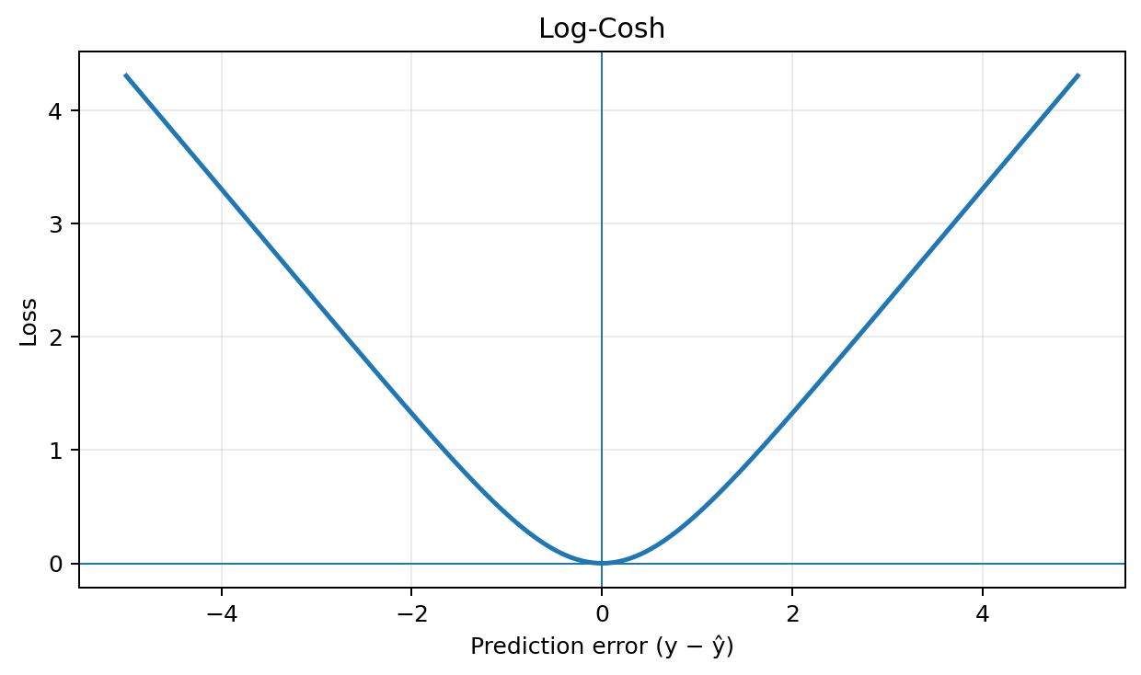
Graph interpretation: It is smooth like MSE near zero but less sensitive to extreme errors.

Advantages
- Smooth and differentiable.
- More robust to extreme errors than MSE.

Disadvantages
- More computationally expensive.
- Less common than MSE, MAE, and Huber Loss.
Typical use: Robust regression.

4. Classification Loss Functions
Classification predicts a class rather than a continuous numerical value. In neural networks, the loss is usually based on predicted probabilities and the true class.

4.1 Binary Cross-Entropy (BCE)
Binary Cross-Entropy is the standard loss for binary classification when the model produces a probability using Sigmoid.
For one sample:
L = −[y log(ŷ) + (1 − y) log(1 − ŷ)]
For n samples:
BCE = −(1/n) Σᵢ [yᵢ log(ŷᵢ) + (1 − yᵢ) log(1 − ŷᵢ)]
Example: if y = 1 and ŷ = 0.9, L = −log(0.9) ≈ 0.105. If y = 1 and ŷ = 0.1, L ≈ 2.303.
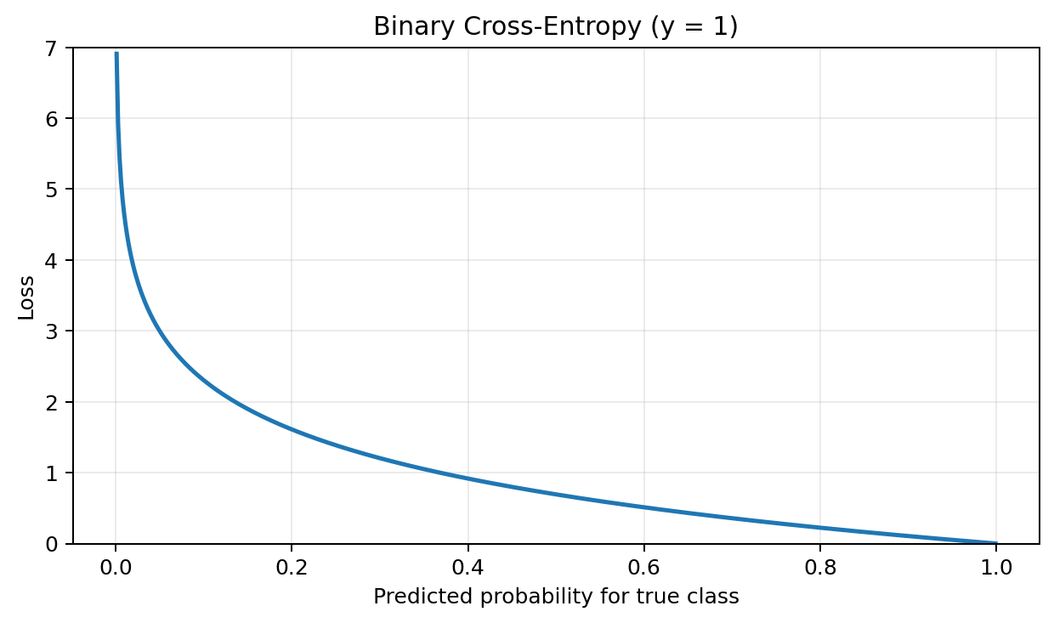
Graph interpretation: for a true positive class (y = 1), the loss approaches zero when the predicted probability approaches 1 and becomes very large when the predicted probability approaches 0.

Advantages
- Excellent for binary classification.
- Works naturally with Sigmoid output.
- Strongly penalizes confident wrong predictions.
- Differentiable and suitable for gradient-based optimization.

Disadvantages
- Confidently incorrect predictions can produce very large loss.
- Requires probability-based predictions.
Typical use: binary classification output layer.

4.2 Categorical Cross-Entropy (CCE)
Categorical Cross-Entropy is commonly used for multi-class classification with one-hot encoded targets.
L = − Σₖ yₖ log(ŷₖ)
For n samples: L = −(1/n) Σⱼ Σₖ yⱼₖ log(ŷⱼₖ)
Typical combination: Softmax output + Categorical Cross-Entropy.
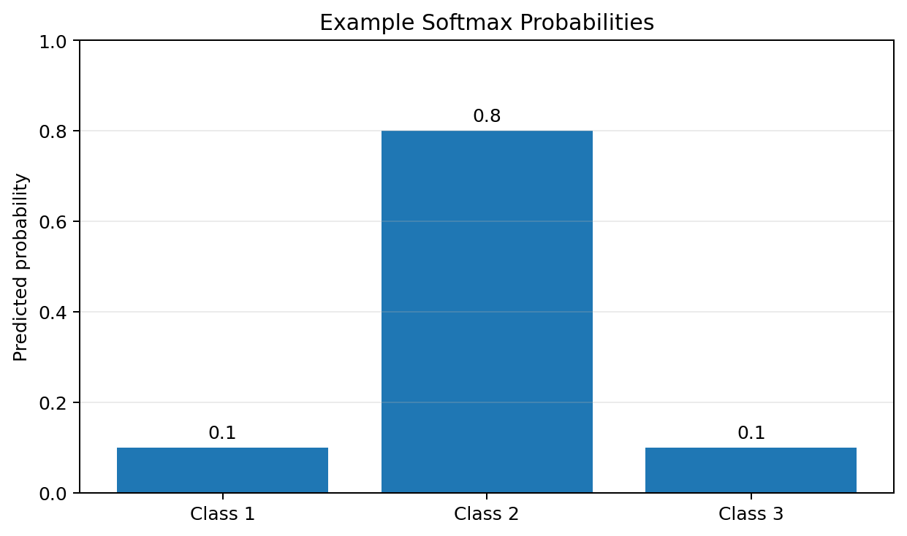
Example: actual class = [0, 1, 0], predicted probabilities = [0.1, 0.8, 0.1]. Loss = −log(0.8) ≈ 0.223.

Advantages
- Natural choice for multi-class classification.
- Works well with Softmax.
- Penalizes incorrect probability assignments.

Disadvantages
- Sensitive to confidently incorrect predictions.
- Designed for probability distributions and one-hot style targets.
Typical use: multi-class classification with one-hot encoded labels.

4.3 Sparse Categorical Cross-Entropy
Sparse Categorical Cross-Entropy uses an integer class label instead of a one-hot vector.
For the correct class k:
L = −log(ŷₖ)
Example: actual label = 1 and prediction = [0.1, 0.8, 0.1]. The loss is −log(0.8) ≈ 0.223.
Difference: Categorical Cross-Entropy uses a target such as [0, 1, 0], while Sparse Categorical Cross-Entropy uses the integer 1 for the same class.
Typical use: multi-class classification when class labels are stored as integers.

4.4 Hinge Loss
Hinge Loss is strongly associated with Support Vector Machines and margin-based classification.
L = max(0, 1 − yŷ), where y ∈ {−1, +1}.
Example: if y = +1 and ŷ = 2, L = 0. If y = +1 and ŷ = 0.5, L = 0.5.
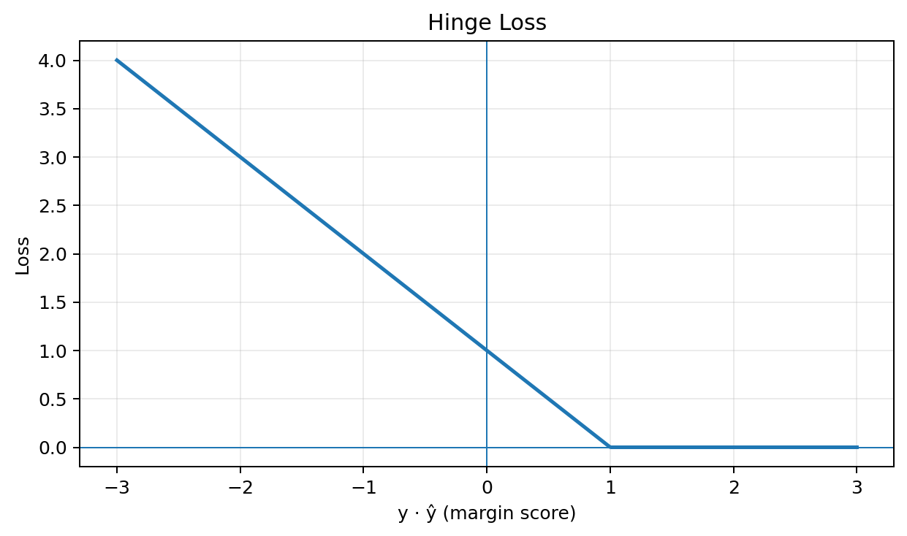
Graph interpretation: the loss becomes zero once the required margin is reached and increases linearly when the margin is insufficient.

Advantages
- Encourages a classification margin.
- Simple mathematical form.
- Important in SVMs.

Disadvantages
- Does not directly produce probabilities.
- Less common than cross-entropy for modern neural networks.

4.5 Focal Loss
Focal Loss is designed for highly imbalanced classification problems. It reduces the contribution of easy examples and focuses training on difficult examples.
A common binary form is:
FL(pₜ) = −α(1 − pₜ)^γ log(pₜ)
Here pₜ is the probability assigned to the true class, α is a weighting factor, and γ controls how strongly easy examples are down-weighted.
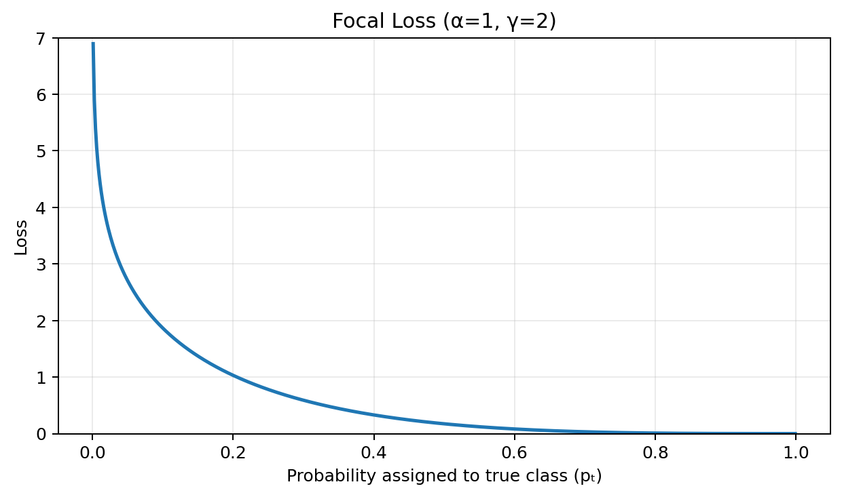
The displayed graph uses α = 1 and γ = 2.

Advantages
- Useful for severe class imbalance.
- Focuses learning on hard examples.
- Common in object-detection systems.

Disadvantages
- Requires additional hyperparameters.
- More complicated than standard cross-entropy.

5. Regression vs Classification: Quick Comparison
Problem | Loss | Equation / Idea | Typical Use
Regression | MSE | Average squared error | General regression
Regression | MAE | Average absolute error | Robust regression
Regression | RMSE | √MSE | Regression evaluation
Regression | Huber | Quadratic for small errors, linear for large errors | Regression with outliers
Regression | Log-Cosh | log(cosh(error)) | Smooth robust regression
Binary classification | Binary Cross-Entropy | −[y log(p)+(1−y)log(1−p)] | Sigmoid output
Multi-class classification | Categorical Cross-Entropy | −Σ yₖ log(pₖ) | Softmax + one-hot labels
Multi-class classification | Sparse Categorical CE | −log(p of correct class) | Softmax + integer labels
Margin classification | Hinge | max(0,1−yŷ) | SVM / margin-based models
Imbalanced classification | Focal Loss | −α(1−pₜ)^γ log(pₜ) | Hard-example focused learning

6. Important Activation + Loss Combinations
Regression: Linear output + MSE / MAE / Huber — The output can represent any real-valued prediction.
Binary classification: Sigmoid + Binary Cross-Entropy — Sigmoid produces a probability between 0 and 1.
Multi-class classification: Softmax + Categorical Cross-Entropy — Softmax produces class probabilities that sum to 1.
Multi-class classification with integer labels: Softmax + Sparse Categorical Cross-Entropy — The target is stored as one class index.
Imbalanced classification: Sigmoid/Softmax + Focal Loss — Focal Loss emphasizes difficult examples.

7. Loss Function in Backpropagation
The loss provides the signal that tells the neural network how wrong its prediction is. Backpropagation computes gradients of the loss with respect to the model parameters.
A simplified weight-update equation is:
w_new = w_old − η (∂L/∂w)
where η is the learning rate. The optimizer uses these gradients to reduce the loss over training iterations.

8. What You Should Remember
- MSE: squares errors and strongly penalizes large errors.
- MAE: uses absolute errors and is more robust to outliers.
- RMSE: square root of MSE and has the same units as the target.
- Huber: combines quadratic behavior for small errors with linear behavior for large errors.
- Binary Cross-Entropy: standard loss for binary classification with Sigmoid.
- Categorical Cross-Entropy: standard loss for multi-class classification with one-hot targets.
- Sparse Categorical Cross-Entropy: multi-class loss with integer class labels.
- Hinge Loss: margin-based classification loss, especially important for SVMs.
- Focal Loss: useful when classes are imbalanced and hard examples need more attention.

