Optimizers and Gradient Descent in Deep Learning
Mathematical foundations, algorithms, equations, intuition, and illustrative graphs

1. Introduction
An optimizer is an algorithm that updates the trainable parameters of a neural network so that the model minimizes a loss function. During training, the network performs forward propagation, calculates the loss, computes gradients through backpropagation, and then uses an optimizer to update weights and biases.
- Loss function → measures prediction error.
- Gradient → indicates the direction and rate of increase of the loss.
- Optimizer → decides how parameters should be changed using the gradients.
- Learning rate → controls the size of each parameter update.

2. Basic Optimization Problem
Let the trainable parameters be θ and the loss function be J(θ). The objective is:
θ* = arg min_θ J(θ)
For a single parameter w, the derivative dJ/dw tells us how the loss changes when w changes.
w_(t+1) = w_t − η · dJ/dw
Here, η (eta) is the learning rate. The minus sign is used because the gradient points toward increasing loss; moving in the opposite direction tends to reduce the loss.

3. Gradient Descent
Gradient Descent is the fundamental optimization method behind many neural-network optimizers. For multiple parameters, the derivative becomes a gradient vector.
θ_(t+1) = θ_t − η ∇J(θ_t)
where ∇J(θ) contains the partial derivatives with respect to every trainable parameter.
∇J(θ) = [∂J/∂θ₁, ∂J/∂θ₂, …, ∂J/∂θₙ]^T
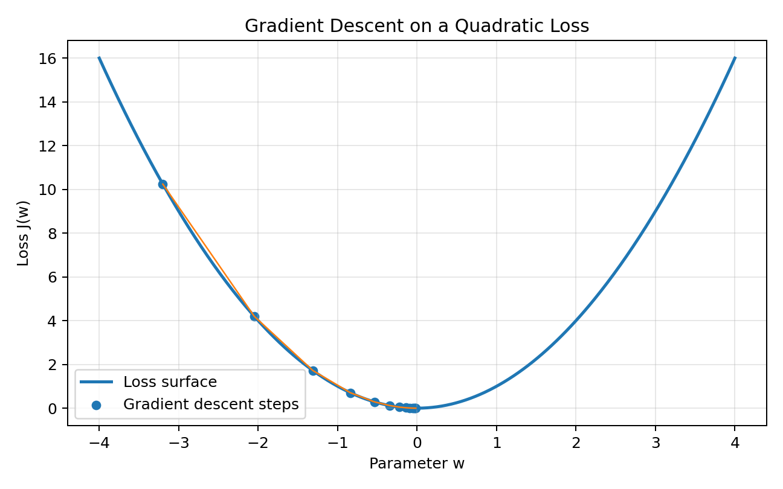
Figure 1. Gradient descent moves down a simple quadratic loss toward its minimum.

4. Types of Gradient Descent

4.1 Batch Gradient Descent
Batch Gradient Descent calculates the gradient using the entire training dataset before making one update.
θ_(t+1) = θ_t − η (1/N) Σᵢ₌₁ᴺ ∇_θ Lᵢ(θ_t)
- Advantage: stable and deterministic gradient estimates.
- Disadvantage: expensive for very large datasets.
- Best suited to: smaller datasets or situations where full-batch optimization is practical.

4.2 Stochastic Gradient Descent (SGD)
SGD updates the parameters using one randomly selected training example at a time.
θ_(t+1) = θ_t − η ∇_θ Lᵢ(θ_t)
- Very frequent updates.
- Can be noisy, which can sometimes help escape shallow regions.
- Usually less computationally efficient per update than mini-batches on modern hardware.

4.3 Mini-Batch Gradient Descent
Mini-batch Gradient Descent uses a small batch of examples, such as 32, 64, or 128 samples, to estimate the gradient.
θ_(t+1) = θ_t − η (1/B) Σᵢ₌₁ᴮ ∇_θ Lᵢ(θ_t)
- Balances the stability of batch GD with the efficiency of SGD.
- Works well with GPUs and vectorized matrix operations.
- This is the practical foundation of most modern deep-learning training.

5. Learning Rate
The learning rate η is one of the most important hyperparameters. A value that is too small can make training very slow; a value that is too large can cause overshooting, oscillation, or divergence.
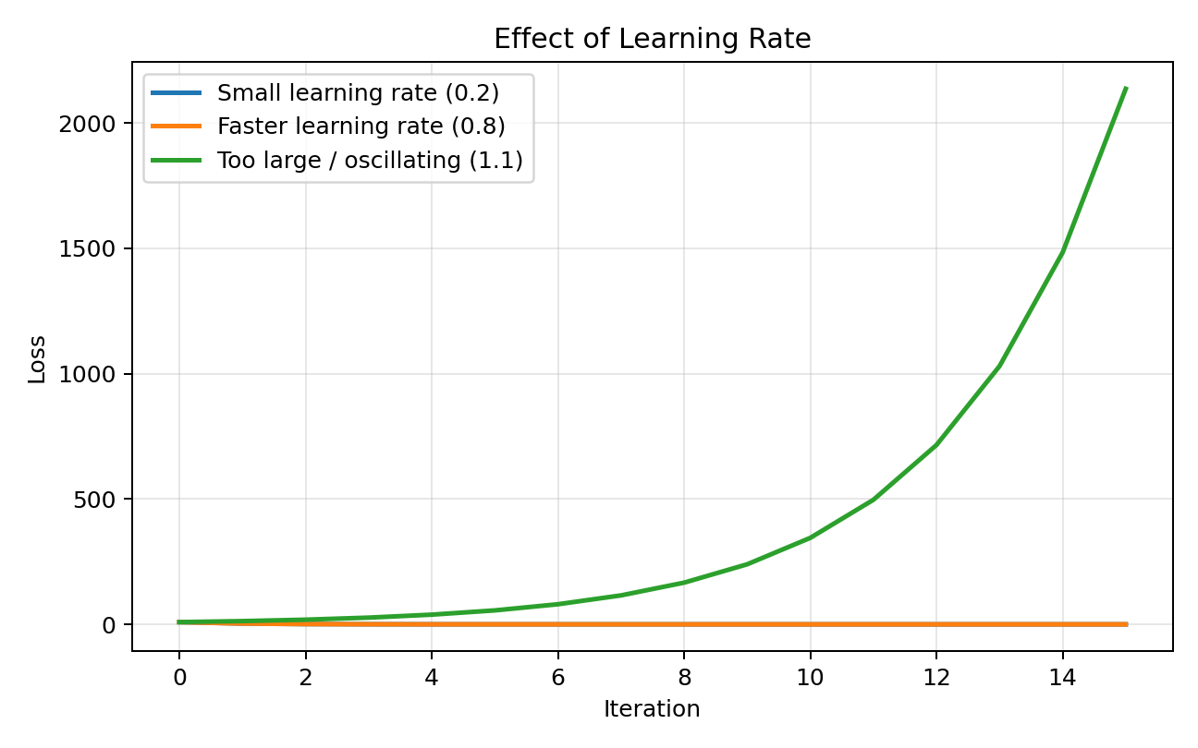
Figure 2. Illustrative effect of different learning rates on a quadratic loss.

6. Momentum
Momentum adds a velocity term so that updates accumulate information from previous gradients. This can reduce zig-zagging and accelerate movement in consistent directions.
v_t = β v_(t−1) + ∇J(θ_t)
θ_(t+1) = θ_t − η v_t
β is the momentum coefficient. A commonly used value is around 0.9, although the best value depends on the problem and optimizer configuration.
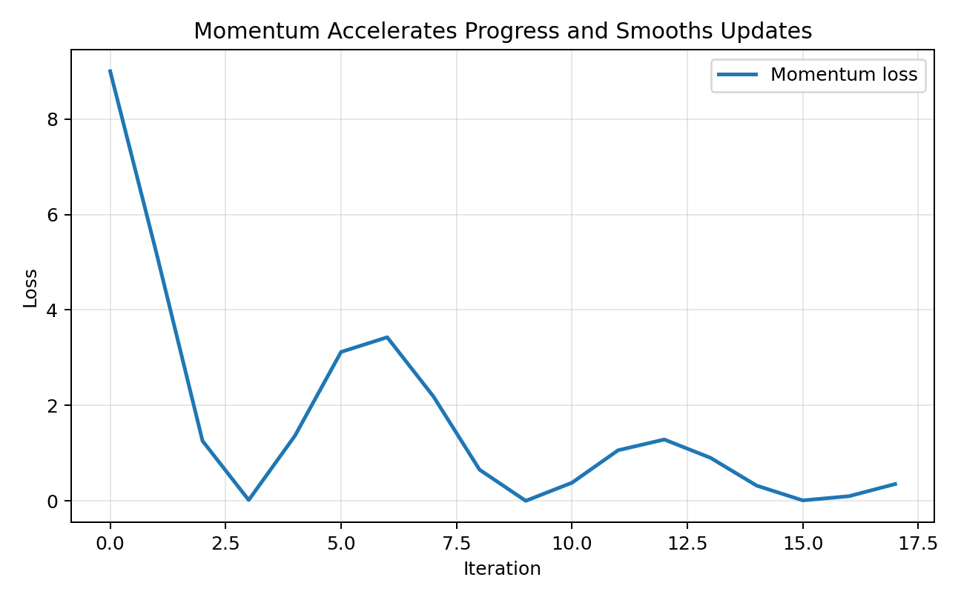
Figure 3. Illustrative momentum behavior on a quadratic objective.

7. Nesterov Accelerated Gradient (NAG)
Nesterov momentum evaluates the gradient at a look-ahead position rather than exactly at the current parameter value. The idea is to anticipate the direction of the accumulated momentum.
v_t = β v_(t−1) + ∇J(θ_t − ηβv_(t−1))
θ_(t+1) = θ_t − η v_t
NAG can provide a more informed correction than conventional momentum in some optimization problems.

8. Adaptive Learning-Rate Optimizers

8.1 AdaGrad
AdaGrad adapts the learning rate for each parameter using the accumulated squared gradients.
G_t = G_(t−1) + g_t ⊙ g_t
θ_(t+1) = θ_t − η · g_t / (√G_t + ε)
- Useful when features or parameters have very different frequencies.
- Learning rates continually shrink because squared gradients accumulate.
- The continual shrinkage can eventually make learning too slow.

8.2 RMSProp
RMSProp addresses AdaGrad's aggressive accumulation by using an exponentially weighted moving average of squared gradients.
s_t = ρs_(t−1) + (1−ρ)g_t²
θ_(t+1) = θ_t − η · g_t / (√s_t + ε)
- Adapts the step size separately for parameters.
- Helps handle non-stationary objectives.
- Often performs better than AdaGrad on deep-learning problems.

9. Adam (Adaptive Moment Estimation)
Adam combines ideas from Momentum and RMSProp. It maintains an exponentially weighted estimate of the first moment (mean) and second raw moment (uncentered variance) of the gradients.
m_t = β₁m_(t−1) + (1−β₁)g_t
v_t = β₂v_(t−1) + (1−β₂)g_t²
Because m_t and v_t start at zero, Adam applies bias correction:
m̂_t = m_t / (1−β₁^t)
v̂_t = v_t / (1−β₂^t)
θ_(t+1) = θ_t − η · m̂_t / (√v̂_t + ε)
- Common default-style values: β₁ ≈ 0.9, β₂ ≈ 0.999, and a small ε.
- Usually converges quickly and requires relatively little manual learning-rate tuning.
- Widely used for neural networks, although SGD with momentum can sometimes generalize better.

10. AdamW
AdamW separates weight decay from the adaptive gradient update. This makes regularization behavior more direct than simply adding an L2 penalty inside the Adam gradient calculation.
θ_(t+1) = θ_t − η · m̂_t/(√v̂_t + ε) − ηλθ_t
AdamW is widely used in modern deep-learning training, especially when weight decay is an important regularization mechanism.

11. Adadelta
Adadelta modifies AdaGrad to reduce the dependence on a globally chosen learning rate by maintaining moving averages of squared gradients and squared parameter updates.
E[g²]_t = ρE[g²]_(t−1) + (1−ρ)g_t²
Δθ_t = − (RMS[Δθ]_(t−1) / RMS[g]_t) g_t
θ_(t+1) = θ_t + Δθ_t

12. Optimizer Comparison
Optimizer | Main idea | Learning rate | Strength | Limitation
Batch GD | Full dataset gradient | Fixed | Stable | Slow on large data
SGD | One sample per update | Fixed | Simple and frequent updates | Noisy
Mini-batch GD | Small batch gradient | Fixed | GPU-friendly | Needs batch-size choice
Momentum | Accumulate velocity | Fixed | Faster and smoother | Extra hyperparameter
NAG | Look-ahead momentum | Fixed | More anticipatory | More complex
AdaGrad | Accumulate squared gradients | Adaptive | Sparse features | Learning rate can shrink too much
RMSProp | Moving average of squared gradients | Adaptive | Good for changing objectives | Hyperparameter sensitive
Adam | First + second moments | Adaptive | Fast, strong default | Can generalize differently from SGD
AdamW | Adam + decoupled decay | Adaptive | Strong regularization behavior | Still needs tuning

13. Illustrative Convergence Graph
The following graph is illustrative rather than a benchmark. It shows the common intuition that different optimizers can produce different convergence trajectories on the same objective.
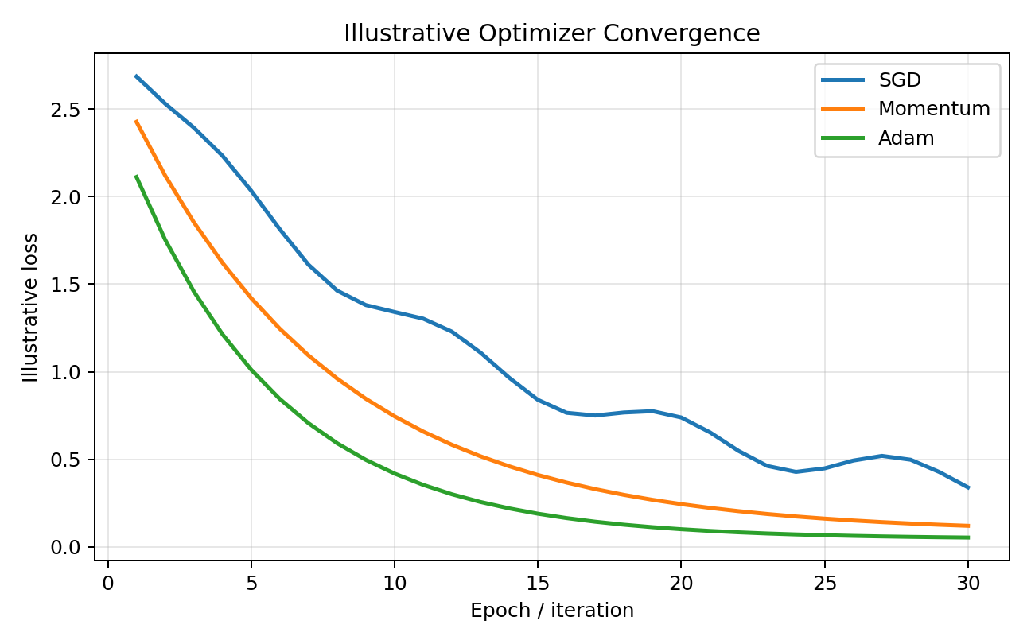
Figure 4. Illustrative loss curves for SGD, Momentum, and Adam.

14. Gradient Descent in a Neural Network
- Initialize weights and biases.
- Pass input data through the network using forward propagation.
- Calculate predictions.
- Calculate the loss using an appropriate loss function.
- Run backpropagation to calculate gradients.
- Pass the gradients to the optimizer.
- Update weights and biases.
- Repeat for many batches and epochs until training converges or a stopping condition is met.
For a parameter θ:
g_t = ∂J/∂θ
θ ← Optimizer(θ, g_t)

15. Simple Numerical Example
Suppose the loss is:
J(w) = w²
Then:
dJ/dw = 2w
Let w = 3 and learning rate η = 0.1.
g = 2(3) = 6
w_new = 3 − 0.1(6) = 2.4
The loss changes from J(3) = 9 to J(2.4) = 5.76, so the update moved toward the minimum at w = 0.

16. Loss Function, Gradient, and Optimizer Relationship
- Loss function answers: 'How wrong is the model?'
- Gradient answers: 'Which direction increases the loss, and how strongly?'
- Optimizer answers: 'How should I use the gradients to update the parameters?'
- Learning-rate scheduling answers: 'How should the step size change during training?'
Forward pass → Loss → Backpropagation → Gradients → Optimizer → Parameter update → Repeat

17. Learning-Rate Scheduling
A learning-rate scheduler changes η during training. Common strategies include step decay, exponential decay, cosine annealing, and plateau-based reduction.
η_t = η₀ · γ^t
In practice, scheduling can improve convergence after the initial rapid-learning phase.

18. Practical Selection Guide
- Start with Adam or AdamW for many deep-learning experiments.
- Try SGD with Momentum when training is stable and generalization is important.
- Use Mini-batch Gradient Descent as the basic training mechanism for most neural networks.
- Use RMSProp when an adaptive method is helpful and Adam is not behaving well.
- Use a validation set to compare optimizers rather than selecting only by training loss.
- Tune the learning rate before aggressively changing many other hyperparameters.

19. Key Takeaways
- Gradient descent is the foundation of neural-network parameter optimization.
- Batch GD uses all samples, SGD uses one sample, and mini-batch GD uses a subset.
- Momentum adds accumulated velocity to make optimization smoother and faster.
- AdaGrad, RMSProp, and Adam adapt the effective learning rate.
- Adam combines first- and second-moment estimates with bias correction.
- AdamW decouples weight decay from Adam's adaptive gradient update.
- The learning rate strongly affects convergence.
- There is no universally best optimizer; the choice depends on the model, dataset, objective, and generalization behavior.

20. Quick Formula Sheet
Method | Core equation
Gradient Descent | θ_(t+1) = θ_t − η∇J(θ_t)
Momentum | v_t = βv_(t−1) + g_t; θ_(t+1) = θ_t − ηv_t
NAG | v_t = βv_(t−1) + ∇J(θ_t − ηβv_(t−1))
AdaGrad | G_t = G_(t−1) + g_t²; θ_(t+1) = θ_t − ηg_t/(√G_t+ε)
RMSProp | s_t = ρs_(t−1)+(1−ρ)g_t²; θ_(t+1)=θ_t−ηg_t/(√s_t+ε)
Adam | m_t, v_t + bias correction; θ_(t+1)=θ_t−ηm̂_t/(√v̂_t+ε)
AdamW | Adam update − ηλθ_t

End of document

