PROJECT 6

Name: Eshwar Malalakere Renukaradhya

Student ID: 101645866

**1. INTRODUCTION:**

In this project we are performing image compression using Adaptive Resonance Theory neural network. 512x512 images are divided into blocks which becomes the input of ART neural network. Code book to reconstruct the images is obtained from the output of ART neural network.

**2. METHODOLOGY:**

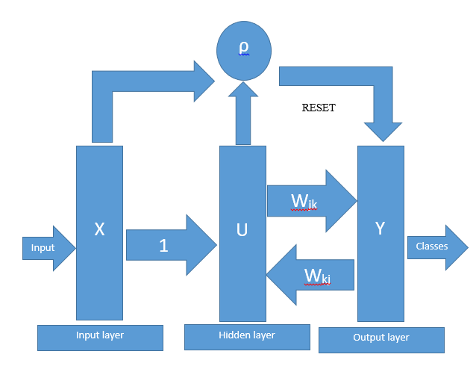

Figure 1. Layers of ART network

CREATE BLOCK CODE & CODE BOOK

BLOCKS

INPUT

ART

Figure 2. ART based image compression

**Image compression** is a technique of converting or encoding an image to reduce its size so that it consumes less space when compared to original image which helps in reduction of storage, cost and transmission.

Here the 512x512 image is divided into 32x32 size blocks. The block is converted to a vector of size 1x1024 which becomes the input to the ART neural network. The weight matrix obtained at the end becomes the code book. The values in the Block code have the corresponding weight vectors in the code book.

Adaptive Resonance Theory network is a simple unsupervised machine learning algorithm. Unsupervised learning algorithm uses input vector to make inferences instead of labels or ground truth.

An ART network is comprised of a comparison field and a recognition field. The comparison field corresponds to an input layer of the neural network and the recognition field corresponds to the output layer. The neurons in the comparison field and the recognition field are interconnected.

The input patterns are normalized. The recognition field neurons are activated when a new input vector is given to the network according to the connection weights. Here the weight matrix is acting like a category template. Category choice is calculated against the input pattern for each category.

CFJ =

Where ^ is the fuzzy AND operator defined by (a ^ b)i = min(ai ^ bi). To break ties we make use of choice parameter α.

The category which has the maximum CFJ is chosen. By comparing the vigilance threshold ρ with the matching function of winning node the category choice is calculated.

MFJ =

MFJ >= ρ

If the matching function of the winning node is greater than the vigilance parameter then it is classified as a match and mapped to the selected node.

WJK = β [WJK ^ UK] + (1 - β) WJK

If the node does not match that node is reset by assigning -1 and again category with maximum CFJ is selected. If all the existing nodes fail a new node is created.

CFJ = -1

The weight matrix obtained at the end is the code book, using which the image can be reconstructed using block code.

After reconstruction of image the following calculations are performed:

* Compression ratio =
* PSNR = 10 log10
* Mean Square Error = ∑(original pixel – reconstructed pixel)2 X (1/N)
* SNR = ∑(original pixel value)2/(error)2

**3. PROGRAM OUTLINE:**

LOAD THE IMAGE AND DIVIDE IT INTO BLOCKS

INITIALIZING WEIGHTS Wjk = 1

APPLY FIRST BLOCK

COMPUTE CFJ USING FUZZY AND LOGIC

IF MFJ IS GREATER, THEN UPDATE WEIGHTS

COMPARE MFJ WITH VIGILANCE PARAMETER

COMPUTE MFJ FOR THE INDEX VALUE OF MAXIMUM CFJ

FIND MAXIMUM CFJ

IF MFJ IS LESSER, THEN RESET Jth NODE

IF ALL EXISTING NODES FAIL CREATE A NEW NODE

Repeat for all BLOCKS

CERATE BLOCK CODE USING LABELS

THE WEIGHT MATRIX IS THE CODE BOOK

RECONSTRUCT THE IMAGE USING BLOCK CODE AND CODE BOOK

CALCULATE COMPRESSION RATIO, MSE, PSNR, SNR

DISPLAY ORIGINAL AND RECONSTRUCTED IMAGES

Figure 3. Program flow chart

**4. RESULTS:**

**Image 1:** Here the 512x512 image is divided into 32x32 size blocks. The block is converted to a vector of size 1x1024 which becomes the input to the ART neural network. The value of vigilance parameter is 0.95 and learning rate is 0.7. The following observations are made:

Compression ratio = 1.1118, MSE = 24.1303, PSNR = 34.3052 dB, SNR = 28.3506 dB.

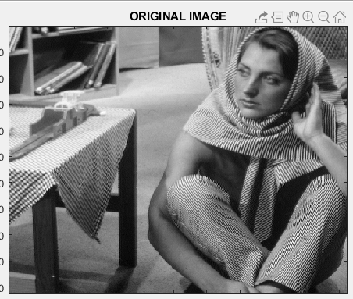

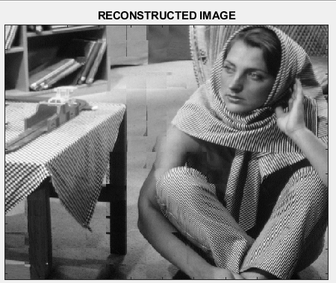

**Image 2:** Here the 512x512 image is divided into 32x32 size blocks. The block is converted to a vector of size 1x1024 which becomes the input to the ART neural network. The value of vigilance parameter is 0.95 and learning rate is 0.7. The following observations are made:

Compression ratio = 1.1315, MSE = 26.5063, PSNR = 33.8973 dB, SNR = 27.5704 dB.

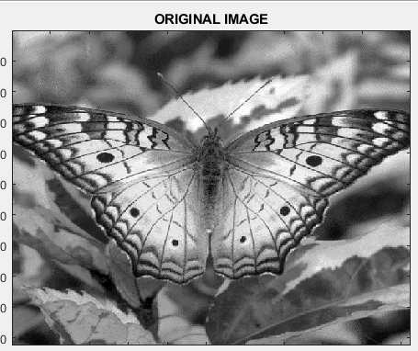

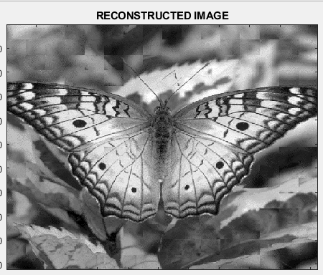

**Image 3:** Here the 512x512 image is divided into 32x32 size blocks. The block is converted to a vector of size 1x1024 which becomes the input to the ART neural network. The value of vigilance parameter is 0.95 and learning rate is 0.7. The following observations are made:

Compression ratio = 1.6384, MSE = 65.7260, PSNR = 29.9534 dB, SNR = 19.9758 dB.

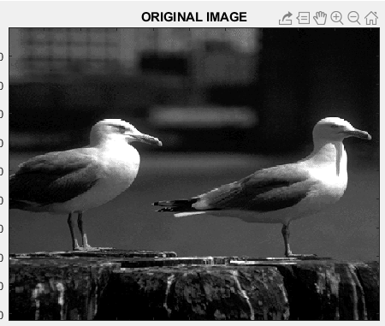

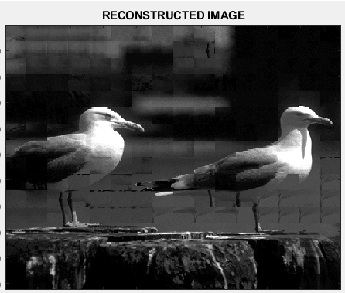

**Image 4:** Here the 512x512 image is divided into 32x32 size blocks. The block is converted to a vector of size 1x1024 which becomes the input to the ART neural network. The value of vigilance parameter is 0.95 and learning rate is 0.7. The following observations are made:

Compression ratio = 1.1315, MSE = 33.6961, PSNR = 32.8550 dB, SNR = 24.3689 dB.

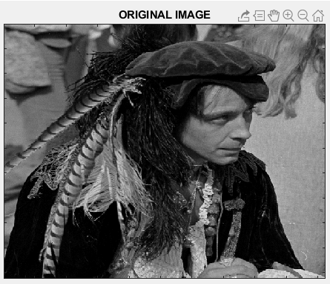

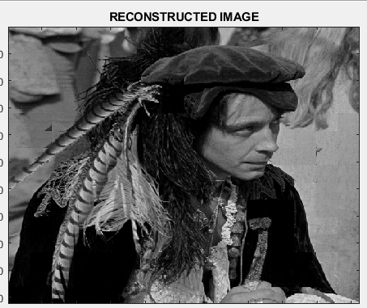

**Image 5:** Here the 512x512 image is divided into 32x32 size blocks. The block is converted to a vector of size 1x1024 which becomes the input to the ART neural network. The value of vigilance parameter is 0.95 and learning rate is 0.7. The following observations are made:

Compression ratio = 1.4443, MSE = 80.7973, PSNR = 29.0568 dB, SNR = 26.0727 dB.

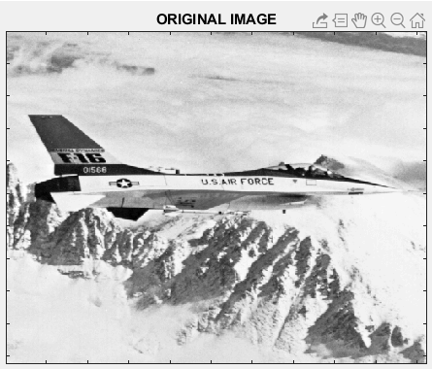

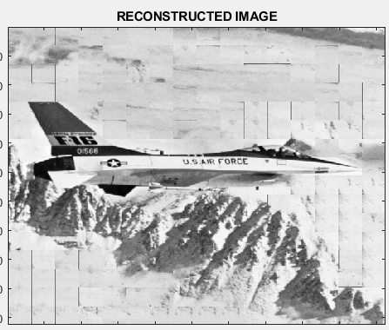

**5. CONCLUSION**

The ART neural network based image compression has been realized and simulated with the help of 512x512 images using MATLAB. The observation made here is the distortion in the reconstructed image and MSE increases as the vigilance parameter value is reduced.

**6. REFERENCES**

[1] <https://pjreddie.com/projects/mnist-in-csv/>

[2] Y. LeCun, L. Bottou, Y. Bengio, and P. Haffner. "Gradient-based learning applied to document recognition." Proceedings of the IEEE, 86(11):2278-2324, November 1998.

[3] https://machinelearningcatalogue.com/algorithm/alg_adaptive-resonance-theory-network.html

[4] http://decsai.ugr.es/cvg/CG/base.htm