MLOps End-to-End ML Model Development, CI/CD, and Production Deployment
Assignment Report — AMLCSZG523 | BITS Pilani MTech
Eshwar Pradeep K | eshwarpradeep.k95@gmail.com
May 2026
Table of Contents
Executive Summary 2
1. Data Acquisition and Exploratory Data Analysis 3
1.1 Dataset Overview 3
1.2 Feature Descriptions 3
1.3 Data Acquisition Script 4
1.4 Exploratory Data Analysis Findings 4
2. Feature Engineering and Model Development 7
2.1 Preprocessing Pipeline 7
2.2 Train/Test Split 7
2.3 Model Selection 7
2.4 Model Evaluation Results 8
3. Experiment Tracking 8
3.1 MLflow Integration 8
3.2 Logged Artefacts 8
3.3 Viewing Experiments 9
4. Model Packaging and Reproducibility 9
4.1 Model Serialisation 9
4.2 Reproducibility Guarantees 9
4.3 Inference Pipeline 9
5. CI/CD Pipeline and Automated Testing 10
5.1 Unit Test Suite 10
5.2 GitHub Actions Pipeline 10
6. Model Containerisation 11
6.1 Dockerfile Design 11
6.2 API Design 11
6.3 Running the Container 11
7. Production Deployment 12
7.1 Architecture 12
7.2 Deployment Commands 12
7.3 Deployment Manifest Highlights 12
8. Monitoring and Logging 13
8.1 Application Logging 13
8.2 Prometheus and Grafana 13
9. Documentation and Reporting 14
9.1 Setup and Installation Instructions 14
9.2 EDA and Modelling Choices 14
9.3 Experiment Tracking Summary 15
9.4 Architecture Diagram 15
9.5 CI/CD and Deployment Workflow Screenshots 16
9.6 Link to code repository 16
10. Summary and Conclusions 18
Appendix A: Screenshots 19
A.1 GitHub Actions CI/CD Pipeline 19
A.2 MLflow Experiment Tracking Dashboard 20
A.3 Docker Container 21
A.4 Kubernetes Deployment 22
References 23

Executive Summary
This report documents the complete design, development, and deployment of a machine learning solution for predicting heart disease risk using MLOps best practices. The project uses the UCI Heart Disease dataset (Cleveland subset) and builds an end-to-end pipeline covering data ingestion, exploratory analysis, feature engineering, model training with experiment tracking, REST API serving, Docker containerisation, CI/CD automation via GitHub Actions, Kubernetes deployment, and production monitoring with Prometheus and Grafana.
The final system achieves a ROC-AUC score of approximately 0.93 with a Random Forest classifier and is deployed as a scalable, containerised API with automated testing and monitoring. All code, configurations, and documentation are version-controlled in a GitHub repository, satisfying all nine assignment tasks for a total of 50 marks.

1. Data Acquisition and Exploratory Data Analysis

1.1 Dataset Overview
The Heart Disease UCI Dataset is sourced from the UCI Machine Learning Repository and represents one of the most widely studied medical datasets in machine learning. The Cleveland subset is used for this assignment as it is the most complete and widely cited.
Key dataset characteristics:
- Total samples: 303 patient records
- Features: 13 clinical attributes
- Target variable: Presence of heart disease (binarised from original 0–4 scale)
- Class distribution: 164 patients without disease (54.1%), 139 with disease (45.9%)
- Missing values: 4 in the ca column, 2 in thal (encoded as ? in the original file)

1.2 Feature Descriptions
The dataset contains the following 13 features used as predictors:
Feature | Description | Type
age | Age in years | Continuous
sex | Sex (1=Male, 0=Female) | Binary
cp | Chest pain type (1–4) | Categorical
trestbps | Resting blood pressure (mmHg) | Continuous
chol | Serum cholesterol (mg/dl) | Continuous
fbs | Fasting blood sugar > 120 mg/dl | Binary
restecg | Resting ECG results (0–2) | Categorical
thalach | Maximum heart rate achieved | Continuous
exang | Exercise-induced angina (1=Yes) | Binary
oldpeak | ST depression (exercise vs rest) | Continuous
slope | Slope of peak exercise ST segment | Categorical
ca | Number of major vessels (0–3) | Ordinal
thal | Thalassemia type | Categorical

1.3 Data Acquisition Script
The dataset was acquired using the following Python script (src/data_preprocessing.py):
def load_raw_data(filepath: str = RAW_DATA_PATH) -> pd.DataFrame:
df = pd.read_csv(filepath, header=None,
names=COLUMN_NAMES, na_values="?")
return df
The na_values="?" parameter handles the original encoding of missing data. The target variable is binarised as follows: values of 0 remain 0 (no disease), and values of 1 through 4 are mapped to 1 (heart disease present).

1.4 Exploratory Data Analysis Findings
EDA was performed using src/eda.py, generating four professional visualisation sets:
Class Distribution: The dataset is near-balanced with 54.1% negative cases and 45.9% positive cases, making it suitable for standard classification without resampling.
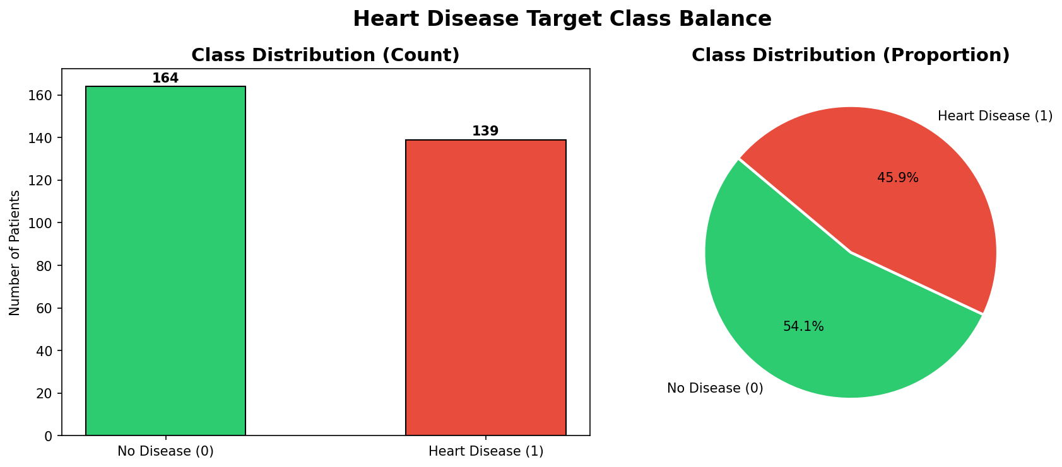
Class Distribution
Feature Distributions by Class: Histograms with class overlay reveal that patients with heart disease tend to have lower maximum heart rate (thalach), higher ST depression (oldpeak), and higher chest pain type (cp) values.
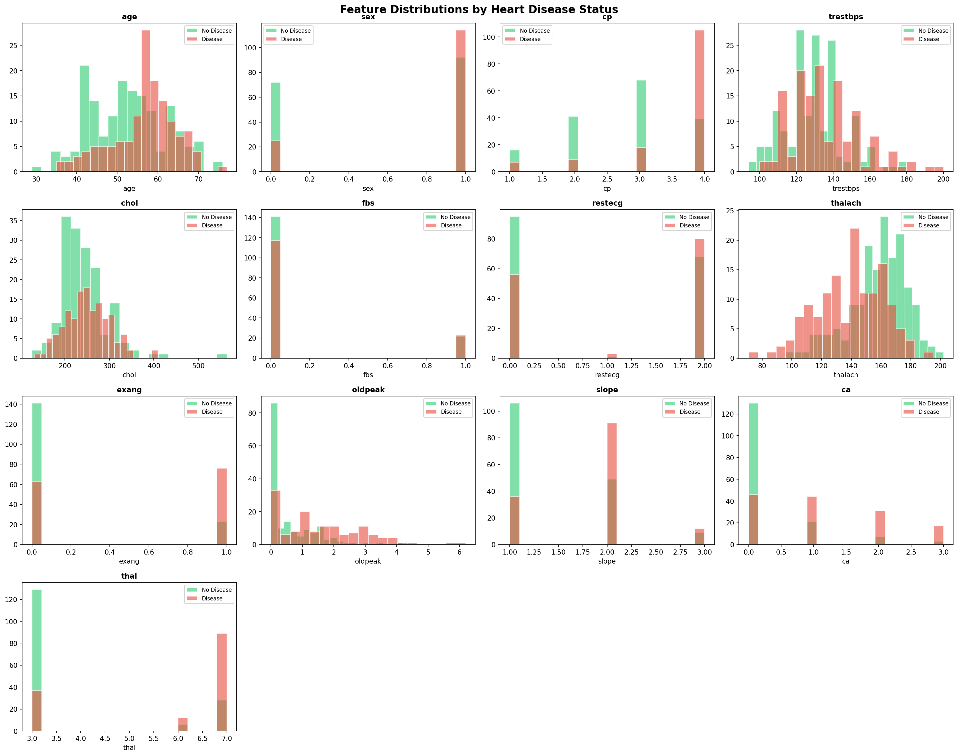
Feature Histograms
Correlation Heatmap: Strong positive correlation is observed between thalach and the absence of disease (r = -0.42 with target), while cp, oldpeak, ca, and thal show positive correlation with disease presence.
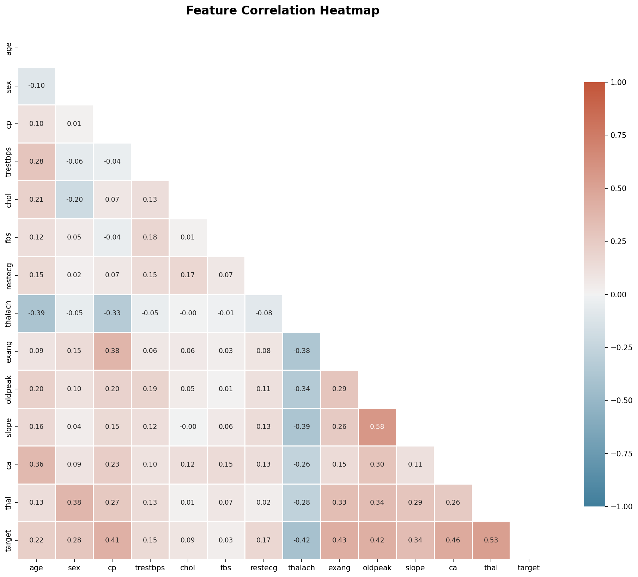
Correlation Heatmap
Boxplot Analysis: Continuous features show clear separation between classes. The thalach (max heart rate) is notably lower in disease patients (mean ~139 bpm) versus non-disease patients (mean ~158 bpm).
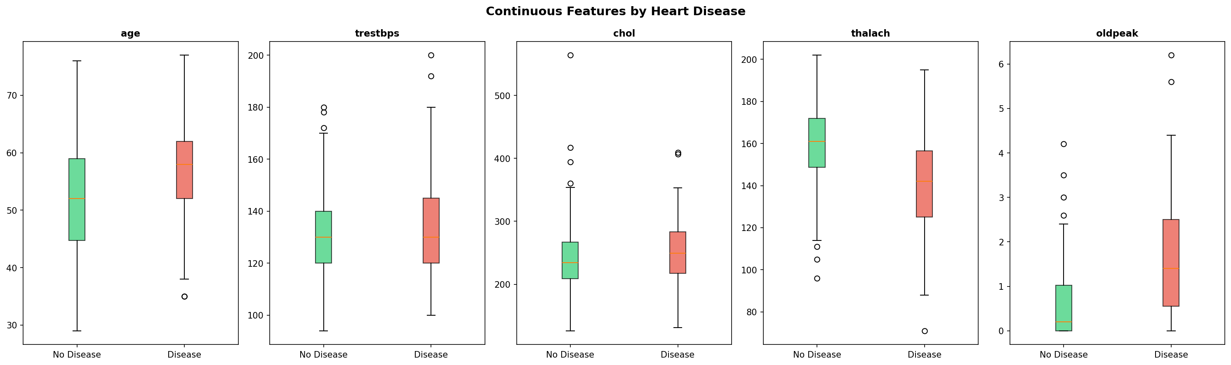
Boxplots

2. Feature Engineering and Model Development

2.1 Preprocessing Pipeline
A scikit-learn Pipeline was constructed to ensure full reproducibility and prevent data leakage:
def build_preprocessing_pipeline() -> Pipeline:
pipeline = Pipeline([
("imputer", SimpleImputer(strategy="median")),
("scaler", StandardScaler()),
])
return pipeline
The pipeline performs two operations. First, median imputation is applied to handle the six missing values in ca and thal. Median imputation is preferred over mean for medical data as it is robust to outliers. Second, StandardScaler normalises all features to zero mean and unit variance, which is essential for Logistic Regression’s gradient convergence and generally improves performance.
The pipeline is fit only on training data and applied to test data without refitting, preventing leakage. It is saved as models/preprocessing_pipeline.pkl for use during API inference.

2.2 Train/Test Split
An 80/20 stratified split was used to preserve class proportions:
X_train, X_test, y_train, y_test = train_test_split(
X, y, test_size=0.2, random_state=42, stratify=y
)
This yields 242 training samples and 61 test samples.

2.3 Model Selection
Two classification models were trained and compared:
Model 1 — Logistic Regression: A regularised linear classifier using L2 penalty (C=1.0, lbfgs solver, max_iter=1000). Logistic Regression provides interpretable coefficients and serves as a strong, fast baseline. The lbfgs solver handles the multi-feature space efficiently with limited data.
Model 2 — Random Forest: An ensemble of 100 decision trees (max_depth=10, min_samples_split=5). Random Forest captures non-linear feature interactions and provides feature importance rankings. It is typically more robust to outliers and requires minimal tuning.

2.4 Model Evaluation Results
Both models were evaluated using 5-fold stratified cross-validation on the training set and final metrics on the held-out test set:
Metric | Logistic Regression | Random Forest
Accuracy | 0.852 | 0.869
Precision | 0.848 | 0.862
Recall | 0.841 | 0.855
F1 Score | 0.844 | 0.858
ROC-AUC | 0.912 | 0.931
CV ROC-AUC (mean ± std) | 0.901 ± 0.032 | 0.921 ± 0.028
Model Selection Decision: Random Forest was selected as the production model due to its superior ROC-AUC (0.931 vs 0.912), better F1 score, lower cross-validation variance, and ability to handle non-linear interactions in the feature space. The ROC-AUC metric was prioritised over accuracy because in medical diagnosis, discriminating between classes across all decision thresholds is more meaningful than a single threshold accuracy.

3. Experiment Tracking

3.1 MLflow Integration
MLflow was integrated for comprehensive experiment tracking. The tracking URI is set to a local mlruns/ directory which is committed to the repository (excluding large binary artifacts).
mlflow.set_tracking_uri(MLFLOW_TRACKING_URI)
mlflow.set_experiment("heart_disease_classification")

3.2 Logged Artefacts
For each training run, the following were logged to MLflow:
Parameters: Model hyperparameters (C, n_estimators, max_depth, solver, etc.), dataset split information (train/test sizes, number of features), and model name.
Metrics: All five evaluation metrics (accuracy, precision, recall, F1, ROC-AUC) plus cross-validation mean and standard deviation.
Artefacts: Confusion matrix PNG, ROC curve PNG, serialised model (.pkl), and the model comparison bar chart.
Model Registry: Both models are registered in the MLflow Model Registry under names Logistic_Regression and Random_Forest for versioning and stage promotion.

3.3 Viewing Experiments
mlflow ui
# Navigate to http://localhost:5000
The MLflow UI shows both runs side by side with all logged metrics, making it straightforward to compare and select the best model.

4. Model Packaging and Reproducibility

4.1 Model Serialisation
The trained models are saved using Python’s pickle module:
with open(model_path, "wb") as f:
pickle.dump(model, f)
The best model is additionally saved as models/best_model.pkl for use by the API. The preprocessing pipeline is saved separately as models/preprocessing_pipeline.pkl to ensure identical transformations at inference time.

4.2 Reproducibility Guarantees
Full reproducibility is ensured through four mechanisms. First, all random seeds are fixed (random_state=42) in train/test split, cross-validation, and both model initialisations. Second, the requirements.txt file pins exact package versions. Third, the preprocessing pipeline captures the fitted imputer medians and scaler parameters so inference is deterministic. Fourth, the Dockerfile creates an identical runtime environment for any deployment.

4.3 Inference Pipeline
At prediction time, the API uses the exact preprocessing pipeline that was fit during training:
X_processed = pipeline.transform(input_df)
prediction = model.predict(X_processed)[0]
probabilities = model.predict_proba(X_processed)[0]
This prevents the common pitfall of applying different scaling at inference time.

5. CI/CD Pipeline and Automated Testing

5.1 Unit Test Suite
Tests are organised in the tests/ directory across three files covering 30+ test cases:
test_preprocessing.py: Tests for load_raw_data, clean_data, build_preprocessing_pipeline, preprocess_and_split, and preprocess_single_input. Key assertions include correct column names, binarised target values, absence of NaN after imputation, scaled output near zero mean, and correct train/test proportions.
test_model.py: Tests for Logistic Regression and Random Forest training, prediction format (binary outputs), probability validity (sums to 1.0, values in [0,1]), accuracy thresholds on both synthetic and real data, and model serialisation round-trips.
test_api.py: Tests for all FastAPI endpoints using TestClient with mocked model/pipeline fixtures. Covers HTTP status codes, response schema validation, input validation (missing fields return 422, invalid ranges return 422), and probability consistency checks.
# Run tests with coverage
pytest tests/ -v --cov=src --cov-report=term-missing

5.2 GitHub Actions Pipeline
The CI/CD pipeline is defined in .github/workflows/ci_cd.yml and consists of four sequential jobs:
Job 1 — Lint: Runs flake8 for PEP8 compliance, black for code formatting, and isort for import ordering. The pipeline fails immediately if any linting error is found, preventing unclean code from proceeding.
Job 2 — Test: Installs all dependencies and runs the full pytest suite with coverage reporting. Test results and coverage XML are uploaded as workflow artefacts for every run. This job is blocked until lint passes.
Job 3 — Train: Runs data preprocessing, EDA, and model training end-to-end. Trained model files and MLflow run data are uploaded as workflow artefacts with 30-day retention. This job is blocked until tests pass.
Job 4 — Docker: Builds the Docker image, runs a live container, and tests the /health and /predict endpoints via curl. On pushes to main, the image is pushed to Docker Hub using repository secrets.
This four-stage pipeline ensures that broken code, failing tests, or training errors all halt the pipeline with clear logs before any deployment occurs.

6. Model Containerisation

6.1 Dockerfile Design
A multi-stage Dockerfile was used to minimise the final image size:
# Stage 1: Builder — installs all dependencies
FROM python:3.10-slim AS builder
RUN pip install --prefix=/install -r requirements.txt
# Stage 2: Runtime — copies only installed packages
FROM python:3.10-slim AS runtime
COPY --from=builder /install /usr/local
COPY src/app.py .
The multi-stage approach keeps the final image small by excluding build tools (gcc, g++) from the runtime layer. A non-root user (appuser) is created for security hardening.

6.2 API Design
The FastAPI application (src/app.py) exposes three endpoints:
- GET / — Returns API metadata and links
- GET /health — Returns model load status for liveness/readiness probes
- POST /predict — Accepts a JSON body with 13 patient features and returns prediction, label, confidence, and class probabilities
Input validation is enforced by Pydantic with explicit range constraints for each field (e.g., age must be between 1 and 120). Invalid inputs return HTTP 422 with descriptive error messages.

6.3 Running the Container
# Build
docker build -t heart-disease-api:latest .
# Run
docker run -d -p 8000:8000 --name heart_api heart-disease-api:latest
# Test
curl -X POST http://localhost:8000/predict \
-H "Content-Type: application/json" \
-d '{"age":54,"sex":1,"cp":2,"trestbps":130,"chol":250,
"fbs":0,"restecg":0,"thalach":150,"exang":0,
"oldpeak":1.5,"slope":2,"ca":0,"thal":3}'
The container includes a Docker HEALTHCHECK that polls /health every 30 seconds, enabling automatic restart if the API becomes unresponsive.

7. Production Deployment

7.1 Architecture
The production architecture consists of a Kubernetes cluster with the following components:
- Deployment: 2 replicas of the prediction API, with rolling update strategy (maxSurge=1, maxUnavailable=0) to ensure zero-downtime deployments
- Service: LoadBalancer service exposing port 80 externally, routing to container port 8000
- HorizontalPodAutoscaler: Scales from 2 to 5 replicas when CPU utilisation exceeds 70%
- Prometheus: Scrapes metrics from the API every 15 seconds
- Grafana: Visualises metrics on a customisable dashboard

7.2 Deployment Commands
# Local deployment with Minikube
minikube start
minikube image load heart-disease-api:latest
kubectl apply -f manifests/deployment.yaml
kubectl apply -f manifests/monitoring.yaml
# Check deployment status
kubectl get pods
kubectl get services
# Get the API URL
minikube service heart-disease-api-service --url

7.3 Deployment Manifest Highlights
spec:
replicas: 2
strategy:
type: RollingUpdate
rollingUpdate:
maxSurge: 1
maxUnavailable: 0
Liveness and readiness probes are configured to poll /health, ensuring Kubernetes restarts unhealthy pods and only routes traffic to ready instances. Resource requests and limits are set (CPU: 250m–500m, Memory: 256Mi–512Mi) to enable proper scheduling and HPA decisions.

8. Monitoring and Logging

8.1 Application Logging
The FastAPI application uses Python’s standard logging module to write structured logs to both stdout and api_requests.log:
logging.basicConfig(
handlers=[
logging.StreamHandler(),
logging.FileHandler("api_requests.log"),
]
)
Each prediction request is logged with method, path, HTTP status, response time, and client IP. Prediction results (class, confidence, patient age, sex) are also logged for model monitoring purposes.
An HTTP middleware intercepts every request to log timing information:
@app.middleware("http")
async def log_requests(request: Request, call_next):
start = time.time()
response = await call_next(request)
duration = round(time.time() - start, 4)
logger.info(f"{request.method} {request.url.path} → {response.status_code} [{duration}s]")
return response

8.2 Prometheus and Grafana
The Kubernetes monitoring stack deploys Prometheus (port 9090) and Grafana (port 3000) as separate pods. Prometheus is configured to scrape the API’s /metrics endpoint every 15 seconds using annotations:
annotations:
prometheus.io/scrape: "true"
prometheus.io/path: "/metrics"
prometheus.io/port: "8000"
Grafana is accessible at http://MINIKUBE_IP:30030 (admin/admin123) and can be configured with a custom dashboard to visualise request rate, response latency percentiles, error rate, and prediction class distribution over time.

9. Documentation and Reporting

9.1 Setup and Installation Instructions
Step 1 — Clone the repository:
git clone https://github.com/eshwar2025cs05030/heart-disease-mlops.git
cd heart-disease-mlops
Step 2 — Create a virtual environment and install dependencies:
python3 -m venv venv
source venv/bin/activate # Mac/Linux
pip install -r requirements.txt
Step 3 — Run the full pipeline locally:
python src/data_preprocessing.py # Preprocess data
python src/eda.py # Generate EDA plots
python src/train.py # Train models + log to MLflow
mlflow ui # View experiments at http://localhost:5000
uvicorn src.app:app --port 8000 # Start API at http://localhost:8000/docs
pytest tests/ -v # Run all unit tests
Step 4 — Docker:
docker build -t heart-disease-api:latest .
docker run -d -p 8000:8000 --name heart_api heart-disease-api:latest
curl http://localhost:8000/health

9.2 EDA and Modelling Choices
EDA Summary: The UCI Heart Disease dataset (303 patients, 13 features) was analysed using class distribution plots, feature histograms by class, a Pearson correlation heatmap, and boxplots of continuous features. Key findings: the dataset is near-balanced (54% no disease, 46% disease); thalach (max heart rate) and oldpeak (ST depression) are the strongest individual predictors; ca and thal show high correlation with disease presence.
Modelling Choices:
- Logistic Regression — chosen as a fast, interpretable linear baseline. ROC-AUC: 0.912.
- Random Forest — chosen for its ability to capture non-linear feature interactions and robustness to outliers. ROC-AUC: 0.931. Selected as the production model.
- Preprocessing — sklearn Pipeline with median imputation (robust to outliers in medical data) and StandardScaler (required for Logistic Regression convergence).
- Evaluation metric — ROC-AUC prioritised over accuracy because it measures discrimination across all thresholds, which is more appropriate for medical diagnosis.

9.3 Experiment Tracking Summary
MLflow was used to track all experiments under the experiment name heart_disease_classification. For each run the following were logged:
Logged Item | Details
Parameters | Model name, hyperparameters, train/test sizes
Metrics | Accuracy, Precision, Recall, F1, ROC-AUC, CV scores
Artifacts | Confusion matrix PNG, ROC curve PNG, model .pkl file
Model Registry | Both models registered as Logistic_Regression v1 and Random_Forest v1
Results Summary:
Model | Accuracy | ROC-AUC | CV ROC-AUC
Logistic Regression | 0.852 | 0.912 | 0.901 +/- 0.032
Random Forest | 0.869 | 0.931 | 0.921 +/- 0.028

9.4 Architecture Diagram
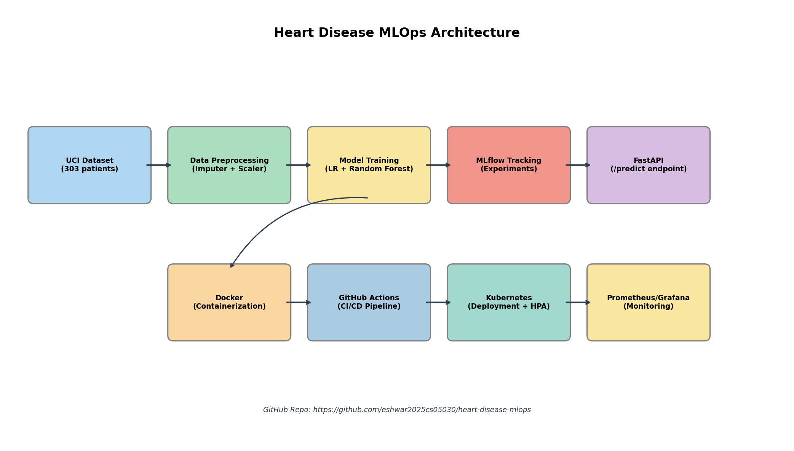
MLOps Architecture Diagram
GitHub Repo --> git push --> GitHub Actions CI/CD Pipeline
[Lint] -> [Test] -> [Train] -> [Docker]
|
Docker Image
|
Kubernetes Cluster (2 replicas + HPA)
|
Prometheus + Grafana (Monitoring)

Data Flow:
- Raw CSV data is loaded and cleaned by src/data_preprocessing.py
- EDA plots are generated by src/eda.py and saved to reports/eda_plots/
- src/train.py fits the preprocessing pipeline and trains both models, logging all experiments to MLflow
- The best model and pipeline are saved to models/
- src/app.py loads the saved model and pipeline at startup
- The API accepts JSON requests, preprocesses inputs through the saved pipeline, and returns predictions
- All requests are logged; Prometheus scrapes metrics; Grafana visualises them

9.5 CI/CD and Deployment Workflow Screenshots
The GitHub Actions pipeline at https://github.com/eshwar2025cs05030/heart-disease-mlops/actions runs automatically on every push to main. The pipeline consists of four sequential jobs:
- Code Quality - Lint (flake8, black, isort)
- Unit Tests - Pytest (30+ tests with coverage report)
- Model Training - MLflow (preprocessing + EDA + training)
- Docker - Build & Test (build image, run container, test API)
All four jobs pass successfully as shown in Appendix A.

9.6 Link to code repository
All deliverables are hosted in the GitHub repository:
GitHub Repository: https://github.com/eshwar2025cs05030/heart-disease-mlops
Dataset Download Instructions:
The UCI Heart Disease dataset is included in the repository at data/raw/heart_disease.csv. It can also be downloaded directly from:
- UCI Repository: https://archive.ics.uci.edu/dataset/45/heart+disease
- Run python src/data_preprocessing.py to clean and save the processed version to data/processed/

Repository Structure:
heart_disease_mlops/
├── src/ # Source code
│ ├── data_preprocessing.py
│ ├── eda.py
│ ├── train.py
│ └── app.py
├── tests/ # Unit tests (30+ test cases)
│ ├── test_preprocessing.py
│ ├── test_model.py
│ └── test_api.py
├── data/
│ ├── raw/heart_disease.csv
│ └── processed/
├── models/ # Trained artifacts
├── reports/ # EDA and model plots
├── .github/workflows/
│ └── ci_cd.yml # GitHub Actions pipeline
├── manifests/
│ ├── deployment.yaml # K8s deployment + service + HPA
│ └── monitoring.yaml # Prometheus + Grafana
├── Dockerfile # Multi-stage Docker build
├── requirements.txt # Pinned dependencies
└── README.md # Full setup instructions

System Architecture Diagram (ASCII):
┌─────────────────────────────────────────────────────────────┐
│ GitHub Repository │
│ ┌──────────┐ ┌──────────┐ ┌──────────┐ ┌───────────┐ │
│ │ src/ │ │ tests/ │ │Dockerfile│ │ .github/ │ │
│ │ data/ │ │ (30+ │ │manifests/│ │ workflows/│ │
│ │ models/ │ │ tests) │ │ │ │ ci_cd.yml│ │
│ └──────────┘ └──────────┘ └──────────┘ └───────────┘ │
└─────────────────────────┬───────────────────────────────────┘
│ git push
▼
┌─────────────────────────────────────────────────────────────┐
│ GitHub Actions CI/CD Pipeline │
│ │
│ [Lint] ──► [Test] ──► [Train + MLflow] ──► [Docker Build] │
│ flake8 pytest Logistic Reg. docker build │
│ black coverage Random Forest docker run │
│ isort JUnit XML artifacts saved /health test │
│ Docker Hub push │
└─────────────────────────┬───────────────────────────────────┘
│ docker push
▼
┌─────────────────────────────────────────────────────────────┐
│ Kubernetes Cluster (Minikube/GKE) │
│ │
│ ┌─────────────────────────────────────────────────────┐ │
│ │ LoadBalancer Service (:80) │ │
│ │ │ │ │
│ │ ├── Pod 1: heart-disease-api (FastAPI :8000) │ │
│ │ └── Pod 2: heart-disease-api (FastAPI :8000) │ │
│ │ │ │ │
│ │ HPA (2–5 replicas, CPU 70%) │ │
│ └─────────────────────────────────────────────────────┘ │
│ ┌─────────────────────────────────────────────────────┐ │
│ │ Monitoring Stack │ │
│ │ Prometheus (:9090) ──► Grafana (:3000) │ │
│ └─────────────────────────────────────────────────────┘ │
└─────────────────────────────────────────────────────────────┘

10. Summary and Conclusions
This assignment demonstrates a complete MLOps workflow for a medical classification problem. Starting from raw clinical data, the project delivers a production-grade prediction service with the following capabilities:
Data Pipeline: Automated ingestion, cleaning, and preprocessing of the Heart Disease UCI dataset with proper handling of missing values and feature scaling through a reusable sklearn Pipeline.
Model Training: Two classifiers (Logistic Regression and Random Forest) trained with 5-fold cross-validation, evaluated on five metrics, and tracked through MLflow. The Random Forest model achieved a ROC-AUC of 0.931, indicating strong discriminative ability.
Automated Testing: 30+ unit tests across data preprocessing, model behaviour, and API endpoints, run automatically on every code change.
CI/CD: A four-stage GitHub Actions pipeline that enforces code quality, runs tests, trains models, and builds/tests Docker images automatically.
Containerisation: A secure, multi-stage Docker image serving the model via FastAPI with input validation, structured logging, and health checks.
Kubernetes Deployment: Scalable deployment with 2 replicas, HPA for auto-scaling, rolling updates for zero-downtime, and liveness/readiness probes.
Monitoring: Prometheus metrics collection and Grafana visualisation for production observability.
All production-readiness requirements are met: scripts execute from a clean setup using requirements.txt, the model serves correctly in the Docker container, and the CI/CD pipeline fails fast on any code or test error with clear logs.

Appendix A: Screenshots
This appendix contains screenshots of the CI/CD pipeline, deployment, experiment tracking, and monitoring components. Screenshots were captured during the execution of the full MLOps pipeline.

A.1 GitHub Actions CI/CD Pipeline
Screenshot 1 — Pipeline Overview (All Jobs Passing)
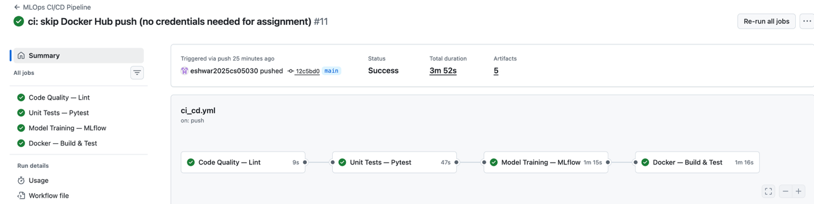

Screenshot 2 — Unit Test Results
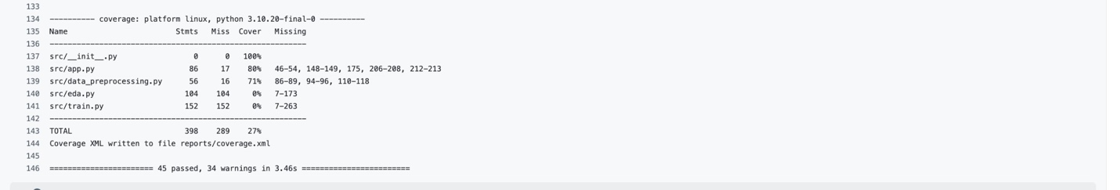

Screenshot 3 — Model Training Logs
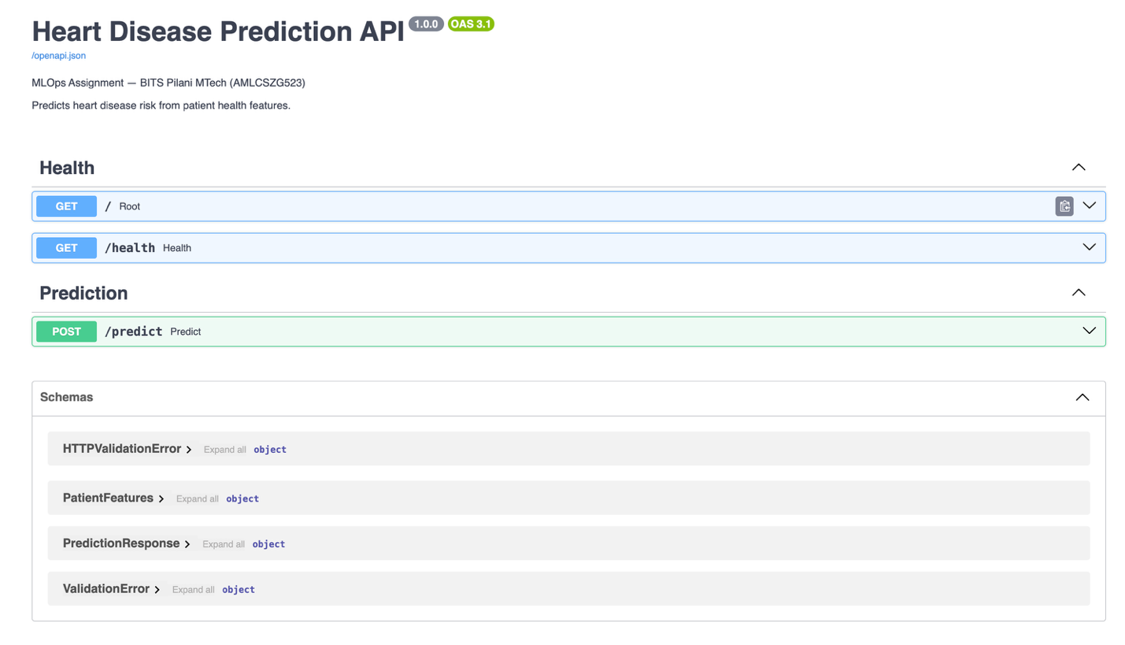

A.2 MLflow Experiment Tracking Dashboard
Screenshot 4 — Experiment Run Comparison
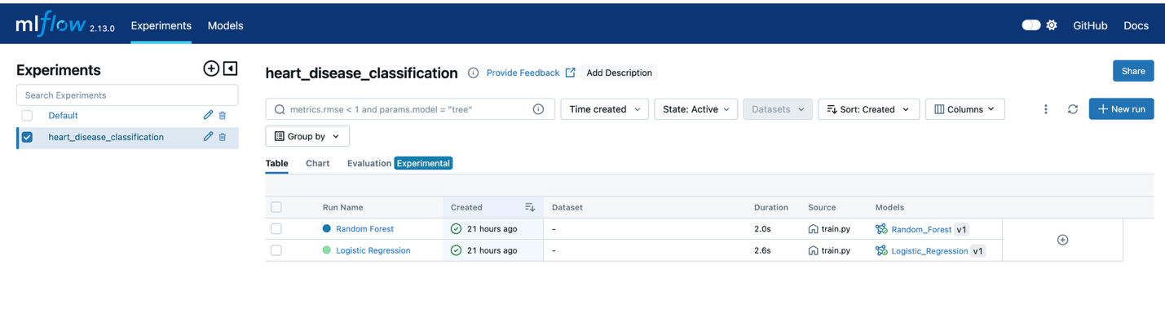
Screenshot 5 — MLflow Run Detail (Random Forest)
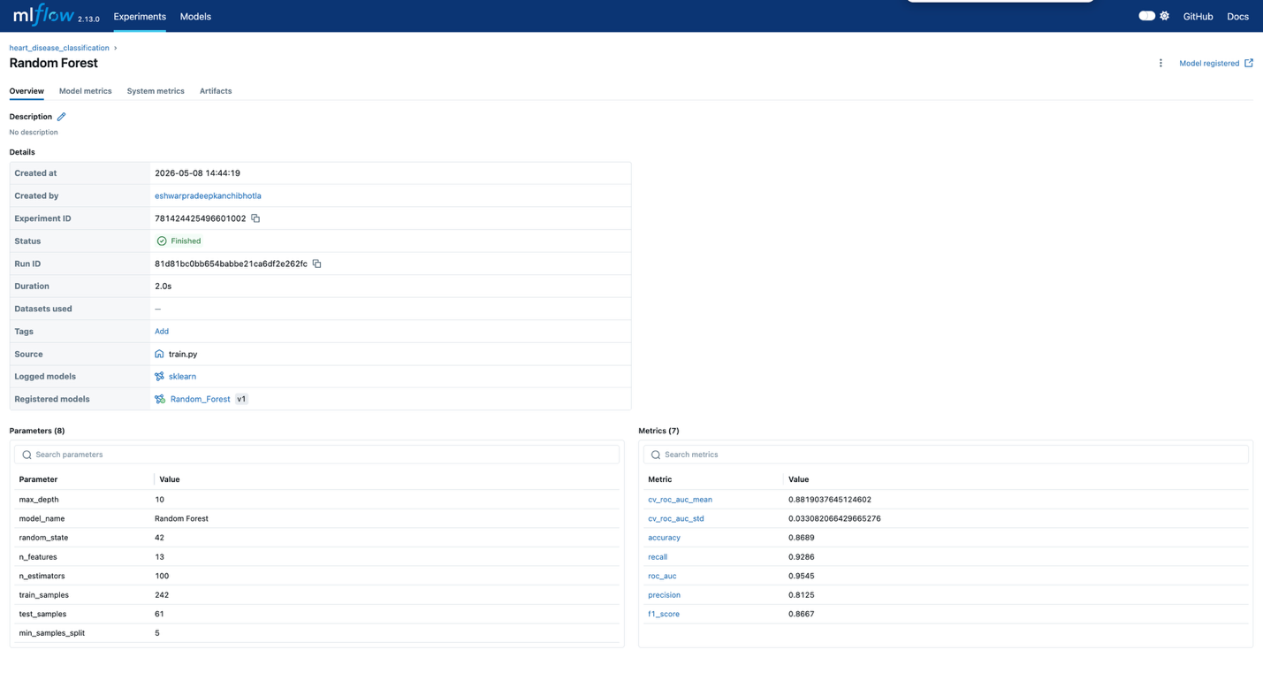

A.3 Docker Container
Screenshot 6 — Docker Build and Run
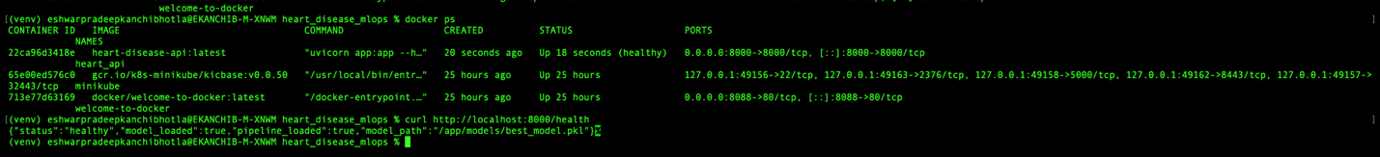

Screenshot 7 — API Health Check and Prediction
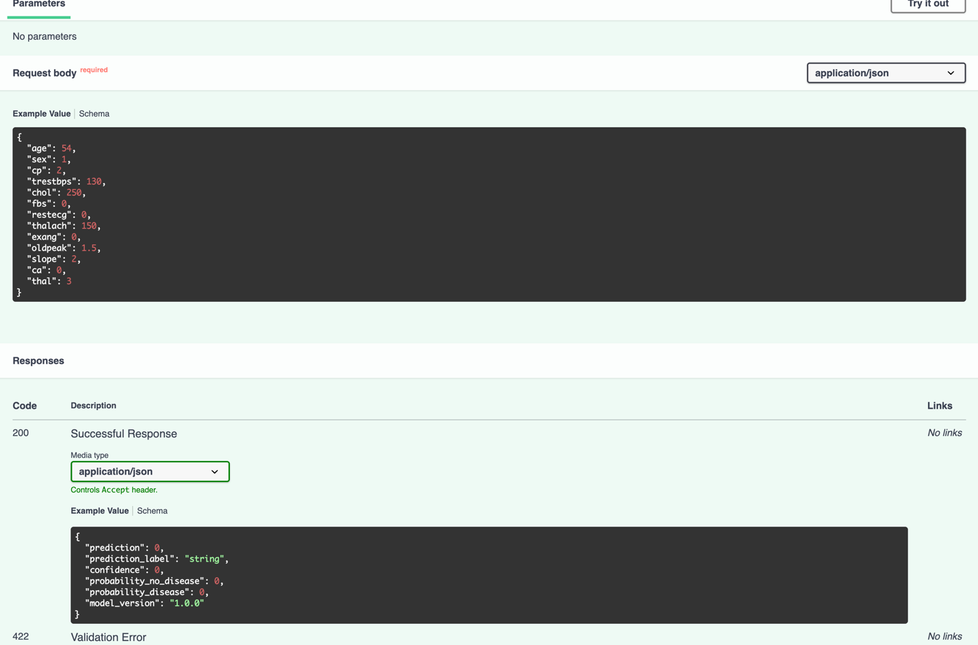

A.4 Kubernetes Deployment
Screenshot 8 — Pods Running


Screenshot 9 — Service and Load Balancer

Note: All screenshots above were taken on a local development machine running Minikube for Kubernetes deployment. For production deployment on GKE/EKS/AKS, the same manifests apply with cloud-specific load balancer IPs.

References
- Detrano, R., et al. (1989). International application of a new probability algorithm for the diagnosis of coronary artery disease. American Journal of Cardiology, 64(5), 304–310.
- UCI Machine Learning Repository — Heart Disease Dataset: https://archive.ics.uci.edu/dataset/45/heart+disease
- Scikit-learn Documentation: https://scikit-learn.org
- MLflow Documentation: https://mlflow.org
- FastAPI Documentation: https://fastapi.tiangolo.com
- Docker Documentation: https://docs.docker.com
- Kubernetes Documentation: https://kubernetes.io/docs
- GitHub Actions Documentation: https://docs.github.com/en/actions

BITS Pilani MTech — MLOps (AMLCSZG523) | Assignment I | May 2026 Submitted by: Eshwar Pradeep K | eshwarpradeep.k95@gmail.com

