SIMATS ENGINEERING
Department of Information Technology
ITA05 – Computer Vision
ASSIGNMENT 1 – CO1
Assignment Title: Apply, Compare and Justify Image Acquisition, Formation and Processing Techniques for a Textile Fabric Defect Inspection System
CO1: Apply the fundamental concepts, image formation models, and processing techniques for analyzing Computer Vision systems.
Student Name | Paidi Eshwar | Register Number | 192321103
Department / Section | Information Technology | Academic Year / Semester | 2025–2026 / ______
Faculty Name | Dr. Murali P | Nature of Assignment | Individual
Duration | 1 Week | Total Marks | 50
Date of Submission | 30.10.2026 | Date of Evaluation | 07.11.2026

Industrial Scenario
Sri Lakshmi Textile Industries, Tiruppur, plans to develop a computer vision-based inspection system for its fabric production line. The system must inspect moving cotton and cotton-polyester fabric, measure fabric width, and identify holes, broken threads, oil stains, weaving irregularities and colour variations. It must estimate the location of each defect and trigger a marking mechanism so that the defective portion can be identified for rework or rejection.

Given Industrial Data and Constraints
Parameter | Specification
Fabric width | 1,000 mm
Camera field of view | 1,200 × 400 mm
Conveyor speed | 0.6 m/s
Smallest defect to be detected | 1.5 mm
Oil-stain contrast | 5–8 grey levels
Required fabric-width measurement accuracy | ±2 mm
Maximum decision time | 0.5 s
Distance between camera and marking mechanism | 0.3 m
Lighting variation | 500–3,000 lux
Camera mounting height | 700 mm above the fabric
Available computing system | 4-core CPU, 16 GB RAM, no GPU
Software environment | Python, OpenCV and NumPy
Network interface | Gigabit Ethernet
Storage capacity | 2 TB
Maximum project budget | ₹1,50,000
Image retention period | 7 days
Maximum acceptable missed-defect rate | 2%

General Instructions
- Answer all ten tasks.
- For every task, three candidate techniques or approaches are provided. Analyse all three alternatives, compare their suitability for the given industrial scenario, select the most appropriate option and justify your selection.
- Support your answers with calculations, diagrams, tables, observations, screenshots or experimental results wherever applicable.
- Clearly state assumptions and show the steps used in numerical calculations.
- Your justification must consider the given operating conditions, accuracy, processing time, hardware limitations and budget.
- Do not provide only definitions. Relate every answer to the textile fabric inspection application.
- Where implementation is required, use Python, OpenCV and NumPy. Include relevant code snippets and sample output.

TASK 1: Overview and Features of Computer Vision – Compare Grading/Inspection Approaches
Marks: 4
Compare the following three approaches for inspecting fabric defects:
Candidate techniques / approaches:
- Manual inspection by trained workers
- Image-processing-assisted inspection, in which an operator reviews computer-generated results
- Fully automated computer vision inspection
Student tasks:
- Explain the working principle of each approach.
- Compare their accuracy, speed, consistency, labour requirement and suitability for continuous fabric production.
- Select the most suitable approach for Sri Lakshmi Textile Industries and justify your decision using the given production conditions.
- Identify at least two limitations of your selected approach and suggest how they can be reduced.
ANSWERS
Answer 8: Manual: trained workers watch the fabric on an inspection frame (or a slowed conveyor) and note defects by eye. Assisted: a camera and OpenCV routines highlight suspected defects on a screen and the operator confirms and marks them. Fully automated: camera, processing and decision logic find, locate and classify defects and fire the marker with no human in the loop (an operator only handles flagged exceptions).
Answer 9: Line speed is 0.6 m/s = 36 m/min. Sustained manual inspection is usually done at about 15–20 m/min, so it cannot keep up. (Human accuracy figures are assumptions from typical literature.)
Criterion | Manual | Image-processing-assisted | Fully automated CV
Accuracy | ~60–80 %; falls with fatigue; 5–8 grey-level stains easily missed | ~85–90 %; limited by operator attention | ≥ 98 % target; measurable, repeatable
Speed | 15–20 m/min (below 36 m/min) | Full speed possible, but review adds delay | Full speed; decision < 0.5 s
Consistency | Varies between workers/shifts | Medium | High, same rules every frame
Labour | 1–2 inspectors per line per shift | 1 operator per line | ≈ 1 supervisor for several lines
Continuous production | Poor | Fair; the 0.5 s decision cannot wait for a person | Good; marker triggered automatically

Answer 10: Fully automated computer vision inspection is selected. The marker is only 0.3 m (0.5 s of travel at 0.6 m/s) downstream, so a human-in-the-loop decision is not possible. The 2 % missed-defect limit, 1.5 mm defects and 5–8 grey-level stains need objective, repeatable measurement, and it fits the ₹1,50,000 budget and CPU-only hardware (Tasks 6 and 9).
Answer 11: (i) False alarms / missed stains from lighting, fabric texture and colour changes: reduce with a light hood and constant-current LEDs, flat-field correction and per-style thresholds. (ii) New or unseen defect types need re-tuning, because the rules are hand-designed: log all flagged frames, review them weekly and add rules or retrain thresholds; keep a manual spot check of about 1 % of production. (iii) Camera/lens drift: periodic calibration with a reference target.

TASK 2: Levels of Computer Vision – Pipeline Design and Operation
Marks: 5
Compare the following system designs:
Candidate techniques / approaches:
- Low-level pipeline: image acquisition, preprocessing and enhancement
- Three-level pipeline: low-level processing, intermediate-level feature extraction and high-level defect decision
- Deep-learning-based pipeline: image acquisition, neural-network inference and defect classification
Student tasks:
- Draw a block diagram for each pipeline.
- Explain the input and output of each processing stage.
- Identify the stages required to detect holes, broken threads, stains and weaving irregularities.
- Compare computational complexity, explainability, hardware requirements and response time.
- Recommend a pipeline that can operate within the available 4-core CPU system and the 0.5-second decision constraint.
ANSWERS
Answer 12: Block diagrams of the three pipelines:
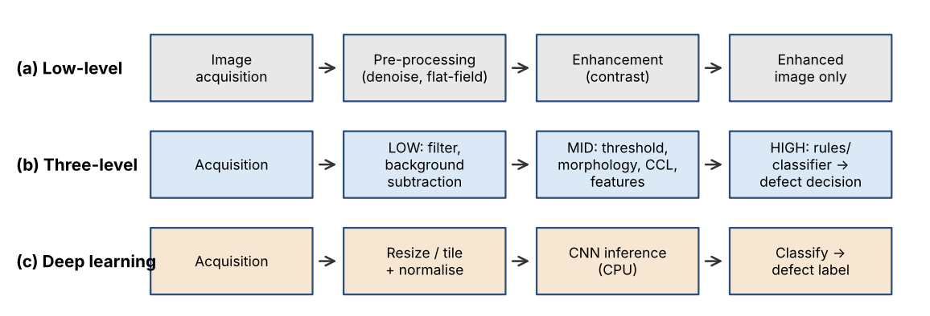
Fig. 1 Block diagrams of the three candidate pipelines
Answer 13: Low-level pipeline: input raw RGB/gray frame (2448×2048); output an enhanced image only. It makes no decision and cannot locate or classify defects by itself. Three-level pipeline: *Low* – input raw frame, output denoised, flat-field-corrected gray image. *Mid* – input the corrected image, output binary defect mask, connected components and features (area, bounding box, elongation, mean contrast, texture energy). *High* – input the feature list, output a defect type, severity and (x, y) in mm, then pass/fail and a marker command. Deep-learning pipeline: input frame tiles (e.g. 224×224), output class probabilities per tile, then a defect label and box.
Answer 14: Stage mapping per defect type:
Defect | Low level | Mid level | High level
Hole | Gaussian blur, flat-field | Threshold on |difference| > 30, CCL | Area ≥ 3 px, near-circular → hole
Broken thread | Directional filters (Sobel, 1×15 line kernel) | Threshold, thinning, connected components | Long, thin, aligned with warp/weft → broken thread
Oil stain | Large-scale background subtraction, heavy smoothing | Low threshold (≈ 2–3 grey levels) + opening | Large blob, soft edge, low contrast → stain
Weaving irregularity | Band-pass / Gabor filtering | Local texture energy or FFT peak shift per block | Block deviates from the periodic pattern → irregularity

Answer 15: Comparison:
Aspect | Low-level only | Three-level | Deep learning (CPU)
Computational complexity | Lowest (~10 ms) | Low–medium; ≈ 0.1 s measured for 5 MP | Very high: ≈ 100 tiles × ~0.6 GFLOP ≈ 60 GFLOP per frame
Explainability | High but no decision | High; every threshold is visible | Low (black box)
Hardware | Any PC | 4-core CPU is enough | GPU needed for real time; also needs thousands of labelled images
Response time | ≈ 0.05 s | ≈ 0.2 s end to end | ≈ 1–3 s on CPU (estimate), exceeds 0.5 s

Answer 16: The three-level pipeline is recommended. It fits the 4-core CPU without a GPU, finishes in about 0.2 s against the 0.5 s limit, and each rule can be tuned on site. The low-level-only pipeline cannot decide, and the CNN is too slow on the CPU and needs labelled data the mill does not yet have.

TASK 3: Image Representation Analysis
Marks: 4
Compare the following image representations for fabric inspection:
Candidate techniques / approaches:
- RGB colour representation
- HSV colour representation
- Grayscale representation
Student tasks:
- Explain how each representation stores image information.
- Discuss the suitability of each representation for identifying colour variations, oil stains, holes and broken threads.
- Compare memory requirements and processing complexity.
- Choose a suitable representation or combination of representations and justify your choice with examples from the scenario.
ANSWERS
Answer 17: RGB: three 8-bit planes per pixel (R, G, B), 24 bits per pixel; colour and brightness are mixed together. HSV: three planes – Hue (colour type, 0–179 in OpenCV), Saturation (colour purity) and Value (brightness); brightness is separated from colour. Grayscale: one 8-bit plane (Y = 0.299R + 0.587G + 0.114B), only brightness.
Answer 18: Suitability (Best / Good / Fair / Poor):
Task | RGB | HSV | Gray
Colour variation | Good but sensitive to lighting | Best: H and S barely change with lux | Poor – colour lost
Oil stains | Fair | Fair (V channel) | Good – 5–8 level darkening is seen in intensity
Holes | Fair | Fair | Best – strong contrast, fast
Broken threads | Fair | Fair | Best – edge/line filters work directly

Answer 19: For a 2448×2048 frame (5,013,504 pixels): RGB = 5,013,504 × 3 = 15.04 MB; HSV = 15.04 MB (plus conversion); Gray = 5.01 MB. Gray is 3× smaller and about 3× cheaper to filter; RGB→HSV needs max/min/division per pixel (≈ 2–3× the cost of RGB→Gray).
Answer 20: A combination is chosen: capture colour (RGB), then use grayscale for the main defect detection (holes, broken threads, stains, texture) and HSV (H and S) on a down-sampled copy only for colour-variation checks. Example: a lot-to-lot dye shift is invisible in gray but shows as a change in mean H/S, while at 500–3,000 lux only V changes, so H/S stay usable. Gray processing keeps the 0.5 s budget.

TASK 4: Connectivity Analysis
Marks: 4
Compare the following pixel-connectivity approaches for identifying defect regions:
Candidate techniques / approaches:
- 4-connectivity
- 8-connectivity
- m-connectivity (mixed connectivity)
Student tasks:
- Define each connectivity approach with a suitable pixel-neighbour diagram.
- For a small binary image containing diagonally and horizontally connected defect pixels, identify the connected components using all three methods.
- Explain how the choice of connectivity may affect defect-region size and component counting.
- Recommend the most appropriate connectivity method for detecting small holes and irregular fabric defects.
ANSWERS
Answer 21: 4-connectivity: p=(x,y) is connected to its horizontal and vertical neighbours (x±1,y), (x,y±1). 8-connectivity: also the four diagonal neighbours. m-connectivity: 4-neighbours, plus a diagonal neighbour q only if N4(p) ∩ N4(q) contains no foreground pixel; this removes the double paths that 8-connectivity creates.
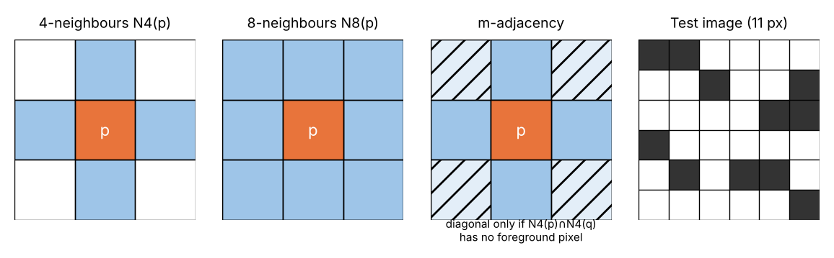
Fig. 2 Neighbourhoods (hatched = conditional diagonals in m-adjacency) and the 6×6 test image
Answer 22: The test image has 11 defect pixels (horizontal pair, several diagonal runs). Results from OpenCV and a small union-find for m-connectivity:
Method | Components | Sizes (pixels)
4-connectivity | 7 | 2, 1, 3, 1, 1, 2, 1
8-connectivity | 4 | 3, 3, 2, 3
m-connectivity | 4 | 3, 3, 2, 3 (same regions, one unique path each)

n4,_=cv2.connectedComponents(A,connectivity=4)-1 # -> 7 components
n8,_=cv2.connectedComponents(A,connectivity=8)-1 # -> 4 components

Answer 23: With 4-connectivity a diagonal crack or slanted broken thread is split into many tiny pieces: the count rises (7 vs 4) and each region is under-sized (largest 3 px, same as 8 here, but single diagonal pixels are counted separately), so small defects may fall below the minimum-area filter and be missed. 8-/m-connectivity merge the pieces into one defect, giving the true size and a single marker command. 8-connectivity can create ambiguous double paths (and occasionally merge two touching defects); m-connectivity removes that ambiguity at slightly higher cost.
Answer 24: 8-connectivity (or m-connectivity if exact boundary tracing is needed) is recommended: a 1.5 mm hole is only 3 px wide and irregular defects are diagonal, so 4-connectivity would fragment them. 8-connectivity is built into `cv2.connectedComponentsWithStats` and is fast enough for the CPU budget.

TASK 5: Image Acquisition Analysis
Marks: 5
Compare the following camera acquisition options for the moving fabric line:
Candidate techniques / approaches:
- Rolling-shutter camera
- Global-shutter camera
- Line-scan camera
Student tasks:
- Explain the image acquisition principle of each camera type.
- Analyse the effect of fabric movement at 0.6 m/s on image distortion and defect visibility.
- Compare image quality, suitability for continuous web inspection, installation complexity and cost.
- Select a camera type for the given fabric width and production process.
- Justify the selection with reference to the 1.5 mm minimum defect size and 0.5-second decision requirement.
ANSWERS
Answer 25: Rolling-shutter: rows are exposed and read out one after another, so each row sees the scene at a slightly different time. Global-shutter: every pixel is exposed in the same instant (then read out), so the frame is a true snapshot. Line-scan: a single (or double) row of pixels is exposed repeatedly, and the moving fabric builds the 2-D image line by line; line rate must match conveyor speed.
Answer 26: Assume 5 MP, 0.49 mm/px and a full-frame readout of 20 ms for a rolling shutter. Skew = v × t_readout = 0.6 m/s × 0.020 s = 12 mm ≈ 24 px, which bends straight yarns, shifts defect positions and distorts the width measurement; 12 mm is 8× the 1.5 mm defect. Motion blur for any area camera = v × t_exposure: 0.6 m/s × 200 µs = 0.12 mm (0.25 px, acceptable) but with a 5 ms exposure under ambient light it is 3 mm (blurs the 1.5 mm defect). Line-scan has no skew; only a line-rate mismatch changes the aspect ratio.
Answer 27: Comparison of the three cameras:
Criterion | Rolling-shutter | Global-shutter (area) | Line-scan
Image quality at 0.6 m/s | Skewed | Sharp snapshot | Very uniform, no seams
Continuous web | Poor | Good with overlap | Excellent, endless image
Installation | Simple | Simple (trigger + light) | Complex: encoder sync, line light, alignment
Cost (estimate) | ≈ ₹15–20 k | ≈ ₹50–60 k | camera ≈ ₹90 k–1.2 L + line light ≈ ₹40 k ⇒ > ₹1.5 L total

Answer 28: A global-shutter GigE area-scan camera is selected. The 1,200 × 400 mm field of view of the specification is an area-scan view. Frame rate needed = v / L = 0.6 / 0.4 = 1.5 fps; running at 2 fps gives an advance of 0.3 m per frame, i.e. 100 mm (25 %) overlap, so no defect is lost at frame edges.
Answer 29: At 0.49 mm/px the 1.5 mm defect spans 3.06 px, and a 200 µs strobed exposure limits blur to 0.12 mm, so it stays visible. Exposure + transfer (5 MB / ≈110 MB/s ≈ 46 ms) + processing (≈0.1 s) is ≈ 0.2 s < 0.5 s. A line-scan camera would be technically excellent (4096 px → 0.29 mm/px, line rate 0.6 m/s ÷ 0.29 mm ≈ 2,050 lines/s) but its camera + line light + encoder interface exceed the ₹1,50,000 budget.

TASK 6: Sampling Analysis
Marks: 5
Evaluate the following image sampling resolutions:
Candidate techniques / approaches:
- Low resolution: 1280 × 1024 pixels
- Medium resolution: 2448 × 2048 pixels
- High resolution: 4096 × 3000 pixels
Student tasks:
- Calculate the total number of pixels for each resolution.
- Estimate the approximate spatial sampling interval across the 1,200 mm field of view, assuming the image width corresponds to the full field-of-view width.
- Determine whether a 1.5 mm defect can be represented adequately at each resolution.
- Compare image storage, processing time and defect-detection capability.
- Select a resolution that balances defect visibility and the available computing resources. Show all calculations.
ANSWERS
Answer 30: Total pixels = width × height (first column below).
Answer 31: Total pixels = width × height. Sampling interval = 1,200 mm ÷ horizontal pixels. Pixels across 1.5 mm = 1.5 ÷ interval.
Resolution | Total pixels | Interval (mm/px) | Pixels across 1.5 mm | 8-bit frame size | Measured time*
1280×1024 | 1,310,720 (1.31 MP) | 1200/1280 = 0.938 | 1.6 | 1.31 MB | 17 ms
2448×2048 | 5,013,504 (5.01 MP) | 1200/2448 = 0.490 | 3.06 | 5.01 MB | 101 ms
4096×3000 | 12,288,000 (12.29 MP) | 1200/4096 = 0.293 | 5.12 | 12.29 MB | 355 ms

*Python/OpenCV 3-level pipeline (Task 2) on a 2-vCPU test machine; the 4-core target PC should be equal or faster. Sensor height outside the 400 mm strip can be cropped (ROI), reducing data further.
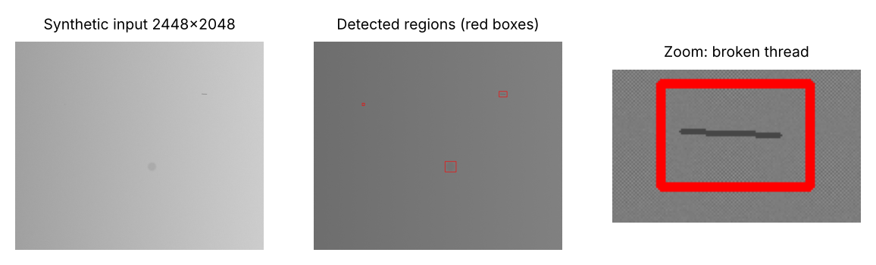
Fig. 2b Sample input and output of the 3-level pipeline (synthetic 2448×2048 fabric with a 1.5 mm hole, 40 mm oil stain of -6 grey levels and a broken thread)
g=cv2.GaussianBlur(gray,(3,3),0); bg=cv2.resize(cv2.blur(cv2.resize(g,(W//8,H//8)),(61,61)),(W,H))
d=g.astype(np.int16)-bg; sharp=(np.abs(d)>30); stain=cv2.morphologyEx((cv2.GaussianBlur(d.astype(np.float32),(0,0),6)<-2).astype(np.uint8),cv2.MORPH_OPEN,np.ones((5,5)))
n,lab,stats,_=cv2.connectedComponentsWithStats(sharp|stain,connectivity=8) # 3 defects found, 101 ms

Answer 32: A defect needs ≥ 2 px (Nyquist) and, for reliable detection against fabric texture and noise, ≈ 3 px. 1280×1024: 1.6 px – not adequate; the hole barely differs from the weave and was unstable (21 false regions in our test). 2448×2048: 3.06 px – adequate (detected hole, thread and stain in the test). 4096×3000: 5.1 px – best, but costly.
Answer 33: Storage for 7 days (2 fps, 16 h/day = 115,200 frames/day): at 5.01 MB raw = 577 GB/day = 4.04 TB (> 2 TB), so frames are JPEG-compressed (assumed ≈ 1.5 MB each): 115,200 × 1.5 MB = 173 GB/day × 7 = 1.21 TB (60 % of 2 TB). 12.29 MP would need ≈ 1.4 TB/day raw and 355 ms of CPU time, leaving too little of the 0.5 s budget. The 1.31 MP option is cheap but misses small defects.
Answer 34: 2448×2048 (5 MP) is selected: 3 px on the smallest defect, ≈ 0.1 s processing, fits storage and ₹ budget. Width check: 0.49 mm/px with sub-pixel edge detection gives ≪ ±2 mm.

TASK 7: Quantization Analysis
Marks: 4
Compare the following intensity quantization options:
Candidate techniques / approaches:
- 8-bit quantization
- 12-bit quantization
- Reduced 4–6 bit quantization
Student tasks:
- Calculate the number of intensity levels available in each option.
- Explain how quantization affects the representation of low-contrast oil stains having only 5–8 grey-level differences.
- Compare image storage requirements and processing implications.
- Recommend a quantization level for reliable defect detection under the stated lighting conditions. Justify your answer.
ANSWERS
Answer 35: Levels = 2^n: 8-bit = 256, 12-bit = 4,096, 4-bit = 16 and 6-bit = 64 (reduced option).
Answer 36: Express each option on the 8-bit scale. A stain of 5–8 grey levels is: 8-bit → 5–8 steps; 12-bit → 80–128 steps; 6-bit (step 4) → 1.25–2 steps; 4-bit (step 16) → 0.3–0.5 step, i.e. it may fall into the same bin as the background and disappear. Quantization noise = step/√12: 8-bit 0.29, 6-bit 1.15, 4-bit 4.6 grey levels, so 6-bit noise is comparable to the stain contrast.
Answer 37: Storage for a 5 MP frame and implications:
Option | Levels | Bytes/pixel | 5 MP frame | Processing implication
4–6 bit | 16–64 | 1 (unpacked) / 0.5–0.75 packed | 5.0 MB (3.8 MB packed 6-bit) | Fast, but stains and texture lost
8 bit | 256 | 1 | 5.01 MB | Native for OpenCV, fastest
12 bit | 4,096 | 2 (16-bit container) | 10.0 MB | 2× memory/bandwidth, some OpenCV ops slower; more headroom

Answer 38: 8-bit is recommended. Stain contrast is 5–8 levels against sensor noise of about 1–2 levels; averaging over a 25-pixel neighbourhood reduces noise by √25 = 5 (to ≈ 0.4), giving SNR > 10. Because contrast scales with illumination (500 → 3,000 lux is 6:1, so an uncontrolled stain would drop to ≈ 1 level at 500 lux), the camera must run under controlled LED light with exposure/gain feedback keeping mean grey at about 110–140. 12-bit capture is the fallback if stain misses exceed the 2 % limit.

TASK 8: Image Formation Analysis
Marks: 5
Compare the following image formation and calibration approaches:
Candidate techniques / approaches:
- Standard perspective imaging without calibration
- Calibrated imaging with geometric correction
- Controlled-illumination imaging with suitable calibration
Student tasks:
- Explain the image formation process for a camera mounted 700 mm above the fabric.
- Discuss perspective distortion and its effect on fabric-width measurement.
- Explain how camera calibration can improve measurement accuracy.
- Analyse how lighting variation from 500 to 3,000 lux can affect defect visibility.
- Recommend an image formation and illumination arrangement that can achieve the required width accuracy of ±2 mm.
ANSWERS
Answer 39: A pinhole/thin-lens model maps a fabric point (X, Y) at distance Z = 700 mm to the sensor point x = f·X/Z. For the 2448-pixel sensor with 3.45 µm pixels: width = 2448 × 3.45 µm = 8.45 mm. Required focal length f = Z × w_sensor / FOV = 700 × 8.45 / 1200 = 4.9 mm (≈ 5 mm lens, FOV ≈ 1,183 mm). Scale = Z/f = 700/4.9 → 0.49 mm per pixel. Such a wide-angle lens (half-angle atan(600/700) = 40.6°) has noticeable radial distortion.
Answer 40: Uncorrected barrel distortion of a typical 5 mm lens is about 2–5 % at the image edge; for an edge at 500 mm that is 10–25 mm, far above ±2 mm. The width is also scaled by Z: if the fabric rises or sags by ΔZ = 10 mm, the width error = 1000 × 10/700 = 14 mm. A ±2 mm requirement (0.2 %) needs ΔZ ≤ 700 × 0.002 = ±1.4 mm. A 1° camera tilt adds only ≈ 0.15 mm (second order).
Answer 41: A planar chessboard target is imaged in ≥ 15 poses; `cv2.calibrateCamera` returns the camera matrix and distortion coefficients (reprojection RMS target < 0.3 px ≈ 0.15 mm); `cv2.undistort` removes distortion and a homography to the fabric plane converts pixels to mm. Sub-pixel edge detection (≈ 0.1–0.2 px ≈ 0.05–0.1 mm) then fits easily within ±2 mm.
ret,K,dist,_,_=cv2.calibrateCamera(objp,imgp,(2448,2048),None,None)
und=cv2.undistort(img,K,dist); width_mm=(xr-xl)*mm_per_px # xl,xr: sub-pixel fabric edges

Answer 42: Grey level ∝ illumination × reflectance, so a stain with 5–8 levels contrast at 3,000 lux falls to 0.8–1.3 levels at 500 lux (invisible), while high lux saturates bright fabrics. Ambient changes also shift thresholds and cause false alarms.
Answer 43: Choose controlled-illumination imaging with calibration (option 3): a shaded hood, two diffuse LED bars at ≈ 45° driven by constant current (≫ ambient, strobed 200 µs), flat-field correction, a calibrated global-shutter camera at 700 mm with a flat, tensioned fabric path (ΔZ ≤ ±1 mm), and fiducial marks on the frame to correct scale each frame. Only this combination holds the ±2 mm width and the 5–8 level stain contrast; options 1 and 2 fail at ambient 500–3,000 lux.

TASK 9: Implementation and Performance Evaluation
Marks: 6
Design and compare three complete implementation configurations:
Candidate techniques / approaches:
- Budget configuration: minimum-cost camera, basic illumination and CPU-based processing
- Balanced configuration: suitable camera, controlled illumination and optimised CPU-based processing
- Premium configuration: high-resolution industrial camera, advanced illumination and higher-performance processing hardware
Student tasks:
- Prepare a block diagram showing camera, illumination, processing unit, storage, network and marking mechanism.
- Prepare a comparison table covering estimated cost, resolution, processing time, storage and expected inspection capability.
- Explain how the system will detect and record holes, broken threads, stains and weaving irregularities.
- Describe how the system will communicate the defect location to the marking mechanism located 0.3 m downstream.
- Evaluate whether each configuration can meet the 0.5-second decision time, 7-day image retention and 2% maximum missed-defect rate.
- Select one configuration that fits the ₹1,50,000 budget and justify your selection. Clearly state any assumptions used in cost estimates.
ANSWERS
Answer 44: Block diagram (same layout for all three; they differ in component grade):
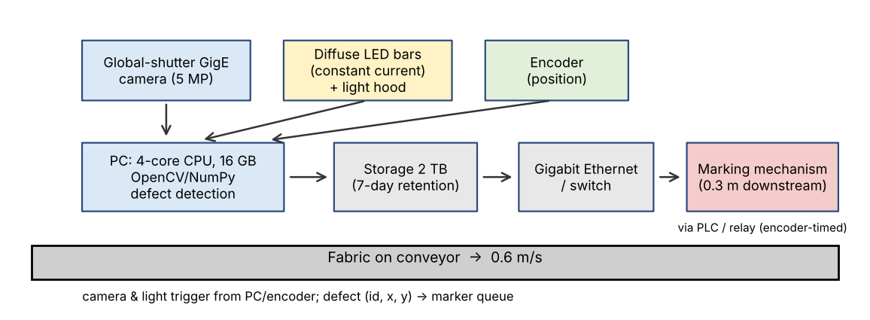
Fig. 3 Block diagram of the recommended (balanced) configuration
Answer 45: Cost assumptions (₹): existing PC, 2 TB storage and Gigabit network are already available (₹0). Prices are approximate Indian market estimates.
Item | Budget | Balanced | Premium
Camera | Rolling-shutter 1.3 MP USB ₹18 k | Global-shutter 5 MP GigE ₹55 k | 12 MP GigE global ₹1.10 L
Lens + illumination | ₹6 k + ₹5 k basic LED | ₹12 k + ₹30 k LED bars, hood | ₹30 k + ₹70 k strobe/UV
Processing | Existing CPU | Existing CPU, optimised | GPU workstation ₹1.40 L
Encoder, marker/PLC, mount, network, calibration target | ₹21 k | ₹40 k (6+15+10+6+3) | ₹40 k
Contingency | – | ₹8 k | –
Total | ≈ ₹50 k | ≈ ₹1,45,000 | ≈ ₹3,90,000
Resolution / pixel size | 1280×1024 / 0.94 mm | 2448×2048 / 0.49 mm | 4096×3000 / 0.29 mm
Processing time | ≈ 0.02 s | ≈ 0.1 s (+0.1 s transfer/overhead) | ≈ 0.1 s on GPU (0.36 s CPU)
Storage/7 days | ~0.4 TB | 1.21 TB (JPEG) | ≈ 3 TB JPEG → exceeds 2 TB
Inspection capability | Misses most 1.5 mm defects | Meets 1.5 mm, 3 px | Best, exceeds need

Answer 46: All configurations run the same logic on each frame: holes – bright/dark blob after background subtraction, area and roundness; broken threads – line filter and elongated component; stains – low-contrast blob after heavy smoothing (≥ 2–3 level threshold); weaving irregularity – block-wise texture-energy/FFT deviation. Each defect is recorded as one row (timestamp, frame ID, type, x/y in mm, area, severity) in SQLite/CSV, plus the JPEG frame; records older than 7 days are deleted by a nightly job.
Answer 47: Defect y-position is expressed in encoder counts: N_mark = N_frame + y_offset + D·k, with D = 0.3 m and k = 10 counts/mm (assumed encoder) → +3,000 counts. The PC places (id, N_mark) in a queue sent over serial/Modbus-TCP to a PLC or USB relay that fires the marker when the counter reaches N_mark. Time check: transit time = 0.3/0.6 = 0.5 s; with ≈ 0.22 s processing the defect has moved 0.13 m, so remaining wait = (0.3 − 0.13)/0.6 ≈ 0.28 s. A defect lying y metres downstream of the camera axis has only (0.3 − y)/0.6 s, so the downstream strip is processed first.
cmd=f"M,{defect_id},{n_frame+int(y_mm*10)+3000}\n"; ser.write(cmd.encode()) # PLC fires at count

Answer 48: Evaluation:
Requirement | Budget | Balanced | Premium
Decision ≤ 0.5 s | Yes (0.05 s) | Yes (≈ 0.2–0.25 s) | Yes with GPU; no on CPU (> 0.5 s)
7-day retention (2 TB) | Yes | Yes, 1.21 TB | No (≈ 3 TB) unless defect-only storage
Missed defects ≤ 2 % | No (1.6 px, 12 mm skew; est. 10–25 % missed) | Yes (estimated ≤ 2 %, validate on ≥ 200 samples) | Yes (≈ 1 %)

Answer 49: The Balanced configuration (≈ ₹1,45,000) is selected: it is the only one that is inside the ₹1,50,000 budget *and* meets the 0.5 s, 7-day and 2 % requirements. Budget is cheap but fails detection; Premium is 2.6× the budget.

TASK 10: Front-End Adaptation Challenge
Marks: 8
Assume that the textile company receives a new export order with the following changed requirements: the system must detect defects as small as 0.4 mm, identify stains visible under ultraviolet (UV) illumination, operate at a conveyor speed of 1.2 m/s, inspect twice the current production volume and produce a decision within 0.3 seconds. The existing PC and project budget must remain unchanged.
Candidate techniques / approaches:
- Retain the existing system with only software changes
- Modify the existing system by upgrading selected components
- Redesign the inspection system using a different acquisition and processing architecture
Student tasks:
- Identify which existing system components will become inadequate under the new requirements.
- Analyse the effect of the increased conveyor speed and smaller defect size on image sampling and acquisition.
- Explain how UV illumination or an additional imaging channel could help identify the new stain type.
- Compare the three adaptation strategies in terms of feasibility, accuracy, processing time, cost and implementation risk.
- Recommend the most practical strategy under the unchanged PC and budget constraints.
- Prepare an updated system block diagram and list the changes required.
- Clearly identify any requirements that cannot realistically be achieved without additional resources, and justify your conclusion.
ANSWERS
Answer 50: Inadequate under the new order: (i) camera/lens – 0.49 mm/px cannot resolve 0.4 mm; (ii) illumination – 200 µs continuous exposure and visible light only, no UV; (iii) PC – throughput limited to ≈ 50 MP/s (5 MP in 0.1 s); (iv) marker position – 0.3 m at 1.2 m/s is only 0.25 s of travel, less than the 0.3 s decision time; (v) frame rate – 3–4 fps required instead of 2. The 2 TB disk and network remain adequate.
Answer 51: A 0.4 mm defect needs ≈ 3 px → pixel size 0.4/3 = 0.133 mm → 1,000 mm / 0.133 = 7,500 px (9,000 px for 1,200 mm) across the web and 400/0.133 = 3,000 rows ⇒ ≈ 27 MP per frame, against 5 MP now (0.4 mm = 0.8 px today). At 1.2 m/s: frame rate ≥ 1.2/0.4 = 3 fps (use 4 fps for overlap); motion blur ≤ 0.5 px = 0.067 mm needs exposure ≤ 0.067/1200 = 56 µs (strobed LEDs). Line-scan equivalent: 1,200/0.133 = 9,000 lines/s × 9,000 px = 81 MB/s, close to the Gigabit limit (≈ 110 MB/s) and above the CPU's ≈ 50 MP/s capability.
Answer 52: Many oils and brighteners fluoresce under 365 nm UV-A: the stain emits visible light (blue-white) while the UV is blocked by a long-pass filter, so the stain contrast rises far above the 5–8 grey levels of visible light (to be verified on samples). The same camera can capture it by alternating visible and UV strobes (8 fps total, 4 fps per channel); the UV channel can be 2×2 binned (1.25 MP) because stains are large, so extra CPU load is only ≈ 5 MP/s. UV-A must be shielded in the hood for operator safety.
Answer 53: Comparison of strategies:
Criterion | S1: software only | S2: upgrade selected parts | S3: full redesign
Feasibility | Cannot add UV or resolve 0.4 mm | Feasible for UV, 1.2 m/s, 0.3 s | Feasible technically
Accuracy | Defects < 1 px lost | 1.5 mm detected; 0.4 mm only partly (long thin lines) | Meets 0.4 mm (≈ 3 × 4k line-scan)
Processing time | Needs > 0.3 s at 1.2 m/s (marker too close) | ≈ 0.2 s; 25 MP/s load (50 %) | Needs ≈ 160 MP/s, GPU/new PC
Cost | ₹0 | ≈ ₹60 k (strobe ₹25 k, UV bar+filter ₹30 k, marker move ₹5 k) | ≈ ₹4–6 lakh + new PC
Risk | High (fails order) | Low–medium | High (time, retraining, PC change)

Answer 54: Strategy 2 (upgrade selected components) is the most practical: it keeps the PC, camera and software core, stays within the ₹1,50,000 ceiling (assumption: the ceiling applies to the upgrade spend, the original ≈ ₹1.45 L system being installed; reused items are the PC, camera, enclosure, encoder and marker), and meets UV stain detection, 1.2 m/s, double volume and 0.3 s decision. Software work: multi-process (4 workers), ROI and 2×2 binning for the UV channel, coarse-to-fine detection.
Answer 55: Updated block diagram and list of changes:
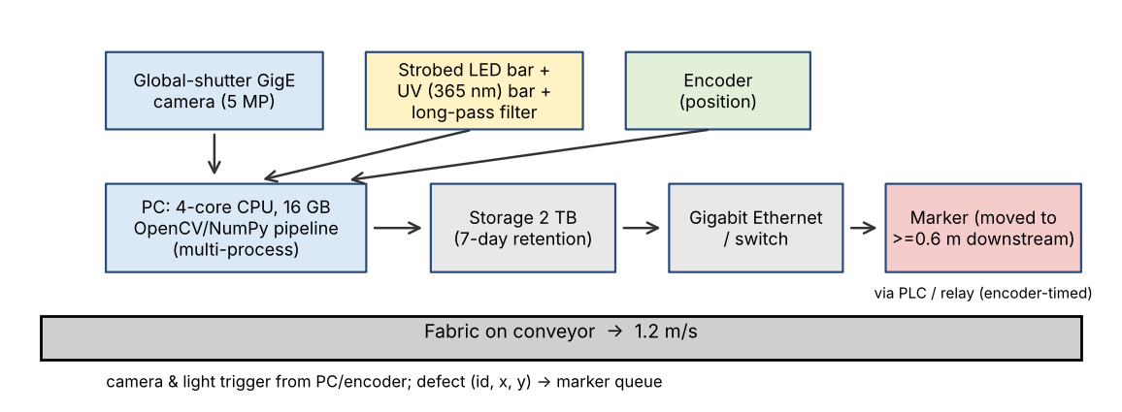
Fig. 4 Updated system block diagram (changes in the light and marker blocks)
Changes required: (1) strobed visible LED bar (≤ 56–200 µs); (2) 365 nm UV bar + long-pass filter; (3) trigger 8 fps alternating visible/UV; (4) move the marker to ≥ 1.2 × (0.3 + 0.05) + 0.2 = 0.62 m downstream (or use an encoder queue); (5) multi-process Python software; (6) recalibrate camera and re-validate thresholds.
Answer 56: With the existing PC and budget, 0.4 mm defect detection across the full 1.0–1.2 m width at 1.2 m/s cannot realistically be achieved: it needs ≈ 27 MP/frame (or ≥ 3 more 5 MP cameras, ≈ ₹1.7 L extra for cameras alone, plus lenses and light) and ≈ 81 MP/s processing (~1.6× the CPU capability, 3× with the UV channel). It is possible only for long thin defects, or at reduced speed/width, or with extra hardware (multi-camera line-scan + a stronger PC). All other new requirements (UV stains, 1.2 m/s, 2× volume, 0.3 s) are achievable with Strategy 2.

Mark Distribution
Task | Topic | Marks
1 | Overview and Features of Computer Vision | 4
2 | Levels of Computer Vision | 5
3 | Image Representation | 4
4 | Connectivity Analysis | 4
5 | Image Acquisition | 5
6 | Sampling Analysis | 5
7 | Quantization Analysis | 4
8 | Image Formation | 5
9 | Implementation and Performance Evaluation | 6
10 | Front-End Adaptation Challenge | 8
 | TOTAL | 50

Submission Requirements
- Submit a neatly formatted assignment report with task-wise headings.
- Include hand-drawn or computer-generated diagrams wherever required.
- Show all numerical calculations with formulae, substitution and final units.
- Include comparison tables and evidence supporting the selected techniques.
- For implementation tasks, attach source code, sample input images and output screenshots.
References / tools: Gonzalez & Woods, *Digital Image Processing*; Szeliski, *Computer Vision: Algorithms and Applications*; OpenCV 5.0 and NumPy documentation; Python 3 and Matplotlib (diagrams). Cost figures are estimates and test images are synthetic.
- Mention references, tools and software libraries used.

