**VISVESVARAYA TECHNOLOGICAL UNIVERSITY**

**“JnanaSangama”, Belagavi-590018**



**A PROJECT REPORT**

**ON**

**“chaperone-Caring the blind”**

***Submitted in the partial fulfillment for the award of Bachelor of Engineering degree i*n**

**COMPUTER SCIENCE AND ENGINEERING**

**Submitted by**

**Eshwar Prasad B (4AD15CS021)**

**Manasa R (4AD15CS043)**

**Manjumallika N (4AD15CS044)**

**Rudresh RM (4AD15CS059)**

**Under the Guidance of**

**Mrs. Archana MR**

Assistant Professor Department of CSE



**DEPARTMENT OF COMPUTER SCIENCE AND ENGINEERING**

**2018-2019**

**VISVESVARAYA TECHNOLOGICAL UNIVERSITY**

**Belagavi – 590018**



**Department of Computer Science and Engineering**

**CERTIFICATE**

This is to certify that the Project Work entitled **“chaperOne-Caring the blind”** is the bonafide work carried out by **Eshwar Prasad B (4AD15CS021), Manasa R (4AD15CS043) ,Manjumallika N (4AD15CS044), Rudresh RM (4AD15CS059)** in partial fulfillment for the award of degree of Bachelor of Engineering in Computer Science and Engineering from VisvesvarayaTechnological University, Belagavi during the year 2018-2019.

Signature of the Guide Signature of HOD Signature of Principal

**Mrs.Archana M R** **Dr.Manjunath S S Dr. L Basavaraj**

Assistant Professor Head of the Department Principal

**External Viva**

**Name of Examiners Signature with date**

**1………………………… ……………………………..**

**2………………………… ……………………………..**

**ACKNOWLEDGEMENT**

The successful completion of our work would be incomplete without the mention of the names of the people who have made it possible. We are indebted to several individuals who have helped us to complete our project.

We are thankful to **Dr. L Basavaraj**, **Principal**, ATME College of Engineering for having granted us permission and extended full use of the college facilities to carry out our project successfully.

We express our profound gratitude to **Dr. Manjunath S S,** Head Department of Computer Science and Engineering for his consistent co-operation and support.

At the outset we express our profound gratitude to our guide **Mrs**. **Archana M R,** Assistant Professor, Department of Computer Science and Engineering for her consistentCo-operation and support.

We are greatly indebted to our project coordinators **Mrs. Sunitha Patel** and **Mr. Puttegowda D,** Assistant Professors Department of Computer Science and Engineering for theirtimely inquiries into the progress of the project.

We also thank all teaching and non teaching staff members of the department for their valuable assistance throughout our academic tenure.

Lastly we would like to thank our family and friends for their cooperation and support for successful completion of our project.

**Eshwar Prasad (4AD14CS021)**

**Manasa R (4AD15CS043)**

**Manjumallika N (4AD15CS044)**

**Rudresh R M (4AD15CS059)**

**ABSTRACT**

chaperOne is a breakthrough technology in navigational and rehabilitative aids for the blind and visually impaired. It is designed to pinpoint and communicate physical location and object location using voice based guide for users for easy mobilization. chaperOne aims to foster confidence and participation, enabling the blind and visually impaired to live as active and independent as possible. This allows them to move independently without any manual help or guidance. chaperOne is a powerful tool for achieving fuller societal inclusion for those who are living with vision loss and blindness to move freely, safely, and independently.

The system is designed to act like an artificial vision and alarm unit. The system consists of ultrasonic sensor, microcontroller (Arduino Uno R3) to receive the sensor signals and process them to short pulses as pass to Arduino pins where buzzers, vibrator and voice alarms are connected.

GPS navigation in the Mobile can be used to guide the blind for new places and unfamiliar places. The blind man uses an earphone to listen to the navigation directions that are coming from the GPS and alert them through buzzer. We seek in our project to provide a smart spectacles affordable and suitable for most blind people, and also it is light in weight. It can be made available to all segments of the society and their families who need them and also if in case of some emergency, using Bluetooth connectivity the contacts of the blind person is reached through smartphone and the location details is given to them. So if any emergency occurs to the blind the application helps automatically to contact their relatives or family members.

|  |  |
| --- | --- |
|  |  |
|  |  |
|  |  |
|  |  |
|  |  |
|  |  |
|  |  |
|  |  |
|  |  |
|  |  |
|  |  |
|  |  |
|  |  |
|  |  |
|  |  |
|  |  |
|  |  |
|  |  |
|  |  |
|  |  |
|  |  |
|  |  |
|  |  |
|  |  |
|  |  |
|  |  |
|  |  |
|  |  |
|  |  |
|  |  |

### Chapter 1

**INTRODUCTION**

Blind and visually impaired people cannot move out nor do their works without any manual help or guide. They are compelled to depend on other people to do anything in their daily life. This leads to over dependency on other people which would reduce the confidence level of those who are visually impaired. Also, without proper help from other persons the visually impaired are prone to accidents.

chaperOne is a device which guides and allows blind and visually impaired people to live independently without taking any manual guide or help. This provides them information and guidance to move from one place to another safely and independently. The software provides a complete oral guide which specifically guides the visually impaired person about the path and direction to take and any obstacles in the path.

Blind mobility is one of the main brainstorming challenges that scientists are still facing around different parts of the world and still research is going on to implement suitable blind assistive devices. In recent years blind mobility has become an important issue since a large number of people are visually impaired or partially sighted. According to the World Health Organization, approximately 0.4% of the population is blind in industrialized countries while the percentage is rising to 1% in developing countries. As of 2012 there were 285 million people who were visually impaired of which 246 million had low vision and 39 million were blind.

### 1.1 Problem Statement

Of all sensations perceived through our senses, those received through sight have the greatest influence on perception. Sight combined with the other senses, basically hearing, allow us to have a global perception. Sight combined with the other senses, basically hearing, allow us to have a global perception and to perform actions according to it. For blind, the lack of sight is a major barrier in daily living: information access, mobility, was finding, interaction with the environment and with other people, among others, are challenging issues. In fact, school and working-age blind have unemployment at high rates. For example, in the US, the blind unemployment rate is around 75% while only 10% of the blind children’s receive instruction in Braille.

Despite various efforts, a truth is that most schools and employers cannot accommodate blind people. In consequence, the person who is blind and his/her family faces important socioeconomic constraints. As blind person has to depend on others for their day to day life so often in our society, people consider them as a burden. In some cases when blind people try to walk independently, they may hit any obstacles or they may hurt themselves. Therefore somewhere there is a need for guide that can inform them about the position of the obstacle situated ahead, and help them to walk safely. Most blinds use a cane as assistance tool.

### 1.2 Existing blind guide Systems

The existing tools of guidance used by visual impaired include cane, guide dog and some electronic device. The blind person can use the cane at the age of 14. A blind uses cane to detect the hindrance before moving step and warns the un-blind people. The weak point of a cane is not convenient to detect the hindrance over waist. Most blind uses cane to detect lower hindrance in front of moving step. There is a possibility of getting hurt by the higher hindrance. The guide dog is a powerful guider for a blind. The blind person can use the guide dog technique at the age of 17 or older. It is not suitable for elementary student, who is too young to control the dog. The guide dog is very expensive, the training and caring of the dog is not easy.

The available electronic guide tools for a blind are laser cane, sonic glasses, and sonic guide etc. Those non-contact distance measurement tools are dominated by ultrasound and laser. These electronic measuring devices transmit narrow beams of sound or light waves that "bounce" off selected solid objects back to the hand-held receiver. Custom electronics and a microprocessor convert the elapsed time into a comprehendible distance measurement unit and transmit the voice message by an earphone. It's quite easy to assess the distance using one of the aforesaid distance meters, but each measurement only gets a single point distance data. In this proposed system, a multi-point vision blind guide has been developed.

### 1.3 Proposed System

The system is designed to act like an artificial vision and alarm unit. The system consists of ultrasonic sensor, microcontroller (Raspberry pi 3 B+) to receive the sensor signals and process them to short pulses as pass to pi pins.

The blind man uses an earphone to listen to the directions that are coming from the sensors. We seek in our project to provide a smart device affordable and suitable for most blind people, and also it is comfortable. It can be made available to all segments of the society and their families who need them and also if in case of some emergency.

#### 1.3.1 Features of the proposed System:

* Acts as a friendly guide.
* Guides them orally.
* Warns them if any obstacles found.
* The end user electronic equipment’s are simple.

### Chapter 2

**Literature survey**

### 2.1 Blind guide - A virtual eye for guiding indoor and outdoor movement.

**Author:** [BálintSöveny;](https://ieeexplore.ieee.org/search/searchresult.jsp?searchWithin=%22Authors%22:.QT.B%C3%A1lint%20S%C3%B6veny.QT.&newsearch=true)[GáborKovács;](https://ieeexplore.ieee.org/search/searchresult.jsp?searchWithin=%22Authors%22:.QT.G%C3%A1bor%20Kov%C3%A1cs.QT.&newsearch=true)[Zsolt T. Kardkovács**.**](https://ieeexplore.ieee.org/search/searchresult.jsp?searchWithin=%22Authors%22:.QT.Zsolt%20T.%20Kardkov%C3%A1cs.QT.&newsearch=true) **Year-**2014.

In this paper, we present a design of wearable equipment that helps with the perception of the environment for blind and visually impaired people in indoor and outdoor mobility and navigation. Our prototype can detect and id0entify traffic situations such as street crossings, traffic lamps, cars, cyclists, other people and low and high obstacles. The detection takes place in real time based on input data of sensors and optical cameras, the mobility of the user is aided with audio signals.

### 2.2 A design of blind-guide crutch based on multi-sensors

**Author:** [Yiting Yi;](https://ieeexplore.ieee.org/search/searchresult.jsp?searchWithin=%22Authors%22:.QT.Yiting%20Yi.QT.&newsearch=true)[Lunfu Dong.](https://ieeexplore.ieee.org/search/searchresult.jsp?searchWithin=%22Authors%22:.QT.Lunfu%20Dong.QT.&newsearch=true) **Year-**2015.

This paper designed a blind-guide system based on the principle of the ultrasonic distance measurement, using a STC15F2K60S2 microcontroller as the core control device. It can detect obstacles overhead, in front, in right front and in left front using three ultrasonic ranging modules. Acquiring and processing the distance information by the MCU, it alarms the user through the voice and the vibration. The system improves the timeliness and accuracy of alarm, and can assist the visual impaired in avoiding obstacles, walking safely and faster.

### 2.3 Smart cane location guide for blind using GPS

**Author:**[Gita Indah Hapsari;](https://ieeexplore.ieee.org/search/searchresult.jsp?searchWithin=%22Authors%22:.QT.Gita%20Indah%20Hapsari.QT.&newsearch=true)[GivaAndrianaMutiara;](https://ieeexplore.ieee.org/search/searchresult.jsp?searchWithin=%22Authors%22:.QT.Giva%20Andriana%20Mutiara.QT.&newsearch=true)[Dicky Tiara Kusumah.](https://ieeexplore.ieee.org/search/searchresult.jsp?searchWithin=%22Authors%22:.QT.Dicky%20Tiara%20Kusumah.QT.&newsearch=true)

**Year-**2017.

Visually impaired have a deficiency in their vision which has limitations in terms of mobility. On the other side, the blind must also run their daily activities. Sometimes, the blind must performs mobility from one building to another building in some area which has a distance like campus, mall and others. In order to make the visually impaired mobility becomes easier, we created a tool that can help them to detect the location of the destination buildings or inform them where the position of the standing place through the sound as the output information. Prototype made using the GPS module, keypad, earphone and raspberry Pi. The results show that the functional testing tools can detect the location area of interest with a deviation of less than 8 m. Also based on the friendly user testing, this prototype categorized good enough to be used by the blind.

### 2.4 Smart guide for blind people

**Author:** [Mohamed Manoufali;](https://ieeexplore.ieee.org/search/searchresult.jsp?searchWithin=%22Authors%22:.QT.Mohamed%20Manoufali.QT.&newsearch=true)[Ahmed Aladwani;](https://ieeexplore.ieee.org/search/searchresult.jsp?searchWithin=%22Authors%22:.QT.Ahmed%20Aladwani.QT.&newsearch=true)[SaifAlseraidy;](https://ieeexplore.ieee.org/search/searchresult.jsp?searchWithin=%22Authors%22:.QT.Saif%20Alseraidy.QT.&newsearch=true)[Ali Alabdouli](https://ieeexplore.ieee.org/search/searchresult.jsp?searchWithin=%22Authors%22:.QT.Ali%20Alabdouli.QT.&newsearch=true) **Year-**2011**.**

A prototype of an intelligent guide for the blind person is successfully designed, implemented and tested. The prototype device is facilitating the movement of blind person by warning him/her about any nearby obstacles in order to help him/her during daily activities. The guidance will be provided in the form of audio instructions through the headset and based on real-time situation for both indoor and outdoor environments. The system is successfully tested at different normal conditions with Emirates Blind Care Association in Sharjah, UAE.

### 2.5 A user-steered guide robot for the blind

**Author**: [Dae Young Kim;](https://ieeexplore.ieee.org/search/searchresult.jsp?searchWithin=%22Authors%22:.QT.Dae%20Young%20Kim.QT.&newsearch=true)[Keon Young Yi.](https://ieeexplore.ieee.org/search/searchresult.jsp?searchWithin=%22Authors%22:.QT.Keon%20Young%20Yi.QT.&newsearch=true) **Year-**2008.

This study deals with a guide robot for blind people. User inputs (i.e., commands for movements) are obtained from blind people through a joystick, which has two potentiometers. Some noise unintentionally caused by the user is included in this input. To reject the unwanted signal, the robot has to recognize the intention of the user even with these noises. In order to make the robot follow the intention, an Omni wheel-based driving unit is attached under the joystick through a link. Although the Omni wheel moves easily along narrow curves, it is important to make the user's wrist or arm holding the joystick comfortable by planning proper motion trajectory. To do this, a fuzzy logic control is employed to identify the user's intention and determine movement velocity and direction of the robot from the joystick signal.

### 2.6 Guiding Blind Transmitters: Degrees of Freedom Optimal Interference Alignment Using Relays

**Author:** [Ye Tian;](https://ieeexplore.ieee.org/search/searchresult.jsp?searchWithin=%22Authors%22:.QT.Ye%20Tian.QT.&newsearch=true)[Aylin Yener](https://ieeexplore.ieee.org/search/searchresult.jsp?searchWithin=%22Authors%22:.QT.Aylin%20Yener.QT.&newsearch=true). **Year-**2013**.**

Channel state information (CSI) at the transmitters (CSIT) is of importance for interference alignment schemes to achieve the optimal degrees of freedom (DoF) for wireless networks. This paper investigates the impact of half-duplex relays on the DoF of the X channel and the interference channel when the transmitters are blind in the sense that no CSIT is available. In particular, it is shown that adding relay nodes with global CSI to the communication model is sufficient to recover the DoF that is the optimal for these models with global CSI at the transmitters. The relay nodes in essence help steer the directions of the transmitted signals to facilitate interference alignment to achieve the optimal DoF with CSIT. The general M × N X channel with relays and the -user interference channel are both investigated, and sufficient conditions on the number of antennas at the relays and the number of relays needed to achieve the optimal DoF with CSIT are established. Using relays, the optimal DoF can be achieved in finite channel uses. The DoF for the case when relays only have delayed CSI is also investigated, and it is shown that with delayed CSI at the relay the optimal DoF with full CSIT cannot be achieved. Special cases of the X channel and interference channel are investigated to obtain further design insights.

### Chapter 3

**Software Requirements and Specification**

**3.3 Hardware Requirements**

* Raspberry pi 3 B+
* Ultrasonic sensor
* Raspberry pi camera module/webcam
* >4GB RAM
* >2GB graphics
* 16GB memory card

**3.4 System Requirements**

* Platform: Machine Learning
* Language used: Python

**3.5 Software Requirements**

* Raspbian
* OpenCV, YOLO
* And other python support libraries

.

### Chapter 4

**SYSTEM DESIGN**

1. **Installing the Raspbian OS and the required python libraries**

The Raspbian Operating System on which the Raspberry pi board runs on is installed on the SD card. Then the Raspberry pi is booted and the required python modules like OpenCV are installed.

**2. Implementing the YOLO for object detection**

You only look once (YOLO) is a state-of-the-art, real-time object detection system. YOLO is extremely fast and accurate.

**How Yolo works?**

Prior detection systems repurpose classifiers or localizers to perform detection. They apply the model to an image at multiple locations and scales. High scoring regions of the image are considered detections.

YOLO use a totally different approach. It apply a single neural network to the full image. This network divides the image into regions and predicts bounding boxes and probabilities for each region. These bounding boxes are weighted by the predicted probabilities. This model has several advantages over classifier-based systems. It looks at the whole image at test time so its predictions are informed by global context in the image. It also makes predictions with a single network evaluation.

The output from the YOLO is converted to voice which tells the person which object is ahead. For that eSpeak is used, eSpeak is a module which converts text to speech. It supports many languages including English and kannada as well.

**3. Measuring the distance between the obstacle and the user**

To measure the distance between the obstacle and the user the ultrasonic sensor is used. It is a compact yet powerful hardware module which can measure the distance using the ultrasonic waves, It has the range upto 10 Meters.

The ultrasonic sensor is connected to the Raspberry pi board and the distance is measured in centimetres and it converted it terms of steps.

**4. Integrating the outputs**

The object detection output from camera and the distance measurement from the ultrasonic sensor are collected and integrated to give the distance of an object from the user through voice command.

### 4.2 Data Flow Model

The data flow diagram depicts the flow of the system how it interacts with the other modules.

**Step 1**: The required modules are installed on the pi board.

**Step 2**: The real-time objection detection data collected from the camera.

**Step 3**: The distance measurement output is produced in terms of centimetres from the ultrasonic sensor and that is converted to steps.

**Step 4**: The output from both the sources is collected and suitable voice commands are given to the user to walk.

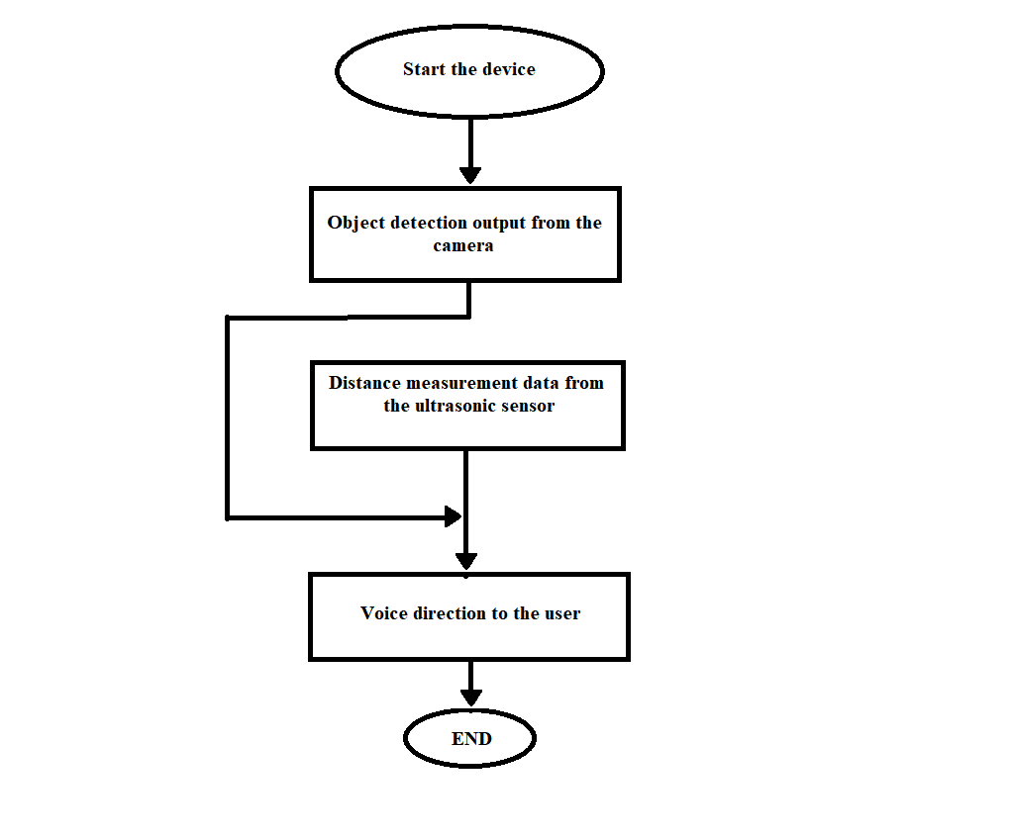

### 4.3 Circuit

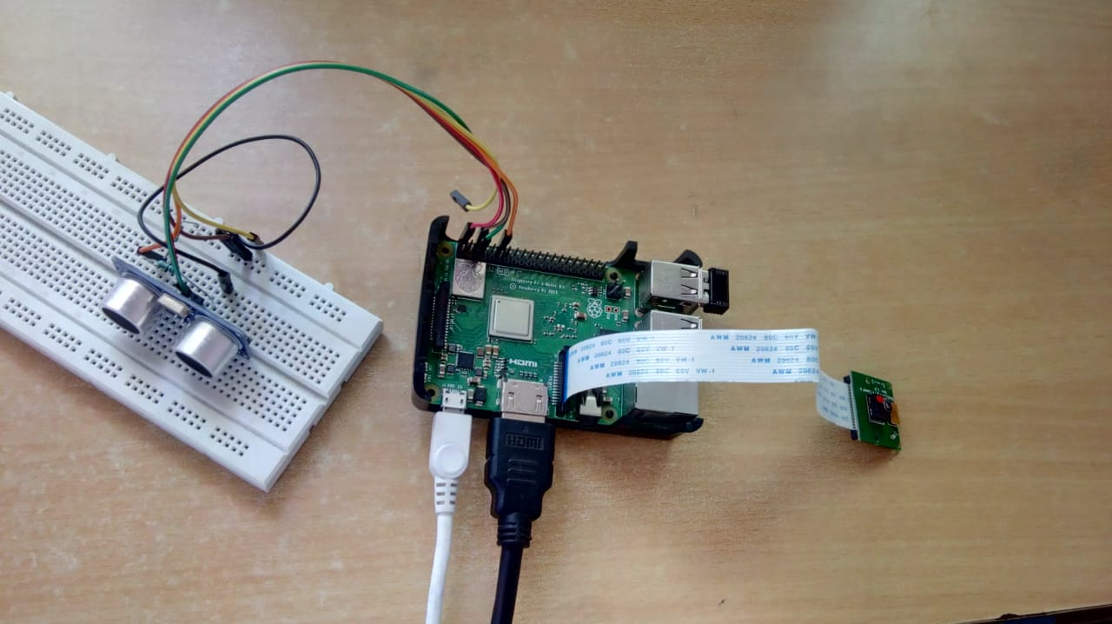

The figure shows the circuit design, in which the Raspberry pi board is connected to the various components like pi camera module and the ultrasonic sensor.

### Chapter 5

**IMPLEMENTATION**

**Psudocode for object detection**

vid = cv.VideoCapture(-1)

while True:

_,frame = vid.read()

height, width = frame.shape[:2]

if count == 0:

frame, boxes, confidences, classids, idxs = infer_image(net, layer_names, \

height, width, frame, colors, labels, FLAGS)

count += 1

else:

frame, boxes, confidences, classids, idxs = infer_image(net, layer_names, \

height, width, frame, colors, labels, FLAGS, boxes, confidences, classids, idxs, infer=False)

count = (count + 1) % 150

classids_cpy = classids

all_freq = {}

for i in classids_cpy:

if i in all_freq:

all_freq[i] += 1

else:

all_freq[i] = 1

**Psudocode to measure distance**

GPIO.setmode(GPIO.BOARD)

TRIG = 5

ECHO = 12

GPIO.setup(TRIG,GPIO.OUT)

GPIO.output(TRIG,0)

GPIO.setup(ECHO,GPIO.IN)

time.sleep(0.1)

GPIO.output(TRIG,1)

time.sleep(0.0001)

GPIO.output(TRIG,0)

while GPIO.input(ECHO) == 0:

pass

start = time.time()

while GPIO.input(ECHO) == 1:

pass

stop = time.time()

os.system(“espeak’ ”+( stop - start) *1700+” steps’ ”)

GPIO.cleanup()

**Psudocode to convert object detection data to voice commands**

f=open('coco-labels')

lines=f.readlines()

for key, value in all_freq.items():

freq=str(value)

os.system('espeak "'+freq+' '+lines[key]+'"')

**TESTING**

Testing is a process of executing a program to ensure that defined input will produce actual results that agree with required outputs. In developing a software project, error can be initiated at any stage during the development. For each phase of the software development cycle there are different techniques for detecting and elimination errors that originate in that phase. However some errors will reflect in the code. Testing performs a very crucial role for quality assurance and for ensuring the reliabilities of the software. The quality of the system depends on its design, development, testing and implementation. Weaknesses in any of these areas will seriously affect the quality and therefore value of the system to its users. Once the code has been generated, testing of the modules begins implementation ends with formal tests.

## 6.1 Purpose of Testing

Testing accomplishes a variety of things, but most importantly it measures the quality of the software we are developing. This view presupposes there are defects in the software waiting to be discovered and this view is rarely disproved or even disputed.

Several factors contribute to the importance of making testing a high priority of any software development effort. These include:

* Reducing the cost of developing the program.
* Ensuring that the application behaves exactly as we explain to the user for the vast majority of programs, unpredictability is the least desirable consequences of using an application.
* Reducing the total cost of ownership. By providing software that looks and behaves as shown in the documentation, the customers require fewer hours of training and less support from product experts.
* Developing customer loyalty and word-of-mouth market share.

## 6.2 Unit Testing

Unit testing is usually conducted as part of a combined code and test phase of the software lifecycle, although it is not uncommon for coding and unit testing to be conducted as two distinct phases.

* **Test strategy and approach**

Field testing will be performed manually and functional tests will be written in detail.

* **Test objectives** 
  1. All the units must work properly.
  2. The data from the units must be accurate.
  3. The user must get the suitable commands.

## 6.3 Test Cases

Test Scenario: The device is started and it should detect the objects and measure the distance between the object and the user.

Expected result: The device should detect the object and it should measure the distance between the object and the user.

Actual results: The device detected the objects and measured the distance between the object and the user.

Result: PASS.

# CONCLUSION AND FUTURE ENHANCEMENT

ChaperOne is a breakthrough technology in navigational and rehabilitative aids for the blind and visually impaired. It aims to foster confidence and participation, enabling the blind and visually impaired to live as active and independent as possible. This allows them to move independently without any manual help or guidance. chaperOne is a navigational package tool built for visually impaired person this guide system can be enhanced with devices which will be available even smaller as this kit .

Further it can be enhance to detect the faces of the person which the user knows and make it to detect the currency notes which helps the blind in commercial field.

# REFERENCES

1. Chaudhry M., Kamran M., Afzal S., ―Speaking monuments — design and implementation of an RFID based blind friendly environment‖, 2nd ICEE International Conf. on 25-26 March, 2008.
2. Velázquez R., ―Wearable Assistive Devices for the Blind.‖ Chapter 17 in A. LayEkuakille&Mukhopadhyay (Eds.), Wearable and Autonomous Biomedical Devices and Systems for Smart ronment: Issues and Character ization, LNEE 75, Springer, 2010, pp 331-349.
3. World Health Organization (2009) Visual impairment and blindnessFact Sheet

N°282. Available online at: http://www.who.int mediacentre/ factsheets/fs282/en/

1. C. Kang, H. Jo and B.Kim, ―A Machine-to-Machine based Intelligent Walking

Assistance System for Visually Impaired Person‖, The Journal of KICS, vol. 36, no. 3, pp. 195-304, 2011.

1. N. Bourbakis, D. Dakopoulos, ―A Comparative Survey on Wearable Systems for Blinds' Navigation,‖ 1st International IEEE-BAIS Symposium on Research on Assistive Technologies, Dayton, OH, pp.3-12, 16 April, 2007.
2. Blind World Magazine (2006) Breaking the chains of paternalism. Available online at: http://home.earthlink.net/~blindworld/NEWS/6-06- 14-02.htm
3. Benjamin J. M., Ali N. A., and Schepis A. F., ―A Laser Cane for the Blind.‖ Proceedings of the San Diego Biomedical Symposium, Vol. 12, pp. 53-57.
4. Madad A. Shah, Sayed H. Abbas, ShahzadA. Malik, ― Blind Navigation via a

DGPS-based Handheld Unit‖, Australian Journal of Basic and Applied Sciences, 4(6): 1449-1458, 2010.

1. Johann B. and Iwan U. ―The GuideCane — A Computerized Travel Aid for the

Active Guidance of Blind Pedestrians‖, Proceedings of the IEEE International

Conference on Robotics and Automation, Albuquerque, NM, Apr. 21-27, 1997, pp.

1283-1288.

1. Sandra M., Nik A. M., Maxim M., Aaron S. ―BlindAid: An Electronic Travel

Aid for the Blind‖, The Robotics Institute, Carnegie Mellon University, Pittsburgh, Pennsylvania 15213.

Blind Guide –Android Application with IOT.

1. Sachin B., Rohan T., Harshranga P., Bhurchandi, K. M. ―Substitute eyes for

Blind using Android‖ India Educators’ Conference (TIIEC), Texas Instruments, 2013, pages: 38-43,DOI: 10.1109/TIIEC.2013.14.

1. Piotr K., Piotr S., Piotr W. and Piotr W. ―Mobile Applications Aiding the

Visually Impaired in Travelling with Public Transport‖, Proceedings of the 2013

Federated Conference on Computer Science and Information Systems, pp. 825–828 .