**Tech-Shop**

an electronic gadgets shop

**Task:1. Database Design:**

**ER Diagram**

4. Create appropriate Primary Key and Foreign Key constraints for referential integrity.

Ans:-

CREATE TABLE Customers (

CustomerID int(3) PRIMARY KEY,

FirstName varchar(50),

LastName varchar(50),

Email varchar(75),

Phone varchar(10),

Address varchar(225)

);

CREATE TABLE Products (

ProductID int(3) PRIMARY KEY,

ProductName varchar(50),

Description varchar(249),

Price decimal(10,2)

);

CREATE TABLE Orders (

OrderID int PRIMARY KEY,

CustomerID int(3),

OrderDate date,

TotalAmount decimal(10, 2),

FOREIGN KEY (CustomerID) REFERENCES Customers(CustomerID)

);

CREATE TABLE OrderDetails (

OrderDetailID int(3) PRIMARY KEY,

OrderID int(3),

ProductID int(3),

Quantity int(5),

FOREIGN KEY (OrderID) REFERENCES Orders(OrderID),

FOREIGN KEY (ProductID) REFERENCES Products(ProductID)

);

CREATE TABLE Inventory (

InventoryID int(5) PRIMARY KEY,

ProductID int(3),

QuantityInStock int(5),

LastStockUpdate date,

FOREIGN KEY (ProductID) REFERENCES Products(ProductID)

);

**

5. Insert at least 10 sample records into each of the following tables.

**Customers**

INSERT INTO Customers (customerid,firstname,lastname,email,phone,address)

VALUES

(101, 'eshwar', 'V', 'eshwar@gmail.com', '9782154201', '32,JP nagar,banglore-49'),

(102, 'reddy', 'V', 'reddy123@gmail.com','9587412368', '45,JJ nagar,banglore'),

(103, 'tom', 'son', 'tom143@gmail.com', '9586741230', '36,LB nagar,banglore-49'),

(104, 'jhon', 'son', 'jhon456@gmail.com', '9513687421', '97,NR layout,hyd-07'),

(105, 'king', 'baby', 'king956@gmail.com', '6365987412', '54,JP nagar,banglore-49'),

(106, 'ntr', 'fan', 'ntrfans@gmail.com', '7898745621', '9,NR layout,hyd-07'),

(107, 'pavan', 'kumar', 'pavan@gmail.com', '7775648921', '13,RR nagar,hyd-04'),

(108, 'ravi', 'sharma', 'ravis123@gmail.com', '9694562100', '49,MR layout,banglore-48'),

(109, 'Hank', 'kumar', 'kumar123@gmail.com', '6457871188', '876 jp nagar,banglore-49'),

(110, 'muni', 'reddy', 'muni23@gmail.com', '8364942155', '24,PK nagar,banglore-04');

**Customers OUTPUT: -**

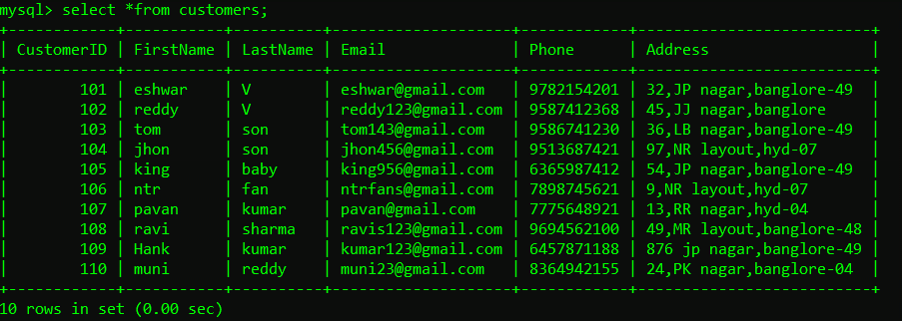

**Products**

INSERT INTO Products (ProductID, ProductName, Description, Price_INR)

VALUES (111, 'HP Laptop', 'High-performance and Best Display laptop', 55999.00),

(112, 'Nothing Smartphone', 'Latest model with Glyph ligthing ', 45999.99),

(113, 'Boat Headphones', 'ANC with 4 mic's wireless headphones', 1499.99),

(114, 'Asus Monitor', '4K curved display', 85299.00),

(115, 'Acer Keyboard', 'gaming keyboard with RCB light', 19499.99),

(116, 'Asus Mouse', 'best Wireless mouse for gaming', 8999.99),

(117, 'HP Printer', 'All-in-one printer', 15549.90),

(118, 'Apple adopter', 'with 120w fast charging',9399.99),

(119, 'Apple series 8 watch', 'with two finger tap opreation', 45599.99),

(120, 'Apple 16 pro max', 'With extra action button', 169499.99);

**Products OUTPUT: -**

**Orders**

INSERT INTO Orders (OrderID, CustomerID, OrderDate, TotalAmount)

VALUES (201, 101, '2024-09-26', 55999.00),

(202, 102, '2024-09-24', 1499.99),

(203, 103, '2024-09-29', 45999.99),

(204, 104, '2024-09-27', 169499.99),

(205, 104, '2024-09-27', 9399.99),

(206, 106, '2024-09-28', 85299.00),

(207, 101, '2024-09-26', 15549.90),

(208, 108, '2024-09-25', 19499.99),

(209, 104, '2024-09-27', 45599.99),

(210, 106, '2024-09-28', 8999.99);

OUTPUT: -**

**OrderDetails**

INSERT INTO OrderDetails (OrderDetailID, OrderID, ProductID, Quantity)

VALUES (211, 201, 111, 1),

(212, 202, 113, 1),

(213, 203, 112, 1),

(214, 204, 120, 1),

(215, 205, 118, 1),

(216, 206, 114, 1),

(217, 207, 117, 1),

(218, 208, 115, 1),

(219, 209, 119, 1),

(220, 210, 116, 1);

**OrderDetails OUTPUT: -**

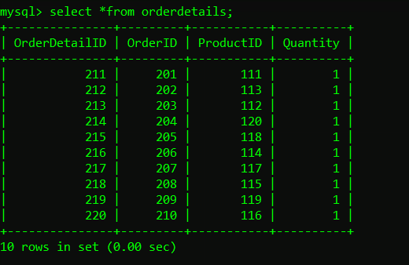

**Inventory**

INSERT INTO Inventory (InventoryID, ProductID, QuantityInStock, LastStockUpdate)

VALUES (301, 111, 15, '2024-09-21'),

(302, 112, 25, '2024-09-21'),

(303, 113, 90, '2024-09-21'),

(304, 114, 15, '2024-09-21'),

(305, 115, 80, '2024-09-21'),

(306, 116, 75, '2024-09-21'),

(307, 117, 10, '2024-09-21'),

(308, 118, 50, '2024-09-21'),

(309, 119, 20, '2024-09-21'),

(310, 120, 10, '2024-09-21');

**Inventory OUTPUT: -**

**Tasks 2**

1. Write an SQL query to retrieve the names and emails of all customers.

Ans : SELECT firstname,lastname,email FROM customers;

2. Write an SQL query to list all orders with their order dates and corresponding customer names.

Ans SELECT ,o.orderdate,c.firstname,c.lastname FROM orders o,customers c WHERE o.customerid=c.customerid;

3. Write an SQL query to insert a new customer record into the "Customers" table. Include customer information such as name, email, and address.   
Ans:- Not possible because customerid should have a value has it is primary key.

4. Write an SQL query to update the prices of all electronic gadgets in the "Products" table by increasing them by 10%.

Ans:- UPDATE products SET price_inr = price_inr * 1.10;

5. Write an SQL query to delete a specific order and its associated order details from the "Orders" and "OrderDetails" tables. Allow users to input the order ID as a parameter.

Ans:- DELETE from orders WHERE orderid=203;

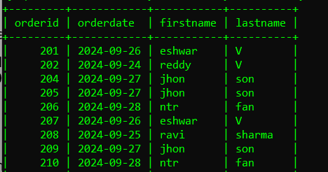

6. Write an SQL query to insert a new order into the "Orders" table. Include the customer ID, order date, and any other necessary information.

Ans:- INSERT INTO Orders (OrderID,CustomerID,Orderdate,Totalamount)

VALUES (211, 105, '2024-09-30', 45999.99);

7. Write an SQL query to update the contact information (e.g., email and address) of a specific customer in the "Customers" table. Allow users to input the customer ID and new contact information.

8. Write an SQL query to recalculate and update the total cost of each order in the "Orders" table based on the prices and quantities in the "OrderDetails" table.

Ans SELECT od.Orderid, SUM(od.Quantity * p.price_INR) AS TotalAmount

FROM Orderdetails od, Products p

WHERE od.ProductID = p.ProductID

GROUP BY od.OrderID;

9. Write an SQL query to delete all orders and their associated order details for a specific customer from the "Orders" and "OrderDetails" tables. Allow users to input the customer ID as a parameter.

Ans

10. Write an SQL query to insert a new electronic gadget product into the "Products" table, including product name, category, price, and any other relevant details.

Ans:- INSERT INTO Products (ProductID, Productname, Description, Price_INR) VALUES (121, 'Samsung Galaxy s23', 'Latest model with AI features', 69999.00);

11. Write an SQL query to update the status of a specific order in the "Orders" table (e.g., from "Pending" to "Shipped"). Allow users to input the order ID and the new status.

Ans:- ALTER TABLE Orders ADD status VARCHAR(20);

UPDATE Orders SET Status = CASE

WHEN customerid =104 THEN 'Shipped'

ELSE 'Not Shipped'

END;

12. Write an SQL query to calculate and update the number of orders placed by each customer in the "Customers" table based on the data in the "Orders" table.

Ans SELECT o.customerid,COUNT(o.orderid) AS num_of_orders FROM orders o

GROUP BY o.customerid;

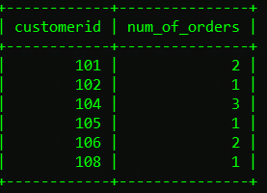

**Tasks 3**

1. Write an SQL query to retrieve a list of all orders along with customer information (e.g., customer name) for each order.

Ans:- SELECT o.orderId ,o.customerid,o.orderDate , o.totalamount ,c.FirstName

,c.LastName from orders o

INNER JOIN customers c ON o.customerId=c.customerId;

2. Write an SQL query to find the total revenue generated by each electronic gadget product. Include the product name and the total revenue.

Ans:- SELECT p.Productname,SUM(od.quantity*p.Price_INR) AS totalrevenue

FROM Products p

JOIN OrderDetails od ON p.ProductID = od.ProductID

GROUP BY productname;

3. Write an SQL query to list all customers who have made at least one purchase. Include their names and contact information.

Ans: SELECT DISTINCT c.Firstname,c.Lastname,c.Phone from Customers c

JOIN Orders o ON c.CustomerID = o.CustomerID;

4. Write an SQL query to find the most popular electronic gadget, which is the one with the highest total quantity ordered. Include the product name and the total quantity ordered.

Ans:- SELECT p.Productname, od.Quantity from products as p

INNER JOIN orderdetails od WHERE p.productid=od.productid

ORDER BY od.quantity desc limit 1;

5. Write an SQL query to retrieve a list of electronic gadgets along with their corresponding categories.

Ans :- SELECT Productname, Description from products;

6. Write an SQL query to calculate the average order value for each customer. Include the customer's name and their average order value.

Ans:- SELECT c.Firstname, c.Lastname, AVG (o.Totalaamount) AS Avgordervalue

FROM Orders o

INNER JOIN Customers c ON o.CustomerID = c.CustomerID

GROUP BY c.Firstname, c.Lastname

ORDER BY Avgordervalue desc;

7. Write an SQL query to find the order with the highest total revenue. Include the order ID, customer information, and the total revenue.

8. Write an SQL query to list electronic gadgets and the number of times each product has been ordered.

Ans:-SELECT p.Productname, COUNT(od.OrderDetailID) AS Num_OfTimesOrdered

FROM Products p

LEFT JOIN OrderDetails od ON p.ProductID = od.ProductID

GROUP BY p.Productname;

9. Write an SQL query to find customers who have purchased a specific electronic gadget product. Allow users to input the product name as a parameter.

Ans:-

10. Write an SQL query to calculate the total revenue generated by all orders placed within a specific time period. Allow users to input the start and end dates as parameters.

Ans :- SELECT SUM(o.TotalAmount) AS Totalrevenu FROM Orders o

WHERE o.OrderDate BETWEEN '2024-09-25' AND '2024-09-30'

**Tasks 4**

1. Write an SQL query to find out which customers have not placed any orders.

Ans:- SELECT c.CustomerID,c.Firstname,c.Lastname FROM Customers c

WHERE c.CustomerID NOT IN (SELECT o.CustomerID FROM Orders o);

2. Write an SQL query to find the total number of products available for sale.

Ans:- SELECT SUM(QuantityInStock) AS TotalProductsAvailable FROM Inventory;

3. Write an SQL query to calculate the total revenue generated by TechShop.

Ans:- SELECT SUM(totalamount) as TotalRevenue FROM orders;

4. Write an SQL query to calculate the average quantity ordered for products in a specific category. Allow users to input the category name as a parameter.

Ans SELECT p.ProductName, AVG(od.Quantity) FROM OrderDetails od

INNER JOIN Products p ON od.ProductID = p.ProductId

GROUP BY p.ProductName;

5. Write an SQL query to calculate the total revenue generated by a specific customer. Allow users to input the customer ID as a parameter.

Ans SELECT CustomerID,SUM(TotalAmount) AS TotalRevenue FROM Orders

WHERE OrderID IN (SELECT OrderID FROM Orders WHERE CustomerID = 104)

GROUP BY CustomerID;

6. Write an SQL query to find the customers who have placed the most orders. List their names and the number of orders they've placed.

Ans:- SELECT c.FirstName, c.LastName, COUNT(o.OrderID) AS Num_of_orders

FROM Customers c

INNER JOIN Orders o ON c.CustomerID = o.CustomerID

GROUP BY c.CustomerID, c.FirstName, c.LastName

ORDER BY Num_of_orders desc;

7. Write an SQL query to find the most popular product category, which is the one with the highest total quantity ordered across all orders.

8. Write an SQL query to find the customer who has spent the most money (highest total revenue) on electronic gadgets. List their name and total spending.

9. Write an SQL query to calculate the average order value (total revenue divided by the number of orders) for all customers.

10. Write an SQL query to find the total number of orders placed by each customer and list their names along with the order count.