1. Provide a SQL script that initializes the database for the Job Board scenario “CareerHub”.

**Ans:-** mysql> USE CareerHub;

Database changed

2. Create tables for Companies, Jobs, Applicants and Applications.

3. Define appropriate primary keys, foreign keys, and constraints.

4. Ensure the script handles potential errors, such as if the database or tables already exist.

**Ans:- From 2,3,4**

mysql> CREATE TABLE Company(

-> CompanyID INT PRIMARY KEY,

-> CompanyName VARCHAR(125),

-> Location VARCHAR(125));

Query OK, 0 rows affected (0.05 sec)

mysql> CREATE TABLE Job(

-> JobID INT PRIMARY KEY,

-> CompanyID INT,

-> JobTitle VARCHAR(125),

-> JobDescription TEXT,

-> JobLocation VARCHAR(125),

-> Salary_PM DECIMAL(10,2),

-> JobType VARCHAR(75),

-> PostedDate DATETIME,

-> FOREIGN KEY (CompanyID) REFERENCES Company(CompanyID));

Query OK, 0 rows affected (0.07 sec)

mysql> CREATE TABLE Applicant(

-> ApplicantID INT PRIMARY KEY,

-> FirstName VARCHAR(50),

-> LastName VARCHAR(50),

-> Email VARCHAR(125),

-> Phone VARCHAR(10),

-> Resume TEXT);

Query OK, 0 rows affected (0.04 sec)

mysql> CREATE TABLE Application(

-> ApplicationID INT PRIMARY KEY,

-> JobID INT,

-> ApplicantID INT,

-> ApplicationDate DATETIME,

-> CoverLetter TEXT,

-> FOREIGN KEY (JobID) REFERENCES Job(JobID),

-> FOREIGN KEY (ApplicantID) REFERENCES Applicant(ApplicantID));

Query OK, 0 rows affected (0.07 sec)

INSERT INTO Company(CompanyID,CompanyName,Location)VALUES

(101,'Hexaware','Chennai,Tamilnadu,India'),

(102,'Orcale','Bangalore,Karnataka,India'),

(103,'Zomata','Bangalore,Karnataka,India'),

(104,'Apple','Apple park,California,USA'),

(105,'Amazon','Hyderabad,Telangana,India');

INSERT INTO Job(JobID,CompanyID,JobTitle,JobDescription,JobLocation,Salary_PM,JobType,PostedDate)VALUES

(111,101,'Full-stack Developer','Good Knowledge on Java,Javascprit,HTML&CSS','Chennai,Tamilnadu,India',45000.00,'Full-time','2024-09-21 09:30:00'),

(112,102,'Database Management','Good Knowledge on MYSQL,SQL,EXCEL','Bangalore,Karnataka,India',65000.00,'Full-time','2024-09-16 11:30:00'),

(113,103,'Delivery Boy','Should Know Driving Two-Wheeler with Driving Lincence','Bangalore,Karnataka,India',20000.00,'PART-time','2024-10-01 12:45:00'),

(114,104,'UI/UX Designer','Good Knowledge on Figma,UI/UX Designing', 'Apple Park, California, USA',35000.00,'PART-time','2024-09-22 13:10:00'),

(115,105,'AWS Cloud Engineer','Good Knowledge on cloud infrastructure and deployments.','Hyderabad, Telangana,India',90000.00,'Full-time','2024-09-25 15:30:00');

INSERT INTO Applicant(ApplicantID,FirstName,LastName,Email,Phone,Resume)VALUES

(201,'Muni','Kumar','munikuamr6s@gmail.com','9568742310','Full-stack Developer with 3 years of experience in JavaScript'),

(202,'Eshwar','Reddy','eshwar567@gmail.com','8569423170','Database Manager with 5 years of experience in MySQL and Excel'),

(203,'Rahul','Sharma','rahulsharma01@gmail.com','9874325615','AWS Certified Cloud Engineer with 2 experience in Cloud Infrastructure'),

(204,'Sunil','Yadav','sunilyadav56@gmail.com','6363598214','UI/UX Designer with 2 years of experience working with Figma'),

(205,'Anusha','Reddy','anusha987@gmail.com','7589642318','AWS Certified Cloud Engineer with experience in Cloud Infrastructure');

INSERT INTO Application(ApplicationID,JobID,ApplicantID,ApplicationDate,CoverLetter)VALUES

(211,111,201,'2024-09-26 9:16:15','I am interested in the Full-stack Developer position at Hexaware.I have good experience in JavaScript it will be usefull to your projects.'),

(212,112,202,'2024-09-30 11:30:40','I believe my 5 years of experience in MySQL and Excel makes me a great fit for this role at Oracle.'),

(213,115,203,'2024-10-01 16:01:30','I my experence in cloud infrastructure is for 2 years and AWS certification will be a add-on value to this job.'),

(214,114,204,'2024-09-25 14:00:55','I am excited to apply to this role at Apple. My experience with Figma is great and it meets with the job requirements.'),

(215,115,205,'2024-09-30 19:30:00','I my interest in cloud infrastructure is great and AWS certification will be a add-on value to this job.');

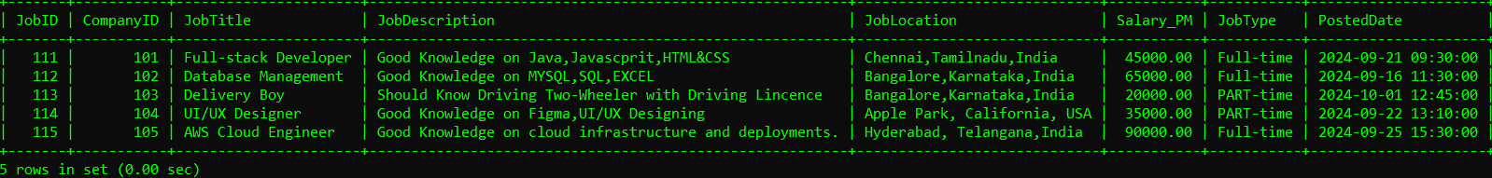

5. Write an SQL query to count the number of applications received for each job listing in the "Jobs" table. Display the job title and the corresponding application count. Ensure that it lists all jobs, even if they have no applications.

**Ans:-**

mysql> SELECT j.JobTitle,COUNT(a.ApplicationID) AS ApplicationCount FROM Job j

-> LEFT JOIN Application a ON j.JobID=a.JobID

-> GROUP BY j.JobTitle;

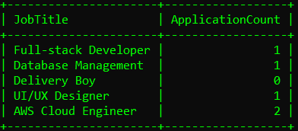

6. Develop an SQL query that retrieves job listings from the "Jobs" table within a specified salary range. Allow parameters for the minimum and maximum salary values. Display the job title, company name, location, and salary for each matching job.

**Ans:-**

mysql> SELECT j.JobTitle,c.CompanyName,j.JobLocation,j.Salary_PM FROM Job j

-> JOIN Company c ON j.CompanyID=c.CompanyID

-> WHERE j.Salary_PM BETWEEN 30000 AND 90000;

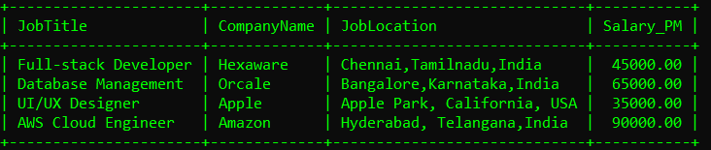

7. Write an SQL query that retrieves the job application history for a specific applicant. Allow a parameter for the ApplicantID, and return a result set with the job titles, company names, and application dates for all the jobs the applicant has applied to.

**Ans:-**

mysql> SELECT j.JobTitle,c.CompanyName,a.ApplicationDate FROM Application a

-> JOIN Job j ON a.JobID=j.JobID

-> JOIN Company c ON j.CompanyID=c.CompanyID

-> WHERE a.ApplicantID=203;

8. Create an SQL query that calculates and displays the average salary offered by all companies for job listings in the "Jobs" table. Ensure that the query filters out jobs with a salary of zero.

**Ans:-**mysql>SELECT AVG(Salary_PM) AS Avg_Salary_PM FROM Job WHERE Salary_PM >= 0;

9. Write an SQL query to identify the company that has posted the most job listings. Display the company name along with the count of job listings they have posted. Handle ties if multiple companies have the same maximum count.

**Ans:-**

mysql> SELECT c.CompanyName, count(j.JobID) AS Count_job FROM Company c

-> JOIN Job j on c.CompanyID=j.CompanyID

-> GROUP BY c.CompanyID ORDER BY Count_job limit 1;

10. Find the applicants who have applied for positions in companies located in 'CityX' and have at least 3 years of experience.

**Ans:-**

mysql> SELECT a.ApplicantID,a.FirstName,a.LastName,c.CompanyName,j.JobTitle

-> FROM Applicant a JOIN Application app ON a.ApplicantID=app.ApplicantID

-> JOIN Job j ON app.JobID=j.JobID

-> JOIN Company c ON j.CompanyID=c.CompanyID

-> WHERE c.Location LIKE '%Bangalore%' AND a.Experience >= 3;

11. Retrieve a list of distinct job titles with salaries between 60,000 and 80,000.

**Ans:-**

mysql> SELECT DISTINCT JobTitle FROM Job

-> WHERE Salary_PM BETWEEN 60000 AND 80000;

12. Find the jobs that have not received any applications.

**Ans:-** mysql> SELECT j.JobTitle FROM Job j

-> LEFT JOIN Application a ON j.JobID=a.JobID

-> WHERE a.ApplicationID IS NULL;

13. Retrieve a list of job applicants along with the companies they have applied to and the positions they have applied for.

**Ans:-**

mysql> SELECT a.ApplicantID,a.FirstName,a.LastName,c.CompanyName,j.JobTitle AS Position FROM Applicant a

-> JOIN Application ap ON a.ApplicantID=ap.ApplicantID

-> JOIN Job j ON ap.JobID=j.JobID

-> JOIN Company c ON j.CompanyID=c.CompanyID;

14. Retrieve a list of companies along with the count of jobs they have posted, even if they have not received any applications.

**Ans:-**

mysql> SELECT c.CompanyID,c.CompanyName,COUNT(j.JobID) AS JobCount FROM Company c

-> LEFT JOIN Job j ON c.CompanyID=j.CompanyID

-> GROUP BY c.CompanyID,c.CompanyName;

15. List all applicants along with the companies and positions they have applied for, including those who have not applied.

**Ans:-**

mysql> SELECT a.ApplicantID,a.FirstName,a.LastName,c.CompanyName,j.JobTitle AS Position FROM Applicant a

-> LEFT JOIN Application ap ON a.ApplicantID=ap.ApplicantID

-> LEFT JOIN Job j ON ap.JobID=j.JobID

-> LEFT JOIN Company c ON j.CompanyID=c.CompanyID;

16. Find companies that have posted jobs with a salary higher than the average salary of all jobs.

**Ans:-**

mysql> SELECT c.CompanyID,c.CompanyName,j.Salary_PM FROM Company c

-> JOIN Job j ON c.CompanyID=j.CompanyID

-> WHERE j.Salary_PM > (SELECT AVG(Salary_PM) FROM Job);

17. Display a list of applicants with their names and a concatenated string of their city and state.   
**Ans:-** Updated the job table with city and state.

mysql> SELECT a.ApplicantID,a.FirstName,a.LastName,CONCAT(j.City, ', ', j.State) AS Location FROM Applicant a

-> JOIN Application ap ON a.ApplicantID=ap.ApplicantID

-> JOIN Job j ON ap.JobID=j.JobID;

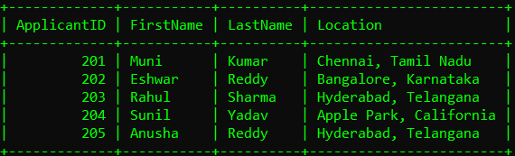

18. Retrieve a list of jobs with titles containing either 'Developer' or 'Engineer'.

**Ans:-** mysql> SELECT JobID,JobTitle FROM Job

-> WHERE JobTitle LIKE '%Developer%' OR JobTitle LIKE '%Engineer%';

19. Retrieve a list of applicants and the jobs they have applied for, including those who have not applied and jobs without applicants.

**Ans:-**

mysql> SELECT a.ApplicantID,a.FirstName,j.JobID,j.JobTitle FROM Applicant a

-> LEFT JOIN Application ap ON a.ApplicantID=ap.ApplicantID

-> LEFT JOIN Job j ON ap.JobID=j.JobID;

20. List all combinations of applicants and companies where the company is in a specific city and the applicant has more than 2 years of experience. For example: city=Chennai

**Ans:-**

mysql> SELECT a.ApplicantID,CONCAT(a.FirstName, ' ', a.LastName) AS

FullName,c.CompanyName,j.JobTitle

-> FROM Applicant a JOIN Application app ON a.ApplicantID=app.ApplicantID

-> JOIN Job j ON app.JobID=j.JobID

-> JOIN Company c ON j.CompanyID=c.CompanyID

-> WHERE j.City=”Chennai” AND a.Experience > 2;

