AI, Generative AI, Automations & Chatbots
Overview of Current Trends - June 2026

1. Foundations of Artificial Intelligence
Artificial Intelligence (AI) refers to the simulation of human intelligence in machines. It encompasses machine learning, deep learning, and neural networks that enable computers to learn from data and make decisions.
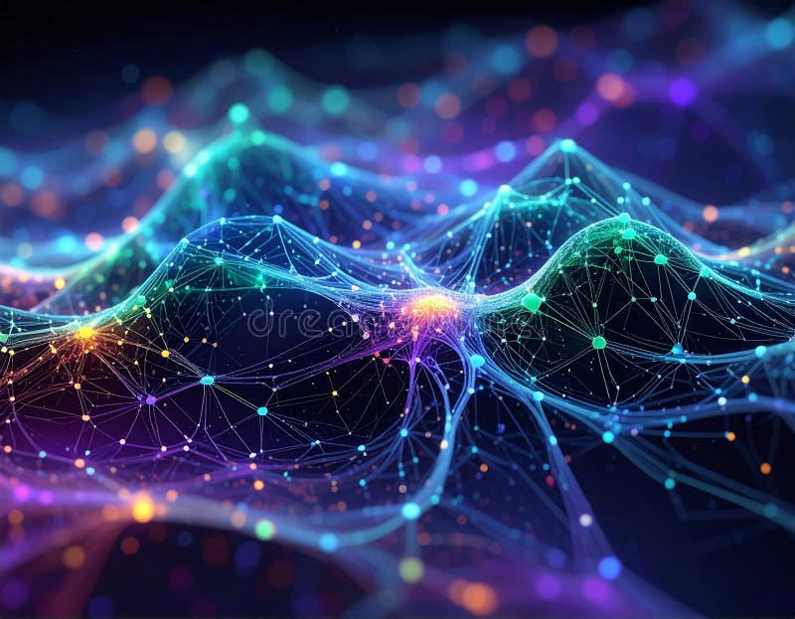

2. Generative AI
Generative AI creates new content like text, images, code, and video from prompts. Key models include GPT series, Claude, Gemini. In 2026, multimodal capabilities (text+image+audio) are standard.
Major 2026 Trends: Agentic AI, Multimodal by default, Domain-specific models.

3. Automations & RPA
Robotic Process Automation (RPA) combined with AI enables intelligent automations. Agentic workflows allow AI to handle complex multi-step tasks autonomously.
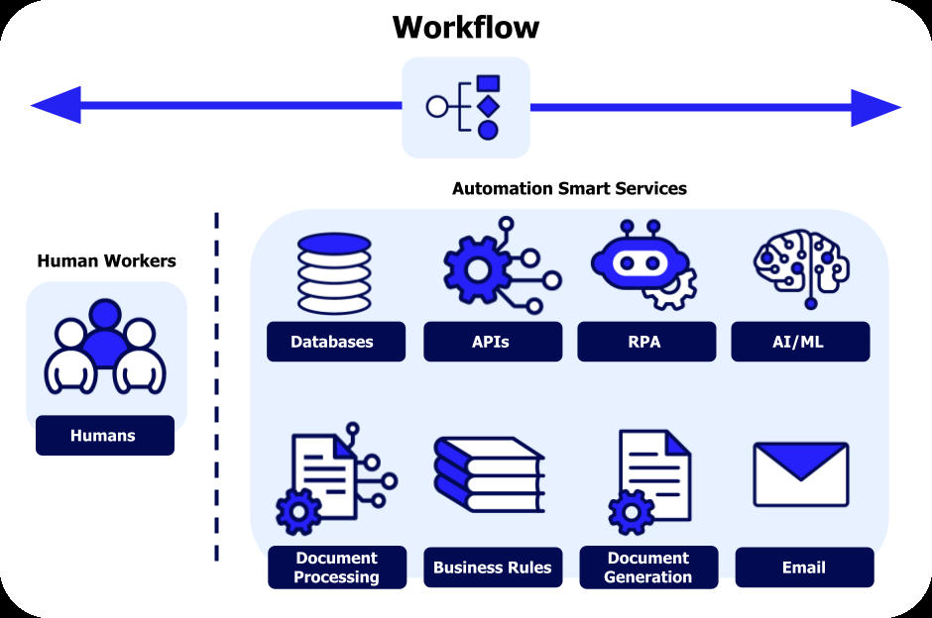

4. Chatbots & Conversational AI
Modern chatbots like ChatGPT, Claude, Grok, Gemini have evolved into agents capable of tool use, memory, and task execution. They power customer support, virtual assistants.
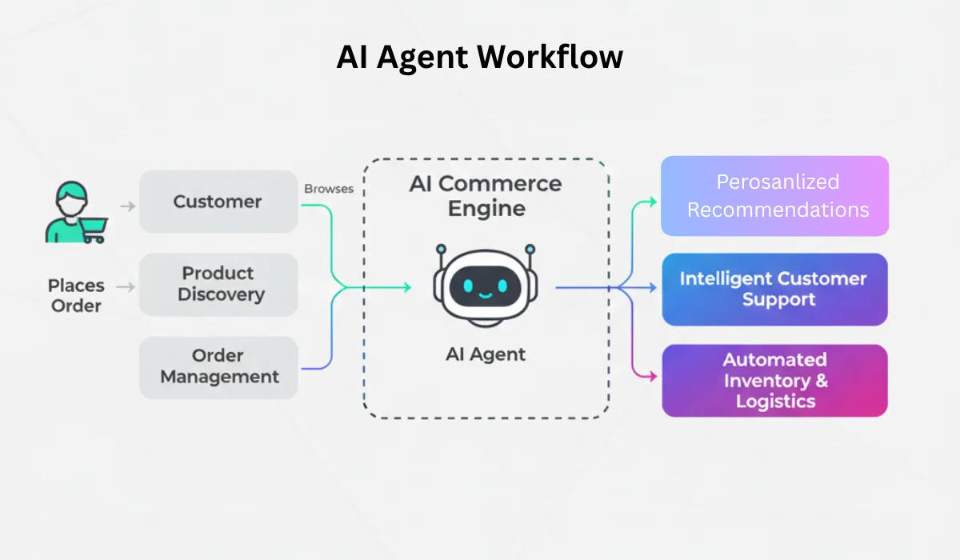

Key 2026 Developments
• Agentic AI: Autonomous goal-oriented systems
• Multimodal models
• Multi-agent orchestration
• On-device AI
• Responsible AI & governance
Sources: Industry reports on agentic AI trends (2026).

