A Mini Project Report
on
ANAEMIA PREDICTION USING MACHINE LEARNING AND EXPLAINABLE AI
Submitted in partial fulfilment of the requirements for the award of the degree of
Bachelor of Engineering
in
Computer Science and Engineering
Submitted by
[ STUDENT NAME 1 ] (16XX-XX-XXX-XXX)
[ STUDENT NAME 2 ] (16XX-XX-XXX-XXX)
[ STUDENT NAME 3 ] (16XX-XX-XXX-XXX)
Under the guidance of
[ Guide Name ]
Assistant Professor
DEPARTMENT OF COMPUTER SCIENCE AND ENGINEERING
Matrusri Engineering College
(Affiliated to Osmania University, Approved by AICTE)
Saidabad, Hyderabad - 500059
(2025-2026)

DEPARTMENT OF COMPUTER SCIENCE AND ENGINEERING
Matrusri Engineering College
(Affiliated to Osmania University, Approved by AICTE)
Saidabad, Hyderabad - 500059
CERTIFICATE
This is to certify that the Mini Project report entitled "Anaemia Prediction using Machine Learning and Explainable AI" is being submitted by [Student Name 1] (16XX-XX-XXX-XXX), [Student Name 2] (16XX-XX-XXX-XXX), and [Student Name 3] (16XX-XX-XXX-XXX) in partial fulfilment of the requirements for the award of the degree of Bachelor of Engineering in "Computer Science and Engineering," Osmania University, Hyderabad, during the academic year 2025-2026. This is a record of bonafide work carried out by them under our guidance. The results presented in this project have been verified and are found to be satisfactory.
Project Guide  [ Guide Name ]  Assistant Professor  Dept. of CSE | Project Coordinator  Mrs. M. Priyanka  Assistant Professor  Dept. of CSE | Head of the Department  Dr. T. Raghunadha Reddy  Professor & Head  Dept. of CSE

External Examiner(s): ______________________________

DECLARATION
We, [Student Name 1] bearing Ht. No. 16XX-XX-XXX-XXX, [Student Name 2] bearing Ht. No. 16XX-XX-XXX-XXX, and [Student Name 3] bearing Ht. No. 16XX-XX-XXX-XXX, hereby certify that the mini project report entitled "Anaemia Prediction using Machine Learning and Explainable AI" is submitted in partial fulfilment of the requirements for the award of the degree of Bachelor of Engineering in Computer Science and Engineering.
This is a record of original work carried out by us under the guidance of [Guide Name], Assistant Professor, Department of Computer Science and Engineering, Matrusri Engineering College, Saidabad. The results embodied in this report have not been reproduced or copied from any other source, and have not been submitted to any other university or institute for the award of any degree or diploma.
[Student Name 1] (16XX-XX-XXX-XXX) _______________________
[Student Name 2] (16XX-XX-XXX-XXX) _______________________
[Student Name 3] (16XX-XX-XXX-XXX) _______________________

ACKNOWLEDGEMENT
It is our privilege and pleasure to express our profound sense of respect, gratitude, and indebtedness to our guide [Guide Name], Assistant Professor, Department of Computer Science and Engineering, Matrusri Engineering College, for valuable inspiration, guidance, constructive criticism, and consistent encouragement throughout this project work.
We express our sincere thanks to our Project Coordinator Mrs. M. Priyanka, Assistant Professor, Department of Computer Science and Engineering, Matrusri Engineering College, for valuable suggestions and constant help in completing the work.
We express our sincere gratitude to Dr. T. Raghunadha Reddy, Professor & Head, Department of Computer Science and Engineering, Matrusri Engineering College, for his precious suggestions, motivation, and co-operation.
We express our sincere thanks to Dr. D. Hanumantha Rao, Principal, Matrusri Engineering College, Saidabad, Hyderabad, for his encouragement and constant support.
We extend our sincere thanks to all the teaching and non-teaching staff of the Computer Science and Engineering Department for their support, cooperation, and guidance.
Last but not least, we wish to acknowledge our parents, family members, and friends for giving us moral strength and encouraging us to complete this project work successfully.

ABSTRACT
Anaemia, a condition marked by a reduced oxygen-carrying capacity of the blood, affects over 1.6 billion people worldwide and is especially prevalent among women and children in resource-constrained settings. While a Complete Blood Count (CBC) test is inexpensive and routine, interpreting the result and reaching a reliable diagnosis still demands clinical expertise that is frequently unavailable. This project develops a fast, accurate and, crucially, interpretable predictor of anaemia from routine CBC parameters, combining machine-learning classification with Explainable Artificial Intelligence (XAI).
Three supervised models - Random Forest, Support Vector Machine (SVM) and XGBoost - are trained on identical, stratified CBC data and compared across five standard metrics: accuracy, precision, recall, F1-score and AUC-ROC. To make every prediction transparent to a clinician, two complementary explainability techniques are integrated: SHAP (SHapley Additive exPlanations) as the primary global-and-local explainer, and LIME (Local Interpretable Model-agnostic Explanations) as an independent local cross-check. A Streamlit web application delivers the full workflow - CBC input, prediction with confidence, three-model comparison, and a feature-by-feature SHAP and LIME explanation, framed by a clear medical disclaimer.
A central and honestly-reported finding is that the public dataset's label is defined from a gender-specific haemoglobin threshold, which produces near-perfect accuracy through label leakage rather than genuine clinical skill. This is quantified through a deliberate haemoglobin-excluded experiment, in which performance collapses toward chance (AUC ~ 0.5). The project's true contribution is therefore the rigorous comparison-plus-explainability pipeline and the methodological honesty surrounding it, demonstrating both how to build an interpretable clinical screening aid and how to critically evaluate one.

TABLE OF CONTENTS
Chapter 1: Introduction 10
1.1 Introduction to Project 10
1.2 Project Category 10
1.3 Objectives 10
1.4 Scope of the Problem 11
1.5 Identification of Need 11
1.6 Existing System 11
1.7 Limitations of the Existing System 11
1.8 Proposed System 11
1.9 Unique Features of the System 12
Chapter 2: Requirement Analysis & SRS 13
2.1 Feasibility Study 13
2.1.1 Technical Feasibility 13
2.1.2 Economic Feasibility 13
2.1.3 Operational Feasibility 13
2.2 Software Requirement Specification (SRS) 13
2.2.1 Data Requirements 13
2.2.2 Functional Requirements 13
2.2.3 Performance Requirements 14
2.2.4 Dependability & Maintainability Requirements 14
2.2.5 Ethical & Safety Requirements 14
2.2.6 Look and Feel Requirements 14
2.3 Validation 15
2.4 Expected Hurdles 15
2.5 SDLC Model 15
Chapter 3: System Design 16
3.1 Design Approach 16
3.2 System Architecture 16
3.3 Structured Analysis & UML Design 17
3.3.1 Component Diagram 17
3.3.2 Object Diagram 17
3.3.3 Class Diagram 18
3.3.4 Deployment Diagram 19
3.3.5 Use Case Diagram 19
3.3.6 State Transition Diagram 20
3.3.7 Activity Diagram 21
3.3.8 Sequence Diagram 21
3.4 Interface Relationship & Dependencies 22
3.5 Dataset Design & Data Dictionary 23
3.6 User Interface Design 23
3.7 Module & Function Reference 24
Chapter 4: Implementation, Testing & Maintenance 26
4.1 Tools and Technologies Used 26
4.2 Coding Standards 26
4.3 Testing Techniques and Test Plans 26
4.4 Executable Code Listings 27
Chapter 5: Results and Discussions 34
5.1 Exploratory Data Analysis 34
5.2 The Label-Leakage Finding 35
5.3 Model Comparison Results (Full Feature Set) 36
5.4 Robustness: Haemoglobin-Excluded Experiment 38
5.5 Explainability Results (SHAP and LIME) 39
5.6 Detailed Test Cases 42
Chapter 6: Conclusion and Future Scope 43
6.1 Conclusion 43
6.2 Future Scope 43
References 44

LIST OF FIGURES
Figure 3.1: Layered System Architecture of the Anaemia Prediction Platform 16
Figure 3.2: Component Diagram of the src/ Modules and Their Interfaces 17
Figure 3.3: Object Diagram Demonstrating Runtime Instance Values 18
Figure 3.4: Class / Module Diagram Modelling the Pipeline Structure 18
Figure 3.5: Deployment Diagram Showing the Local Single-Machine Setup 19
Figure 3.6: Use Case Diagram Modelling User Interactions 20
Figure 3.7: State Transition Diagram of the Prediction Lifecycle 20
Figure 3.8: Activity Diagram Showing the Prediction Workflow 21
Figure 3.9: Sequence Diagram of a Single Prediction Request 22
Figure 3.10: Module Dependency Chart (Acyclic depends-on Graph) 22
Figure 3.11: User Interface Wireframe of the Streamlit Application 24
Figure 5.1: Target Class Balance (Anaemic vs Not-Anaemic) 34
Figure 5.2: Distributions of the CBC Features 35
Figure 5.3: Feature Distributions Split by Class 35
Figure 5.4: Correlation Heatmap of Features and Target 35
Figure 5.5: Haemoglobin vs Result - the Gender-Specific Threshold Behind Label Leakage 36
Figure 5.6: Model Metrics Comparison (Full Track) 37
Figure 5.7: Confusion Matrices - Full Track 37
Figure 5.8: ROC Curves - Full Track 38
Figure 5.9: Confusion Matrices - Haemoglobin-Excluded Track 39
Figure 5.10: ROC Curves - Haemoglobin-Excluded Track 39
Figure 5.11: SHAP Summary (Beeswarm) - Full Track 40
Figure 5.12: SHAP Feature Importance (Mean |SHAP|) - Full Track 40
Figure 5.13: Local SHAP Waterfall - One Anaemic Patient 40
Figure 5.14: Local SHAP Waterfall - One Healthy Patient 41
Figure 5.15: SHAP Summary (Beeswarm) - Haemoglobin-Excluded Track 41
Figure 5.16: LIME Local Explanation - One Anaemic Patient 41

LIST OF TABLES
Table 3.1: CBC Feature Data Dictionary 23
Table 3.2: Dataset Summary and Class Balance 23
Table 3.3: src/ Module and Function Reference 24
Table 4.1: Tools and Technologies Used 26
Table 5.1: Model Comparison - Full Feature Set (with Haemoglobin) 36
Table 5.2: Model Comparison - Haemoglobin-Excluded Track (Robustness Test) 38
Table 5.3: Pipeline and Prediction Test Cases 42
Table 5.4: Findings, Explainability and Input-Validation Test Cases 42

Chapter 1: Introduction

1.1 Introduction to Project
Anaemia is one of the most widespread public-health conditions in the world. It occurs when the blood has a reduced capacity to carry oxygen, most commonly because of a low concentration of haemoglobin (Hb), the iron-rich protein in red blood cells. The World Health Organization estimates that anaemia affects more than 1.6 billion people, with the heaviest burden falling on pregnant women and young children in low- and middle-income regions. Left undetected, it causes fatigue, impaired cognitive development, complications in pregnancy and reduced productivity.
A Complete Blood Count (CBC) is a cheap, fast and routinely available blood test that reports haemoglobin together with red-cell indices such as MCV, MCH and MCHC. However, turning these numbers into a confident diagnosis still requires trained personnel, who are scarce in exactly the settings where anaemia is most common. Machine learning can screen CBC results in milliseconds, but a clinician will not - and should not - trust an opaque 'black box'. Explainable Artificial Intelligence (XAI) closes this gap by revealing which blood values drove each prediction. This project therefore couples accurate prediction with per-patient explanations to build a trustworthy decision-support prototype for early anaemia screening.
DISCLAIMER: This system is an educational decision-support prototype, not a diagnostic tool. It must never be used for real medical decisions. All clinical diagnosis must be made by a qualified medical professional.

1.2 Project Category
This project falls under the category of Machine Learning, Healthcare Analytics and Explainable Artificial Intelligence. It combines supervised classification (Random Forest, SVM and XGBoost) with model-interpretability techniques (SHAP and LIME) and a Python-based interactive web application (Streamlit). The work is implemented entirely in Python using the scientific stack (scikit-learn, XGBoost, SHAP, LIME, pandas and matplotlib), with trained models persisted using joblib for reuse by the application.

1.3 Objectives
- Build and compare three models. Train Random Forest, SVM and XGBoost on the same CBC data and objectively select the best performer.
- Integrate Explainable AI. Apply SHAP for global and local explanations and LIME for an independent local cross-check.
- Identify influential features. Determine which CBC parameters most strongly drive the anaemia prediction.
- Evaluate rigorously. Measure every model on five metrics - accuracy, precision, recall, F1-score and AUC-ROC - plus confusion matrices and ROC curves.
- Build an accessible interface. Provide a simple web UI that takes CBC inputs and returns a prediction with a clear explanation and disclaimer.
- Test robustness honestly. Run a haemoglobin-excluded experiment to expose and quantify label leakage in the dataset.

1.4 Scope of the Problem
Early detection of anaemia is critical, yet in many primary-care and rural settings the interpretation of CBC reports is delayed by a shortage of trained staff. The scope of this project is to build a software prototype that screens a single patient's CBC values and returns an immediate, explained anaemia prediction. The system targets the binary screening task (anaemic vs not-anaemic) using the red-cell indices available in the chosen dataset. It is explicitly scoped as a mini-project and educational demonstrator: it is not clinically validated, does not replace laboratory diagnosis, and is not intended for deployment in real clinical workflows.

1.5 Identification of Need
Conventional anaemia screening depends on the manual interpretation of CBC reports by a clinician or laboratory technician. This is slow, expertise-dependent and inconsistent between practitioners, and it offers no way to prioritise the most urgent cases. A growing body of work applies machine learning to this problem, but two needs remain poorly served. First, most approaches report a single, often near-perfect accuracy number without any explanation a clinician can inspect. Second, and more seriously, many fail to disclose that their target label is derived from haemoglobin itself - so the headline accuracy reflects a definition, not predictive skill. There is therefore a clear need for a screening tool that is both interpretable and methodologically honest about what its accuracy actually means.

1.6 Existing System
In the existing system, a blood sample is processed by a haematology analyser that produces the CBC report. A clinician or technician then reads the haemoglobin value and red-cell indices, compares them against reference ranges, and decides whether the patient is anaemic. Some hospital information systems flag out-of-range values automatically, but the clinical judgement remains manual. Earlier machine-learning studies in the literature train classifiers on CBC datasets and report accuracy, but typically present the model as an opaque predictor without per-patient justification and without auditing the dataset for label leakage.

1.7 Limitations of the Existing System
- Slow and expertise-dependent. Manual interpretation needs trained personnel who are often unavailable in low-resource settings.
- Inconsistent. Interpretation can vary between practitioners, producing different conclusions for similar reports.
- No prioritisation. Every report is read with equal manual effort; there is no automatic triage of likely-anaemic cases.
- Opaque ML alternatives. Prior machine-learning models usually output a prediction with no explanation a clinician can trust or verify.
- Undisclosed label leakage. Reported accuracies are frequently inflated because the label is derived from haemoglobin, a fact rarely stated openly.

1.8 Proposed System
The proposed system is an end-to-end machine-learning and Explainable-AI pipeline for anaemia screening. It (1) loads and cleans the CBC data and produces a fixed, stratified train/test split; (2) trains Random Forest, SVM and XGBoost on identical data and compares them across five metrics; (3) explains predictions globally and locally with SHAP, cross-checked with LIME; (4) serves predictions and explanations through a Streamlit web application carrying a medical disclaimer; and (5) runs a haemoglobin-excluded robustness experiment that deliberately exposes and quantifies label leakage. The selected representative model is XGBoost, confirmed - not merely assumed - through the metric comparison.

1.9 Unique Features of the System
- Three-model live comparison. All three classifiers run on the patient's input and are compared side-by-side in the UI, making the comparison objective visible, not just offline.
- Dual explainability (SHAP + LIME). Each prediction is justified feature-by-feature with SHAP and independently cross-checked with LIME, increasing trust when the two agree.
- Honest leakage analysis. A dedicated haemoglobin-excluded track quantifies exactly how much of the accuracy comes from the label definition - a rare degree of methodological transparency.
- Plain-English reasoning. The app translates SHAP values into a readable headline (e.g. the single value that most drove the decision) plus clinical context against WHO cut-offs.
- Reusable, single-source codebase. All ML logic lives in src/ and is imported by both the notebooks and the app, so the app can never disagree with the report.
- Built-in safety framing. A prominent disclaimer appears on every surface, reinforcing that the tool is an educational prototype, not a diagnostic device.

Chapter 2: Requirement Analysis & SRS

2.1 Feasibility Study
A feasibility study was carried out to confirm that the project could be delivered within the constraints of a mini-project. It was assessed across three dimensions: technical, economic and operational.

2.1.1 Technical Feasibility
The project is technically feasible. All required libraries - scikit-learn, XGBoost, SHAP, LIME, pandas, matplotlib and Streamlit - are mature, open-source and well documented. They run on standard consumer hardware with no GPU requirement, since the dataset is small (a few hundred rows) and the models are lightweight. Model training, evaluation and explanation each complete in seconds, and the trained models are persisted as .pkl files so the application loads instantly.

2.1.2 Economic Feasibility
The project is economically feasible at zero software cost. The entire toolchain - Python, its scientific stack, Streamlit, Git and VS Code - is free and open-source. No paid cloud services, licences or specialised hardware are needed; development and demonstration run on a single laptop. The dataset is publicly available at no cost.

2.1.3 Operational Feasibility
The project is operationally feasible. The Streamlit interface presents simple labelled number inputs for each CBC value and a single Predict button, requiring no technical knowledge from the user. Results are shown immediately as a clear prediction, a confidence value, a model-comparison table and an explanation. The app runs in any modern web browser, making it easy to demonstrate and evaluate.

2.2 Software Requirement Specification (SRS)

2.2.1 Data Requirements
The system requires a CBC dataset containing red-cell parameters and a binary anaemia label. The chosen dataset (Biswaranjan Rao 'Anemia Dataset', Kaggle) provides Gender, Hemoglobin, MCH, MCHC and MCV as features and Result (0 = not anaemic, 1 = anaemic) as the target. Exact-duplicate rows are removed before splitting to prevent identical patients leaking across the train/test boundary. The cleaned data is split in a stratified 80/20 ratio and standard-scaled, with the scaler fit on the training set only and persisted for reuse.

2.2.2 Functional Requirements
- CBC input. The system must accept Gender plus four numeric CBC values (Hemoglobin, MCH, MCHC, MCV) within sensible physiological ranges.
- Prediction. It must scale the input with the saved scaler and predict anaemic / not-anaemic together with the probability of anaemia.
- Model comparison. It must run all three trained models on the input and display their test-set scores and individual verdicts.
- SHAP explanation. It must compute and display per-feature SHAP contributions for the prediction, including a ranked breakdown and a waterfall chart.
- LIME explanation. It must produce an independent LIME explanation of the same prediction as a second opinion.
- Disclaimer. It must display a medical disclaimer prominently on the interface.

2.2.3 Performance Requirements
- Prediction latency. A single prediction with its SHAP explanation must return in well under one second on a standard laptop.
- LIME latency. The LIME second opinion, which perturbs the input a few thousand times, must complete within a few seconds.
- Reproducibility. A fixed random seed (42) must make every split, training run and result exactly reproducible.
- Startup. Cached loading of the model and scaler must keep the app responsive after the first request.

2.2.4 Dependability & Maintainability Requirements
- Single source of truth. Paths, the feature list and constants live only in src/config.py, so changes propagate consistently.
- Reusable logic. All ML logic lives in src/ and is imported by notebooks, tests and the app, eliminating duplicated or divergent code.
- Graceful failure. Invalid inputs (missing or non-numeric values) must be rejected rather than producing a silent, wrong prediction.
- Tested pipeline. A light pytest suite verifies that artifacts load, the split is correct, predictions are sane and the documented findings hold.

2.2.5 Ethical & Safety Requirements
- Non-diagnostic framing. Every report, slide and UI surface must state that the system is an educational prototype, not a diagnostic tool.
- No overstated claims. Results must be presented honestly, including open disclosure of the label-leakage limitation.
- Interpretability. Predictions must be explainable so a human can audit the reasoning rather than trust a black box.
- Data privacy. The system processes a single user-entered CBC row in memory and stores no personal data.

2.2.6 Look and Feel Requirements
- Clarity. The interface must use clearly labelled inputs with units and helpful hints for each CBC field.
- Readable output. Predictions must be colour-coded (e.g. red for anaemic, green for not anaemic) with a plain-English explanation.
- Accessibility. The layout must work in any modern browser without installation beyond running the Streamlit command.

2.3 Validation
Input validation is enforced at the interface and data layers. The Streamlit number inputs constrain every CBC field to a physiologically sensible minimum and maximum, preventing negative or out-of-range values. The prediction path selects exactly the required feature columns, so a row missing any feature raises an error rather than silently predicting, and non-numeric values are rejected by the scaler. These behaviours are confirmed by dedicated tests (test_missing_feature_raises and test_nonnumeric_input_rejected).

2.4 Expected Hurdles
- Label leakage. Because the dataset's label is defined from a haemoglobin threshold, any model given haemoglobin scores near-perfectly. This is addressed by openly reporting the leakage and running a haemoglobin-excluded experiment that quantifies it.
- Duplicate rows. 887 of the 1,421 raw rows are exact duplicates; if left in, identical patients would appear in both train and test sets and inflate scores. They are removed before splitting.
- Scale sensitivity of SVM. SVM is distance-based and sensitive to feature scale, so all features are standardised with a scaler fit on training data only.
- Explainer output shapes. Tree models return SHAP values in different shapes (RandomForest includes a class axis, XGBoost does not); the explainer normalises both to the anaemic class.
- Readable explanations. Models train on scaled values, which are unreadable on a chart, so SHAP and LIME are computed on scaled inputs but displayed in real CBC units.

2.5 SDLC Model
The project followed an incremental, phase-based Software Development Life Cycle, well suited to a research-oriented mini-project. Work was divided into clearly defined phases, each producing a verifiable artifact: environment and repository setup; dataset selection and documentation; exploratory data analysis including the leakage check; preprocessing and split; model training and comparison; evaluation on five metrics; explainability with SHAP and LIME; the Streamlit application; light testing; and finally the report, presentation and viva preparation. Because each phase handed a concrete contract to the next (for example, the saved split and scaler from preprocessing), issues were caught early and downstream phases stayed consistent and reproducible.

Chapter 3: System Design

3.1 Design Approach
The system follows a modular, layered design with a strict separation of concerns. All reusable logic is organised into a Python package (src/) whose modules each own one responsibility: configuration, data loading, preprocessing, training, evaluation and explanation. The notebooks (for exploration) and the Streamlit application (for demonstration) import from this package, so the same logic is written exactly once and can never drift between the report and the app. Configuration - paths, the feature list and constants - is centralised in config.py as a single source of truth, and dependencies between modules form a clean, acyclic graph.

3.2 System Architecture
The architecture is organised into four layers. The Data Layer holds the raw CBC dataset, the processed train/test split and the saved metrics and figures. The Machine-Learning Layer holds the six trained model files (three classifiers x two feature tracks) and the fitted scaler. The Application / Inference Layer wraps these artifacts with prediction and explanation functions (predict_all, shap_explanation, lime_explain_row). The Presentation Layer is the Streamlit web app that collects CBC inputs and renders the prediction and explanations. At inference time, data flows bottom-up; the models themselves are produced offline, top-down.
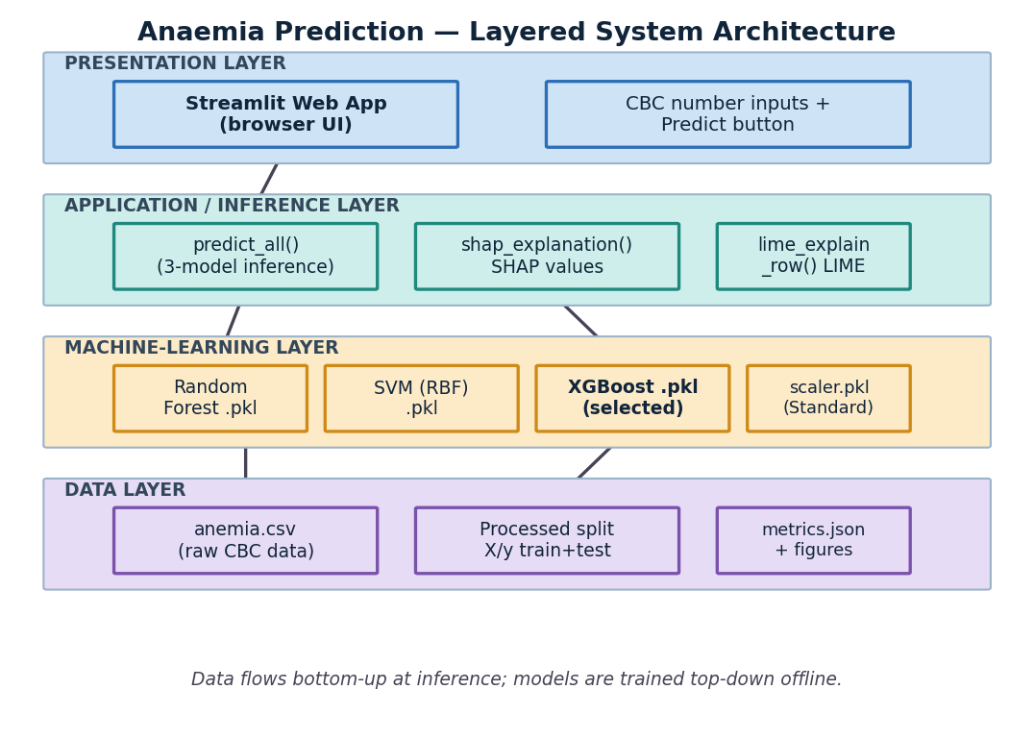
Figure 3.1: Layered System Architecture of the Anaemia Prediction Platform

3.3 Structured Analysis & UML Design
To model the structure, behaviour and deployment of the system, a set of Unified Modeling Language (UML) diagrams was prepared. Each captures a different perspective of the pipeline.

3.3.1 Component Diagram
The component diagram shows the src/ modules and how they depend on one another through their public functions. config.py is the shared configuration component; data_loader and preprocess prepare data; train, evaluate and explain consume it; and streamlit_app and test_pipeline sit at the top as consumers of the pipeline.
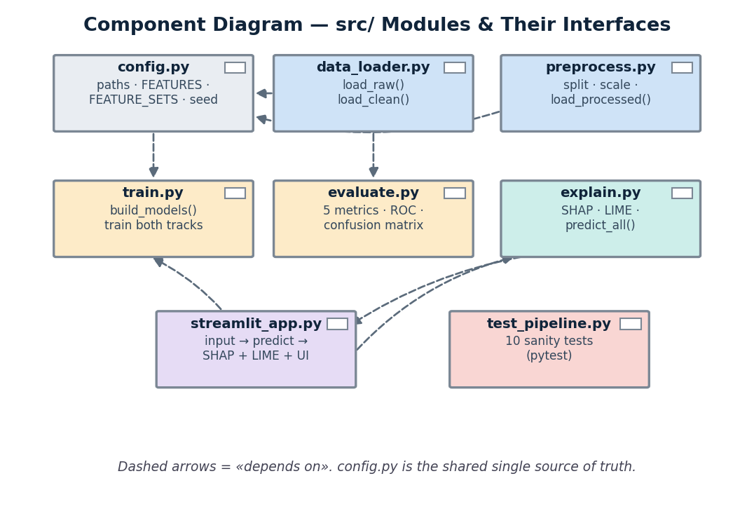
Figure 3.2: Component Diagram of the src/ Modules and Their Interfaces

3.3.2 Object Diagram
The object diagram captures a single live prediction for an anaemic patient, showing the runtime instances and their values: the input CBC row, the fitted scaler, the XGBoost classifier, the resulting SHAP explanation and the final prediction object.
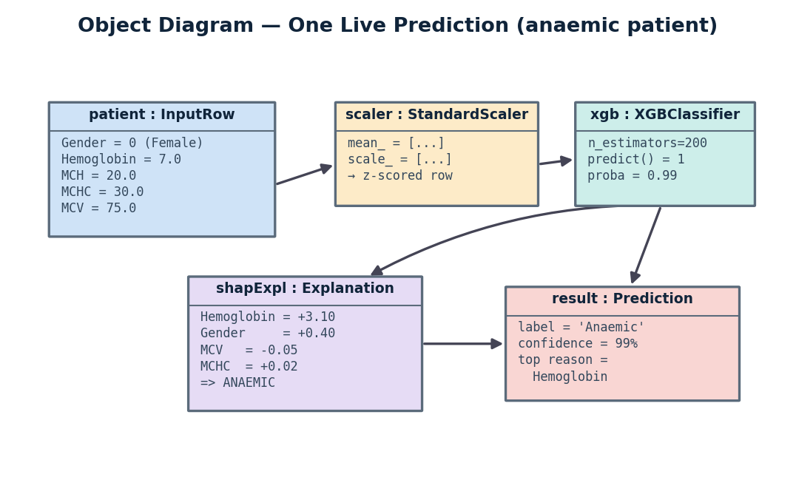
Figure 3.3: Object Diagram Demonstrating Runtime Instance Values

3.3.3 Class Diagram
The class diagram models the pipeline's modules as cohesive units with their key attributes and methods, and the relationships between them. Solid arrows denote use/creation; dashed arrows denote a dependency on shared configuration and processed data.
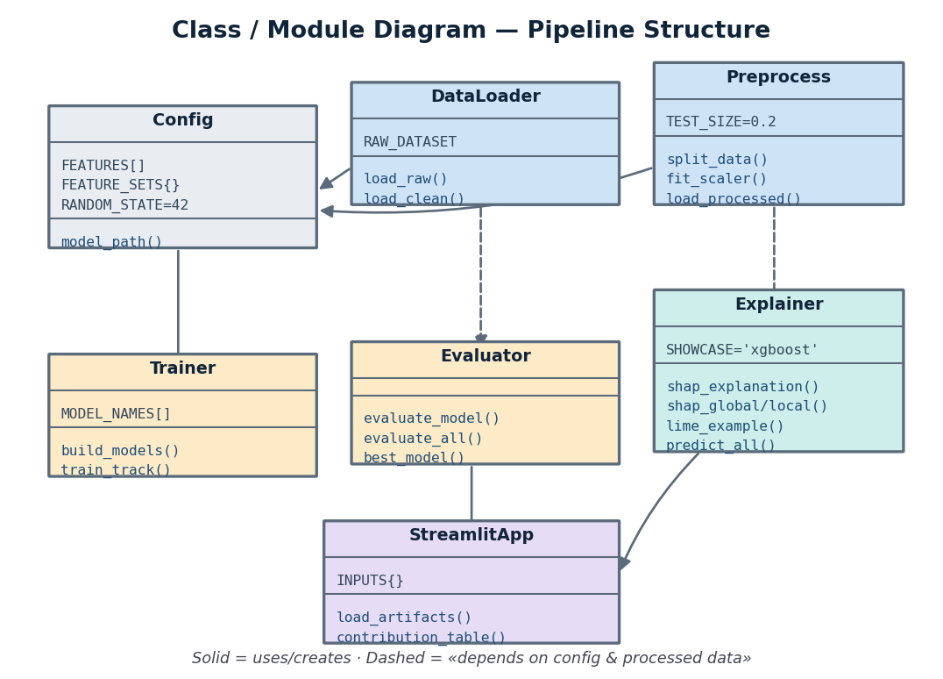
Figure 3.4: Class / Module Diagram Modelling the Pipeline Structure

3.3.4 Deployment Diagram
The deployment diagram describes the physical setup. The whole system runs locally on a single machine: a web browser communicates over HTTP with the Streamlit server, which loads the model and scaler files and the scientific-Python libraries from the same host.
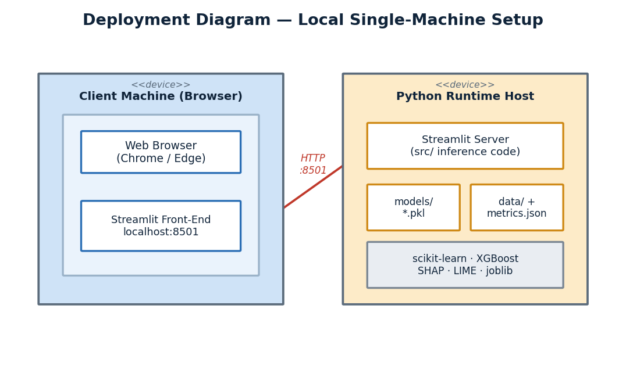
Figure 3.5: Deployment Diagram Showing the Local Single-Machine Setup

3.3.5 Use Case Diagram
The use case diagram defines the interactions of the User (a clinician or student) with the system: entering CBC values, getting a prediction, viewing confidence, comparing all three models, seeing the SHAP and LIME explanations, and reading the disclaimer. The offline ML Pipeline appears as a supporting actor that produces the trained models and explanations.
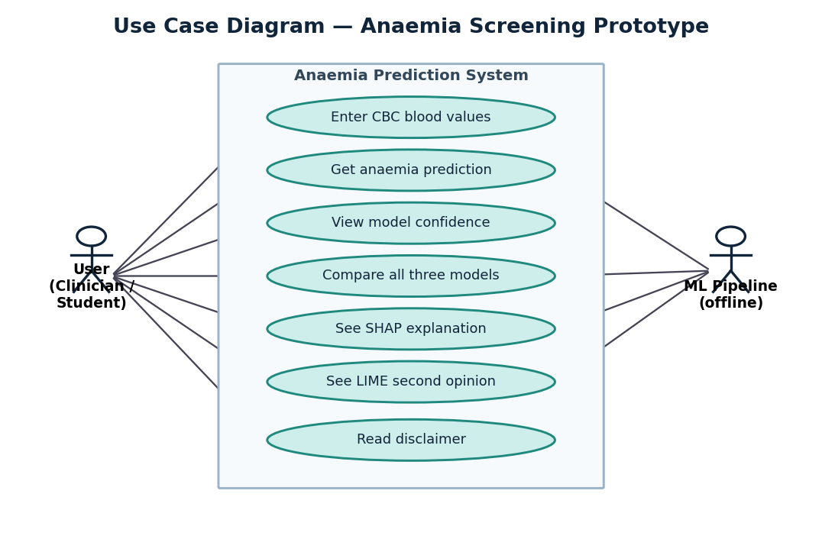
Figure 3.6: Use Case Diagram Modelling User Interactions

3.3.6 State Transition Diagram
The state diagram shows the lifecycle of a prediction: from Idle, through Inputs Entered, Input Validation, Scaling and Inference, and Explanation, to the Result being displayed - with transitions for invalid input (re-enter) and for starting a fresh prediction.
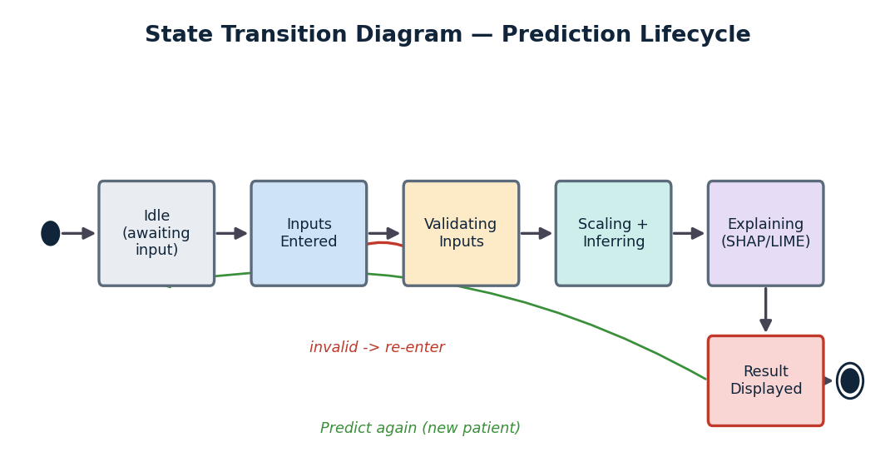
Figure 3.7: State Transition Diagram of the Prediction Lifecycle

3.3.7 Activity Diagram
The activity diagram models the complete step-by-step workflow from opening the app to displaying the explained result, including the validation decision branch and the sequential computation of the prediction, the three-model comparison, and the SHAP and LIME explanations.
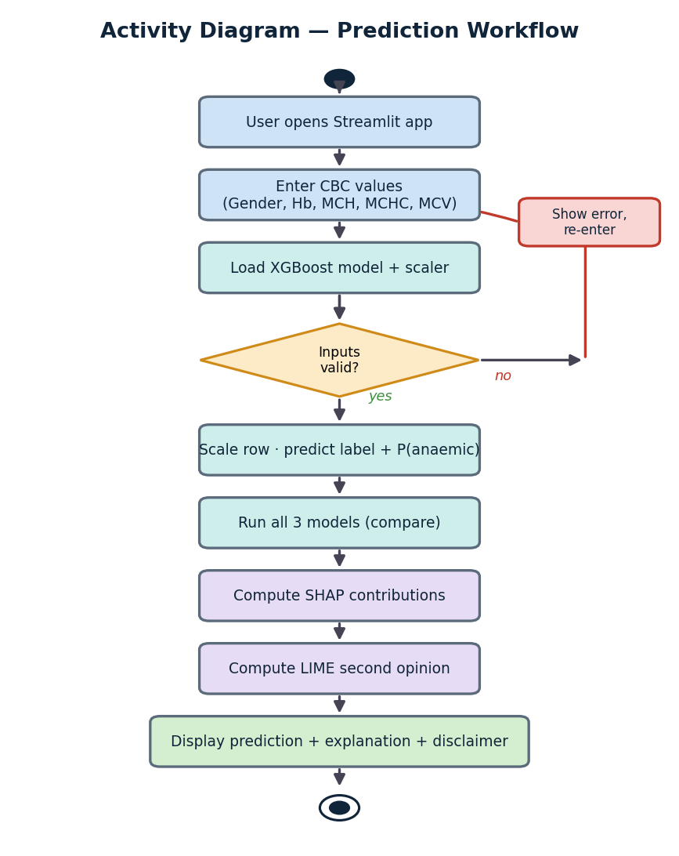
Figure 3.8: Activity Diagram Showing the Prediction Workflow

3.3.8 Sequence Diagram
The sequence diagram captures the ordered messages exchanged during one prediction between the user, the Streamlit app, the scaler/XGBoost model, the SHAP explainer and the LIME explainer, ending with the explained result returned to the user.
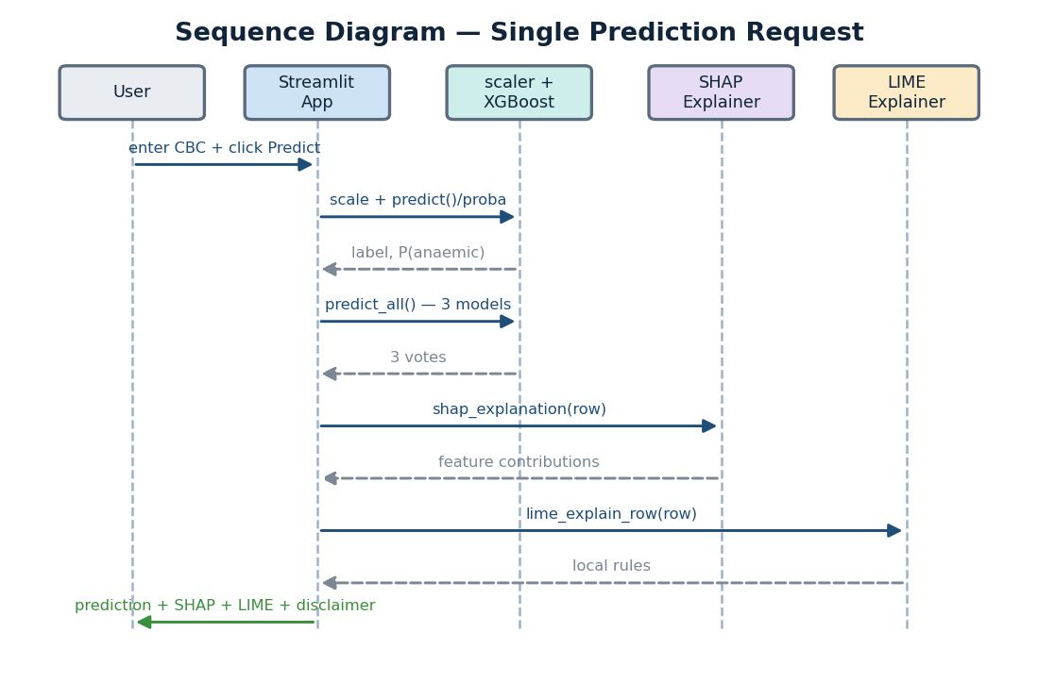
Figure 3.9: Sequence Diagram of a Single Prediction Request

3.4 Interface Relationship & Dependencies
The modules form a clean, unidirectional dependency graph. Every module depends on config.py; data_loader and preprocess prepare data consumed by train, evaluate and explain; and the application and tests sit at the top. There are no circular imports, so each module can be tested or replaced independently.
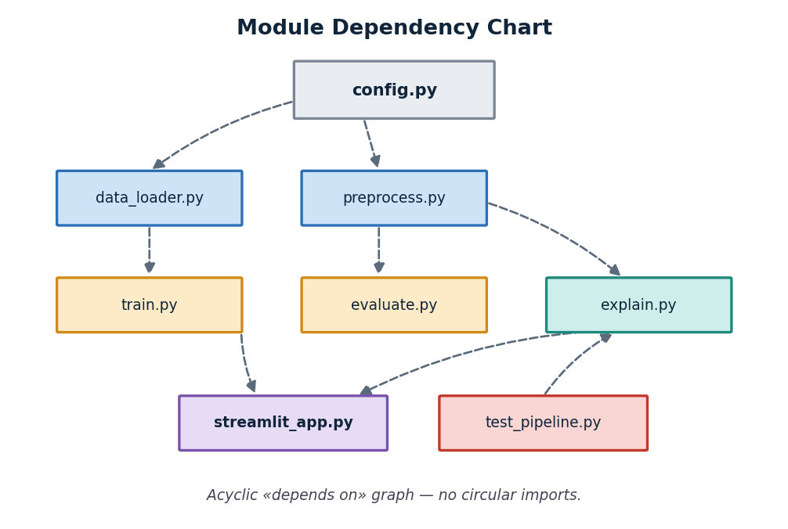
Figure 3.10: Module Dependency Chart (Acyclic depends-on Graph)

3.5 Dataset Design & Data Dictionary
The model operates on five input features and one target, all numeric. Gender is already encoded as 0/1 in the raw data, so no additional label encoding is required. Table 3.1 documents each field; Table 3.2 summarises the dataset before and after cleaning.
Table 3.1: CBC Feature Data Dictionary
Field | Type | Role | Unit / Encoding | Description
Gender | int (0/1) | Feature | 0 = Female, 1 = Male | Patient sex; affects the WHO anaemia cut-off.
Hemoglobin | float | Feature | g/dL | Haemoglobin concentration; the dominant, definitional feature.
MCH | float | Feature | pg | Mean Corpuscular Haemoglobin - average Hb mass per red cell.
MCHC | float | Feature | g/dL | Mean Corpuscular Haemoglobin Concentration.
MCV | float | Feature | fL | Mean Corpuscular Volume - average red-cell size.
Result | int (0/1) | Target | 0 = Not anaemic, 1 = Anaemic | Class label, defined from a gender-specific Hb threshold.

Table 3.2: Dataset Summary and Class Balance
Property | Value | Notes
Source | Biswaranjan Rao 'Anemia Dataset' (Kaggle) | Public, free.
Raw rows x columns | 1,421 x 6 | No missing values.
Exact duplicates removed | 887 | Prevent train/test leakage of identical patients.
Unique patients used | 534 | Basis for the 80/20 split.
Train / Test sizes | 427 / 107 | Stratified, random_state = 42.
Class balance (clean) | 53.7% not-anaemic / 46.3% anaemic | Well balanced.

3.6 User Interface Design
The user interface is a single-page Streamlit application. A title and a prominent yellow disclaimer sit at the top. Below them, the CBC inputs are arranged in two columns: a Gender dropdown and number inputs for Hemoglobin, MCH, MCHC and MCV, each with its unit and a helpful tooltip. A primary Predict button triggers inference. The result area then shows a colour-coded prediction with a confidence metric, a table comparing all three models, a SHAP explanation (a plain-English headline, a ranked contribution table and an expandable waterfall chart) and a LIME second opinion. A wireframe of this layout is shown in Figure 3.11.
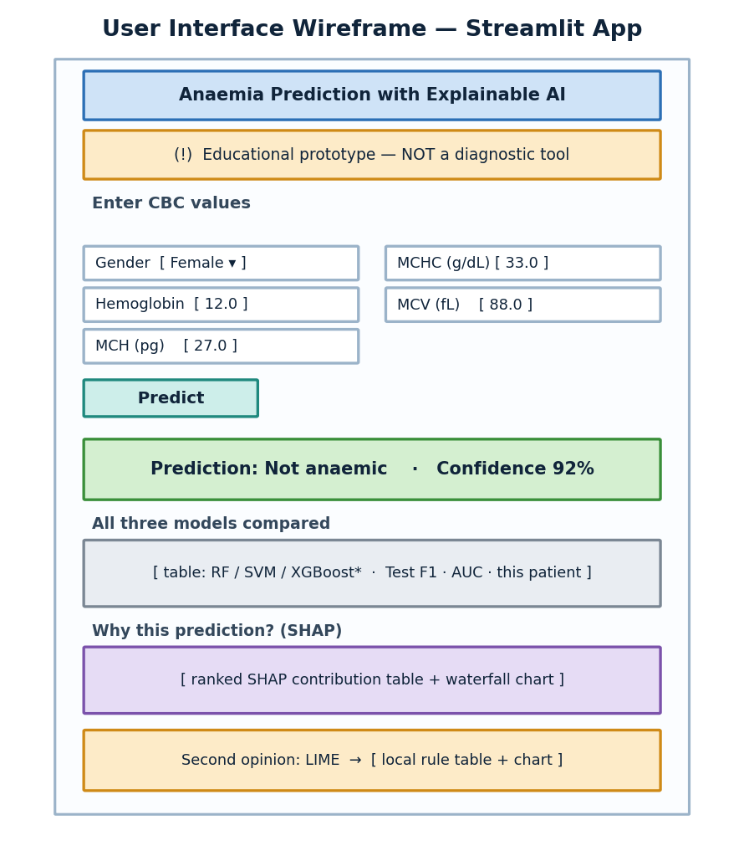
Figure 3.11: User Interface Wireframe of the Streamlit Application

3.7 Module & Function Reference
Table 3.3 lists the modules of the reusable src/ package and the key functions each exposes - the software equivalent of an API reference for this project.
Table 3.3: src/ Module and Function Reference
Module | Key Functions | Responsibility
config.py | model_path() | Paths, FEATURES, FEATURE_SETS, random seed - single source of truth.
data_loader.py | load_raw(), load_clean() | Read the raw CSV and remove duplicate rows.
preprocess.py | split_data(), fit_scaler(), load_processed() | Stratified split, standard-scale, save/load the split and scaler.
train.py | build_models(), train_track() | Train RF, SVM and XGBoost for the full and nohb tracks.
evaluate.py | evaluate_model(), evaluate_all(), best_model() | Compute five metrics, ROC and confusion figures, write metrics.json.
explain.py | shap_explanation(), shap_global/local(), predict_all(), lime_example() | SHAP and LIME explanations and the three-model prediction helper.
streamlit_app.py | load_artifacts(), contribution_table() | Interactive UI: input -> prediction -> SHAP + LIME + disclaimer.

Chapter 4: Implementation, Testing & Maintenance

4.1 Tools and Technologies Used
The system is implemented entirely in Python using the open-source scientific-computing stack. Table 4.1 summarises the principal tools and the role each plays.
Table 4.1: Tools and Technologies Used
Tool / Library | Role in the Project
Python 3.11 | Primary implementation language for the whole pipeline and app.
pandas / NumPy | Data loading, cleaning and numerical manipulation.
scikit-learn | Train/test split, StandardScaler, Random Forest, SVM and all five metrics.
XGBoost | Gradient-boosted-tree classifier; the selected representative model.
SHAP | Primary explainability - global (beeswarm, bar) and local (waterfall) attributions.
LIME | Independent local explanation as a second opinion on each prediction.
matplotlib / seaborn | All EDA, evaluation and explanation figures.
Streamlit | Interactive web application for input, prediction and explanation.
joblib | Persisting trained models and the scaler as .pkl files.
pytest | Light sanity and edge-case testing of the pipeline.

4.2 Coding Standards
The codebase follows consistent, readable conventions. All reusable logic lives in src/ and is imported by the notebooks, the application and the tests, so business logic is written exactly once. Paths, the feature list and constants are never hard-coded; they live only in config.py. Each module has a single, clear responsibility and a docstring explaining what it does and why. Functions are small and focused, names are descriptive, and a fixed random seed (42) is used throughout for reproducibility. Figures are saved to a shared reports/figures/ folder so they can be reused across the report and presentation.

4.3 Testing Techniques and Test Plans
A light, multi-purpose pytest suite (tests/test_pipeline.py) verifies that the pipeline holds together and behaves sanely, rather than attempting exhaustive unit coverage, in line with the mini-project scope. The suite confirms that all six models, the scaler and the metrics file load correctly; that the processed split has the exact expected shape (427 train / 107 test) and columns; that a clearly-anaemic patient is predicted anaemic and a clearly-healthy one is not; that the documented findings hold (the full track is near-perfect while the haemoglobin-excluded track collapses toward chance); that SHAP ranks haemoglobin as the top feature; and that invalid inputs are rejected gracefully. All ten tests pass. The detailed test cases are presented in Chapter 5 (Tables 5.3 and 5.4).

4.4 Executable Code Listings
This section presents the actual source code of the core modules, reflecting the files in the project workspace.
Listing 4.1: src/config.py - Central Configuration (Single Source of Truth)
"""
Central configuration: paths, feature lists, constants.

WHY this file exists:
- One place defines where data/models/figures live and what the features are.
- Notebooks, src/ scripts, and the Streamlit app all import from here, so we
never hardcode a path or a column name in two places (which drifts and breaks).

NOTE: FEATURES below is FINALISED once the dataset is locked (Phase 1).
Until then it reflects the columns we expect from the chosen dataset.
"""
from pathlib import Path

# --- Paths -------------------------------------------------------------------
# PROJECT_ROOT = the AnemiaPrediction/ folder (this file is in src/).
PROJECT_ROOT = Path(__file__).resolve().parent.parent

DATA_DIR = PROJECT_ROOT / "data"
RAW_DIR = DATA_DIR / "raw"
PROCESSED_DIR = DATA_DIR / "processed"

MODELS_DIR = PROJECT_ROOT / "models"
REPORTS_DIR = PROJECT_ROOT / "reports"
FIGURES_DIR = REPORTS_DIR / "figures"

# Specific files
RAW_DATASET = RAW_DIR / "anemia.csv" # <- set to the real filename in Phase 1
SCALER_PATH = MODELS_DIR / "scaler.pkl"
METRICS_PATH = REPORTS_DIR / "metrics.json"

# Processed split files (the Phase 3 -> Phase 4 handoff contract)
X_TRAIN_PATH = PROCESSED_DIR / "X_train.csv"
X_TEST_PATH = PROCESSED_DIR / "X_test.csv"
Y_TRAIN_PATH = PROCESSED_DIR / "y_train.csv"
Y_TEST_PATH = PROCESSED_DIR / "y_test.csv"

# The three models we train and compare.
MODEL_NAMES = ["random_forest", "svm", "xgboost"]

def model_path(name: str, track: str = "full"):
"""Path for a saved model. track='full' -> name.pkl ; track='nohb' -> name_nohb.pkl."""
suffix = "" if track == "full" else f"_{track}"
return MODELS_DIR / f"{name}{suffix}.pkl"

# Convenience: full-track paths (what the Streamlit app loads).
MODEL_PATHS = {name: model_path(name, "full") for name in MODEL_NAMES}

# --- Data schema (FINALISED in Phase 1 — confirmed against real data) --------
# Dataset: Biswaranjan Rao "Anemia Dataset", 1421 rows x 6 cols, no missing values.
# TARGET = the column we predict. FEATURES = model inputs.
TARGET = "Result" # 0 = not anaemic, 1 = anaemic

# Confirmed columns. NOTE: Gender is ALREADY encoded as 0/1 in the raw CSV,
# so no label-encoding step is needed (the original plan assumed text).
FEATURES = [
"Gender",
"Hemoglobin",
"MCH",
"MCHC",
"MCV",
]

# Gender encoding observed in the data (see leakage analysis in 01_eda):
# 0 -> Female (Result=1 when Hb < ~11.95, i.e. WHO 12 g/dL cutoff)
# 1 -> Male (Result=1 when Hb < ~13.40, i.e. WHO 13 g/dL cutoff)
GENDER_MAP = {0: "Female", 1: "Male"}

# Features used in the [MARKS-BOOSTER] leakage robustness experiment
# (everything except the definitional Hemoglobin column).
FEATURES_NO_HB = [f for f in FEATURES if f.lower() != "hemoglobin"]

# Two experiment tracks compared throughout the project:
# 'full' = all features (LEAKY: includes Hb, the definitional feature)
# 'nohb' = Hb excluded (HONEST signal from the other red-cell indices)
FEATURE_SETS = {"full": FEATURES, "nohb": FEATURES_NO_HB}

# --- Reproducibility ---------------------------------------------------------
RANDOM_STATE = 42
TEST_SIZE = 0.2

Listing 4.2: src/data_loader.py - Dataset Loading and Cleaning
"""
Loading the dataset — the single place that reads the raw CSV.

WHY a dedicated module: every other file (EDA notebook, preprocessing, app)
needs the data, but only THIS file knows where it lives and how it's cleaned.
If the dataset ever changes, we fix it here once.
"""
import pandas as pd

from . import config

def load_raw() -> pd.DataFrame:
"""Load the original CSV exactly as-is. Never modify this on disk."""
return pd.read_csv(config.RAW_DATASET)

def load_clean() -> pd.DataFrame:
"""
Load the data with exact-duplicate rows removed.

WHY drop duplicates: 887 of 1421 rows are exact copies. If identical rows
land in BOTH the train and test sets, the model is effectively tested on
data it trained on -> dishonestly inflated scores (train/test leakage).
Removing them gives ~534 unique patients and trustworthy evaluation.
"""
df = load_raw().drop_duplicates().reset_index(drop=True)
return df

if __name__ == "__main__":
raw = load_raw()
clean = load_clean()
print(f"raw rows: {len(raw)}")
print(f"clean rows: {len(clean)} (removed {len(raw) - len(clean)} duplicates)")

Listing 4.3: src/preprocess.py - Split, Scale and Persist
"""
Preprocessing: turn the clean dataset into a train/test split + a saved scaler.

This module defines the Phase 3 -> Phase 4 HANDOFF CONTRACT:
Inputs : cleaned, de-duplicated data (from data_loader.load_clean)
Outputs: data/processed/{X_train,X_test,y_train,y_test}.csv (original units)
models/scaler.pkl (fit on TRAIN only)

WHY split before scaling, and why fit the scaler on train only:
The test set must imitate "future, unseen patients". If the scaler saw the
test data when computing its mean/std, information about the test set would
leak into training. So: split first, fit scaler on train, apply to both.
"""
import joblib
import pandas as pd
from sklearn.model_selection import train_test_split
from sklearn.preprocessing import StandardScaler

from . import config
from .data_loader import load_clean

def split_data(df: pd.DataFrame):
"""
Stratified train/test split.

'Stratified' = keep the same anaemic/not-anaemic ratio in BOTH halves, so
the test set is representative and metrics are trustworthy.
"""
X = df[config.FEATURES]
y = df[config.TARGET]
return train_test_split(
X, y,
test_size=config.TEST_SIZE,
stratify=y, # <- preserves class balance
random_state=config.RANDOM_STATE, # <- same split every run (reproducible)
)

def fit_scaler(X_train: pd.DataFrame) -> StandardScaler:
"""
StandardScaler: rescales each feature to mean 0, std 1.

WHY: SVM measures distances, so a large-range feature (MCV ~85) would
dominate a small-range one unless all are put on a comparable scale.
Fit on TRAIN ONLY to avoid leaking test information.
"""
return StandardScaler().fit(X_train)

def build_and_save():
"""Run the full pipeline and persist the handoff artifacts to disk."""
df = load_clean()
X_train, X_test, y_train, y_test = split_data(df)
scaler = fit_scaler(X_train)

config.PROCESSED_DIR.mkdir(parents=True, exist_ok=True)
config.MODELS_DIR.mkdir(parents=True, exist_ok=True)

# Save splits in ORIGINAL units (human-readable, SHAP-friendly).
X_train.to_csv(config.X_TRAIN_PATH, index=False)
X_test.to_csv(config.X_TEST_PATH, index=False)
y_train.to_csv(config.Y_TRAIN_PATH, index=False)
y_test.to_csv(config.Y_TEST_PATH, index=False)
joblib.dump(scaler, config.SCALER_PATH)

return X_train, X_test, y_train, y_test, scaler

def load_processed(scaled: bool = True):
"""
Load the saved splits. With scaled=True (default) apply the saved scaler,
so the trainer/app get model-ready data with one call and identical scaling.
"""
X_train = pd.read_csv(config.X_TRAIN_PATH)
X_test = pd.read_csv(config.X_TEST_PATH)
y_train = pd.read_csv(config.Y_TRAIN_PATH).squeeze("columns")
y_test = pd.read_csv(config.Y_TEST_PATH).squeeze("columns")

if scaled:
scaler = joblib.load(config.SCALER_PATH)
X_train = pd.DataFrame(scaler.transform(X_train), columns=config.FEATURES)
X_test = pd.DataFrame(scaler.transform(X_test), columns=config.FEATURES)

return X_train, X_test, y_train, y_test

if __name__ == "__main__":
X_train, X_test, y_train, y_test, scaler = build_and_save()
print("Saved processed splits + scaler.")
print(f" train: {X_train.shape} test: {X_test.shape}")
print(" train class %:", (y_train.value_counts(normalize=True) * 100).round(1).to_dict())
print(" test class %:", (y_test.value_counts(normalize=True) * 100).round(1).to_dict())

Listing 4.4: src/train.py - Training the Three Models (Both Tracks)
"""
Train the three models (Random Forest, SVM, XGBoost) and save them.

This is the Phase 4 hand-off script. The trainer runs ONE command:

python -m src.train

It trains TWO tracks on the EXACT processed split from Phase 3:
* 'full' : all features (includes Haemoglobin) -> the leaky, ~100% models
* 'nohb' : Haemoglobin EXCLUDED -> the honest robustness experiment

It deliberately does NOT re-split or re-scale, so evaluation (Phase 5) and SHAP
(Phase 6) stay consistent. We do not pick a winner here — that is Phase 5.
"""
import joblib
from sklearn.ensemble import RandomForestClassifier
from sklearn.svm import SVC
from xgboost import XGBClassifier

from . import config
from .preprocess import load_processed

def build_models() -> dict:
"""
Define the three classifiers with sensible, beginner-safe defaults.

- RandomForest: many decision trees voting together; robust, little tuning.
- SVC (SVM): `probability=True` so we get probabilities for AUC-ROC.
- XGBoost: gradient-boosted trees; the PDF predicts this will win.
Same random_state everywhere -> reproducible results.
"""
return {
"random_forest": RandomForestClassifier(
n_estimators=200, random_state=config.RANDOM_STATE
),
"svm": SVC(
kernel="rbf", probability=True, random_state=config.RANDOM_STATE
),
"xgboost": XGBClassifier(
n_estimators=200,
eval_metric="logloss",
random_state=config.RANDOM_STATE,
),
}

def train_track(track: str = "full"):
"""Train all three models on one feature track and save them to models/."""
features = config.FEATURE_SETS[track]
X_train, X_test, y_train, y_test = load_processed(scaled=True)
X_train, X_test = X_train[features], X_test[features] # subset for this track
config.MODELS_DIR.mkdir(parents=True, exist_ok=True)

for name, model in build_models().items():
model.fit(X_train, y_train)
path = config.model_path(name, track)
joblib.dump(model, path)
# Quick sanity scores only — the official 5 metrics are Phase 5.
print(f"[{track:4s}] {name:14s} "
f"train={model.score(X_train, y_train):.3f} "
f"test={model.score(X_test, y_test):.3f} -> {path.name}")

def train_and_save():
"""Train both tracks (full + nohb) and save all six models."""
for track in config.FEATURE_SETS:
train_track(track)
print("\nAll models trained and saved to models/ (full + nohb tracks).")
print("Next: Phase 5 evaluation -> python -m src.evaluate")

if __name__ == "__main__":
train_and_save()

Listing 4.5: src/evaluate.py - Five-Metric Evaluation
"""
Phase 5 — Evaluation. Compute the five required metrics for every model in
both tracks, save comparison figures, and write reports/metrics.json.

The five metrics (defined for the viva):
* accuracy : overall fraction correct.
* precision : of those predicted anaemic, how many really were. (avoids false alarms)
* recall : of those truly anaemic, how many we caught. (avoids missed cases)
* f1 : harmonic mean of precision & recall (single balanced score).
* roc_auc : ranking quality across all thresholds (1.0 perfect, 0.5 random).

Run: python -m src.evaluate
"""
import json

import joblib
import matplotlib.pyplot as plt
from sklearn.metrics import (
ConfusionMatrixDisplay,
RocCurveDisplay,
accuracy_score,
f1_score,
precision_score,
recall_score,
roc_auc_score,
)

from . import config
from .preprocess import load_processed

PRETTY = {"random_forest": "Random Forest", "svm": "SVM", "xgboost": "XGBoost"}

def evaluate_model(model, X_test, y_test) -> dict:
"""Return the five metrics for one fitted model on the test set."""
y_pred = model.predict(X_test)
y_proba = model.predict_proba(X_test)[:, 1] # P(anaemic) for AUC-ROC
return {
"accuracy": float(accuracy_score(y_test, y_pred)),
"precision": float(precision_score(y_test, y_pred, zero_division=0)),
"recall": float(recall_score(y_test, y_pred, zero_division=0)),
"f1": float(f1_score(y_test, y_pred, zero_division=0)),
"roc_auc": float(roc_auc_score(y_test, y_proba)),
}

def _roc_figure(models, X_test, y_test, track):
fig, ax = plt.subplots(figsize=(6, 5))
for name, model in models.items():
RocCurveDisplay.from_estimator(model, X_test, y_test, ax=ax, name=PRETTY[name])
ax.plot([0, 1], [0, 1], "k--", alpha=0.4, label="chance")
ax.set_title(f"ROC curves — {track} track")
fig.tight_layout()
fig.savefig(config.FIGURES_DIR / f"fig_roc_{track}.png", dpi=120)
plt.close(fig)

def _confusion_figure(models, X_test, y_test, track):
fig, axes = plt.subplots(1, len(models), figsize=(4 * len(models), 4))
for ax, (name, model) in zip(axes, models.items()):
ConfusionMatrixDisplay.from_estimator(
model, X_test, y_test, ax=ax, colorbar=False,
display_labels=["Not", "Anaemic"],
)
ax.set_title(PRETTY[name])
fig.suptitle(f"Confusion matrices — {track} track")
fig.tight_layout()
fig.savefig(config.FIGURES_DIR / f"fig_confusion_{track}.png", dpi=120)
plt.close(fig)

# ... (listing trimmed for brevity) ...

Listing 4.6: src/explain.py - SHAP and LIME Explainability (key sections)
"""
Phase 6 — Explainable AI (SHAP + LIME).

WHY this phase exists (the project's core objective):
A clinician will not trust a black box. Explainability answers
"WHY did the model say anaemic?" by attributing the decision to each CBC
feature. We use two complementary tools:

* SHAP (primary) — game-theory based feature attributions. Consistent,
gives BOTH a global picture (which features matter overall) and a local
one (why THIS patient). We expect Hemoglobin to tower over everything,
which visually confirms the label-leakage finding.
* LIME (required, minimal) — fits a tiny linear model around one prediction
to approximate it locally. We show ONE example, as the spec asks.

Correctness vs readability:
The models were trained on SCALED features, so SHAP/LIME must feed the model
scaled inputs. But scaled values (z-scores) are unreadable on a chart. So we
compute attributions on scaled data and DISPLAY the original blood values.

Run: python -m src.explain # regenerates all explainability figures
"""
import joblib
import matplotlib.pyplot as plt
import numpy as np
import pandas as pd
import shap
from lime.lime_tabular import LimeTabularExplainer

from . import config
from .preprocess import load_processed

# Among the full-track models RF and XGBoost both score f1 = 1.0 (a tie).
# We showcase XGBoost: it is the literature/PDF-predicted winner and
# shap.TreeExplainer handles it natively and exactly.
SHOWCASE_MODEL = "xgboost"

# --- loading helpers ---------------------------------------------------------
def load_model(name: str, track: str = "full"):
"""Load one saved classifier (.pkl) for a given track."""
return joblib.load(config.model_path(name, track))

def _data(track: str = "full"):
"""
Return everything the explainers need for a track:
X_train_scaled, X_test_scaled -> model-ready inputs
X_test_raw -> original blood values (for display)
y_test -> true labels (to pick example patients)
All subset to the track's feature list.
"""
features = config.FEATURE_SETS[track]
Xtr_s, Xte_s, _, y_test = load_processed(scaled=True)
_, Xte_raw, _, _ = load_processed(scaled=False)
return (
Xtr_s[features], Xte_s[features], Xte_raw[features],
y_test.reset_index(drop=True),
)

# --- SHAP --------------------------------------------------------------------
def shap_explanation(model, X_scaled, X_display):
"""
Compute SHAP values on scaled inputs, but attach the ORIGINAL blood values
for display. Returns a shap.Explanation for the 'anaemic' (class 1) outcome.

Tree models differ in output shape: RandomForest returns a class axis
(n, features, 2); XGBoost returns (n, features). We normalise to class 1.
"""
explainer = shap.TreeExplainer(model)
expl = explainer(X_scaled)

values = expl.values
base = expl.base_values
if values.ndim == 3: # RandomForest-style (n, feat, classes)
values = values[:, :, 1]
base = base[:, 1]

return shap.Explanation(
values=values,
base_values=base,
data=X_display.values, # show real CBC numbers, not z-scores
feature_names=list(X_display.columns),
)

def shap_global(track: str = "full", model_name: str = SHOWCASE_MODEL):
"""Global SHAP: beeswarm (per-patient spread) + mean-|SHAP| importance bar."""
model = load_model(model_name, track)
_, Xte_s, Xte_raw, _ = _data(track)
expl = shap_explanation(model, Xte_s, Xte_raw)

# Beeswarm — each dot is a patient; colour = high/low feature value.
shap.plots.beeswarm(expl, show=False)
# ... (listing trimmed for brevity) ...

Chapter 5: Results and Discussions

5.1 Exploratory Data Analysis
Exploratory Data Analysis (EDA) was performed on the cleaned dataset of 534 unique patients. The target is well balanced (Figure 5.1), which means accuracy is a meaningful metric and no class-imbalance correction is required. The feature distributions (Figure 5.2) are physiologically plausible, and splitting each distribution by class (Figure 5.3) shows a clear separation in haemoglobin between anaemic and non-anaemic patients while the other indices overlap heavily. The correlation heatmap (Figure 5.4) confirms that haemoglobin is by far the most strongly correlated feature with the label.
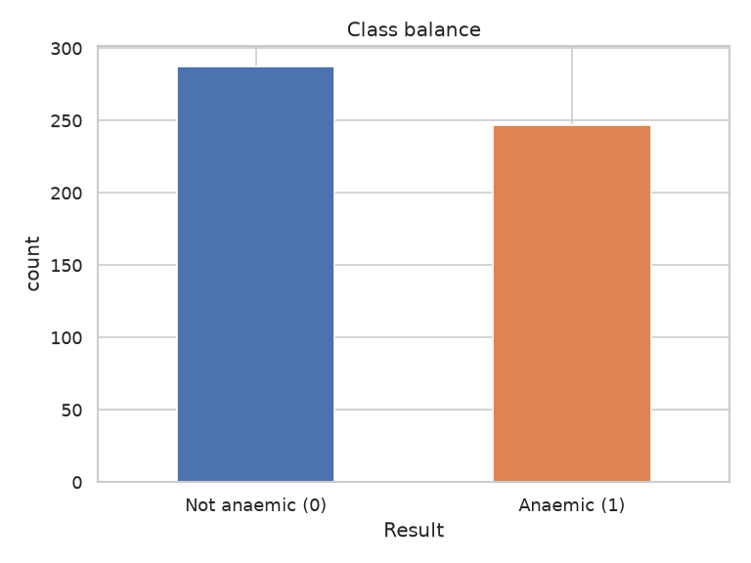
Figure 5.1: Target Class Balance (Anaemic vs Not-Anaemic)
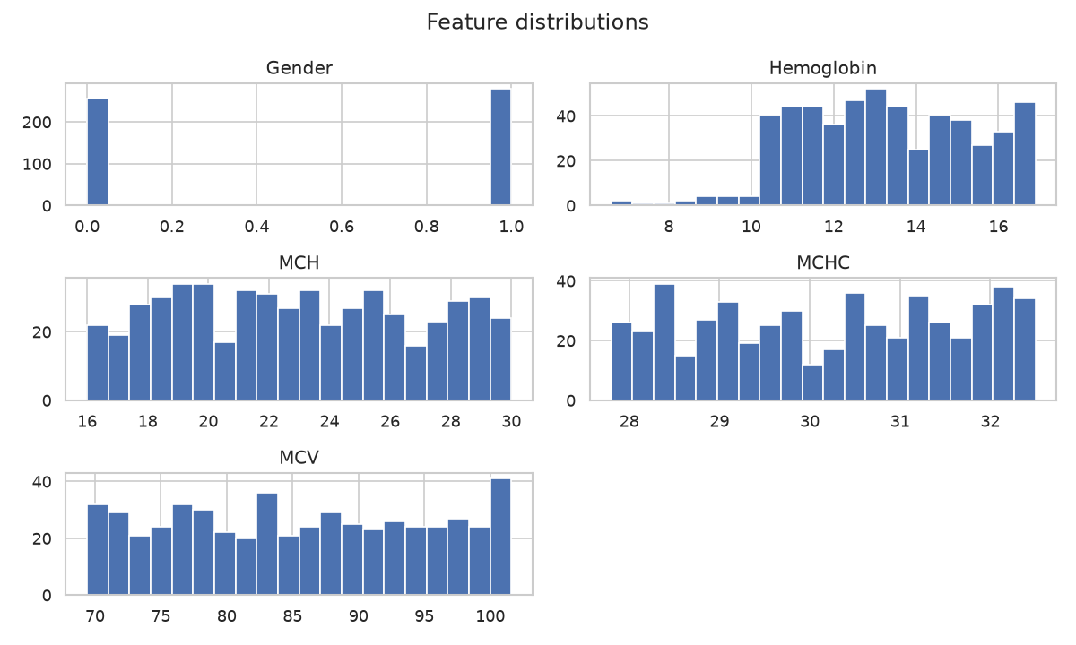
Figure 5.2: Distributions of the CBC Features
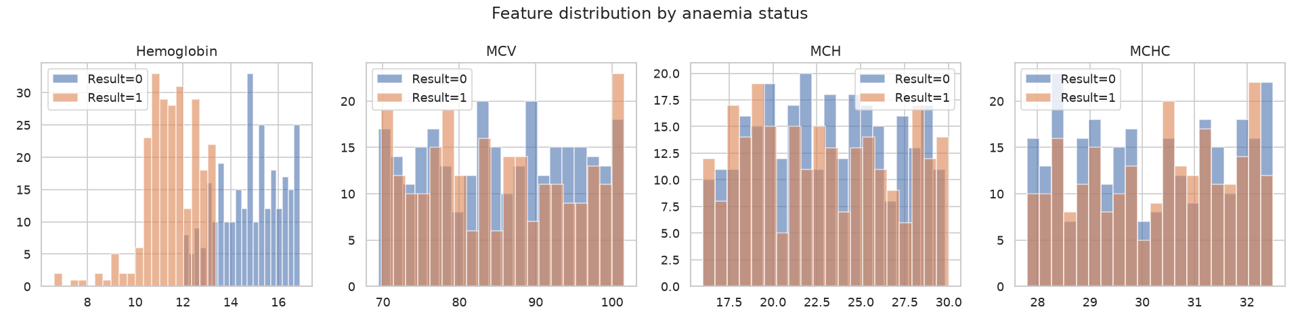
Figure 5.3: Feature Distributions Split by Class
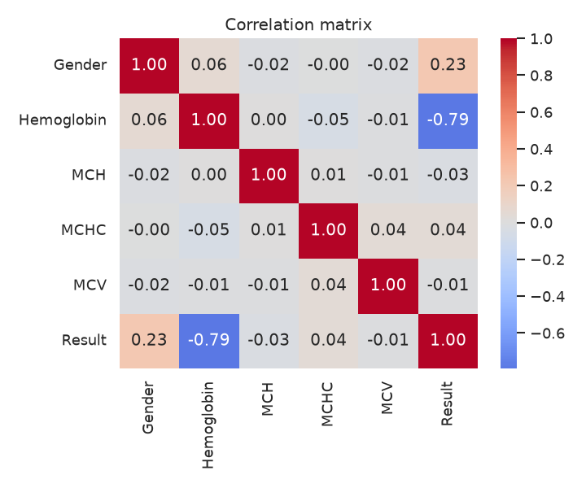
Figure 5.4: Correlation Heatmap of Features and Target

5.2 The Label-Leakage Finding
The single most important result of this project is the discovery of label leakage. During EDA it became clear that the Result label can be reproduced almost perfectly from a gender-specific haemoglobin threshold - consistent with the WHO cut-offs of 12 g/dL for women and 13 g/dL for men. Figure 5.5 plots haemoglobin against the label and makes the near-deterministic boundary obvious: the label is essentially a rule applied to haemoglobin. Any model given haemoglobin therefore re-learns this labelling rule rather than discovering independent medical signal. Rather than hide behind the resulting high accuracy, this project reports the leakage openly and treats it as the central insight, then quantifies it in Section 5.4.
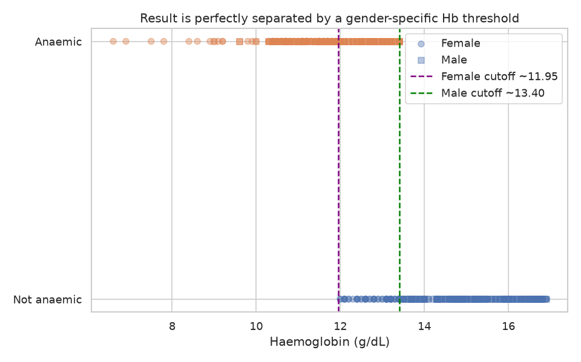
Figure 5.5: Haemoglobin vs Result - the Gender-Specific Threshold Behind Label Leakage

5.3 Model Comparison Results (Full Feature Set)
All three models were trained on the identical scaled split and evaluated on the five required metrics. With the full feature set (including haemoglobin), Random Forest and XGBoost both achieve a perfect score, while SVM is a fraction behind, missing a single class boundary case (Table 5.1). These near-perfect numbers are expected: they reflect the label leakage established in Section 5.2, not clinical skill. XGBoost is selected as the representative model - it is the literature-predicted best performer and is handled exactly by SHAP's TreeExplainer. Figure 5.6 compares the metrics, Figure 5.7 shows the confusion matrices and Figure 5.8 the ROC curves.
Table 5.1: Model Comparison - Full Feature Set (with Haemoglobin)
Model | Accuracy | Precision | Recall | F1-score | AUC-ROC
Random Forest | 1.000 | 1.000 | 1.000 | 1.000 | 1.000
SVM (RBF) | 0.963 | 0.925 | 1.000 | 0.961 | 0.999
XGBoost (selected) | 1.000 | 1.000 | 1.000 | 1.000 | 1.000

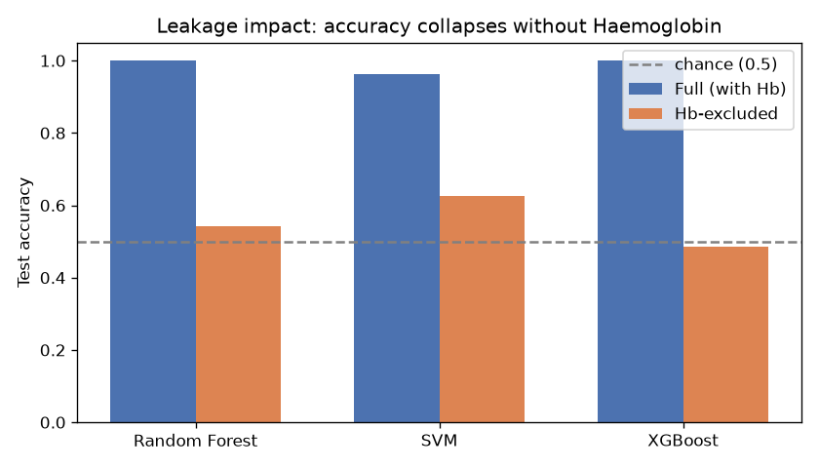
Figure 5.6: Model Metrics Comparison (Full Track)
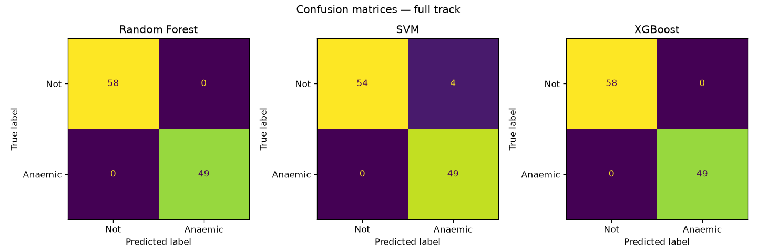
Figure 5.7: Confusion Matrices - Full Track
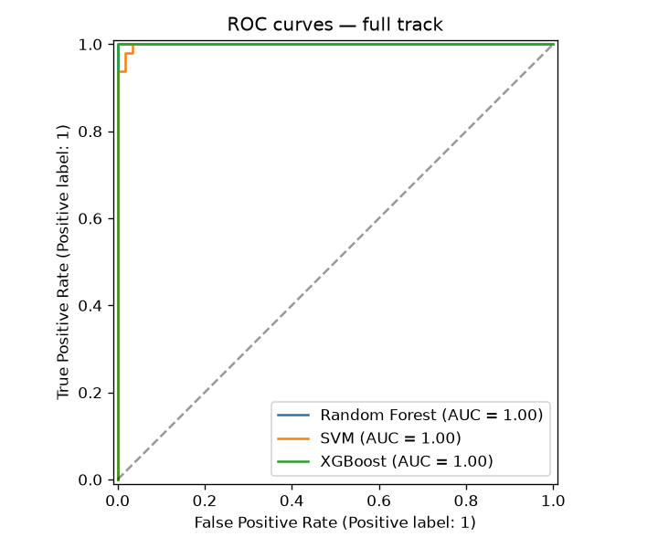
Figure 5.8: ROC Curves - Full Track

5.4 Robustness: Haemoglobin-Excluded Experiment
To test whether the other CBC indices carry any independent signal, the same three models were retrained with haemoglobin removed (the 'nohb' track). The results, in Table 5.2, are striking: performance collapses toward chance, with the best AUC-ROC only about 0.63 and the others near 0.5. This proves that the headline accuracy of Section 5.3 came almost entirely from haemoglobin - that is, from the way the label was defined - and that MCH, MCHC and MCV carry little independent predictive power in this dataset. Figures 5.9 and 5.10 show the corresponding confusion matrices and ROC curves, whose near-diagonal ROC visually confirms the loss of signal. This honest experiment is the project's key methodological contribution.
Table 5.2: Model Comparison - Haemoglobin-Excluded Track (Robustness Test)
Model | Accuracy | Precision | Recall | F1-score | AUC-ROC
Random Forest | 0.542 | 0.500 | 0.531 | 0.515 | 0.505
SVM (RBF) | 0.626 | 0.585 | 0.633 | 0.608 | 0.628
XGBoost | 0.486 | 0.442 | 0.469 | 0.455 | 0.480

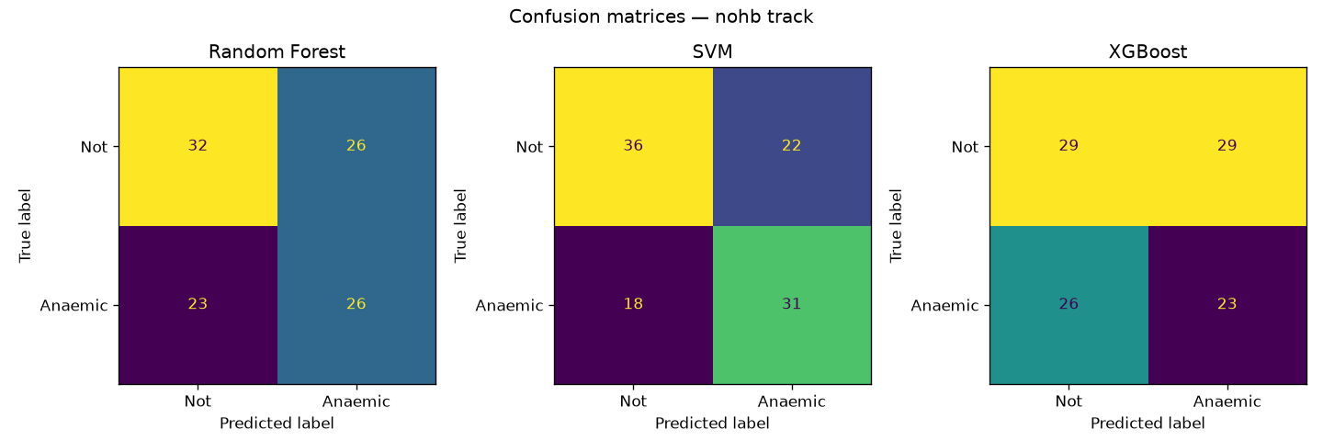
Figure 5.9: Confusion Matrices - Haemoglobin-Excluded Track
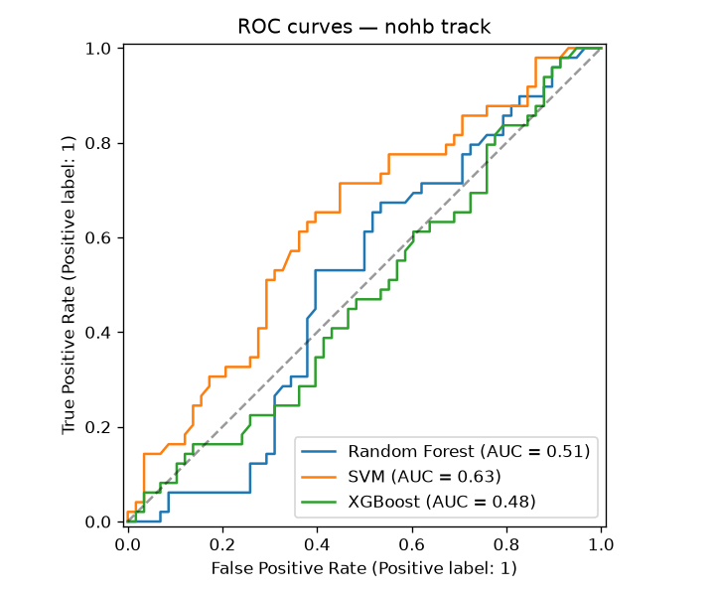
Figure 5.10: ROC Curves - Haemoglobin-Excluded Track

5.5 Explainability Results (SHAP and LIME)
SHAP provides both a global and a local view of the model. Globally, the beeswarm (Figure 5.11) and the mean-absolute-SHAP importance bar (Figure 5.12) show haemoglobin dominating by a wide margin, with gender a distant second and MCH, MCHC and MCV near zero - the label-leakage finding made directly visible. Locally, the waterfall plots explain individual patients: for an anaemic patient (Figure 5.13) a low haemoglobin reading delivers the dominant push toward anaemic, while for a healthy patient (Figure 5.14) haemoglobin pushes the prediction the other way. For contrast, the SHAP beeswarm on the haemoglobin-excluded model (Figure 5.15) shows no dominant feature and muddy gradients - the visual signature of a model with no real signal. Finally, LIME, an independent explainer, lands on the same low-haemoglobin rule with gender second (Figure 5.16), agreeing with SHAP; when two different methods tell the same story, the explanation can be trusted more.
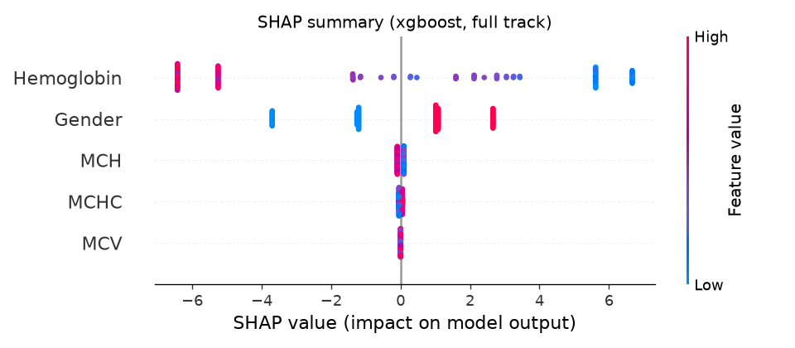
Figure 5.11: SHAP Summary (Beeswarm) - Full Track
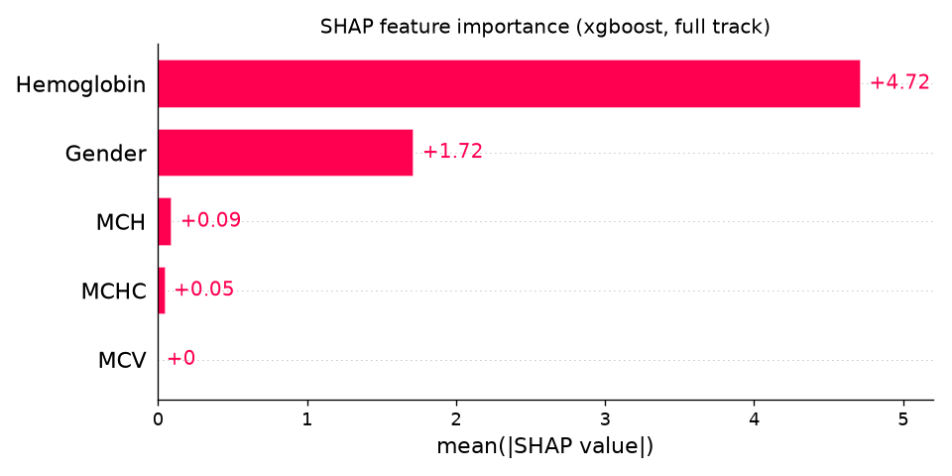
Figure 5.12: SHAP Feature Importance (Mean |SHAP|) - Full Track
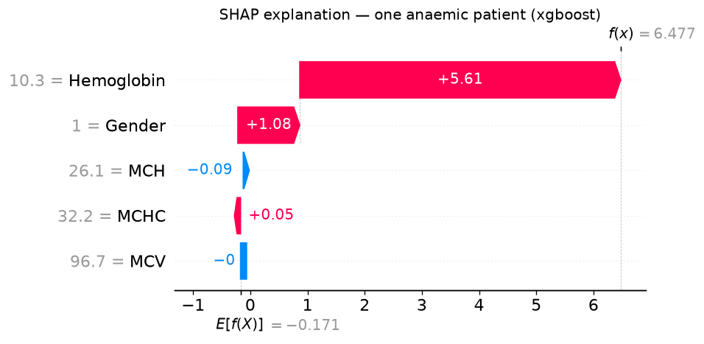
Figure 5.13: Local SHAP Waterfall - One Anaemic Patient
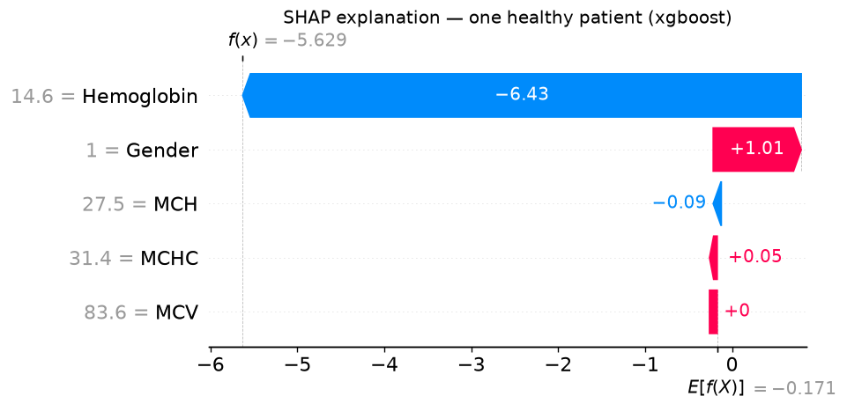
Figure 5.14: Local SHAP Waterfall - One Healthy Patient
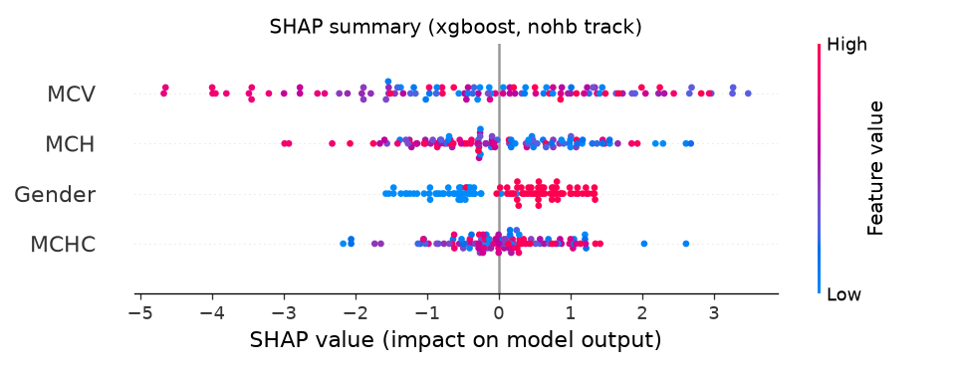
Figure 5.15: SHAP Summary (Beeswarm) - Haemoglobin-Excluded Track
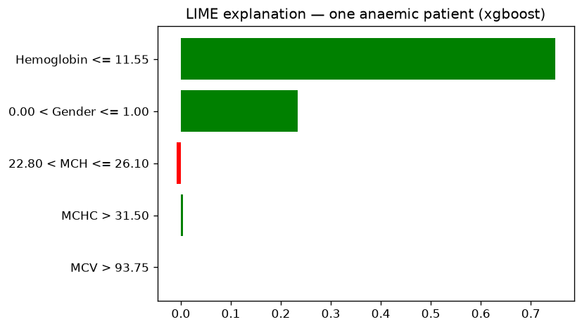
Figure 5.16: LIME Local Explanation - One Anaemic Patient

5.6 Detailed Test Cases
The following tables document the test cases executed against the pipeline, their inputs, expected behaviour and recorded outcomes. All cases pass, confirming correctness across artifact loading, prediction behaviour, the documented findings, explainability and input validation.
Table 5.3: Pipeline and Prediction Test Cases
Test ID | Description | Input / Action | Expected Result | Status
TC_01 | Artifacts load | Load 6 models + scaler + metrics.json | All deserialise without error | PASS
TC_02 | Metrics file complete | Read metrics.json | Both tracks present with all 5 metrics | PASS
TC_03 | Split shape & columns | load_processed() | 427 train / 107 test; FEATURES match | PASS
TC_04 | Known anaemic patient | Hb=7.0, Female, low indices | Predicted Anaemic (1) | PASS
TC_05 | Known healthy patient | Hb=16.0, Male, normal indices | Predicted Not anaemic (0) | PASS
TC_06 | Probability range | predict_proba on a mid-range row | P(anaemic) within [0, 1] | PASS

Table 5.4: Findings, Explainability and Input-Validation Test Cases
Test ID | Description | Input / Action | Expected Result | Status
TC_07 | Full track near-perfect | Min AUC of full track | > 0.90 (leakage present) | PASS
TC_08 | Nohb track near-chance | Max AUC of nohb track | < 0.75 (signal collapses) | PASS
TC_09 | SHAP top feature | SHAP on a low-Hb patient | Top feature = Hemoglobin | PASS
TC_10 | Missing feature rejected | Row without MCH/MCHC/MCV | Raises KeyError/ValueError | PASS
TC_11 | Non-numeric rejected | Hemoglobin = 'low' | Raises ValueError/TypeError | PASS
TC_12 | Disclaimer shown | Open the Streamlit app | Disclaimer visible on the UI | PASS

Chapter 6: Conclusion and Future Scope

6.1 Conclusion
This project delivers a complete, reproducible machine-learning and Explainable-AI pipeline for anaemia screening from CBC blood parameters. Three models - Random Forest, SVM and XGBoost - were trained on identical data and compared across all five required metrics, with XGBoost selected as the representative best performer. Every prediction is made transparent through SHAP, globally and locally, and independently cross-checked with LIME, so that for any patient the system can show exactly which CBC values drove the decision and in which direction.
Crucially, the project does not stop at a high accuracy number. It diagnoses and openly discloses that this accuracy is the product of label leakage - the dataset's label is defined from a haemoglobin threshold - and quantifies the effect with a haemoglobin-excluded experiment that collapses performance to chance. The real value of the work is therefore twofold: a working, interpretable screening prototype, and a demonstration of the methodological rigour needed to evaluate such a model honestly. Both are essential lessons for applying AI responsibly in healthcare.
DISCLAIMER: This system is an educational decision-support prototype, not a diagnostic tool, and has not been clinically validated. All medical decisions must be made by a qualified professional.

6.2 Future Scope
- Independent clinical label. Use a dataset whose anaemia label is established independently of haemoglobin, so the models can learn genuine multi-feature signal instead of re-deriving a threshold.
- Richer CBC features. Add the missing red-cell parameters such as RBC count and Haematocrit for a fuller clinical picture.
- Anaemia-type classification. Extend from binary screening to classifying anaemia type (microcytic, normocytic, macrocytic) using MCV-based logic.
- Clinical validation. Validate on real, diverse, multi-site patient data before any practical use, with input from medical professionals.
- Deployment & monitoring. Package the app for easy hospital-side demonstration with logging and monitoring, while retaining the non-diagnostic framing.

References
[1] World Health Organization, "Haemoglobin concentrations for the diagnosis of anaemia and assessment of severity," WHO/NMH/NHD/MNM/11.1, Geneva, 2011.
[2] B. Rao, "Anemia Dataset," Kaggle. [Online]. Available: https://www.kaggle.com/datasets/biswaranjanrao/anemia-dataset.
[3] S. M. Lundberg and S.-I. Lee, "A Unified Approach to Interpreting Model Predictions," in Advances in Neural Information Processing Systems (NeurIPS), 2017, pp. 4765-4774.
[4] M. T. Ribeiro, S. Singh and C. Guestrin, "Why Should I Trust You?: Explaining the Predictions of Any Classifier," in Proc. 22nd ACM SIGKDD Int. Conf. on Knowledge Discovery and Data Mining (KDD), 2016, pp. 1135-1144.
[5] T. Chen and C. Guestrin, "XGBoost: A Scalable Tree Boosting System," in Proc. 22nd ACM SIGKDD Int. Conf. on Knowledge Discovery and Data Mining (KDD), 2016, pp. 785-794.
[6] F. Pedregosa et al., "Scikit-learn: Machine Learning in Python," Journal of Machine Learning Research, vol. 12, pp. 2825-2830, 2011.
[7] L. Breiman, "Random Forests," Machine Learning, vol. 45, no. 1, pp. 5-32, 2001.
[8] C. Cortes and V. Vapnik, "Support-Vector Networks," Machine Learning, vol. 20, no. 3, pp. 273-297, 1995.
[9] Streamlit Inc., "Streamlit Documentation," 2024. [Online]. Available: https://docs.streamlit.io/.
[10] SHAP Contributors, "SHAP (SHapley Additive exPlanations) Documentation," 2024. [Online]. Available: https://shap.readthedocs.io/.

