Chapter 3 Selections

1. <, <=, ==, !=, >, >=

2.
true
false
false
true
true
true

3. No. Boolean values cannot be cast to other types.

4.
if (y > 0)
x = 1;

5.
if (score > 90)
pay *= 1.03;

6.
if (score > 90)
pay *= 1.03;
else
pay *= 1.01;

7.
If number is 30,
(a) displays
30 is even
30 is odd

(b) displays
30 is even

If number is 35,
(a) displays
35 is odd

(b) displays
35 is odd

8. Note: else matches the first if clause. No output if x = 3 and y = 2. Output is “z is 7” if if x = 3 and y = 4. Output is “x is 2” if if x = 2 and y = 2.

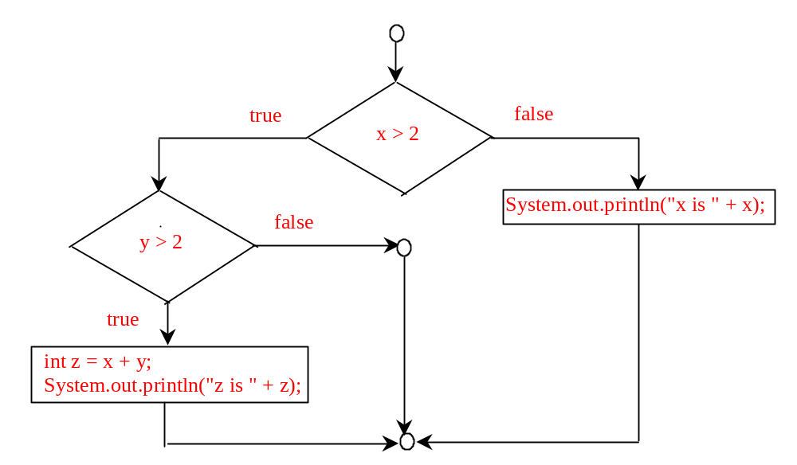
9. No output if x = 2 and y = 3. Output is “x is 3” if x = 3 and y = 2. Output is “z is 6” if x = 3 and y = 3.

10.
Consider score is 90, what will be the grade?

11. a, c, and d are the same. (B) and (C) are correctly indented.

12.

newLine = (count % 10 == 0);

13.

Both are correct. (b) is better.

- for (a) if number is 14, the output is
14 is even
if number is 15, the output is
15 is multiple of 5
if number is 30, the output is
30 is even
30 is multiple of 5

for (b) if number is 14, the output is
14 is even
if number is 15, the output is
15 is multiple of 5
if number is 30, the output is
30 is even

15. 0.5, 0.0, 0.234

16. (int)(Math.random() * 20)

10 + (int)(Math.random() * 10)

10 + (int)(Math.random() * 41)

17. Yes

18. (true) && (3 > 4)
false

!(x > 0) && (x > 0)
false

(x > 0) || (x < 0)
true

(x != 0) || (x == 0)
true

(x >= 0) || (x < 0)
true

(x != 1) == !(x == 1)
true

19. (x > 1) && (x < 100)

20. ((x > 1) && (x < 100)) || (x < 0)

21. x > y > 0
incorrect

x = y && y
incorrect

x /= y
correct

x or y
incorrect

x and y
incorrect

22.
a. x is 2.
b. x is 1.

23.
If ch is 'A', the expression is true;
If ch is 'p', the expression is false;
If ch is 'E', the expression is true;
If ch is '5', the expression is false;

24.

(x < y && y < z) is true
(x < y || y < z) is true
!(x < y) is false
(x + y < z) is true
(x + y < z) is true

25. age > 13 && age < 18

26.

weight > 50 || height > 60.

27.

weight > 50 && height > 60.

28.

weight > 50 ^ height > 60.

29. Switch variables must be of char, byte, short, or int data types. If a break statement is not used, the next case statement is performed. You can always convert a switch statement to an equivalent if statement, but not an if statement to a switch statement. The use of the switch statement can improve readability of the program in some cases. The compiled code for the switch statement is also more efficient than its corresponding if statement.

30. y is 2.

- x is 17

switch (a) {
case 1: x += 5; break;
case 2: x += 10; break;
case 3: x += 16; break;
case 4: x += 34;
}

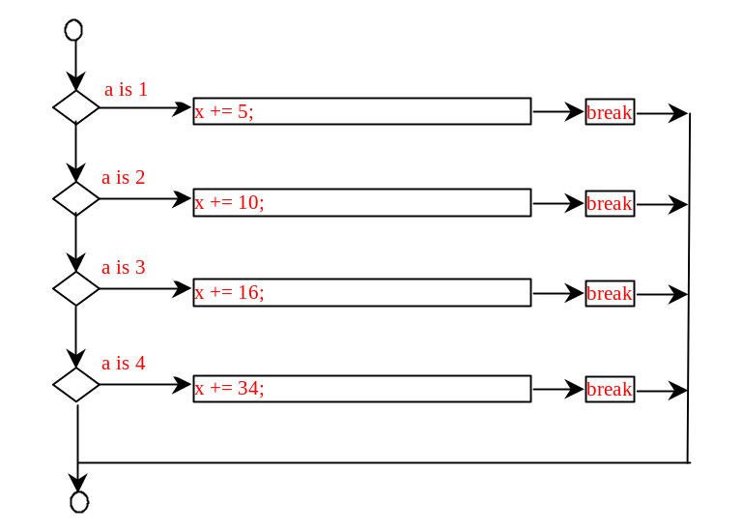
32. switch (day) {
case 0: dayName = "Sunday"; break;
case 1: dayName = "Monday"; break;
case 2: dayName = "Tuesday"; break;
case 3: dayName = "Wednesday"; break;
case 4: dayName = "Thurday"; break;
case 5: dayName = "Friday"; break;
case 6: dayName = "Saturday"; break;
}

33. Sorted

34.
(A) ticketPrice = (ages >= 16) ? 20 : 10;
(B) System.out.print((count % 10 == 0) ? count + "\n" : count + " ");

35.
(A)

if (x > 10)
score = 3 * scale;
else
score = 4 * scale;

(B)

if (income > 10000)
tax = income * 0.2;
else
tax = income * 0.17 + 1000;

(C)

if (number % 3 == 0)
System.out.println(i);
else
System.out.println(j);

36.

The specifiers for outputting a boolean value, a character, a decimal integer, a floating-point number, and a string are %b, %c, %d, %f, and %s.

37.
  - the last item 3 does not have any specifier.
  - There is not enough items
  - The data for %f must a floating-point value

38.
- amount is 32.320000 3.233000e+01
- amount is 32.3200 3.2330e+01
- *false // * denote a space
- **Java // * denote a space
- false*****Java
- *falseJava

39. The precedence order for boolean operators is ^, &&, and ||

true || true && false is true

true && true || false is true

- True
- both are false
- Yes. Yes. Yes.
- To display a confirmation dialog box, invoke JOptionPane.showConfirmDialog(null, “Prompting message”). The method returns an int value: 0 if the Yes button is clicked, 1 if the No button is clicked, and 2 if the Cancel button is clicked,

