Chapter 6 Single-Dimensional Arrays
1. See the section "Array Basics."

2. The memory is allocated when an array is created.

x is 60
The size of numbers is 30

4. Indicate true or false for the following statements:

1. Every element in an array has the same type.
Answer: True

2. The array size is fixed after it is declared.
Answer: False

3. The array size is fixed after it is created.
Answer: True

4. The element in the array must be of primitive data type.
Answer: False

5. Which of the following statements are valid array declarations?

int i = new int(30);
Answer: Invalid

double d[] = new double[30];
Answer: Valid

char[] r = new char(1..30);
Answer: Invalid

int i[] = (3, 4, 3, 2);
Answer: Invalid

float f[] = {2.3, 4.5, 5.6};
Answer: Valid

char[] c = new char();
Answer: Invalid

6. You access an array using its index. arrayRefVar[index] is known as an array indexed variable.

7. The array index type is int and its lowest index is 0.

a[2]

8.
(a)
double[] list = new double[10];

(b)
list[list.length – 1] = 5.5;

(c)
System.out.println(list[0] + list[1]);

(d)
double sum = 0;
for (int i = 0; i < list.length; i++)
sum += list[i];

(e)
double min = list[0];
for (int i = 1; i < list.length; i++)
if (min > list[i]) min = list[i];

(f)
System.out.println(list[(int)(Math.random() * list.length)]);

(g)
double[] list = {3.5, 5.5, 4.52, 5.6};

9. A runtime exception ArrayIndexOutOfBounds occurs.

10. Line 3: the array declaration is wrong. It should be double[]. The array needs to be created before its been used. e.g. new double[10]
Line 5: The semicolon (;) at the end of the for loop heading should be removed.
Line 5: r.length() should be r.length.
Line 6: random should be random()
Line 6: r(i) should be r[i].

11. 1 1 1 1 1 1

12. System.arraycopy(source, 0, t, 0, source.length);

13. The second assignment statement myList = new int[20] creates a new array and assigns its reference to myList.

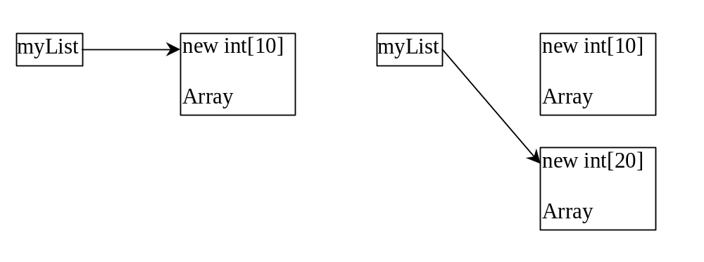

14 False. When an array is passed to a method, the reference value of the array is passed. No new array is created. Both argument and parameter point to the same array.

15

numbers is 0 and numbers[0] is 3

16.

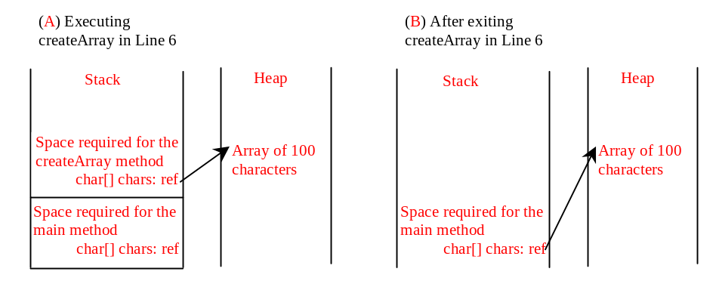
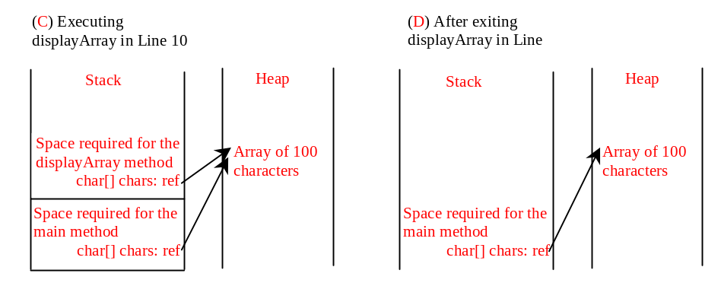
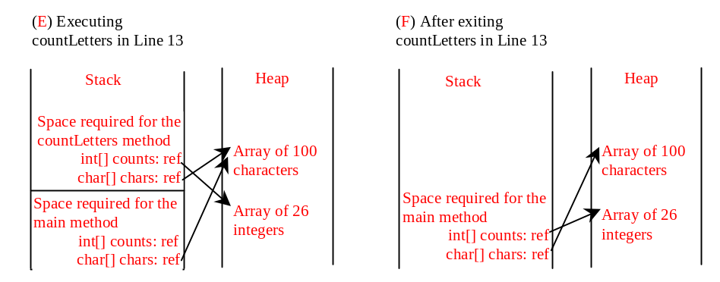
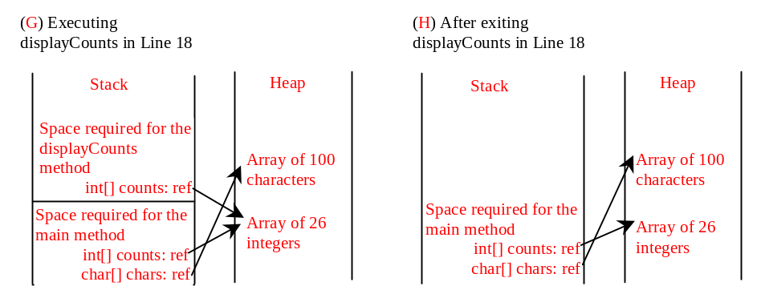
17. Only one variable-length parameter may be specified in a method and this parameter must be the last parameter. The method return type cannot be a variable-length parameter.

18. The last one
printMax(new int[]{1, 2, 3});
is incorrect, because the array must of the double[] type.

19. Omitted

20. Omitted

21. Omitted

22. Omitted

23 Simply change (currentMax < list[j]) on Line 10 to (currentMax > list[j])

24 Simply change list[k] > currentElement on Line 9 to list[k] < currentElement

- You can sort an array of any primitive types except boolean. The sort method is void, so it does not return a new array.

26. To apply java.util.Arrays.binarySearch(array, key), the array must be sorted in increasing order.

27.
[7, 7, 7, 7]
[2, 4, 7, 10]
false

