Chapter 24 Developing Efficiency Algorithms
1. The constant factor is ignored in big O notation, because it has no impact on the growth rate of the time complexity function. A nondominating term is ignored in Big O notation, because as the input size grows, the dominating term grows much faster than the nondominating term.

2.

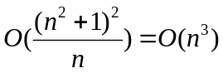, 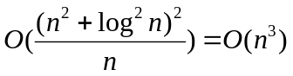, 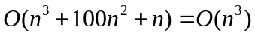, 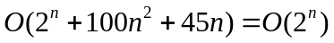, 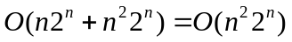

3.
(A)
5

(B)
1

(C)
The ceiling of log₂n times

(D)
The ceiling of log₃(n/15) times

4. if n is 10: (a) 10 (b) 10^2 (c) 10^3 (d) 10*10^2
if n is 20: (a) 20 (b) 20^2 (c) 20^3 (d) 20*20^2

Using Big-O notation:
O(n), O(n^2), O(n^3), O(n^2)

5. mA: O(n). mB: O(n^2). mC: O(n). mD: O(n^2)

6. An O(n) time algorithm for this is

int sum = 0;
for (int i = n1; i <= n2; i++)
sum += i;

An O(1) time algorithm for this is

int sum = n2(n2 + 2) / 2 – n1(n1 + 2) / 2;

7.
result = a;
i = 2;

while (i <= n) {
result = result * result;
i *= 2;
}

for (int j = i / 2 + 1; j <= n; j++)
result = result * a;

Assume that 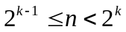. The while loop is executed k-1 times. The for loop is executed at most 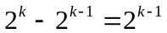 times. So, the total complexity is O(n).

Consider another implementation:

public static int f(int a, int n) {
if (n == 1) {
return a;
}
else {
int temp = f(a, n / 2);
if (n % 2 == 0) {
return temp * temp;
}
else {
return a * temp * temp;
}
}
}

This implementation results in O(logn) complexity.

8.
500, 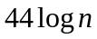, 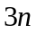, 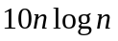, 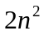, 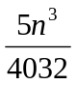, 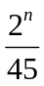

9. Adding two matrices: O(n*m). Multiplying two matrices: O(nmk)

10. The algorithm can be designed as follows: Maintain two variables, max and count. max stores the current max number, and count stores its occurrences. Initially, assign the first number to max and 1 to count. Compare each subsequent number with max. If the number is greater than max, assign it to max and reset count to 1. If the number is equal to max, increment count by 1. Since each element in the array is examined only once, the complexity of the algorithm is O(n).

- The algorithm can be designed as follows: For each element in the input array, store it to a new array if it is new. If the number is already in the array, ignore it. The time for checking whether an element is already in the new array is O(n), so the complexity of the algorithm is O(n^2).

- This is similar to bubble sort. Whenever a swap is made, it goes back to the beginning of the loop. In the worst case, there will be O(n^2) of swaps. For each swap, O(n) number of comparisons may be made in the worst case. So, the total is O(n^3) in the worst case.

- See the definition and example in the text.
- The recursive Fibonacci algorithm is inefficient, because the subproblems in the recursive Fibonacci algorithm overlaps, which causes redundant work. The non- recursive Fibonacci algorithm is dynamic algorithm that avoids redundant work.
- To prove this is wrong, all you need is to give a counter example to show the algorithm does not work. Try n = 64 and m = 48. The algorithm will produce the gcd 8, but the actual gcd is 16.
- If n is not a prime, then there exists two number n1 and n2 such that n1 * n2 = n. Assume n1 <= n2, n1 <= . If n1 is not a prime, you can continue the same process to find the factors of n1, until a factor is a prime.
- See the text.
- See the definition and example in the text.
- See the text.
- Yes. Finding the minimum in the first half and the second half of the list and return the minimum of these two. So, the time complexity is O(n) = 2 * O(n/2) + O(1) = O(n).
- See the definition and example in the text.
- O(n!)
- See the text
- See the text
- See the text

