Chapter 25 Sorting
1. See the text. The time complexity for a bubble sort is O(n^2).
2. Omitted.
3. n – 1 times
4. See the text. The time complexity for a merge sort is O(nlogn).
5. Omitted.

6. Consider a list with two elements. firstHalf will be the entire list.

7. See the text. The time complexity for a quick sort is O(n^2) in the worst case and O(nlogn) in the average case.

8. Quick sort does not need to create temporary arrays, while merge sort needs temporary arrrys.

9. Omitted

10. A binary tree is complete if every level of the tree is full except that the last level may not be full and all the leaves on the last level are placed left-most. A heap is a binary tree with the following properties:

- It is a complete binary tree.
- Each node is greater than or equal to any of its children.

11. The return value will be null.

12.

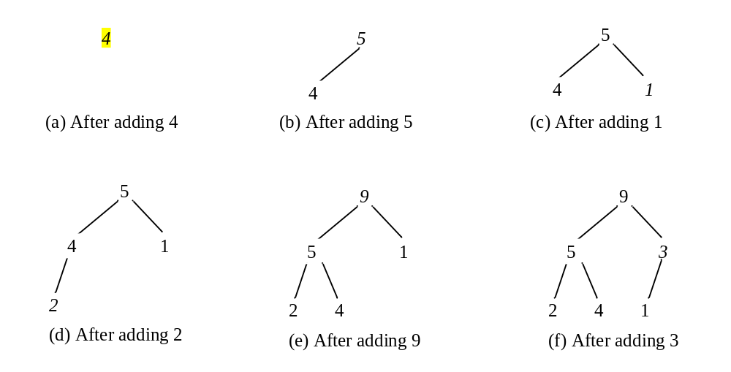

13.
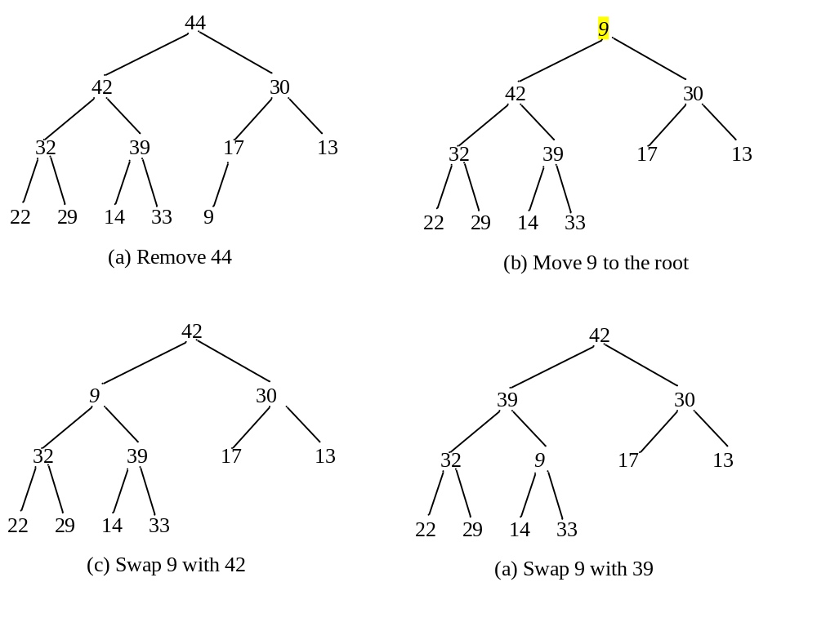
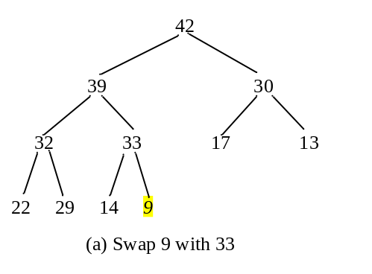
14. O(logn) for both insertion and deletion.

15. Omitted.
16. Omitted.
17. Lines 1 and 2 are wrong, because Object and Number do not implement Comparable.
18. Bucket sort is not suitable for sorting strings.
19. Omitted.

- See the text. The time complexity for an external sort is O(nlogn) on disk I/O of blocks of data.
- Omitted.

