MINI-ONE
REFERENCE
Version 1 – September 2026
Edward Sicoe
github.com/esicoe/mini-one

1 CHANGELOG
Version | Date (yyyy/mm/dd) | Change Note
0 | 2026/09/16 | Release
1 | 2026/09/28 | Removed via shorting GND and D−

2 SUBSYSTEM DIAGRAM
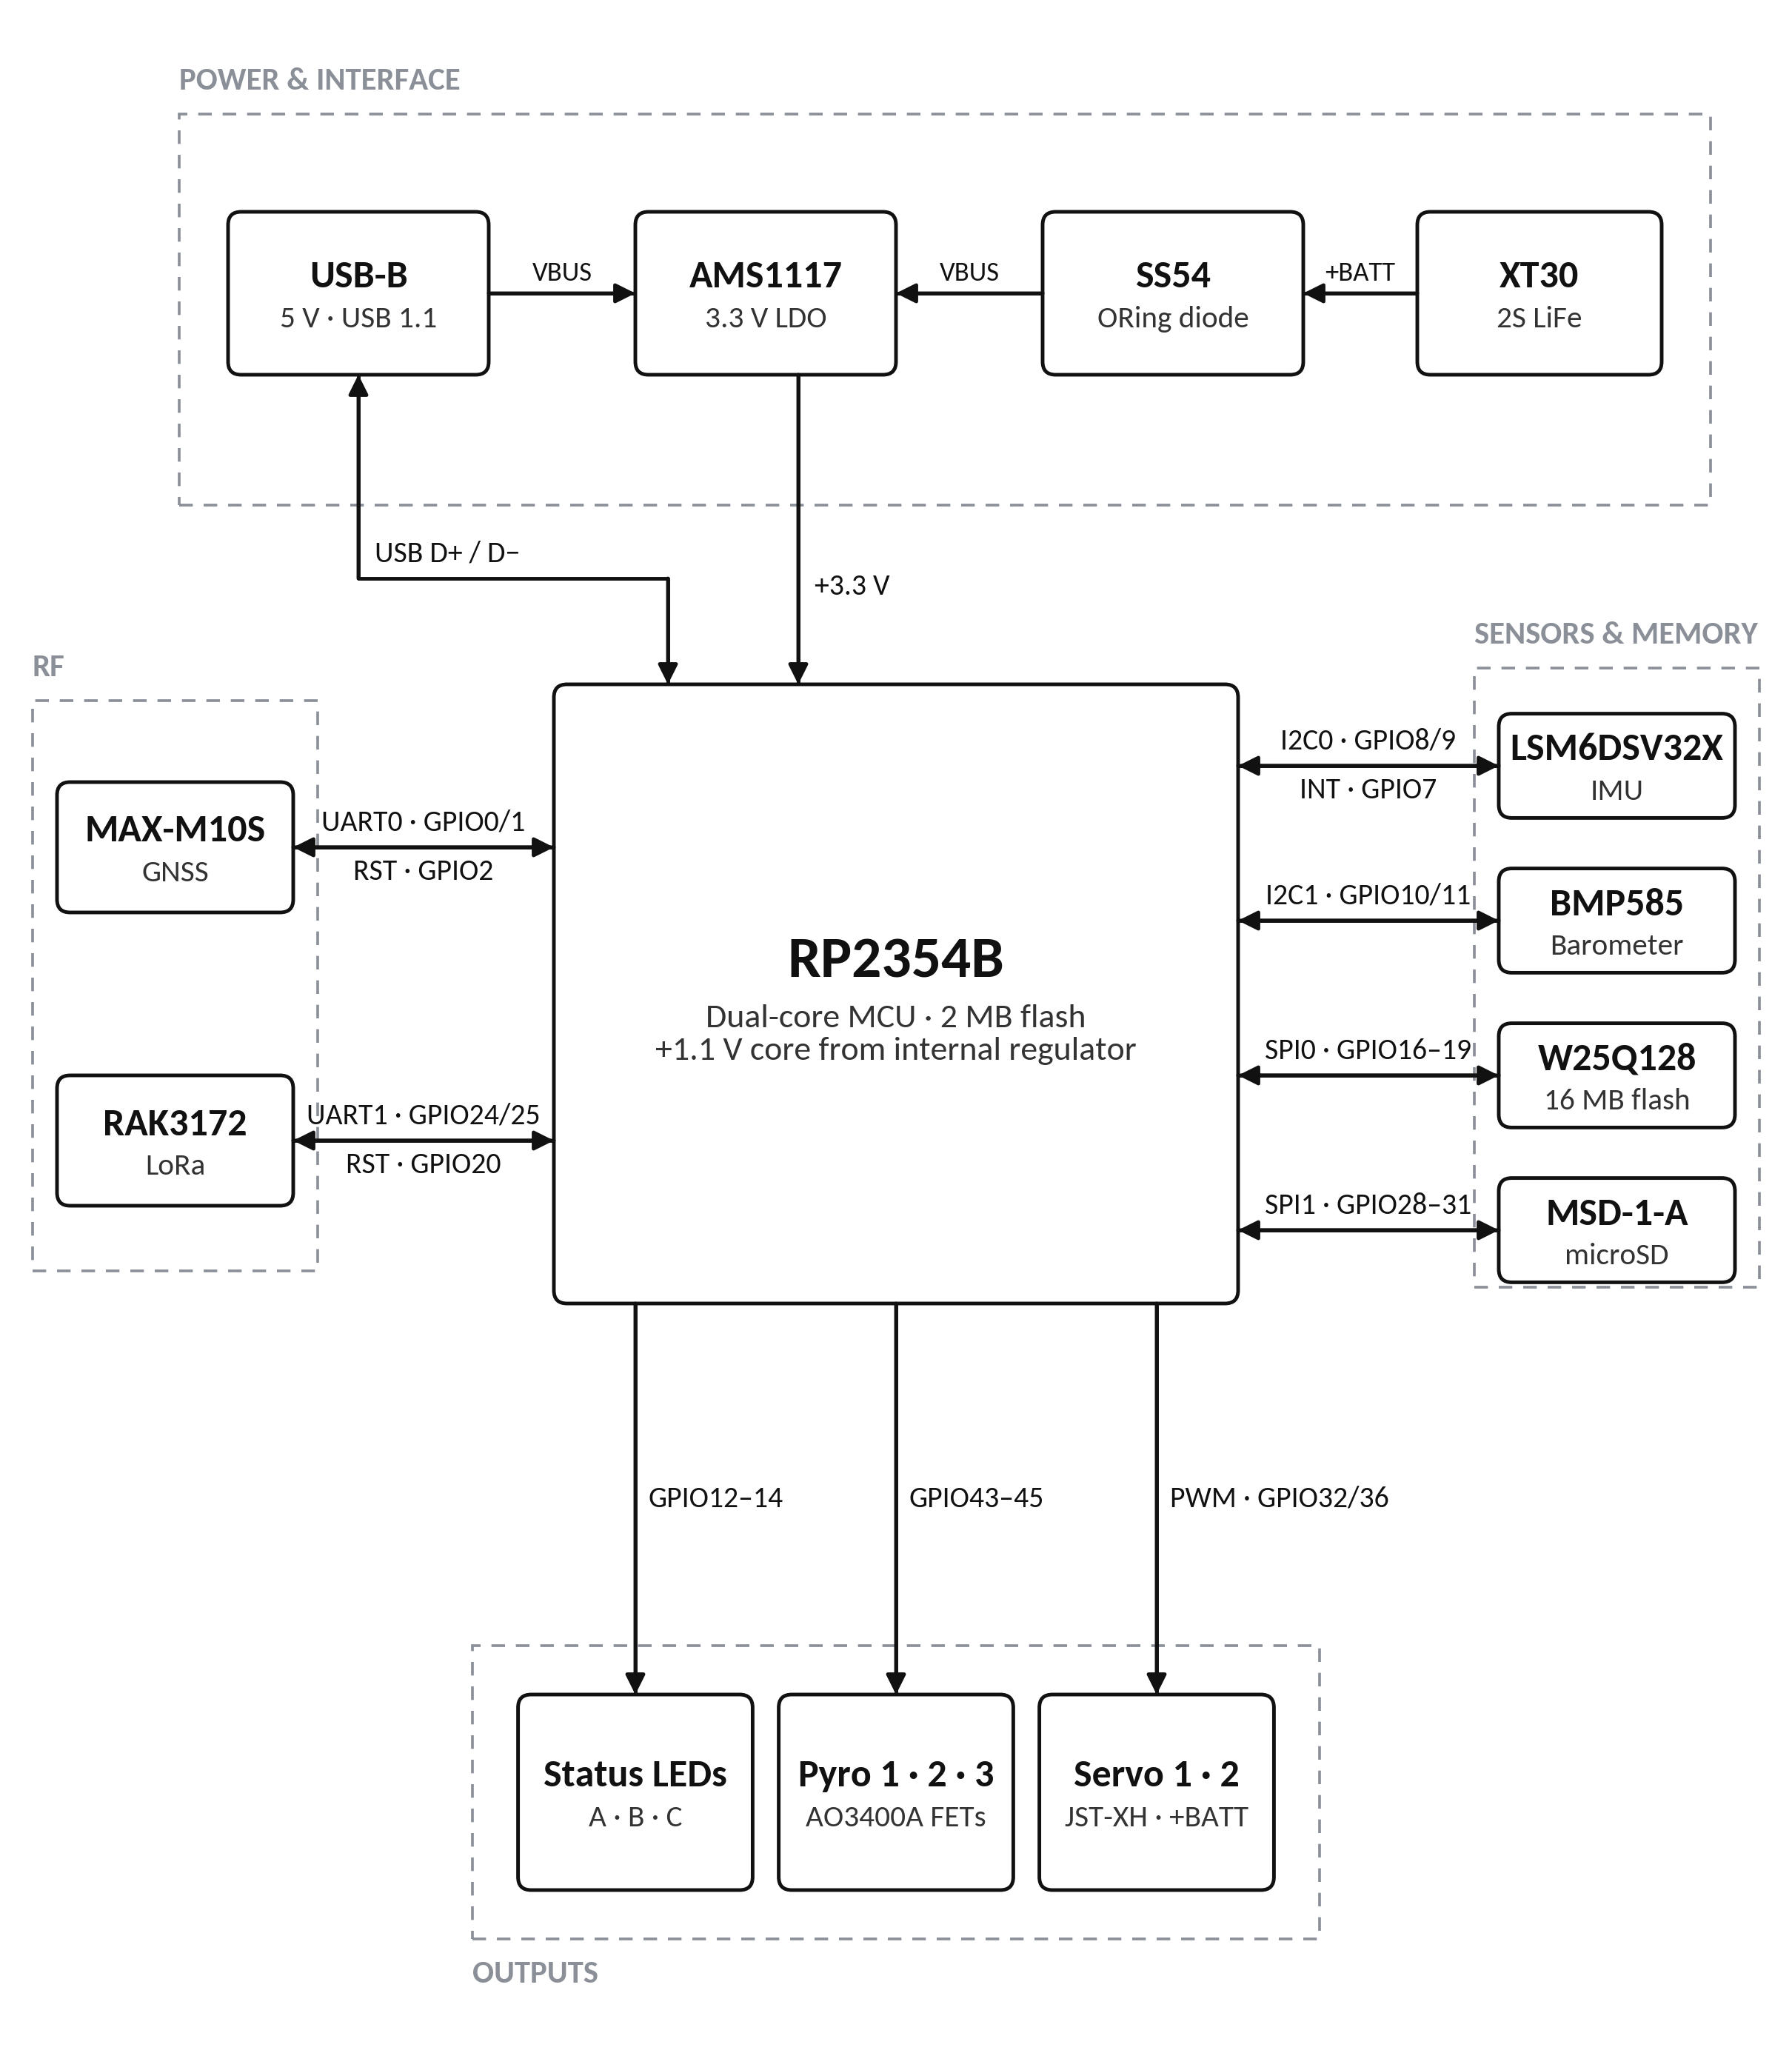

3 PCB DIAGRAM - FRONT
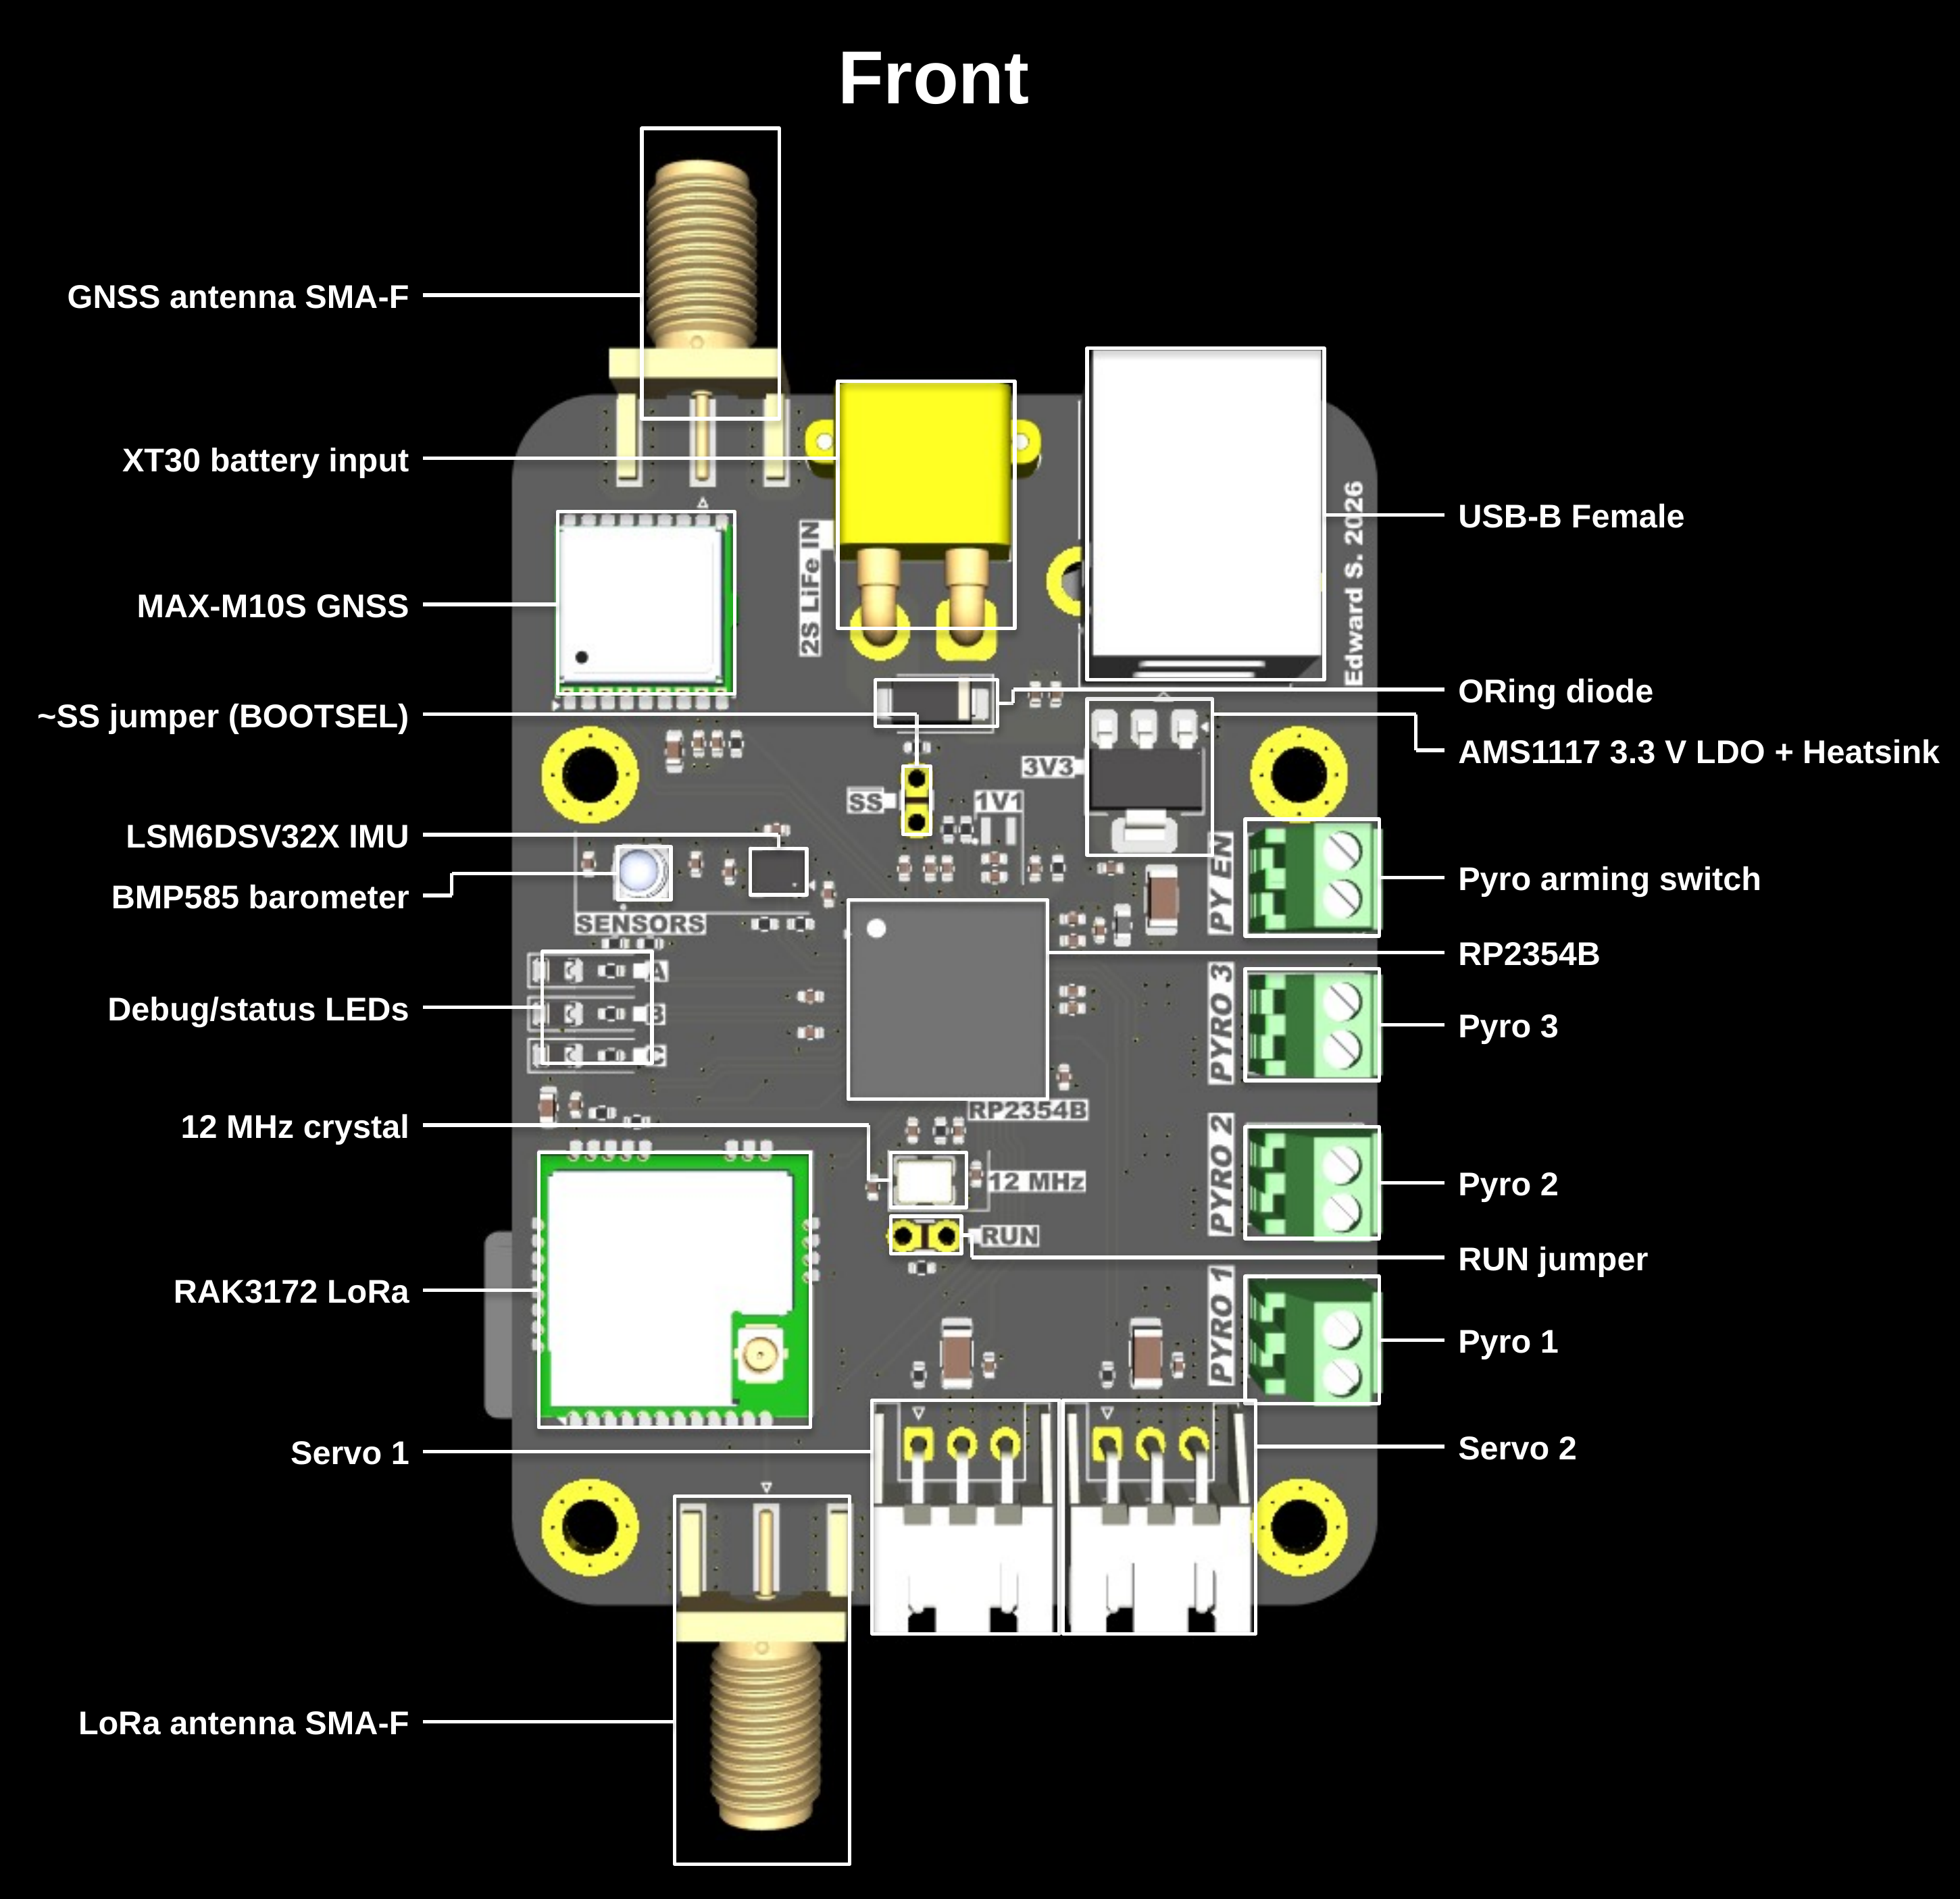

4 PCB DIAGRAM - REAR
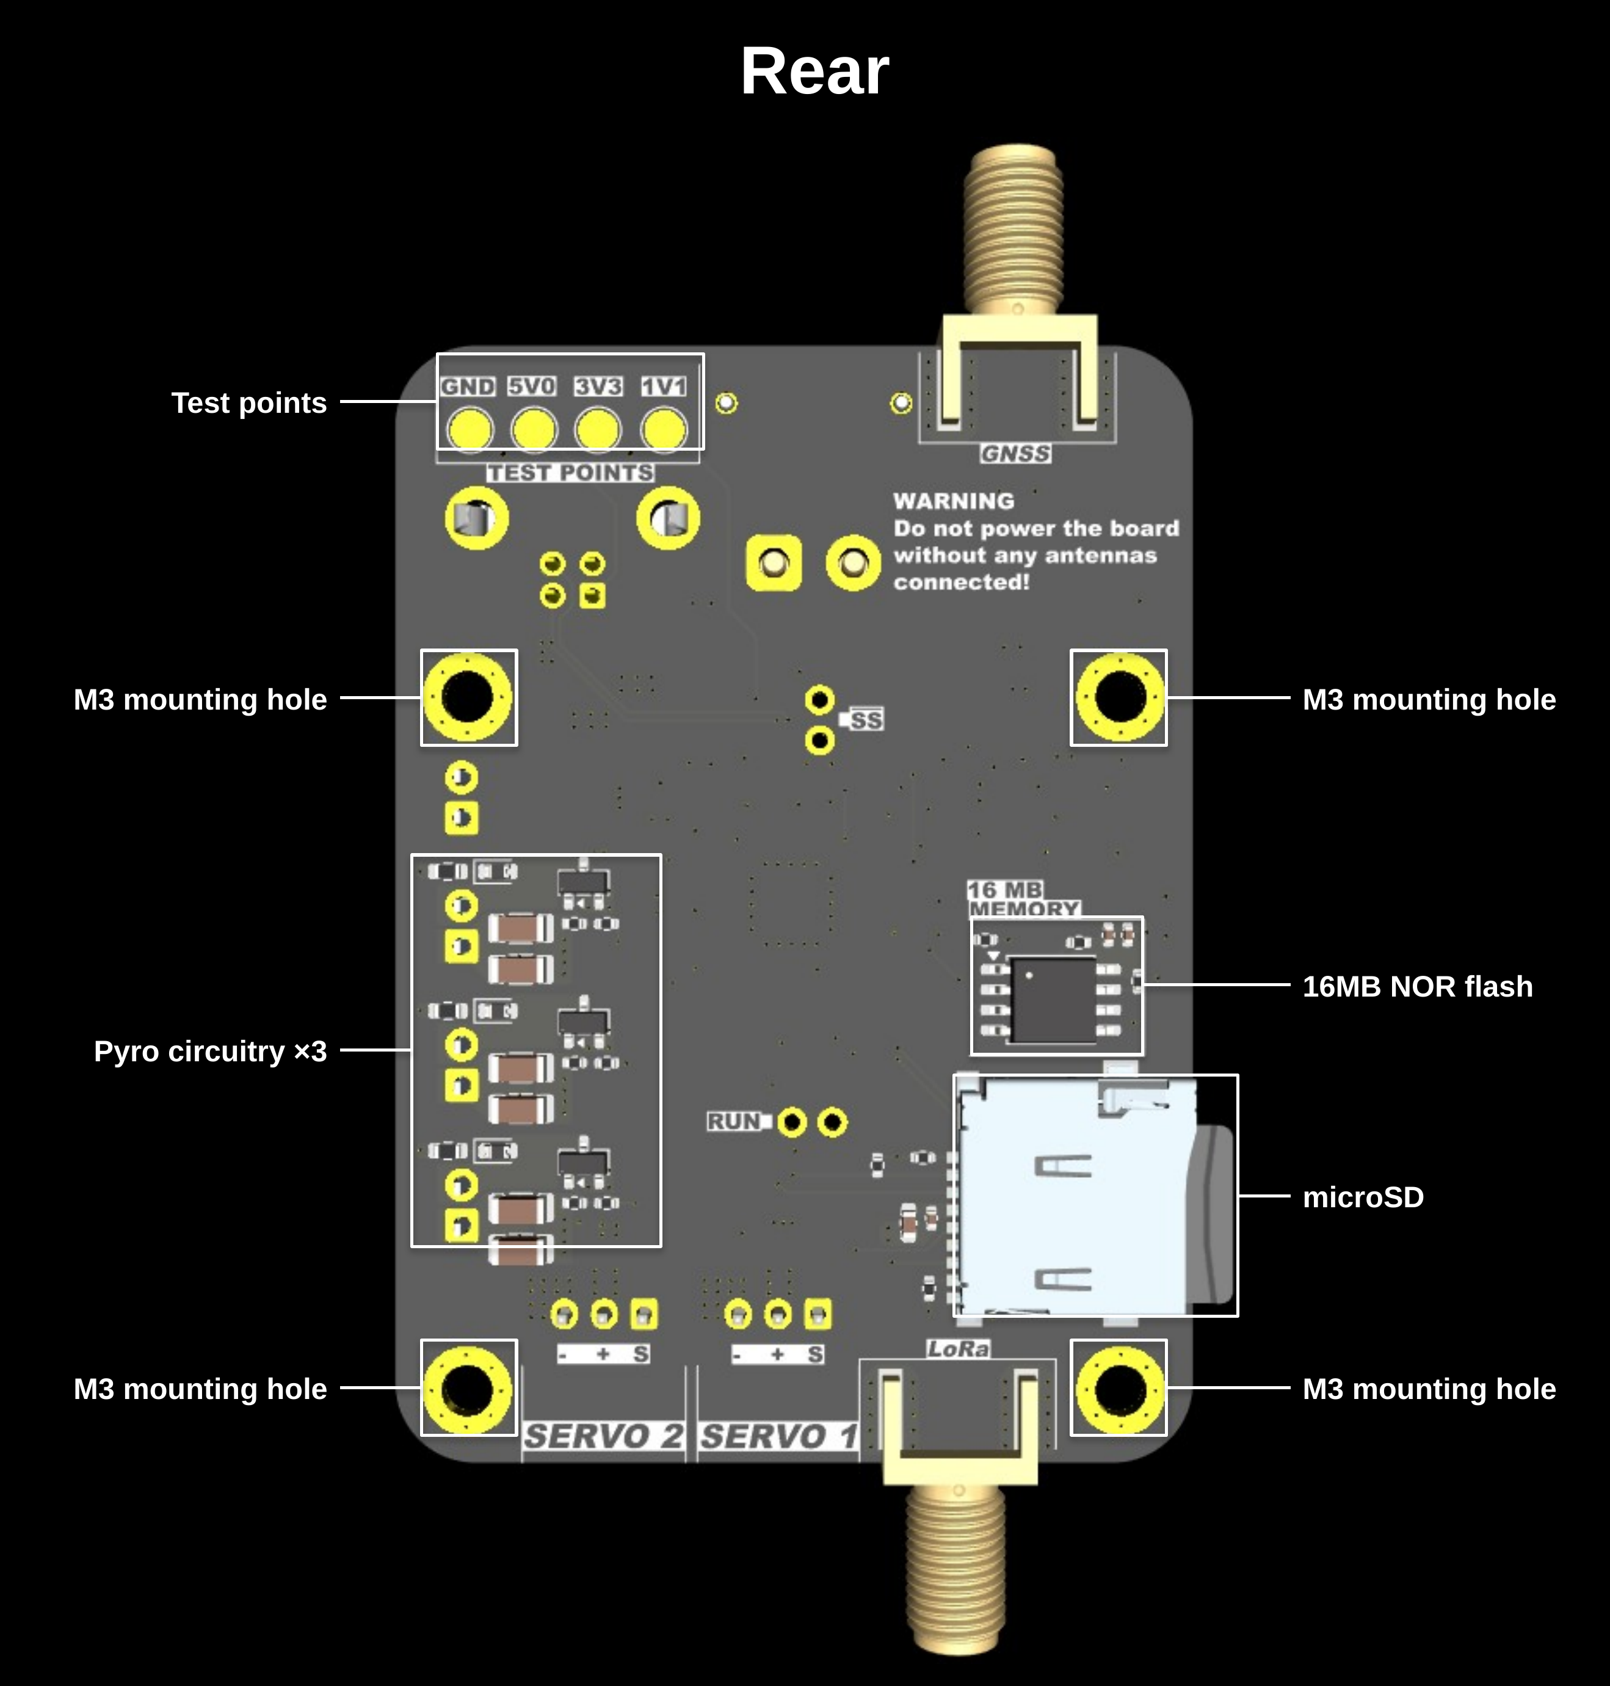

5 TABLE OF COMPONENTS
Component | MPN | Datasheet | Details
Microcontroller | RP2354B | Datasheet | Dual Cortex-M33 cores 150 MHz. Hazard3 cores are unused.
IMU | LSM6DSV32X | Datasheet | 6-axis, ±32 g accelerometer, ±4000 dps gyroscope.
Barometer | BMP585 | Datasheet | Pressure and temperature sensor.
Flash memory | W25Q128JVSIQ | Datasheet | 128 Mbit NOR flash.
microSD socket | MSD-1-A | Datasheet | -
GNSS | MAX-M10S-00B | Datasheet | U-blox M10 GNSS module with a passive ANT.
LoRa radio | RAK3172-8-SM-NI | Datasheet | 863–928 MHz LoRa with a passive ANT.
3.3 V regulator | AMS1117-3.3 | Datasheet | 1 A LDO, VBATT or VBUS to 3.3V. Heatsink for VBATT power dissipation.
ORing diode | SS54 | Datasheet | ORing the battery onto VBUS.
Pyro FET | AO3400A | Datasheet | Low-side MOSFET for each of the 3 pyro channels.
Crystal | ABM8-272-T3 | Datasheet | MCU’s clock.
Core regulator inductor | AOTA-B201610S3R3-101-T | Datasheet | Inductor for onboard RP2354B 1.1V regulator
USB connector | USB1030-GF-P-B-B | Datasheet | USB-B female.
Battery connector | XT30PW-M | Product page | XT30 male battery input.
Pyro / arm terminals | 282834-2 | Product page | 01x02 2.54mm screw terminals.
Servo connectors | S3B-XH-A | Datasheet | 3-pin 2.54mm JST-XH, powered from +BATT for HV servos.
Antenna connectors | 132289 | Product page | SMA-F.
Status LEDs | KT-0805Y | Product page | Yellow LEDs.

6 COMPONENT PROGRAMMING REFERENCES
Component | Bus | Pins | Pico SDK reference
IMU | I²C0 | SDA - GPIO8 / PIN6  SCL - GPIO9 / PIN7  INT1 - GPIO7 / PIN4 | hardware_i2c
Barometer | I²C1 | SDA - GPIO10 / PIN8  SCL - GPIO11 / PIN9 | hardware_i2c
Flash memory | SPI0 | MISO - GPIO16 / PIN16  CS - GPIO17 / PIN17  SCK - GPIO18 / PIN18  MOSI - GPIO19 / PIN19 | hardware_spi
MicroSD | SPI1 | MISO - GPIO28 / PIN36  CS - GPIO29 / PIN37  SCK - GPIO30 / PIN38  MOSI - GPIO31 / PIN39 | hardware_spi
GNSS | UART0 | TX - GPIO0 / PIN77  RX - GPIO1 / PIN78  Reset - GPIO2 / PIN79 | hardware_uart
LoRa radio | UART1 | TX - GPIO24 / PIN25  RX - GPIO25 / PIN26  Reset - GPIO20 / PIN20 | hardware_uart
Status LEDs | GPIO | LED A - GPIO12 / PIN11  LED B - GPIO13 / PIN12  LED C - GPIO14 / PIN13 | hardware_gpio
Pyro channels | GPIO | Pyro 1 - GPIO43 / PIN54  Pyro 2 - GPIO44 / PIN55  Pyro 3 - GPIO45 / PIN56 | hardware_gpio
Servos | PWM | Servo 1 - GPIO32 / PIN40 (PWM8 A)  Servo 2 - GPIO36 / PIN45 (PWM10 A) | hardware_pwm
USB | USB 1 HS | D+ USB_DP / PIN67  D- USB_DM / PIN66 | pico_stdio_usb

