Requirements: SV Calculator Application

1. Intro
   1. Pur

This document defines the requirements for the Calculator application. This document will provide a single point of source that provides detail requirements for specific functional features.

1. V mvcvvcvcm
2. Specific Requirements
   1. General View

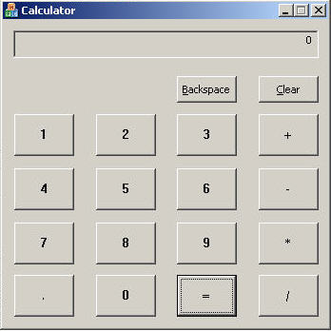

Figure 1: General View

* 1. Functionality

|  |  |
| --- | --- |
| ***F-1*** | Following controls should present:  - Ten digit buttons: “0”, “1”, “2”, “3”, “4”, “5”, “6”, “7”, “8” and “9” buttons;  -the “.” button;  - Four arithmetic operation buttons such as: “+”, “-”, “*” and “/”;  - the “=” button;  - the “Clear” button;  - the “Backspace” button;  - Read-only edit field. |
| ***F-2*** | Clicking any digit button should entail appearing of appropriated digit in the edit field. |
| ***F-3*** | If some digit is already displayed in the edit field, then new entered digit should be placed after it. |
| ***F-4*** | Clicking “.” button should entail adding “.” symbol to currently displayed number. |
| ***F-5*** | If the “.” symbol is already presented in currently displayed number, then second clicking “.” button should not entail any changes. |
| ***F-6*** | Executing following scenario should entail adding for two numbers:  Scenario: Enter first number, click “+” button, enter second number, click “=” button.  Result: Sum of first and second numbers displayed in the edit field. |
| ***F-7*** | Executing following scenario should entail subtraction for two numbers:  Scenario: Enter first number, click “-” button, enter second number, click “=” button.  Result: Second number deducted from first number and result displayed in the edit field. |
| ***F-8*** | Executing following scenario should entail multiplication for two numbers:  Scenario: Enter first number, click “*” button, enter second number, click “=” button.  Result: Multiplication of first and second numbers displayed in the edit field. |
| ***F-9*** | Executing following scenario should entail division for two numbers:  Scenario: Enter first number, click “/” button, enter second number, click “=” button.  Result: First number divided by second number and result displayed in the edit field. |
| ***F-10*** | Clicking the “Clear” button should entail clearing edit field (displaying “0” in it) and all previous actions are discarded. |
| ***F-11*** | Clicking the “Backspace” button should entail deleting last digit from currently displayed number in edit field. |
| ***F-12*** | Calculator should be closed by clicking “X” system button. |

* 1. Usability

|  |  |
| --- | --- |
| ***U-1*** | In case of any error the component should report the error in user-friendly way not allowing displaying of the messages and error codes that are not understandable for the user. |

* 1. Performance

|  |  |
| --- | --- |
| ***P-1*** | Time interval between user click/keystroke on “0”, …, “9”, “.”, “Backspace” or “Clear” buttons and finishing corresponding activity (display a digit, clearing, etc.) should not exceed 1 second. |
| ***P-2*** | Time interval between user click/keystroke on “+”, “-”, “*”, “/” or “=” buttons and finishing corresponding activity (dividing, etc.) should not exceed 2 seconds. |
| ***P-3*** | Any operation should not exceed 3% CPU usage. |

* 1. User Interface

|  |  |
| --- | --- |
| ***UI-1*** | Calculator GUI created in complete single style. |

* 1. Help/Online Documentation

No Help/Online Documentation should be provided.