Raspberry Pi

Piracast-setup

Step 1:install raspberry os:

Requirements:

Hardware:

1.Memory card reader

2. 8 GB or more memory card

Software:

1.Download sdcard formatter-https://www.sdcard.org/downloads/formatter_4/eula_windows/SDFormatterv4.zip

2.Download win32 disk imager-http://sourceforge.net/projects/win32diskimager/files/latest/download

3.Download raspian wheezy image version:3.12.22+.

* Go to raspberrypi.org and you can find raspian wheezy image.
* And you can download it from there for free.

Installing:

1.Download and install sdcard formatter(SDFormatter)

2.Format the sd card using the sd card formatter.

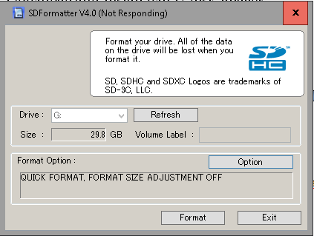

* This software automatically detects the sdcard and shows its information.
* Now you can format the sd card.

3. Download and install win32 disk imager

4. Open win32 disk imager and select the image (raspian image ver:3.12.22+) and select the memory card

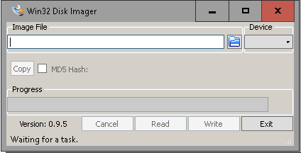

* Now choose the raspbian image from the directory ,that have been already downloaded.

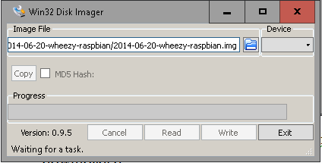

* Click on write option after adding the wheezy image.
* After few minutes you get your raspbian wheezy image ready and can be inserted in your pi.

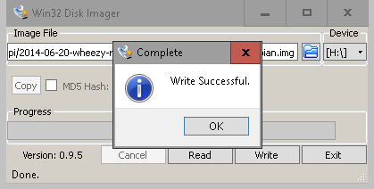

* This message on screen ensures that raspbian image has been write

success.

Configuring os:

* Insert the os installed memory card and turn on the pi by connecting keyboard, mouse, ethernet link,wifi adapter(Tp link -tl-wn725n ver 2).

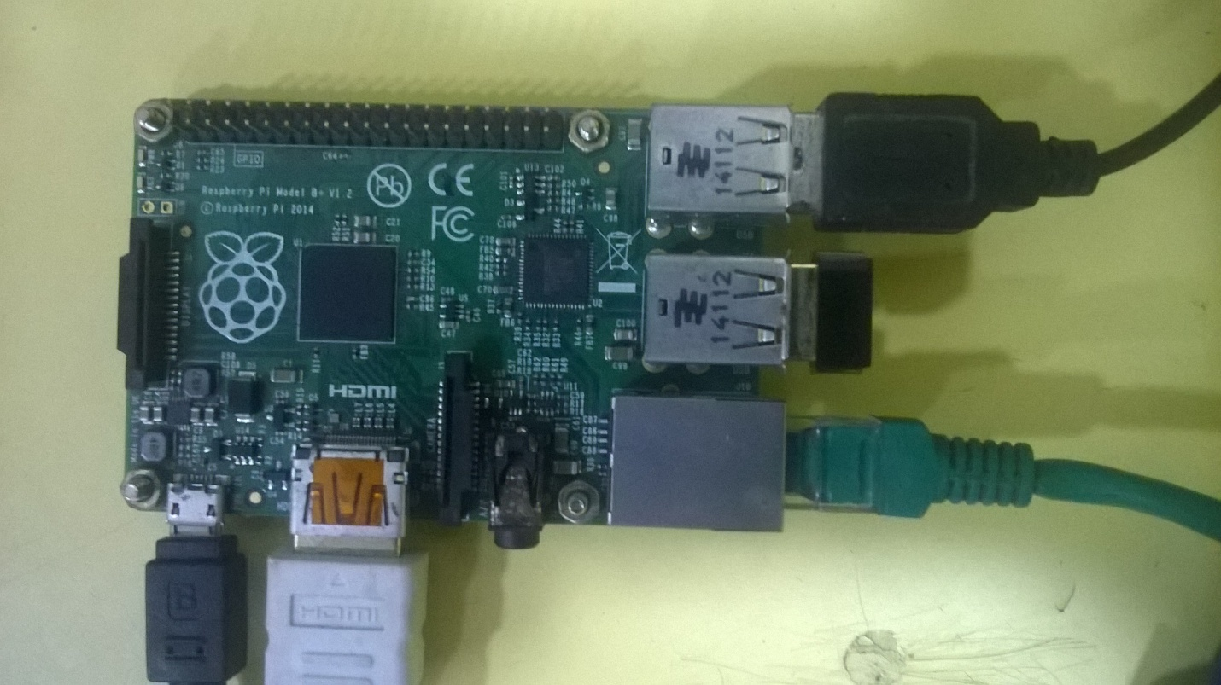

* After booting up for the first time you will be in configuration screen.

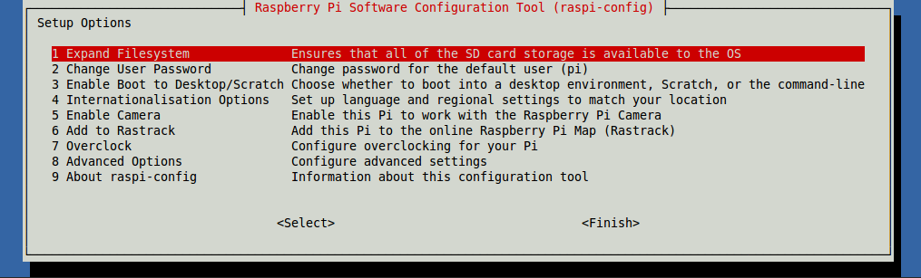

select:1.Expand file system (this is for expanding memory card storagelike partition).

select:2.Enable boot to, console text console requiring login

select:3.Advanced settings:A4 enable ssh

3. pi user name: pi

password: raspberry

STEP 2:Installing wifi Driver

Requirements:

Hardware:

1.wi-fi adapter (Tp link -tl-wn725n ver 2).

Software:

1. OS image:debian wheezy(ver 3.12.22+#691)

2. Piracast-Master setup: <https://github.com/codemonkeyricky/piracast/archive/master.zip>

* Master.zip file will be downloaded and extract it in the same folder where you downloaded it.
* And copy the extracted file in a pen drive.

3. Driver file: <https://dl.dropboxusercontent.com/u/80256631/8188eu-20140616.tar.gz>

* 8188eu-20140616.tar.gz file will be downloaded by clicking this link.
* Extract the file inside a folder and copy it in a pen drive.

4. Turn on the pi by connecting wi-fi adapter,Lan,keyboard,mouse.

5. login to pi

6. Type : startx (it will boot you to the graphical desktop screen.)

Steps installing driver:

1.Insert the pendrive in raspberrypi containing the driver file that you have downloaded and extracted in step 3.

2.Open the filemanager in raspberry pi.

3.And copy the driver in the working directory.

3.Close file manager.

4.Open LX terminal.

* Now type the command : sudo install -p -m 644 8188eu.ko /lib/modules/3.12.22+/kernel/drivers/net/wireless

(you are installing the wifi driver into the rasperry)

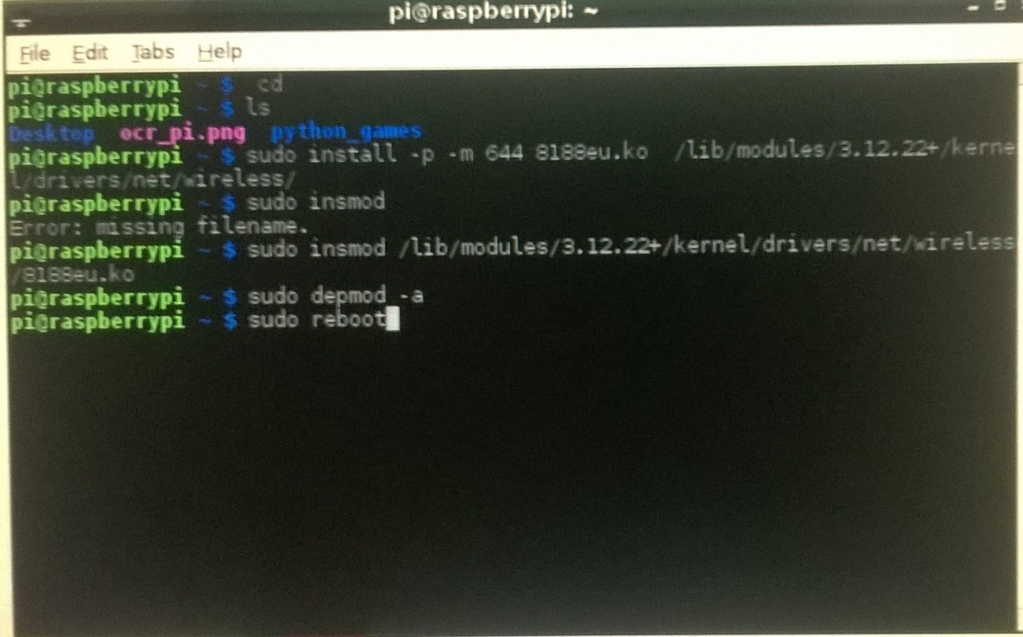

* Then Type :sudo insmod /lib/modules/3.12.22+/kernel/drivers/net/wireless/8188eu.ko

(you are inserting the file into the kernel of raspberry pi)

* Type :sudo depmod -a (you are deploying and activating the driver)
* Type:sudo reboot (Restart).
* Thats it your wifi driver installed.

STEP 3:Installing DHCP server

Requirements:

1.Connect the internet to pi using wired lan connection.

2.Plug in the wifi-adapter in raspberry pi(must be done).

3.Pendrive with miracast software.

Steps copying piracast-master software:

1. login to pi and type startx to boot into graphical screen.

2. Insert the piracast-master software copied pendrive in pi.

3. Open file manager .

4. Copy the piracast-master folder from pendrive to pi working folder (extracted piracast master folder).

5. Restart

Steps installing server:

1. Type: sudo apt-get install isc-dhcp-server (Downloading application)

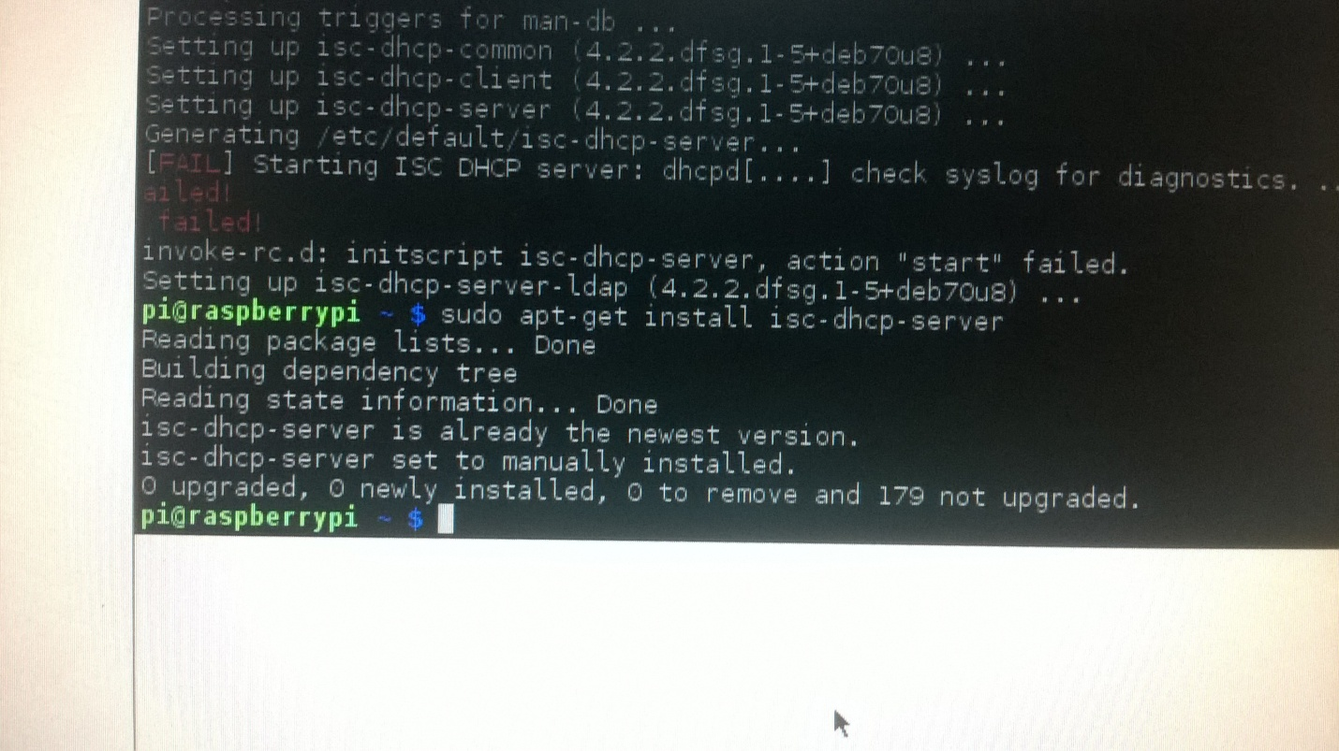

2. Type: cd piracast-master (you are opening the piracast-master folder)

3. Type: sudo cp env/isc-dhcp-server /etc/default (you copying isc-dhcp-server file to the default folder in pi)

4. Type: sudo cp env/dhcpd.conf /etc/dhcp/ (you copying the dhcpd config file to the dhcp folder in pi)

5. Type: sudo cp env/interfaces /etc/network/interfaces (you copying the interfaces file to pi interfaces)

6.Thats it !!! you have configured and installed dhcp server.

STEP 4:Installing Piracast software

Requirements:

1. Connect the internet to pi using wired lan connection.

2. Plug in the wifi-adapter in raspberry pi must.

Steps installing Piracast software:

1. Type: cd piracast-master (you are opening piracast-master folder)

2. Type: cd target (you are opening target folder)

3. Type : make core ( you are compiling and installing the piracast software)

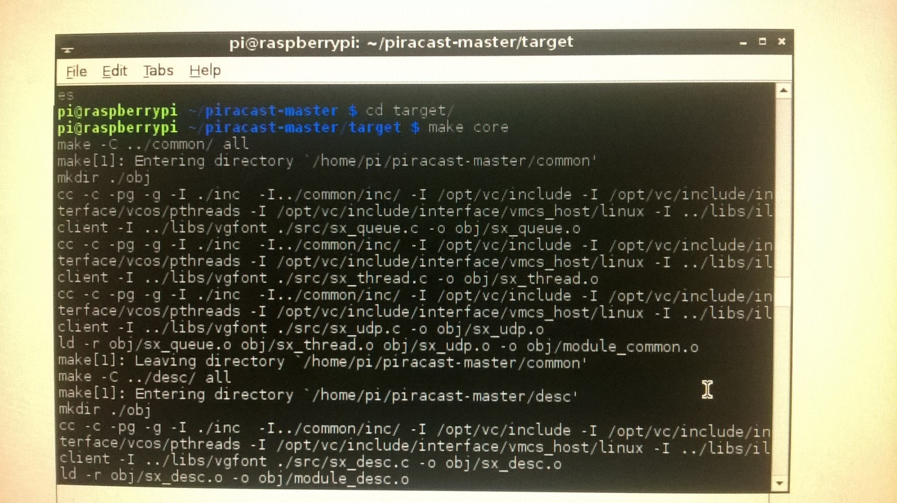

4. Thats it!!! you have installed piracast sucessfully

Final step:Configuring and starting Piracast

Requirements:

1.Plug in the wifi-adapter in raspberry pi must.

Steps configuring permission for Piracast software: (or else u will get permission denied error).

1.login into pi

2.Type: cd piracast-master (you are opening piracast-master folder)

3.Type: sudo chmod 777 -R scripts/ (you are changing the mode and opening permisssion)

4.Type: cd scripts (you are openin scripts folder)

5.Type: sudo nice -n -20 ./core & (The mode for running piracast application)

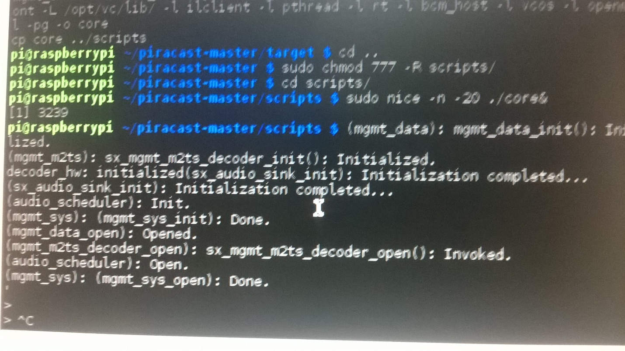

6.Type: sudo python piracast.py (you are starting the piracst application).

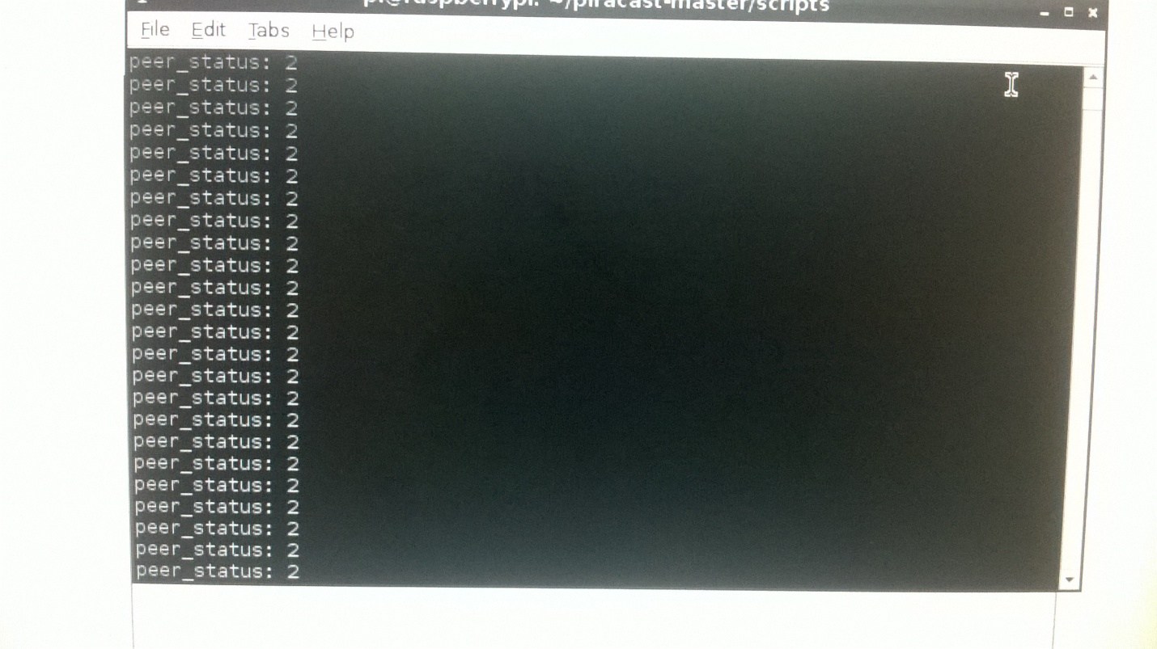

7.In your mobile: Turn on screen mirroring and select the piracast display device .

8.Your screen will be mirroring in certain automated steps.

9.Thats it!!!! you are a piracast master.