# HARDWARE

## Terminology

|  |  |
| --- | --- |
| **Term** | **Description** |
| **controller** | A controller consists of a board, firmware, and software. It controls the drives and implements the functions. |
| **duplex/simplex configurations** | Duplex is a two-controller module configuration within the storage array. Simplex is a single-controller module configuration. |
| **HDD** | Hard disk drives (HDDs) are data storage devices that use rotating metal platters with a magnetic coating. |
| **HIC** | A host interface card (HIC) connects the array to the host. It can optionally be installed within a controller canister. |
| **IB** | InfiniBand (IB) is a communications standard for data transmission between high-performance servers and storage systems. |
| **IOPS** | IOPS is input/output operations per second. |
| **mirroring** | Mirroring is the replication of data volumes onto separate storage arrays to ensure continuous availability. |
| **pool** | A pool is a set of drives that is logically grouped. You can use a pool to create one or more volumes accessible to a host. |
| **power/fan canister** | A power/fan canister is an assembly that slides into a shelf. It includes a power supply and an integrated fan. |
| **rack unit (U)** | A rack unit (abbreviated U) is a unit of measure defined as 44.50 millimeters (1.75 in). |
| **SAS** | Serial Attached SCSI (SAS) is a point-to-point serial protocol that links controllers directly to disk drives. |
| **RoCE** | RDMA over Converged Ethernet (RoCE) is a network protocol that allows remote direct memory access (RDMA) over an Ethernet network. |
| **shelf** | A shelf is an enclosure installed in a cabinet or rack. It contains the hardware components for the storage array. There are two types of shelves: a controller shelf and a drive shelf. A controller shelf includes controllers and drives. A drive shelf includes input/output modules (IOMs) and drives. |
| **snapshot** | A snapshot image is a logical copy of volume data, captured at a particular point-in-time. Like a restore point, snapshot images allow you to roll back to a known good data set. |
| **SSD** | Solid-state disks (SSDs) are data storage devices that use solid state memory (flash) to store data persistently. SSDs emulate conventional hard drives and are available with the same interfaces that hard drives use. |
| **storage array** | A storage array includes shelves, controllers, drives, software, and firmware. |
| **volume** | A volume is a container in which applications, databases, and file systems store data. It is the logical component created for the host to access storage on the storage array. |
| **workload** | A workload is a storage object that supports an application. For some applications, System Manager configures the workload to contain volumes with similar underlying volume characteristics. These volume characteristics are optimized based on the type of application the workload supports. |

## E-Series Hardware Overview

* 2U & 4U Rack Unit devices

* E2800 series – entry-level hybrid
* EF280 series – entry-level all flash
* EF300 series – entry-level all flash, all NVMe
* E5700 series – midrange hybrid
* EF570 series – midrange all flash
* EF600 series – midrange all flash, all NVMe

## Shelves

## E-Series Deployment Workflow

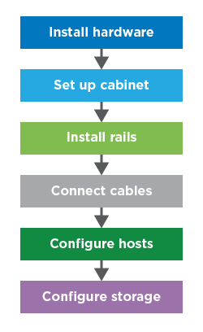

## Topologies

### Direct Attach

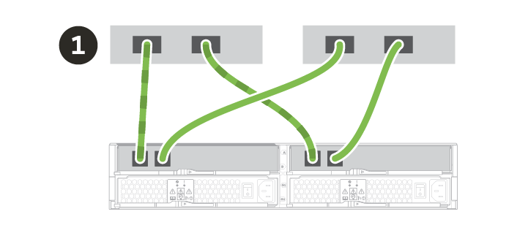

### Switch

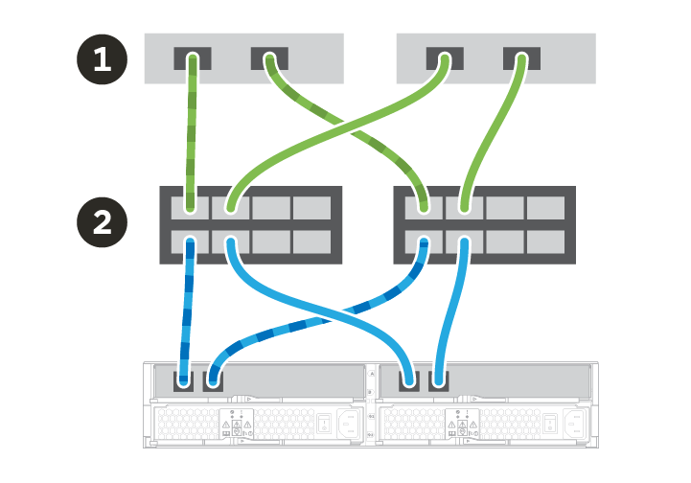

### Required components

* **Cables**: SAS, Fibre Channel (FC), Ethernet, InfiniBand
* Small form-factor pluggable (SFP) or Quad SFP (QSFP) transceivers
* Switches
* Host bus adapters (HBAs)
* Host channel adapters (HCAs)
* Network interface cards (NICs)

## Installation Guides

* <https://docs.netapp.com/ess-11/topic/com.netapp.nav.hiu/home.html>

## Drive Replacement

### Why a Drive Fails?

* Drives will always be failed upon failing a write request.
* Other failure reasons are determined by the Drive Error Thresholds specified for each drive type in the Drive Exception Management region of the NVSRAM.
* Different versions of NVSRAM will have different settings for primary and secondary drives to accommodate a variety of solutions.
* When a drive exceeds the error thresholds determined by the NVSRAM, the drive will be failed.

**Note:** Drive error thresholds and time window values are stored in NVSRAM

The array automatically detects many drive problems and if it is not able to correct a given problem, will fail the drive and automatically replace the failed capacity with either preservation capacity (in the case of pools), or a hot spare (in the case of volume groups).

At other times, **you may suspect that a drive has a problem before the system detects it**. In such a situation **you can manually fail the drive**, but the array does not automatically replace it because the array does not know your intentions. In this case **you will have to manually initiate the takeover operation.**

## How To Properly Select Enclosure for Disk Replacement

1. What is the Current Data Rate listed?

If 6, go to step 2. If 12, go to step 5.

2. Is there a Drawer column?

If yes, DE6600

If no, go to step 3.

3. Are there more than 12 drives listed in the same tray?

Yes -> DE5600

No -> Step 4

4. If you search the Product ID, is the DE1600 listed?

Yes -> DE1600

No -> Go back to step 1 and try again.

5. Is there a Drawer column?

Yes-> DE460C

No -> Step 6.

6. Are there more than 12 drives listed in the same tray?

Yes -> DE224C

No -> Step 7.

7. If you search the Product ID, is the DE212C listed?

Yes -> DE212C

No -> Go back to step 1 and try again.

## Power Supply Replacement

* Go to Storage Array Profile > Shelves
* Check for the affected power supply
* Get Part Number

#### PREQ creation

* Search by **Category**
* Category **Power Supplies**
* Platform Name **E-Series Model**
* Click **Apply**
* Make sure to match the part number and the enclosure type.

## Fan Replacement

* Check **state capture data** > **ssmShowSubTree** > Fan **speed**
* Compare values using below table
* **Code: Speed (RPM): Description:**
* 0000   0 - 499       Fan stopped
* 0001   500 - 999     Fan at lowest speed
* 0002   1000 - 1499   Fan at second lowest speed
* 0003   1500 - 1999   Fan at speed 3
* 0004   2000 - 2499   Fan at speed 4
* 0005   2500 - 2999   Fan at speed 5
* 0006   3000 - 3499   Fan at intermediate speed
* 0007        > 3500   Fan at highest speed
* Go to Storage Array profile > Shelves/trays

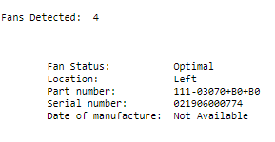

* Notate the part number and **location.**
* PREQ > Search By **Category** > **Fans** > **Platform** > Match both part numbers to confirm.

**Note:** 60 drive enclosures have Fans independent from PSU, hence, they can be replaced separately.

## Drawer Replacement

* Snake cable reseat on either **A** or **B** side.
* Check the Drawer Controller Module (DCM) at stateCaptureData *dcmmShow.*

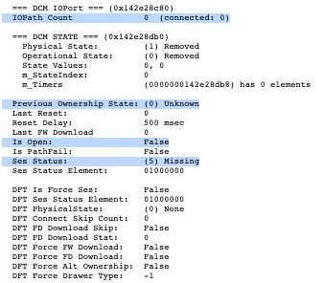

* You can also check the *isRedundant* field
* Search by **Category** > **Drive** **Drawer** > **Platform**

## SFP Replacement

* Search by **Category** > **SFPs**> **Platform**
* Make sure to match the supported data rate with the PREQ.

## Controller Replacement

* Check Storage array profile > controllers > Part Number of the affected device.
* Using the PREQ tool search by **Part**

## ESM Replacement

Go to Storage Array profile > Shelves/trays

**Note:** Before reseating or replacing ESM components, make sure that there is at least one active ESM that has two connection for each controller to prevent redundancy loss.

<https://kb.netapp.com/Advice_and_Troubleshooting/Data_Storage_Systems/E-Series_Storage_Array/How_to_identify_a_degraded_SAS_port_on_an_ESM_within_E-Series>