Chalcolithic pits at Ovçular Tepesi

Rémi Berthon, Alexia Decaix, Zsófia Eszter Kovács, Wim Van Neer, Margareta

Tengberg, George Willcox & Thomas Cucchi

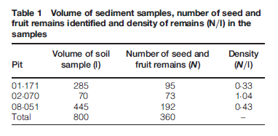

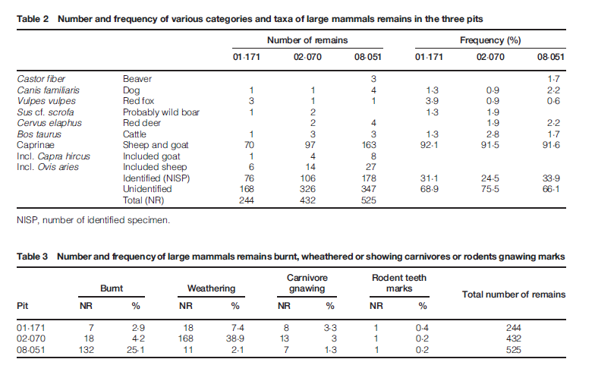

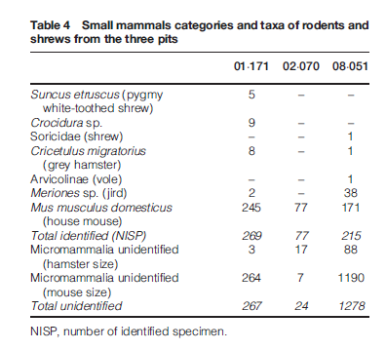

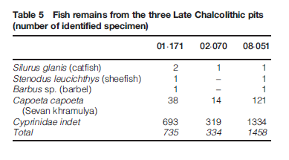

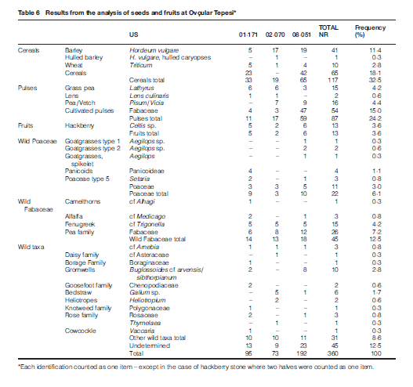

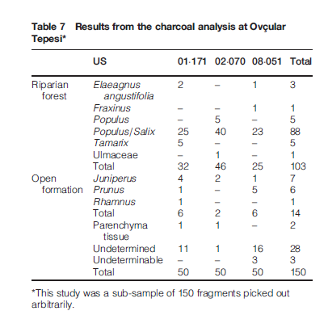

A ritual deposit of fox remains at Ovçular Tepesi (Nakhchivan, Azerbaijan)

and its relation with the pastoral nature of Late Chalcolithic communities

Rémi Berthon

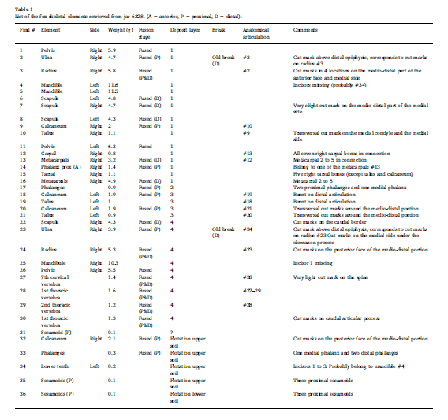

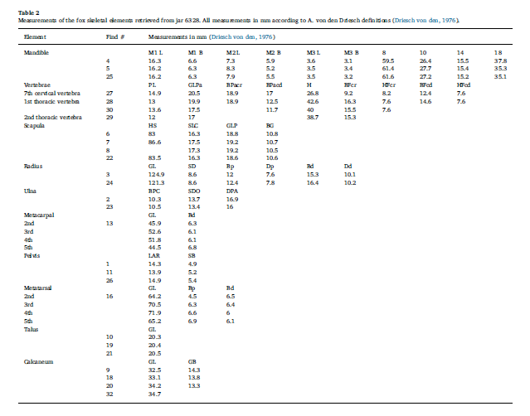

On the trail of Neolithic mice and men towards

Transcaucasia: zooarchaeological clues from

Nakhchivan (Azerbaijan)

THOMAS CUCCHI1,2\*, ZSÓFIA ESZTER KOVÁCS3, RÉMI BERTHON1,4, ANNIE ORTH5,

FRANÇOIS BONHOMME5, ALLOWEN EVIN2,1, ROOHOLLAH SIAHSARVIE5,6,

JAMSHID DARVISH6,7, VELI BAKHSHALIYEV8 and CATHERINE MARRO9

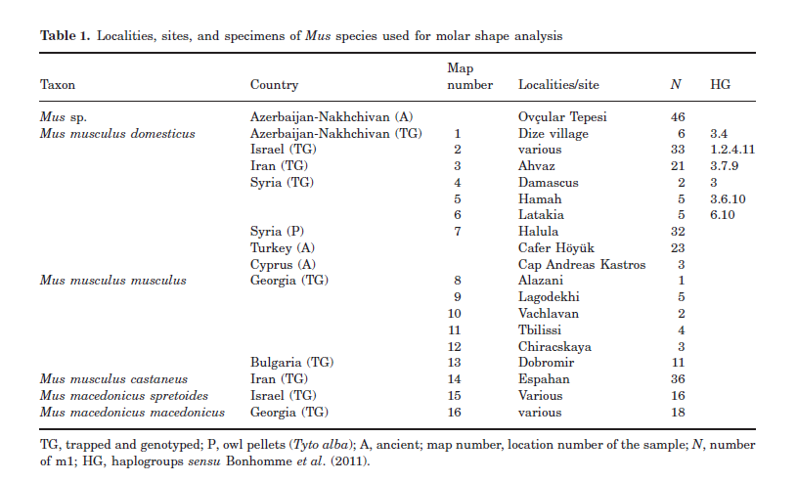

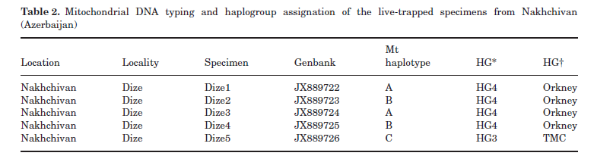

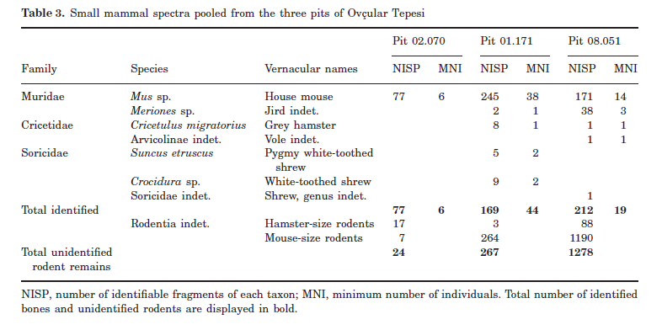

Vegetation and plant exploitation at Mentesh Tepe (Azerbaijan),

6th-3rd millennium BC initial results of the archaeobotanical study

Alexia Decaix a, b, Erwan Messager c, \*, Margareta Tengberg a, Reinder Neef d,

Bertille Lyonnet e, Farhad Guliyev f

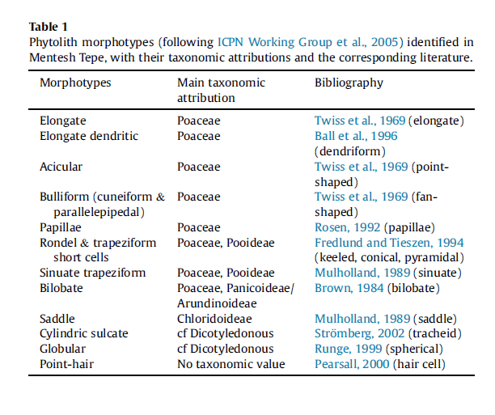

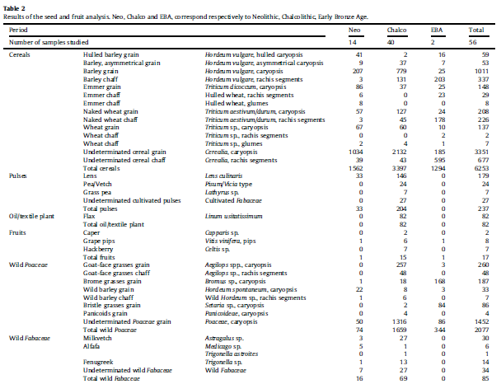

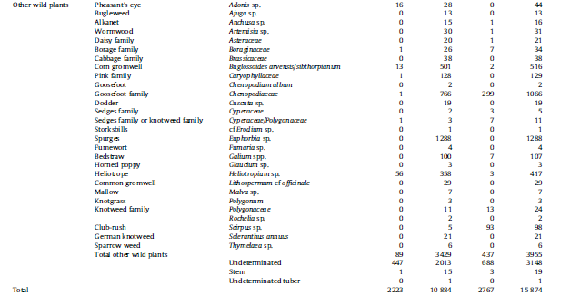

Archaeometallurgical Investigations in

Nakhchivan, Azerbaijan: What Does the Evidence

from Late Chalcolithic Ovçular Tepesi Tell Us about

the Beginning of Extractive Metallurgy?

Nicolas Gailhard, Michael Bode, Veli Bakhshaliyev, Andreas Hauptmann &

Catherine Marro

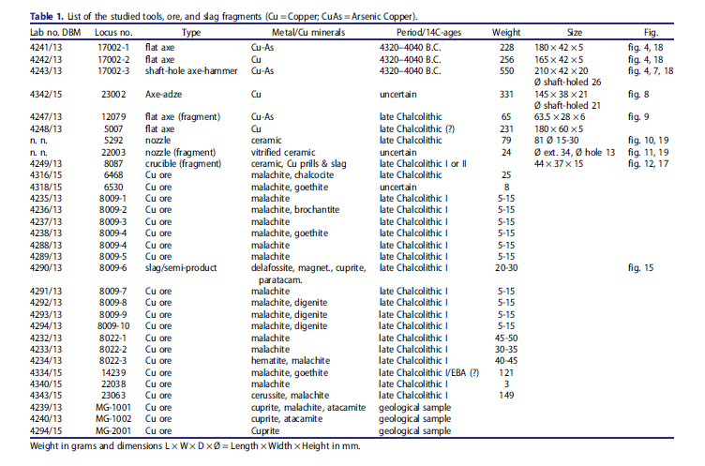

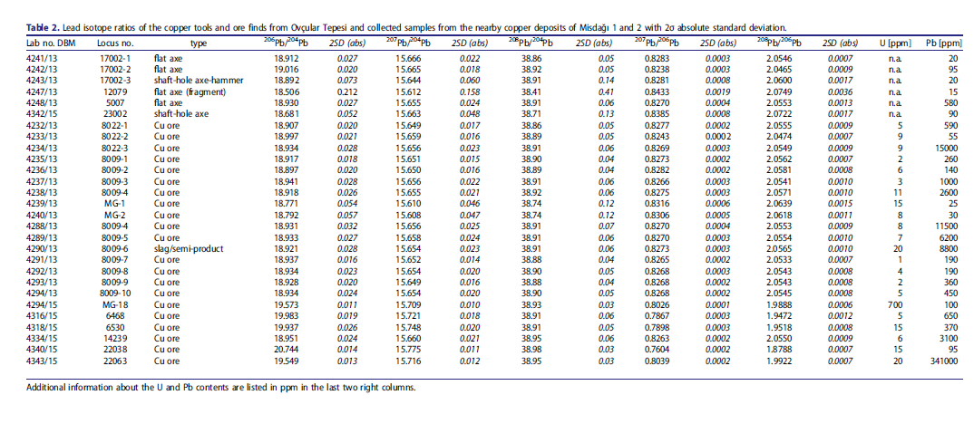

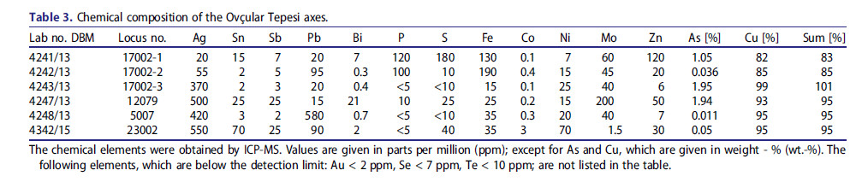

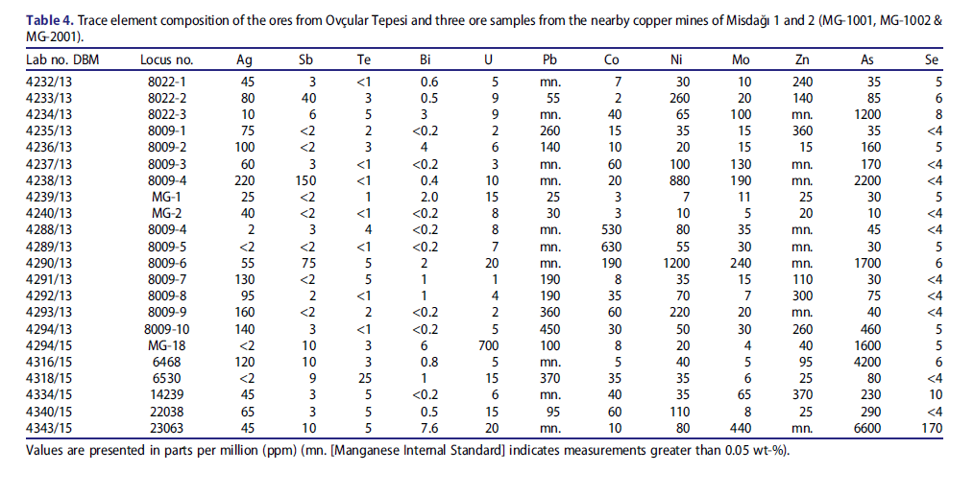

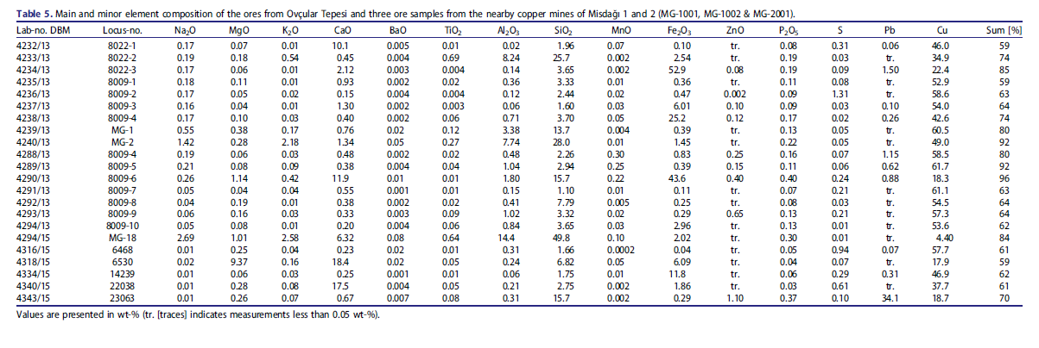

Mentesh Tepe, an early settlement of the Shomu-Shulaveri Culture in

Azerbaijan

Bertille Lyonnet a, \*, Farhad Guliyev b, Laurence Bouquet c, Ga€elle Bruley-Chabot c,

Anaïck Samzun c, Laure Pecqueur c, Elsa Jovenet c, Emmanuel Baudouin d,

Michel Fontugne e, Pascal Raymond c, Emeline Degorre f, Laurence Astruc g,

Denis Guilbeau h, Ga€elle Le Dosseur i, Norbert Benecke j, Caroline Hamon k,

Modwene Poulmarc'h l, Antoine Courcier m

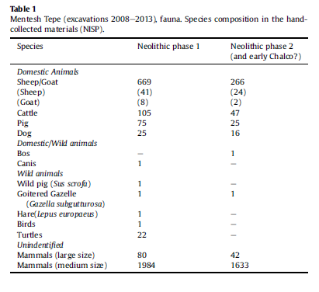

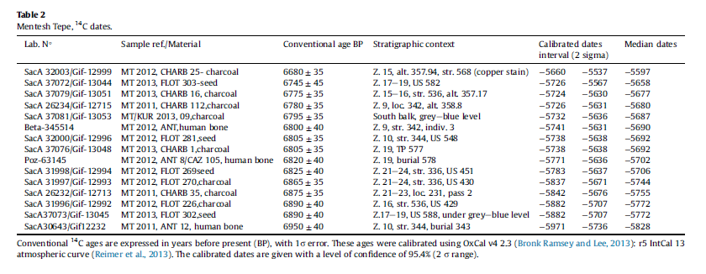

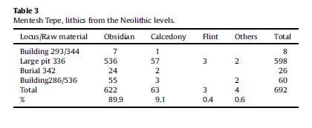

On the Genesis of the Kura-Araxes phenomenon: New evidence from Nakhchivan(Azerbaijan)

Catherine Marro, Rémi Berthon and Veli Bakhshaliyev

