Using the Laser Bike Jig

Edward Sitarski
edward.sitarski@gmail.com

October, 2022

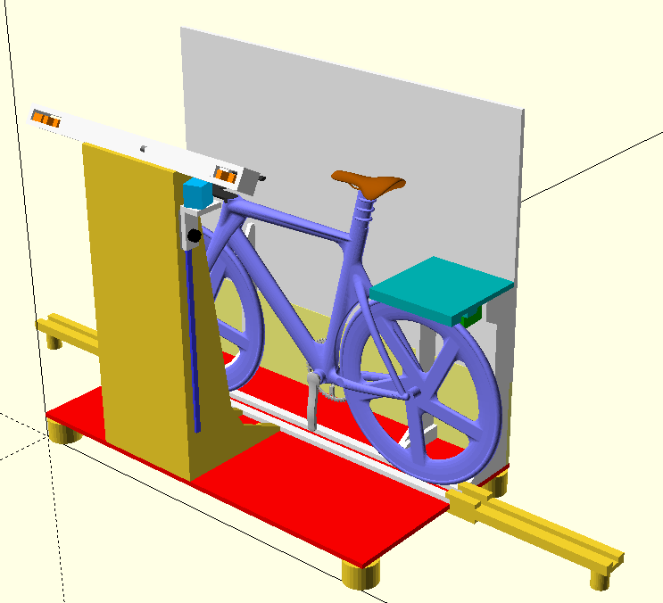
Using the Laser Bike Jig

Table of Contents
Using the Laser Bike Jig 1
Introduction 1
Moving, Locking and Leveling 1
Operating the Bike Jig 2
Laser Lines 2
Time Trial Handlebar Extension Gauge 3
Digital Level 3
Electrical Power on the Bike Jig 3
Checking Mass Start and Sprint Bikes 4
Checking Time Trial Bikes 8
Checking Tandem Bikes 12

Using the Laser Bike Jig

Introduction
The Laser Bike Jig is designed to check that Time Trial and Mass Start/Sprint bikes are compliant with the UCI rules effective January 1st, 2023.
This document does not cover specifics about the UCI equipment rules or how they are applied. Please consult the latest UCI rules available on the www.uci.org website.
The Laser Bike Jig is very fast, accurate and easy to use. It is possible to check dozens of bikes in a few minutes.
The Laser Bike Jig is a precision instrument. Treat it with care.
It uses Class 2 lasers similar to laser levels. Never look directly into any laser.
Be responsible. Do not leave the jig unsupervised - especially if children are present. It is not a toy. Use the key to turn it off (and/or unplug it) when it is unattended.
The jig primarily consists of the laser column (the part in front with the lasers), the trapdoor lid (holds the back wheel), the backboard (the board the lasers shine on) and the tandem extensions (used to extend the bike jig track to accommodate tandem bicycles). See the diagram on the cover page.

Moving, Locking and Leveling
Roll the bike jig to where it is needed.
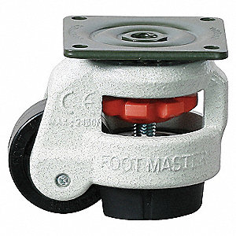
Lock and level the bike jig. The jig has “leveling castors” with a thumb wheel that raise and lower a rubber foot (see photo). When all feet are lowered, the jig cannot move.
Lower the feet by turning the thumb wheel in the opposite direction to the green arrows shown on the base of the jig. Use the feet to level the jig by adjusting them to different heights. It is important for the bike jig to be level.
To move the bike jig again, rotate all the thumb wheels in the direction of the green arrows until they cannot be turned anymore. This retracts the feet fully and the bike jig will roll freely.

Operating the Bike Jig
Ensure the bike jig is plugged in to a working outlet. The start button should be outlined in green. If the bike jig fails to operate, try another outlet that is known to be working.
Press the button. This activates the lasers for 2 minutes, then turns them off automatically. Pressing the button while the lasers are on will restart the timer again.
The horizontal laser on the right side is controlled with its own switch on top.
There is a key that disables/enables the bike jig. The lock must be in the ON position for the jig to work.
Do not let anyone stand on the jig while measuring a bike. Standing on the jig causes it to deflect and will result in inaccurate measurements.

Laser Lines
Review the UCI rules 1.3.022 and 1.0.023. Note there are 3 Classes of riders based on height.
The laser bike jig generates 7 lasers lines: 6 vertical lines and one horizontal line.
The vertical laser lines are as follows, from left to right:
Distance | Used For
850mm | Class 3 TT handlebar limit
830mm | Class 2 TT handlebar limit
800mm | Class 1 TT handlebar limit
750mm | Default TT handlebar limit
0mm | Center of Bottom Bracket
50mm | Saddle setback

The 750mm and 850mm line have secondary labels as follows:

Distance | Used For
100mm | Mass Start/Sprint Bike handlebar limit
0mm | Center of Front Wheel Spindle

These lines are used to check the maximum horizontal distance of the handlebars to the front wheel spindle (1.34.022).
There is also a horizontal laser line on an adjustable track on the right of the laser column. This is used to check that the handlebars are lower than the peak of the saddle.
As the horizontal line is not always required, this laser has its own switch on the top.

Time Trial Handlebar Extension Gauge
Time trial handlebar extensions are measured with the Plexiglass gauge.
It can be found in a bracket on the inside of the laser column.
The gauge is marked with +/-100mm, +/-120mm and +/-140mm lines corresponding to Class 1, 2 and 3 riders (see UCI rule 1.0.023).
It also contains useful measurements for other rules (min/max saddle length, etc.).
See the Time Trial Bikes section for details.
Always return the Time Trial Handlebar Extension Gauge to the bracket when not in use.

Digital Level
Used to measure seat angle as well as forearm support angle for time trial handlebar extensions.
It can be found on a shelf on the inside of the laser column.

Electrical Power on the Bike Jig
There are two available outlets at the base of the laser column as part of its extension cord. These can be used for a fan or a power supply (for example, recharging a tablet or operating a computer).

Checking Mass Start and Sprint Bikes
- Lift the trapdoor lid on the right.
- Put the bike in the jig making sure the tires are in the track. The handlebars are on your left.
- Lower the trapdoor lid onto the back wheel so that it is in the track. The bike is now held securely in the jig.
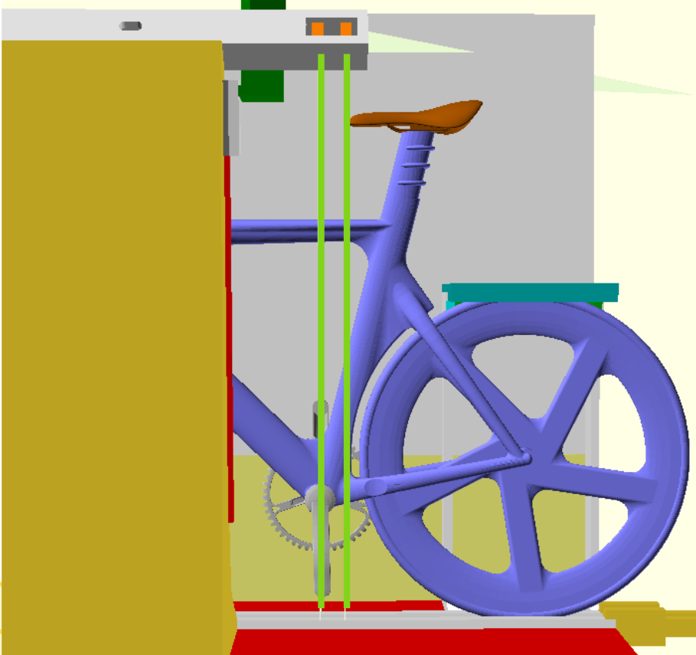
- Adjust the bike forwards/backwards so at the 0mm laser (second from the right) is perfectly aligned on the center of the bottom bracket. The bike should look as above.
- Check that the saddle tip is behind the 0mm line. Check if the saddle is ahead of the 50mm line (a morphological exception).
- Check the saddle angle by putting the Plexiglass gauge on the saddle, then put the digital level on top of that.
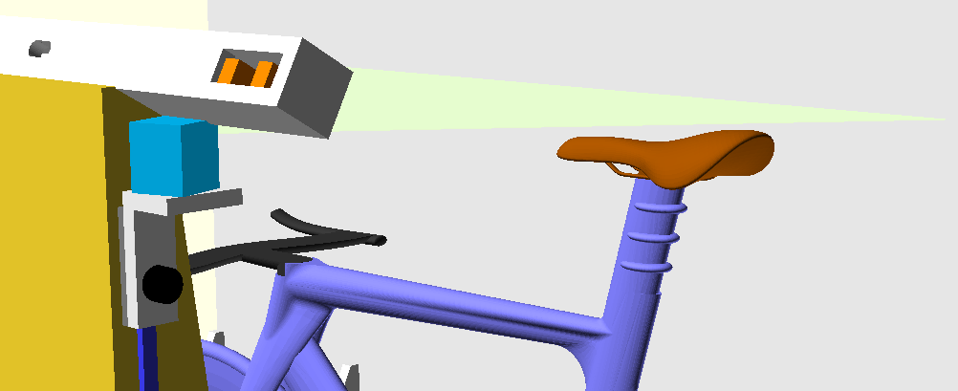
- Check that the handlebars are lower than the saddle. Turn on the horizontal level by pressing the button on the top, loosen the knob, slide the laser so the line is at the top of the saddle, then tighten the knob again. It does not take a lot of force to tighten it, so be gentle.
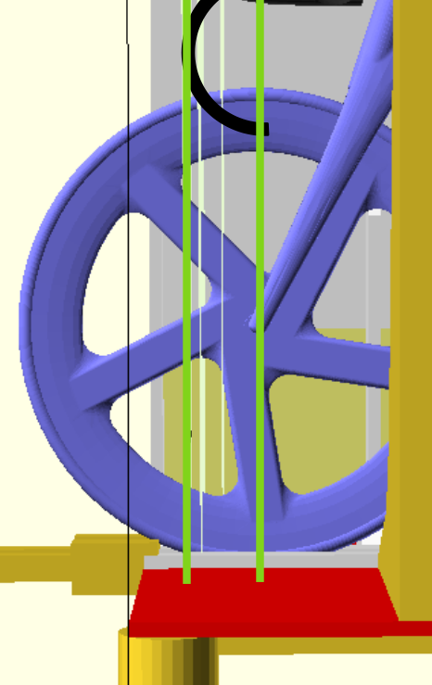
- With the bike still in the jig, roll the bike forward so the front wheel spindle is centered on the 0mm (750mm) vertical line. It should like as above.
- Check that the handlebars are within the 100mm (850mm) vertical line limit.
- Roll the bike out of the jig to the left.
Notes:
The above steps are a recommendation only. Skip steps that are obviously not required, or add steps you feel are necessary.
To check many bikes quickly, try skipping using the trapdoor. Most bikes will lean against the jig and will be stable enough to measure.
Some bikes (eg. Hope/Lotus) have a shape that gets in the way of one of the trapdoor support tabs. This tab can be moved out of the way by releasing the latch with the red handle and folding the tab inward. Secure the tab with the latch to its normal position when finished.

Checking Time Trial Bikes
- Lift the trapdoor lid on the right.
- Put the bike in the jig making sure the tires are in the track. Ensure the handlebars are on the left.
- Lower the trapdoor lid onto the back wheel so that it fits in the track. The bike is now held securely in the jig.
- Adjust the bike forwards/backwards so at the 0mm laser (second from the right) is centered on the bottom bracket. It should look as above.
- Check that the saddle behind the 0mm line. Check whether the saddle is in front of the 50mm line. If so, this is a morphological exception.
- Check the saddle angle by putting the Plexiglass gauge on the saddle, then put the digital level on top.
- Check that the handlebars are lower than the saddle. Turn on the horizontal level by pressing the button on the top, loosen the handle, slide it so the line is at the top of the saddle, then tighten the handle again. It does not take a lot of force to tighten it. Handlebar extensions are exempt and can be above the saddle height.
- Review the Class of the rider based on height.
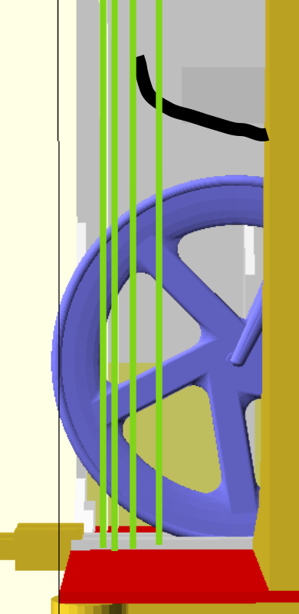
- Check that the handlebar extension length conforms to the rules for the rider Class as specified in UCI rule 1.0.023. To do so, check the appropriate laser lines at the 750mm, 800mm, 830mm and 850mm on the left side of the jig. Do not move the bike from its alignment on the bottom bracket laser. The handlebar extension check should look as above.
- Check that the angle of the forearm supports with the digital level.
- Use the Plexiglass gauge to check the maximum +/- of the extensions.
To do so, place the left side of the gauge so it contacts the middle of the forearm support.
If the extensions are at an upward angle, this will be the left corner of the gauge. If the extensions are at a downward angle, this will be the right corner of the gauge.
Make sure the gauge is level by using the attached bubble indicator, then check that the handlebar extensions are within +/- 10cm, +/- 12cm or +/- 14cm based on the 1, 2, 3 rider Class.
It is best to bend down to get on the same level as the handlebar extensions.
Notes:
The above steps are a recommendation only. Skip steps that are obviously not required, or add steps you feel are necessary.
Some bikes are so wide that one of the support tabs is in the way. To move this tab, release the latch with the red handle and push the tab inward. Secure the tab back to its normal position with the latch when finished.

Checking Tandem Bikes
- Install the tandem track extensions.
- Remove both tandem extensions from under the trapdoor lid.
- Hook the extensions to the bike jig track. Ensure that the tracks are aligned. See above for details.
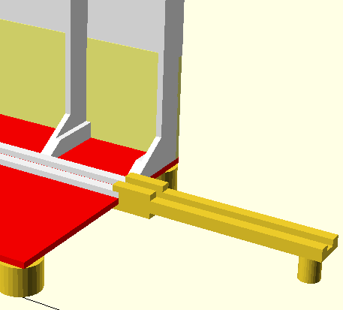Figure 2: Right Side
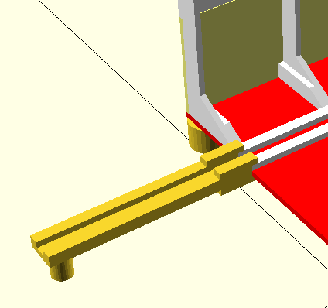Figure 1: Left Side
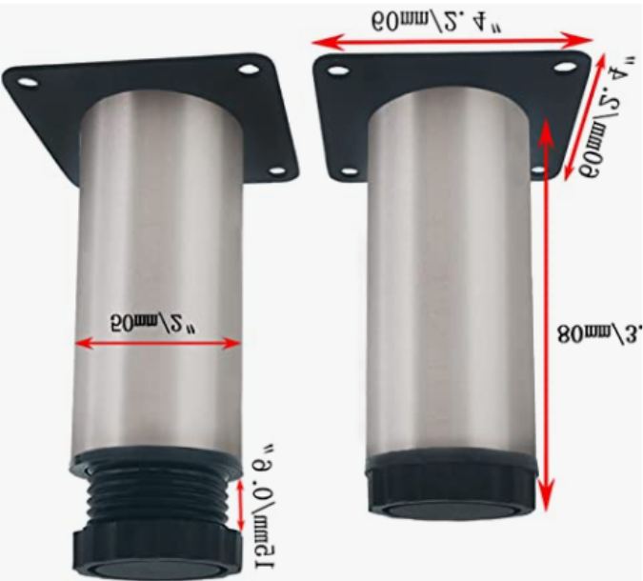
- Twist the foot on the leg of each extension until the track is completely level. Using the bubble levels.
- Lift up the trapdoor lid and leave it in the up position.
- Put the tandem bike in the jig, align the front rider’s bottom bracket, and do the same checks for Time Trial bikes.
- Roll the tandem bike forward, align the rear rider’s bottom bracket, and check the seat position and angle. You can use the trapdoor lid to hold the bike when checking the rear rider.
- When finished checking tandem bikes, return the track extensions to their position under the trapdoor lid.

